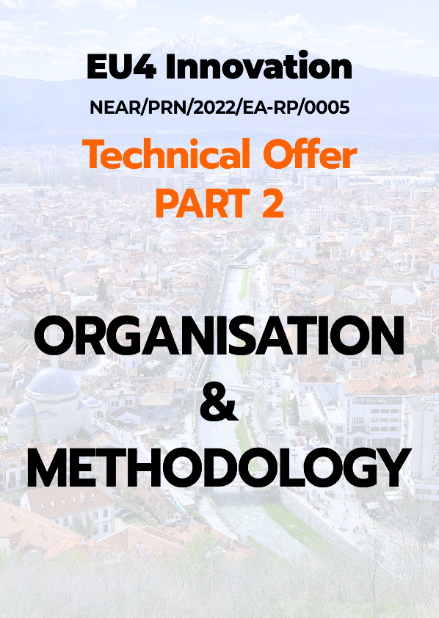

**EU4 INNOVATION**

**NEAR/PRN/2022/EA-RP/0005**

|  |  |  |
| --- | --- | --- |
|  |  |  |
|  |

**PROJECT INFORMATION**

|  |  |
| --- | --- |
| Project Title: | EU4 INNOVATION |
| Project reference: | NEAR/PRN/2022/EA-RP/0005 |
| Funding: | IPA ACTION PROGRAMME 2019, Part II |
| Location[1]: | Pristina; Prizren (Innovation and Training Park); potential travel within Kosovo and/or outside Kosovo may be required |
| Contracting Authority[2]: | EU Office in Kosovo (EUOK) |
| Responsible Body[3]: | EU Office in Kosovo (EUOK) |
| Implementing Authority[4]: | Ministry of Economy and Energy (MoEE) |
| Target groups[5]: | Relevant staff of the Ministry of Economy and Energy and the Ministry of Internal Affairs, other ministries, governmental agencies, business organisations, chambers of commerce, Central Bank of Kosovo, other banks and financial institutions, NGOs, social partners, financial institutions and other relevant stakeholders. |
| Project duration[6]: | 24 Months - **Inception**: 4 months (max); **Implementation**: 19 Months; **Closing**: 1 Month |
| Intended commencement date[7]: | October 2022 |

**TABLE OF CONTENTS**

**Consortium members I**

**EVOLUXER I**

**SEIDOR II**

**Bit4ID II**

**KOSOVO LEGAL SERVICES COMPANY V**

**Consortium highlights and strengths VI**

**Technical proposal highlights and strengths VII**

1. Section 1 – Rationale 2

A. Summary 2

B. Digital Economy in the EU: Current Situation and Policy Priorities 6

C. View on current situation 18

1.1. Understanding the ToR 26

1.1.1. Objectives 26

1.1.2. Outputs/Results 28

1.1.3. Key issues 29

1.2. Risks and assumptions 31

2. Section 2 – Strategy 39

2.1. Project approach 39

2.1.1. Overview 39

2.1.2. Specific methodology 41

A. Base eID Framework 43

B. Detailed description of the proposed eID Framework 48

C. Compliance of the proposed eID Base Framework 92

D. Assessing the current situation 103

E. Build and Deploy the Digital Identity Service 104

F. Capacity Building 124

G. Awareness raising 126

2.1.3. Toolbox 127

2.2. Project organisation 134

2.2.1. Organisation chart 134

2.2.2. Project Team 135

2.2.2.1. Senior Experts 137

2.2.2.2. Other Experts 140

2.2.3. Teamwork 148

2.3. Scope of the Work 149

2.3.1. Overview 149

2.3.2. Project Work Breakdown Structure - WBS 152

2.4. Activities 155

2.4.1. INC - Inception Phase 156

2.4.2. IMP.BDIS - Build Digital Identity Service Implementation 170

2.4.3. IMP.DDIS - Deploy Digital Identity Service Implementation 173

2.4.4. IMP.CB - Capacity Building Implementation 175

2.4.5. IMP.AR - Awareness Raising Implementation 188

2.4.6. MC - Monitoring&Control 193

2.4.7. RP – Reporting 197

2.4.8. CL – Closing Phase 201

3. Section 3 – Backstopping 205

A. Approach 205

B. Working Structure 208

C. Working Process 209

D. Working with the key stakeholders 209

E. Project Management 211

F. Scope management 212

G. Time management 212

H. Resource management 214

I. Knowledge Management 223

J. Risk management 225

K. Change Management 227

L. Reliability Management 229

M. Compliance 231

N. Project ecosystem management 232

O. Management of external suppliers and services 235

3.1. Consortium Management Board 243

3.2. Financial Management 243

3.3. HR management 245

3.4. IT&C support 247

3.5. Quality Assurance 250

3.6. Project Director 252

3.7. Backstopping Team Leaders 253

3.8. Technical teams 255

3.9. Logistic support team 259

3.10. Local support 259

3.11. Legal support team 260

3.12. Knowledge management 260

4. Section 4 – Involvement of all members of the Consortium 265

A. Summary 265

B. Presentation of Consortium Members 266

EVOLUXER 266

SEIDOR 270

Bit4ID 274

KOSOVO LEGAL SERVICES COMPANY 280

C. Consortium partners’ synergies/ complementary areas of expertise 281

D. Consortium Function 282

E. Consortium Management 282

F. Cooperation Model among Consortium Members 283

G. Consortium Members’ roles and contributions 285

H. Allocation and management of project resources 290

5. Section 5 – Timetable of work 292

A. Approach 292

B. Time Management 292

C. Workplan 294

6. Log Frame 314

**LIST OF TABLES**

Table 1 - Abbreviations and Acronyms G

Table 2-References G

Table 3-Consortium Leader-EVOLUXER SL I

Table 4 - Consortium Partner 1: Seidor II

Table 5 - Consortium Partner 2: bit4id II

Table 6 - Consortium Partner 3 - Kosovo Legal Services Company V

Table 7 - Consortium Strengths VI

Table 8 - Main sections of the Technical Proposal VII

Table 9 - Technical Proposal Strengths VIII

Table 10 - Key Success Factors 28

Table 11 - Key Technical issues and challenges 29

Table 12 - Key Management issues and challenges 30

Table 13 - Key Relational issues and challenges 30

Table 14 - Assumptions 31

Table 15 - Risks 35

Table 16 - Main principles of our strategy 41

Table 17 - General compliance matrix 45

Table 18 - Use cases and general requirements compliance 92

Table 19 - Architectural composition compliance 93

Table 20 - Registration Process Compliance 95

Table 21 - Usage of eID Service Compliance 95

Table 22 - Mobile eID Functional Compliance 96

Table 23 - Mobile eID Non-Functional Compliance 97

Table 24 - Signing/Signature Validation Functional Compliance 98

Table 25 - Signing/Signature Validation Non-Functional Compliance 98

Table 26 - Software (API) for Service Providers Functional Compliance 99

Table 27 - Software (API) for Service Providers Non-Functional Compliance 99

Table 28 - Administration Module Functional Compliance 99

Table 29 - Administration Module Non-Functional Compliance 100

Table 30 - Messaging Hub Functional Compliance 101

Table 31 - - Messaging Hub Non-Functional Compliance 101

Table 32 - CA Functional Compliance 102

Table 33 - CA Non-Functional Compliance 103

Table 34 - Internal Acceptance Criteria 120

Table 35 - Tools 128

Table 36 - Procedures 132

Table 37 - Quality of the proposed expert team 135

Table 38 – Other Experts Categories 140

Table 39 - Indicative list of other experts 141

Table 40 - Project Phases and Implementation Chapters 150

Table 41 - Project WBS 152

Table 42 - Social Media in Kosovo 191

Table 43 - Main principles of the organisational structure 214

Table 44 - Supplier selection grid 236

Table 45 - Highlights of the backstopping structure 242

Table 46-Main activities of financial backstopping function 243

Table 47 - Financial Manager 244

Table 48 - Highlights of the HR Strategy 246

Table 49-Principles of the Project IT Environment 247

Table 50-Main functionalities of the Project IT Environment 248

Table 51-QA/QC: Sources for quality criteria 250

Table 52 - Quality Manager 252

Table 53-Project Director 252

Table 54-Backstopping technical teams 255

Table 55 - Proposed Backstopping Area Leaders 257

Table 56-Knowledge Management methods and tools 260

Table 57-High level Consortium Members Involvement 265

Table 58 - Consortium Partner 1: Seidor 270

Table 59 - Consortium Partner 2: Bit4ID 274

Table 60 - Consortium Partner 3 - Kosovo Legal Services Company 280

Table 61 - Consortium Members: Relevant Expertise 282

Table 62 - Consortium Members Involvement: Detailed contribution 286

Table 63-Constraints and Milestones of the Timetable of Work 295

Table 64-Timetable of work 297

Table 65 - Log Frame 314

**LIST OF FIGURES**

Figure 1 - e-IDAS Scope 5

Figure 2 – Strategy outline 40

Figure 3 - eID Base Framework: Digital Signature Modules (summary) 46

Figure 4 - eID Framework: Concept Structure 47

Figure 5 - smartCMS overview 51

Figure 6 - SignCloud overview 52

Figure 7 - SignBox overview 52

Figure 8 - Verification/Validation for signed documents overview 53

Figure 9 - Integration with existing information systems - overview 53

Figure 10 - Logging module 54

Figure 11 - API overview 54

Figure 12 - eID: Main workflow 56

Figure 13 - Web signature flow 57

Figure 14 - integration Flow 57

Figure 15 - Root Certificate Authority Flow 58

Figure 16 - Additional CA flow 58

Figure 17 - Registration Authority Flow 59

Figure 18 - Validation Authority Flow 59

Figure 19 - Time Stamping Flow 60

Figure 20 - Securing Keys Flow 60

Figure 21 - Verification and Validation Flow 61

Figure 22 - Digital Certificates Management Flow 62

Figure 23 - Audit and Log Flow 63

Figure 24 - Connect exisiting ICT (Single-Sign-On) Flow 64

Figure 25 - Personal Data Protection Flow 64

Figure 26 - SignCoud Server 66

Figure 27 - SmartCMS Homepage 77

Figure 28 - smartCMS: requests management 78

Figure 29 - smartCMS: registration of a new user 79

Figure 30 - smartCMS Self-Service Portal 80

Figure 31 - Self-Service Portal: Identity life-cycle management 81

Figure 32 - Self-Service Portal: Integration with kiosks (example) 81

Figure 33 - Flow diagram for the citizen enrolment process 83

Figure 34 - VIDchain and VIDwallet 85

Figure 35 - Verifiable Credential Issuance 86

Figure 36 - Credential Verification 87

Figure 37 - VIDwallet, the VIDchain EBSI SSI Wallet 88

Figure 38 - Remote Signing process with the SignCloud mobile application 90

Figure 39 - [1] Connection of the UKC Client to the SignCloud; [2] Display of the available digital identities into the UKC 90

Figure 40 - Adding a digital signature to a Word document 91

Figure 41 - Methodology: Assessment of current situation 104

Figure 42 - Methodology: Build and Deploy Digital Identity Service 105

Figure 43 - Methodology: CI/CD Pipelines 106

Figure 44 - Methodology: Software development 106

Figure 45 - Software requirements specification development process 108

Figure 46 - Correlation between analysis and design stage 110

Figure 47 - Server, business and database tier 110

Figure 48 - Web Service 111

Figure 49 - Processes implemented in the Database Design 111

Figure 50 - Processes implemented in the Software Design 112

Figure 51 - Components of Software Testing 119

Figure 52 - Indicative Table for Test Case ID: Short Description 122

Figure 53 – Factors to be tested 123

Figure 54 - HTTP proxy 124

Figure 55 - Methodology: Capacity Building 125

Figure 56 - Methodology: Awareness Raising 126

Figure 57 - Project Organisation Chart 134

Figure 58 - Expert Team 135

Figure 59 - Approach to deliver Scope of Work 149

Figure 60 - Project Phases, Implementation Chapters and Deliverables 151

Figure 61 - Project WBS 154

Figure 62 - Inception Phase 157

Figure 63 - Stakeholders Map 163

Figure 64 - Build Digital Identity Service 170

Figure 65 - Deploy Digital Identity Service 173

Figure 66 - Capacity Building 176

Figure 67 - Awareness Raising 188

Figure 68 - Monitoring&Control 193

Figure 69 - Closing 197

Figure 70 – Reporting milestones of the project 200

Figure 71 - Principles underlying the set-up of the management team 205

Figure 72 - Management approach basics 206

Figure 73 - Project Phases 207

Figure 74 - Principles of our Project Management Manual 209

Figure 75 - Project Management Trifecta 211

Figure 76 - Project Coordinators’ responsibilities 217

Figure 77 - Quality Management Trifecta 218

Figure 78 - Knowledge Management 223

Figure 79 - Knowledge management sources 224

Figure 80 - Example of change log 229

Figure 81 - Reliability Management Trifecta 230

Figure 82 - Communications & escalations at project level 233

Figure 83 - Internal communications 234

Figure 84 - Consultation strategy timeline 235

Figure 85 - Backstopping structure 240

Figure 86 - Project Information Flow 241

Figure 87 - Architecture of the Project IT Environment 249

Figure 88 - Duration of project phases 306

Figure 89 - Duration of Software Activities 307

Figure 90 - Structure of design-development-testing activities 307

Figure 91 - Planning balanced approach 308

Figure 92 - Resources Allocation per Activity 309

Figure 93 - Resources Involvement per Activity 310

Figure 94 - Senior Experts per Activity 311

Figure 95 - Relevant Resources per Software Related Activities 311

**ABBREVIATIONS, ACRONYMS, REFERENCES**

Table 1 - Abbreviations and Acronyms

|  |  |
| --- | --- |
| EVO | EVOLUXER International Consulting - Consortium Leader |
| KLSC | Kosovo Legal Services Company – Consortium Partner |
| SEID | Seidor – Consortium Partner |
| TLSP | Telespazio – Consortium Partner |
| PD | Project Director |
| TL | Team Leader |
| CAUT[8] | Contracting Authority |
| IAUT[9] | Implementing Authority |
| TA | Technical Assistance |
| C&V | Communication and Visibility |
| PR | Progress Report |
| DFR | Draft Final Report |
| FR | Final Report |
| ORR | On-Request Report |
| MOM | Minutes of Meeting |
| INC | Inception Phase |
| IMP | Implementation Phase |
| BDIS | Build Digital Identity Service Implementation Chapter |
| DDIS | Deploy Digital Identity Service Implementation Chapter |
| CB | Capacity Building Implementation Chapter |
| AR | Awareness Raising Implementation Chapter |
| MC | Monitoring&Control Phase |
| CL | Closing Phase |
| OVI | Objective Verifiable Indicator |
| SOW | Scope of Work |
| WBS | Work Breakdown Structure |
| ToR | Terms of Reference |
| TP | Technical Proposal (this document) |
| PSC | Project Steering Committee |
| PSC1-8 | Quarterly Steering Committee Meetings |
| CI/CD | Continuous Integration/Continuous Deployment |

Table 2-References

| Item | ToR Reference | Short Name |
| --- | --- | --- |
| ToR Abbreviations | ToR, §Abbreviations, pg.2 | N/A |
| Expected Outputs | ToR, §2.3, pd. 9-11 | Outputs a, b, c, d |
| Minimum required deliverables | ToR, §2.3, pd. 9-11 | Deliverable 1 - 9 |
| Technical Study for Preparation for implementation of e-IDAS in Kosovo produced under the project EuropeAid/139756/DH/SER/XK | ToR, Annexes | Technical Study |

**EXECUTIVE SUMMARY**

**Consortium members**

The Consortium was brought together on the basis of its complementary skills and its capacity to efficiently and effectively implement all aspects of the project. In this section we present the Consortium partners and highlight the Consortium strengths. Further in the Technical Proposal we demonstrate how the Consortium will act as a single unit throughout the project implementation phase based upon the partners’ previous collaborative experience gained through various projects. Moreover, we identify synergies and complementarities among partners and relevant best practices based on their experience.

The Consortium consists of five members, who have joined forces in order to strengthen knowledge and experience-based synergies among individual members, drawing from their relevant experience in executing similar projects.

Unlike a temporary grouping, the Consortium will work as a stable, well-structured and integrated team. At the same time, it will be sufficiently flexible and responsive in order to deliver high quality results.

Table 3-Consortium Leader-EVOLUXER SL

| **EVOLUXER** | | |
| --- | --- | --- |
|  | Address: | Calle Ferraz, 28, 28008 Madrid, Spain |
| Web: | http://evoluxer.com/ |
| Phone: | +34 91 758 86 92 / +34 91 541 6035 |
| Email: | [projects@evoluxer.com](mailto:projects@evoluxer.com) |
| LinkedIn: | https://www.linkedin.com/company/evoluxer-sl/ |
| EVOLUXER SL is a Spanish leading consulting firm with strong presence in South East Europe, active in the provision of technical consultancy and services.  The company provides its services to both public sector entities and private sector businesses and has an active presence in all countries of its wider geographical region, offering services that meet the increased requirements resulting from the transformation of the economies in South East Europe and the Mediterranean Region.  The company is following a long-term strategic plan aiming to establish its leading presence in the region through a comprehensive portfolio of services, using as its key leverages:   * its highly qualified and experienced personnel, * the use of state-of-the-art technologies, * the development of solid and long-term international co-operations and * the significant geographical coverage that it offers   EVOLUXER offers its services mobilizing more than 30 highly trained consultants as permanent staff and over 8.000 potential external collaborators around the world. The appropriate measures are taken on a day-to-day basis for the continuous evaluation of the external collaborator and the training of internal staff for securing the high quality of offered services. | |

Table 4 - Consortium Partner 1: Seidor

| **SEIDOR** | |
| --- | --- |
|  | Seidor is a multinational that provides ICT services with 100% Spanish capital. Its origins date back to 1982 when it was founded by three brothers in Vic. The three founders are still leading the company. Nowadays, SEIDOR is still growing at an average rate of 20% per year and has over 6.000 employees.  With sales of 500 M€ in 2020 up from 410M€ in 2019, and staff of over 6.000 professionals, Seidor currently helps over 5,000 customers protect their technology investments and has become their technology partner of choice. We have achieved this special status thanks to our commitment to excellence. We have gained this status thanks to the professionalism of our technical employees, who are experts in their chosen field as attested by the certifications they hold from leading manufacturers |
|  | |

Table 5 - Consortium Partner 2: bit4id

| **Bit4ID** | |
| --- | --- |
|  | Founded in 2004, BIT4ID operates in the field of information security and more specifically in the field of "digital identity," as also indicated by the company name itself: BIT4ID - Best Information Technology for digital Identity.  All products and systems are developed and manufactured in BIT4ID's research and development laboratories in Napoli. The group's turnover is over 25 million euros with about 200 people employed in offices in Italy (Naples, Rome, Milan), Spain (Barcelona), Peru (Lima), the United Kingdom (London), and India (New Delhi).  Geographically, Bit4id has a recognized leadership position in Italy, has a strong presence in Spain, numerous clients in other European countries (mainly in Portugal, Poland, Bulgaria, Czech Republic, Slovenia, Romania, Hungary), South America (Peru, Ecuador), India and Macau in China |
| BIT4ID develops and markets products, systems and services based on PKI technology and cryptographic chips with applications and customers in the Public Administration, Banking, Trust Service Providers (certification authorities), system integrators and in general where digital signature, authentication and encryption capabilities are required.  BIT4ID's range of products and systems includes the following market segments:   1. Hardware devices such as smartcard readers and cryptographic tokens for authentication and digital signature. 2. Drivers and system libraries for interfacing applications to cryptographic devices (PKCS#11 libraries, CSP/KSP, TokenD/CryptoTokenKit). 3. Desktop and mobile applications for digital signature and encryption. 4. Strong authentication systems over corporate networks or the Internet and single sign-on systems with tokens or smartcards (e.g., with the Regional Services Card or Electronic Identity Card). 5. Automated batch digital signature systems for digital transformation.   Services and projects for provisioning cryptographic devices by interfacing with Trust Service Providers for issuing digital certificates, either through tokens or remotely  BIT4ID is one of the few companies in the domestic and international market that can express deep expertise in the entire PKI technology stack, from cryptographic hardware design to low-level cross-platform library development, from digital signature client applications to sophisticated server systems for digital identity management, from complete PKI infrastructures to value-added digital identity services.    Particularly about the latter aspects, i.e., the implementation of infrastructure for trust service providers both with a fully on-premises model run by the customer and with an Infrastructure as a Service model run by BIT4ID, there are numerous high-profile references that we can list.  BIT4ID recently participated, as a technology and professional services provider of the Infocert-Aruba RTI, in the implementation of the new qualified CA of InfoCamere S.C.p.A. Thanks also to the skills and software systems developed by BIT4ID, Infocamere has been accredited as a Qualified Trusted Service Provider for digital signature, time stamp, electronic seal, as well as non-qualified services related to CNS.  BIT4ID fully developed the infrastructure of Uanataca S.A., QTSP doubly accredited in Spain at in MINTEUR and in Italy at AgID for digital signature services, time stamp, electronic seal. Uanataca S.A. is a BIT4ID group company established to offer digital identity services both in the form of certification services and as PKIaaS.  Azienda Zero, an entity of the health service of the Veneto region, is an accredited QTSP in Italy for the provision of digital signature, time stamp, and electronic seal services. Azienda Zero's infrastructure is fully outsourced at the datacenter of Uanataca S.A. Again, the BIT4ID and Uanataca teams took care of all technological, organizational, and documental aspects to pass the compliance audit required by AgID to avail of the status of qualified trust service provider.  The list of eIDAS-accredited QTSPs using BIT4ID and Uanataca's PKIaaS services also includes the following companies on the European Trusted List:   * BEWOR TECH, S.L. * DOCUTEN, S.L. * ELECTRONIC IDENTIFICATION, S.L. * ECERTIC DIGITAL SOLUTIONS, S.L. * VALIDATED ID, S.L * BRANDOCS, S.L.   This list just given is intended to highlight not only the technical expertise of BIT4ID in the implementation of infrastructure, but also and especially the experience gained in accreditation processes, which allows the client, who uses the services of BIT4ID, to have a guaranteed result. BIT4ID provides a multidisciplinary team with experience in the areas of legal, compliance, project management and technology.  In addition to accredited infrastructures according to eIDAS, BIT4ID has recently been awarded several prestigious PKI projects, worldwide, of strategic interest to the nations involved.  In Jordan, BIT4ID participated, on behalf of the Ministry of ICT (MoICT), in the implementation of the expansion of the national PKI infrastructure, used for the issuance of the electronic identity card, to support remote digital signature through an on-boarding process of users via eID.  In El Salvador, BIT4ID implemented the Root CA of the Ministry of Economy (MINEC) thanks to a fund provided by the World Bank (FOMILENIO II).  In Ecuador, BIT4ID saw the reconfirmation of its maintenance services for the PKI infrastructure, complete with remote signature and time stamp services, implemented on behalf of the Consejo de la Judicatura.  In several countries around the world, BIT4ID experts are called upon to serve as consultants on digital identity, electronic signature, and digital transformation projects; below is a summary list of consulting projects recently completed or nearing completion:   * SIGIEP, Ministère des Postes et Télécommunications, Cameroon * UNIRED, Administradora de Pagos de Nicaragüa * Registro Nacional de Identificación y Estado Civil de Perú * Transacciones y Transferencias, Red 5B de Guatemala | |

Table 6 - Consortium Partner 3 - Kosovo Legal Services Company

| **KOSOVO LEGAL SERVICES COMPANY** | | |
| --- | --- | --- |
|  | Address: | Str. Simon Shiroka 30C, E2/3, 10000 Pristine, Kosovo |
| Web: | [www.klsc.eu](http://www.klsc.eu) |
| Phone: | +383 (0) 38 778 095 |
| Email: | [info@klsc.eu](mailto:info@klsc.eu) |
| Company description  Kosovo Legal Services Company L.L.C (KLSC) is a Kosovo-based consultancy company operational since January 2011, that aims to provide technical assistance services to companies, public organizations and institutions, particularly within the scope of programmes and projects financed by international or bilateral bodies. | |
| Company profile  Information Technology has been an important component of nearly all our projects, through which framework, we have successfully contributed to the following areas:   * Currently in the process of supporting the Civil Registration Agency in Kosovo in the update of the IT and legal infrastructure for the matching and linking exercise between the certified-copy e-archive and the CCSR; * Assessed the pilot database on the criminal records and as per its results established a new National Centralized Criminal Record Database, currently under the framework of the Kosovo Judicial Council but transferring its ownership to the Ministry of Justice; * Assessing the status of the database of Sequestrated and Confiscated Assets which belongs to its specialized Agency within the Ministry of Justice; * Recovering the Database of the Agency for Management of Sequestrated and Confiscated Assets; populated it with data and conduct quality control functions; * Contributed to the maintenance and population of the Court Electronic Case Management Database; * Updated the software of the Financial Intelligence Unit of Kosovo to be fully in line with the new standards of GoAML; * Carried out needs and functional assessment of the free legal professions database and its interoperable with the one of the Ministry of Justice, Cadastral Agency, KBRA; * Developed Solution to the Ministry of Environment and Spatial Planning on how to deal with appeals of decision on constructions without permits. | | |

**Consortium highlights and strengths**

Table 7 - Consortium Strengths

|  |  |
| --- | --- |
| GENERAL EXPERIENCE | All members of the Consortium are well-established companies with proven experience in South East Europe and Western Balkans, which represents a guarantee in terms of understanding the country-specific political and socio-economic landscape. This creates a solid base for the design of a tailor-made project management and implementation methodology. |

|  |  |
| --- | --- |
| SPECIFIC EXPERIENCE | More than 10 years of experience in coordinating and managing EU-funded technical assistance projects in South East Europe and Western Balkans Countries. Extensive capacity to effectively manage complex large-scale projects involving partners (organisations) from various countries. |

|  |  |
| --- | --- |
| EXPERTISE | Extensive and proven expertise in the field of the project in many countries world-wide together with the whole range of experts that shall support the implementation of such eID solution at national level |

|  |  |
| --- | --- |
| COMPLEMENTARITY | The Members of the Consortium fully cover the wide range of expertise and know-how required for this project and there is clear definition of the responsibilities and contribution of each Consortium Member to the project implementation. |

|  |  |
| --- | --- |
| INTEGRATION | We have established a Consortium which will work as an integrated structure/team so as to be able to deliver optimal services. The members of our Consortium bring complementary skills and experience to the Project and together are capable of providing the wide range of services required under the ToR. |

**Technical proposal highlights and strengths**

Our Consortium and Project Team possess the necessary knowledge and experience that will ensure successful realisation of the project purpose and results. The Consortium as well as the Project Team possess the needed features, knowledge and capacity to successfully implement the present Project and are strongly committed to provide added-value high quality services and results that fully meet the requirements of the ToR as well as the needs and anticipated expectations of the Contracting Authority, Implementing Authority and Beneficiaries.

The Technical Proposal contains all the information required and offers a clear view on our approach and strategy for the project implementation. The main sections, which can be found in our Technical Proposal, are presented in the table below:

Table 8 - Main sections of the Technical Proposal

|  |  |  |
| --- | --- | --- |
| RATIONALE | * Our comments on the Terms of Reference for the successful execution of activities, in particular regarding the objectives and expected results, thus demonstrating the degree of understanding of the contract. * Our opinion on the key issues related to the achievement of the contract objectives and expected results. | Section 1 of the Technical Proposal |
| STRATEGY | * An outline of the approach proposed for contract implementation. * A list of the proposed tasks you consider necessary to achieve the contract objectives. * Inputs and outputs | Section 2 of the Technical Proposal |
| BACKSTOPPING | A description of the support facilities (back-stopping) that the we will provide to the team of experts during execution of the contract | Section 3 of the Technical Proposal |
| Involvement of all members of the consortium | A description of the input from each member of the consortium and the distribution and interaction of tasks and responsibilities between them. | * Section 4 of the Technical Proposal |
| Timetable of work | * The timing, sequence and duration of the proposed tasks, taking into account travel time. * The identification and timing of major milestones in executing the contract, including an indication of how the achievement of these would be reflected in any reports, particularly those stipulated in the Terms of Reference. | * Section 5 of the Technical Proposal * Section 2.4 of the Technical Proposal |
| LOG FRAME | A logical framework reflecting the considerations described in the technical proposal | * Section 6 of the Technical Proposal |

The main highlights and strengths of our Technical Proposal are summarised below:

Table 9 - Technical Proposal Strengths

|  |  |  |
| --- | --- | --- |
| STRUCTURE | Following a well-defined structure, our strategy and methodology proposed in the Technical Proposal covers 100% the scope of the work and demonstrates very clear how the expected results will be achieved | * Section 1, Rationale * Section 2, Strategy * Section 3, Backstopping * Section 4, Involvement of all members of the Consortium * Section 5, Timetable of Work * Section 6, Log frame |

|  |  |  |
| --- | --- | --- |
| LOGICAL FRAMEWORK APPROACH | While introducing well recognised and proved methodologies and tools for the most important tasks and activities, we keep everything within the Logical Framework Approach in order to allow easy assessment and evaluation of the results achieved | * Section 6, Log frame |

|  |  |  |
| --- | --- | --- |
| VISION | The combined expertise and experience of the Consortium Members achieved at international level and in EU countries was decisive in shaping a complete and professional vision of the project as demonstrated in this Technical Proposal | * Section 2, Strategy |

|  |  |  |
| --- | --- | --- |
| INVOLVEMENT | Each Consortium Member will be involved in the implementation of the project according to its expertise while the entire Consortium will act as a single and integrated unit. | * Section 2.4, Tasks and activities * Section 3, Backstopping * Section 4, Involvement of all Consortium members |

|  |  |  |
| --- | --- | --- |
| COMPLIANCE | While proposing innovative methods and tools for the implementation of the project, the Consortium will execute the work in full compliance with all laws and regulations applicable at European level, in Kosovo and in the countries of each Consortium Member and will deliver expected results accordingly. | * Section 1.1, Country background and general overview * Section 1.2, Project context * Section 3.11, Legal support |

|  |  |  |
| --- | --- | --- |
| EFFICIENCY AND EFFECTIVENESS | Being fully aware of the time and budget constraints, the Consortium propose innovative tools in order to increase the efficiency and effectiveness of the activities while allowing the experts to be focused on their duties and improving the quality of the expected results. | * Section 3, Backstopping * Section 3.4, IT&C support * Section 3.9, Logistic support |

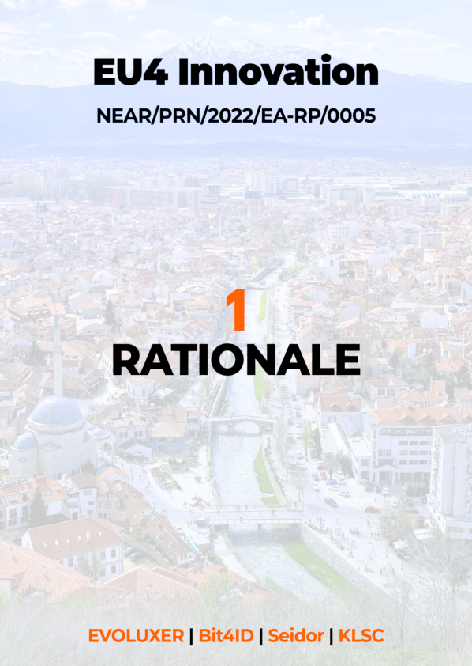

## Section 1 – Rationale

1. **Summary**

This section provides the Contractor’s understanding and comments on the Terms of Reference, in particular with regard to its objectives, purpose and expected results.

After setting the background context and project environment, we identify and analyse the needs addressed by the proposed project, the key issues related to the achievement of project objectives and expected results, the underlying assumptions and the potential risks affecting project implementation, as well as how we intend to prevent and mitigate these.

We present here our understanding of the assignment based on the analysis of the context in which the project will be implemented.

Next sections will address first the country background and the European context of the country.

Based on our previous experience and on the information available at the date of submission of this Technical Proposal, we are able to include in the Rationale, our comments related to the key success factors for the implementation of the project.

As a logical consequence, our view on key issues will be also presented.

We will conclude the Rationale with presenting the assumptions be base our strategy on and risks we foresee for the implementation.

Key success factors, key issues, assumptions and risks are important parts of the foundation on which we build our strategy for the implementation of this project, as it will be further described in this Technical Proposal.

The project context is well described in the Technical Study Prepa**ration for implementation of e-IDAS in Kosovo** developed under the project **EuropeAid/139756/DH/SER/XK.** From the analysis of the said technical study we understand that there are a number of obstacles that shall be overcome in the next period in order to establish an efficient Digital Identity Service in Kosovo. We also understand that these obstacles can be divided in two main categories, legal aspects and technical aspects. Other recommendations fall into organisational and eID awareness categories Technical aspects (meaning the implementation of a fully functional eID service compliant with e-IDAS) will be directly addressed during this project as well as the critical organisational aspects (CA and RA compliance) and the awareness raising aspects.

One of our major tasks that we will perform during the inception period will be to assess the situation against the recommendations made by the Technical Study, finalised in 2021. The output of this task will provide the update situation as of 2022 and will consist in the baseline for the implementation of this project.

The legal aspects are mostly related to the need to amend the local legal framework in order to allow the proper use by the citizens and businesses of a Digital Identity Service. We are aware that solving these aspects are not part of this assignment nor in our power to solve them, these are to be solved through the law making process in Kosovo and by the competent authorities. However, we believe that a good communication between our implementation team and the task forces/workgroups/stakeholders involved in this process is essential for ensuring the achievement of the expected results of this project. For this reason, our experts will be available to participate or to advise the competent authorities with regards to the needed amendments to laws/by-laws or to the needed new legal acts to be adopted. As it will be later presented in this Technical Proposal, our team of experts contains remarkable local legal experts having in the same time a very relevant experience with the EU legal framework.

Nevertheless, even under the legal aspects, Kosovo made some important steps ahead both in aligning the local legal framework with EU relevant legal acts but also in creating the grounds for using eID on a large scale.

*“… specific provisions of the Law on Identity Cards, as well as of the law on the Information Society Services would require moderate revisal and amend in the context of terms and requirements of the national eID system.”*

*“… from the perspective of eIDAS Regulation, then importantly, Kosovo's government has already started the transposition of eIDAS the respective Regulation to harmonise national laws with the relevant acquis of the EU. It is planned that during this year (2021), the law that will transpose the eIDAS Regulation, will be approved by Kosovo’s institutions.”*

From the technical point of view, the most important aspect that we would like to mention is that one of the eID carriers (in fact, the most relevant and difficult to be implemented), the identity card, is already in place.

*“… the identity card is obligatory for all citizens from the age of sixteen. Issued Identity cards, by default, contain 4 certificates and 4 key-pairs corresponding to certificates. So, authentication, alias authentication, file encryption and digital signature functions have corresponding certificates and key-pairs. This approach serves as an appropriate, high-level trust foundation, and is deemed to be a solid ground for eID usage, since issued certificates have government-level warranties.”*

The current identity card of Kosovo creates solid grounds for the full implementation and usage of full eID services for all the required use cases. Of course, the related software modules, the cross-platform distribution of them (currently being available for Windows systems only) shall be made operational together with the individual hardware devices (such as identity card readers – where possible and at affordable costs) or with having the possibility to store the key pairs on other devices (such as USB), but the foundation is already in place.

The organisational aspects/gaps are very closed connected with the legal aspects. We believe that the most important thing that needs to be solved is related to the **OOP** principle. Here, the grounds are also set through the implementation of the Government Gateway (GG), but the real situation is that OOP is not fully adopted.

*“Even though Kosovo has set a vision to improve the provision of services and their digitalisation, increase accountability, transparency and enable the wider use of public sector information in the draft Electronic Governance Strategy 2020-2025, and states that the Government of the Republic of Kosovo aims to improve the functioning and modernisation of public administration and service delivery, there is no clear evidence of the adoption of the OOP though.”*

**We know that OOP is a real issue in other countries also (including EU countries)** but the implementation of this principle will bring more evident value to the Digital Identity Service. Technically speaking, eID services can be operational without OOP also but the effectiveness of eID services will be, by far, lower and the end-user’s interest, satisfaction and trust in the eID services will be difficult to be raised to those levels that will allow full adoption of these services since the main expectation of the eID services users will be to make their life easier (mostly in relation with the Government bodies/agencies) and not to experience the same complexity but in an electronic way.

Another important organisational aspect is related to the CA. Currently, there is only one CA and that one belongs to the public sector. Moreover, the current CA is not yet fully compliant with the EU practice in the domain.

*“… present CA is not properly certified as a trust service provider. Basic documents like Certification Hierarchy, Trust Services Practice Statement, Certification Practice Statement, Certificate Policies etc. to demonstrate how the chain of trust is built up, and how the trust services are offered, are not published”*

It is known that the European practice in this area is to have more than one CA/TSP pe country and it is also known that most of these CAs are either public-private or 100% private organisations. This project will bring more clarity to this aspect too by providing all the tools and means that will allow the current (and future) CAs to operate in full compliance with the related EU framework (mostly e-IDAS) from both technical and organisational sides.

When it comes to the awareness and trust of the potential users of eID services, the situation is a consequence of the gaps in the legal and organisational matters.

First,

*“… citizens still do not experience the benefits of eID in their daily lives, as special laws are not harmonised and front-desk service delivery procedures have not changed that prevents citizens and businesses from benefitting from the eID functions”*

And second,

*The current state of play in the provision of e-services demonstrates that the services consist solely of information of the services that entities may offer (with some exemptions), and of the applications that can be downloaded. As a rule, services that have legal or financial effect and require processing personal data, are not available via electronic channels. Nevertheless, entities are committed to make more services available in electronic channels.*

In other words, although some steps ahead were made, there is little chance to convince the potential users of eID service (citizens and businesses) to actually use it since there is too little value that can bring into their life. A graphical illustration of e-IDAS scope can reveal what the real value of eID service can be:

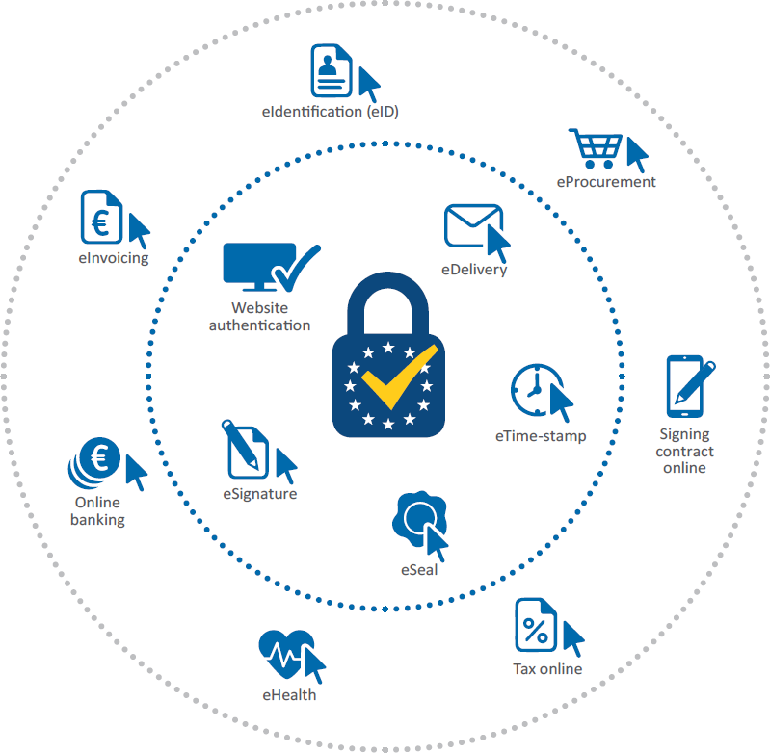

Figure 1 - e-IDAS Scope

This project will be mainly focused on the inner circle[10], [11] of the e-IDAS scope and we believe that this is a very good approach since the implementation of the inner scope of e-IDAS is really feasible within the framework of this project (as we will further demonstrate in the Technical Proposal) and will have a more than significant impact on the potential users (provided that filling-in some of the legal and organisational gaps that are not in the scope of the project or are not in our hands to be achieved will be also completed). Once the population and the private sector will see that eSignature and eSeal will become effective (and having the same legal power as the traditional ones) and they will understand that, using the same means (eID carriers), they will have access to the existing electronic services (such as tax or eBanking), the good penetration rate and adoption level of the other electronic services from the outer circle of the e-IDAS scope will be ensured.

However, at least in the first stages of creating and raising the awareness about the eID service, there are a number of steps that shall be performed and these will be carried out through the Awareness Raising implementation chapter of this project. This implementation chapter will create the momentum that will be further supported by the proper implementation of all activities within this project (mostly by the quality and reliability of the results from the technical activities of this project).

Recital 17 of the eIDAS Regulation states:

*A well-functioning e-ID system is a precondition for smooth e-governance. A strong eID with a high assurance level is commonly used to interact in e-governance processes, and hence it is fully trusted by all government entities. However, government-level designed eID infrastructure will also attract the private sector and individuals to use the eID also in their everyday activities. Although the main focus of the eIDAS Regulation is to grant access to online public services cross-border, Member States are also encouraged to support the voluntary reuse of eIDAS-based eIDs by the private sector*

Kosovo is now in this point of establishing a fully operational eID system. Important steps (organisational, legal) were already made and there are strong commitments to finalise them. The foundation is present through the Kosovo identity card. There is enough knowledge at the level of public administration and most relevant part of the private sector. A very well documented Technical Study was finalised recently (2021). Statistics about internet penetration, usage of internet apps, e-commerce, e-banking, etc. reveals that the population and businesses are in favour to move towards electronic services. So, there is time now to “**connect the dots**” and put in place the means for efficient and effective usage of electronic services through a reliable and performant Digital Identity Service.

1. **Digital Economy in the EU: Current Situation and Policy Priorities**

**Overview of EU’s Digital Single Market policy developments**

Boosting the digital transformation of governments remains a top priority for the European Union. In pursuit of the EU Digital Decade ambition, Europe aims to provide all key public services online by 2030. Investments and cornerstone policies are being put in place to make this happen.

The COVID-19 pandemic has radically changed the role and perception of digitalisation in our societies and economies and accelerated its pace. Digital technologies are now imperative for working, learning, entertaining, socialising, shopping, and accessing everything from health services to culture. It has also shown the decisive role that disruptive innovation can play. The pandemic has also exposed the vulnerabilities of our digital space, its dependencies on non-European technologies, and the impact of disinformation on our democratic societies.

In the light of these challenges, EU’s stated ambition is more relevant than ever: to pursue digital policies that empower people and businesses to seize a human centred, sustainable, and more prosperous digital future.

*“The Digital Decade policy programme is the way towards a more innovative, inclusive, and sustainable future for Euro*

*pe. Unlocking the potentials of the digital transformation, specifically by setting up and implementing multi-country projects, will pave the way for a competitive and sovereign Europe. We have to swiftly embark on the Path to the Digital Decade to make sure Europe is ready for the challenges in an evolving and inter-connected world.” Commissioner for the Internal Market, Thierry Breton, 14 July 2022*

**On 9 March 2021, the Commission adopted the Communication “The 2030 Digital Compass: the European way for the Digital Decade” (‘Digital Compass Communication’)**. The Communication presented a vision, targets, and avenues for a successful digital transformation of the European Union by 2030.

**EUʼs digital ambitions for 2030 will be pursued through concrete terms:**

* targets at EU level and projected trajectories at EU and national level
* a robust joint governance framework to monitor progress and address insufficiencies
* multi-country projects combining investments from the EU, Member States and the private sector

**around the below four cardinal points:**

|  |  |  |  |
| --- | --- | --- | --- |
| Icon of an antenna | Icon of the Euro symbol | Icon of stylised people | Icon of a stylised globe |
| Skills | Secure and sustainable digital infrastructures | Digital transformation of businesses | Digitalization of public services |

**Moreover, on 26 January 2022, the Commission proposed an inter-institutional solemn declaration on digital rights and principles for the digital decade.**

**The EU is committed to pursue a human-centric, sustainable vision for digital society throughout the digital decade to empower citizens and businesses.**

The digital rights and principles outlined in the declaration include:

* **People** **at the centre**. Digital technologies should protect people’s rights, support democracy, and ensure that all digital players act responsibly and safely. The EU promotes these values across the world.
* **Solidarity and inclusion**. Technology should unite, not divide, people. Everyone should have access to the internet, to digital skills, to digital public services and to fair working conditions.
* **Freedom of choice**. People should benefit from a fair online environment, be safe from illegal and harmful content, and be empowered when they interact with new and evolving technologies like artificial intelligence.
* **Participation**. Citizens should be able to engage in the democratic process at all levels and have control over their own data.
* **Safety and security**. The digital environment should be safe and secure. All users, from childhood to old age, should be empowered and protected.
* **Sustainability.** Digital devices should support sustainability and the green transition. People need to know about the environmental impact and energy consumption of their devices.

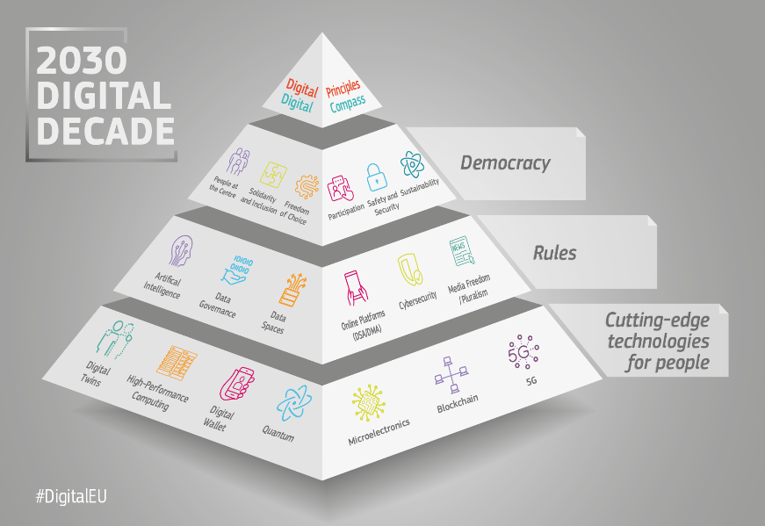The **2030** **Digital Decade policy programme** is based on the Digital compass. It sets out digital ambitions for the next decade in the form of clear, concrete targets. The Digital compass uses the 4 points of the compass to identify the main goals:

1. a digitally skilled population and highly skilled digital professionals
2. secure and sustainable digital infrastructures
3. digital transformation of businesses
4. digitalisation of public services

**Key policy areas to ensure these goals are met include cloud computing, artificial intelligence, digital identities, data, and connectivity.**

**The Policy Programme: A Path to the Digital Decade** sets up a monitoring and cooperation mechanism to achieve the common objectives and targets for Europe's digital transformation set out in the 2030 Digital Compass.

**Digital public services and environments in the EU**

Coronavirus (COVID-19) has put citizens, businesses, and governments to the test. It has prompted Europe to rethink the value of digitalisation and how government services are delivered. Have governments been able to adapt and become more digitalised?

EU is working to help public administrations across Europe to make the change to digital so all citizens can enjoy the benefits of smart public services during the Digital Decade. It is focusing on reducing barriers to public services and ensuring they are accessible across borders.



**EU eGovernment Benchmark 2022 report was published in July 2022,** and it is highlighted that digital government plays a vital role in providing public services to citizens and businesses, especially in times of social and economic disruption, such as during the COVID-19 coronavirus pandemic.

The eGovernment Benchmark sheds light on eGovernment in 35 European countries, referred to as ‘Europe’ or the ‘EU27+’: the 27 European Union Member States, Iceland, Norway, Switzerland, Albania, Montenegro, North Macedonia, Serbia, and Turkey.

Online public services are evaluated on the basis of four dimensions, which consist of 14 underlying indicators, broken down into 48 survey questions. The four dimensions can be described by the following key questions:

**1. User Centricity** – To what extent are services provided online? How mobile friendly are they? And what online support and feedback mechanisms are in place?

**2. Transparency** – Are public administrations providing clear, openly communicated information about how their services are delivered? Are they transparent about policy making and digital service design processes, as well as about the way people’s personal data is being processed?

3**. Key Enablers** – What technological enablers are in place for the delivery of eGovernment

services?

4**. Cross-Border Services** – How easily are citizens from abroad able to access and use the online services? And what online support and feedback mechanisms are in place for cross border.

users?



In particular for **Key Enablers**, **two thirds of all services enable users to identify themselves online with the use of an official electronic identification solution (eID**). Similarly, interoperable data systems help governments to pre-fill 67% of online application forms with information already known. More than three quarters of governments have implemented a digital mailbox solution and offer services where users can upload or obtain online documentation.

For Cross-Border Services, close to half of the services, 46%, can be completed online by non-nationals. Key obstacles are linguistic issues and the fact that **only a quarter of the services accept eIDs from other European countries.**

The above reveal that a key aspect of digital public services is ensuring we have a secure digital identity. Having a digital identity allows us to prove who we are – or what business we own – to online services.

In this regard and based on the EU eGovernment Benchmark 2022 report findings, it is key to further reinforce the interoperability ambition, since well-implemented and interoperable key enabling technologies build the foundations for the next generation of eGovernment.

Paving the way for future eIDs and wider implementation of interoperable solutions will create a more consistent eGovernment experience for different users, different services providers, and across European countries.

For example, by resolving login issues, as currently less than half, 46%, of the services allow a single sign-on, while users can login with their eID for three quarters of central government services, but only for about one third of regional and local administrations.

**Online platforms and e-commerce in the EU**

**Online platforms**

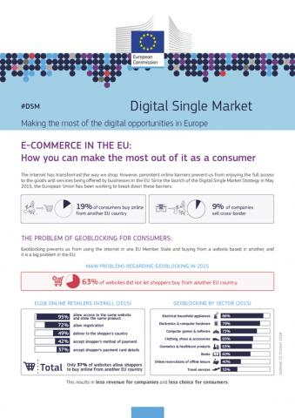EU wants to ensure businesses and citizens can use online platforms and e-commerce services no matter where they are in the EU. Online platforms are a key part of the online world.

**Over 1 million EU businesses sell goods or digital services via online platforms. And, as European citizens, we use them on a daily basis.**

EU is introducing rules to ensure that these websites foster an environment where EU business can thrive. The rules will also ensure users are treated fairly and can use online platforms without fear of manipulative algorithms or illegal goods and content.

The EU’s approach can be defined by 3 areas of action:

* breaking down online barriers, allowing full access to goods and services across the EU
* ending unjustified cross-border barriers
* making it easier and safer to shop online no matter where you are in the EU

**To achieve this, the Digital Services Act (DSA) and the Digital Markets Act (DMA**) were introduced early in 2022**, as a key component of the European digital strategy to make Europe fit for the digital age.**

These acts seek to ensure European citizens can be confident in their safety online and businesses can thrive in the digital world. It is also ensuring e-commerce rules stay up to date in the Digital Decade.

**The DSA contains EU-wide due diligence obligations that will apply to all digital services that connect consumers to goods, services, or content**, including new procedures for faster removal of illegal content as well as comprehensive protection for users' fundamental rights online.

**The DMA is part of the ambitious reform of the digital space together with the Digital Services Act, aiming at ensuring a safe and accountable online environment**.

**The DMA aims to create an effective enforcement mechanism ensuring rapid compliance with precise obligations.** It appliesto gatekeepers, companies which create bottlenecks between businesses and consumers, and sometimes even control entire ecosystems, made up of different platform services such as online marketplaces, operating systems, cloud services or online search engines. These gatekeepers will be subject to a number of clearly defined obligations and prohibitions. These are established by reference to the most unfair market practices, or practices that create or strengthen barriers for other companies, with the overall aim of ensuring the contestability of gatekeepers' digital services.

**E-commerce**

At the same time, the internet has transformed the way we shop. However, persistent online barriers prevent from enjoying the full access to the goods and services being offered by businesses in the EU. Since the launch of the Digital Single Market Strategy in May 2015, the European Union has been working to break down these barriers.

**In this context and to reach the full potential of e-Commerce** the EU has made it easier and safer for European consumers to shop online no matter where they are in the EU.

To boost e-commerce EU has worked on several measures and mainly on:

* the revised Payment Services Directive and new rules on cross-border parcel delivery services that are already in force
* new rules to stop unjustified geo-blocking
* revised consumer protection rules
* new VAT rules for the online sale of goods and services.

The above will ensure that no longer unjustified barriers will be faced such as being re-routed back to a country-specific website or having to pay with a debit or credit card from a certain country. They will end online discrimination on the basis of nationality or place of residence.

**Electronic Identification (eID) in the EU**

**Electronic identification (eID) policy and legislative framework**

**Electronic identification (eID) is one of the tools to ensure secure access to online services and to carry out electronic transactions in a safer way. Together with electronic Trust Services (eTS), they are the key enablers for secure electronic transactions and central building blocks of the Digital Single Market.**

Electronic ID systems generate a variety of benefits for individuals, businesses, and government, including facilitating commerce in the digital economy, enabling e-government services, and improving security for online transactions. Creating a widely accepted form of electronic identification will not only enable individuals to use online applications more securely, but it will also allow the public and private sectors to offer a wide array of innovative and productivity-enhancing products and services online that require one’s identity, or an aspect of one’s identity to be confirmed.

**In 1999, the European Commission published its first eSignatures Directive (eSignatures Directive 1999/93/EC)[12]**. **In July 2014, the Regulation 910/2014 on electronic identification and trust services for electronic transactions in the internal market (eIDAS Regulation[13]) was adopted** to provide a predictable regulatory environment to enable secure and seamless electronic interactions between businesses, citizens, and public authorities.

It is important to note that eIDAS was adopted as a regulation rather than a directive. Directives contain legal principles and are subject to member state interpretation and implementation. Regulations represent European Union laws directly applicable in the member states. Thus, one of the most important aspects of the eIDAS was its uniform application across all member states

**eIDAS aims to offer a comprehensive legal framework that will boost mutual recognition and inter-operation of cross-border eID management, trust services and certificates.** The Regulation is part of a series of reforms in line with the Commission's “Digital Agenda” which pushes for a unified internal market across all member states. Though the main aim of the Regulation is to manage electronic seals, time stamps, certificate services for website authentication and electronic documents and their delivery, eID management had to be addressed first, as it would allow authentication to all other services. eIDAS defines an interoperability framework of national electronic identity management (eIDM) systems. Minimum specifications are not defined by the Regulation but are included in subsequent implementation acts. Member states that wish to operate cross-border transactions through their schemes need to notify their national eID interoperability to the Commission. Notification is not obligatory and can only happen for national schemes (either public sector schemes or private schemes officially recognised by the state) that are used to identify citizens at least one public service. Successful notification comes after a lengthy deliberation process where member states make (non-binding)

**“Electronic identification”** relates to the process of using personal identification data in an electronic form, uniquely representing either a natural or a legal person, or a natural person representing a legal person.

**“Electronic identification means”** is the material and/or immaterial unit containing the personal identification data and which is used for authentication to an online service, and

**“Electronic identification scheme”** is the system for electronic identification under which electronic identification means are issued to natural or legal persons, or natural persons representing legal persons

The **eIDAS Regulation sets the framework for the interoperability of identity** and trust services with a view to their use in national administrative procedures, but also provides a reliable framework for application in the economic sector. It ensures that people and businesses can use their own national electronic identification schemes (eIDs) to access public services. It also creates a European internal market for electronic trust services, namely electronic signatures, electronic seals, time stamp, electronic delivery service and website authentication, by ensuring that they will work across borders and have the same legal status as traditional paper based processes.

Furthermore, the eIDAS Regulation introduces several provisions, which aim to build a framework allowing citizens to use their electronic identification means across borders with a shared level of trust. The provisions primarily encompass the following elements, in particular: **notification, mutual recognition, level of assurance**.

The EU recognised the shortcomings of eIDAS, and after a consultation, **it outlined the need to improve the coverage, user experience and cross-border acceptance of digital identity services in the EU**. In September 2020, Ursula von der Leyen, President of the European Commission, revealed plans for a re-vamp of the system: **eIDAS 2.0. At its centre will be new Digital Identity Wallet**. Any EU citizen or company will be able to request one (although it will remain voluntary for citizens). It will be accepted everywhere across the union.

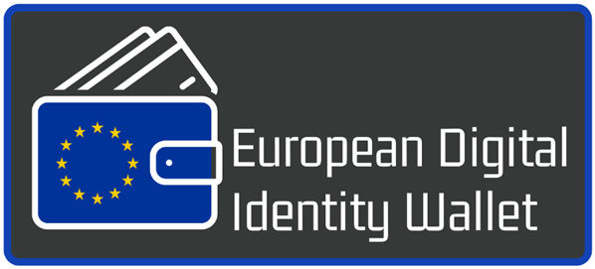One of the foundations of the European Union is the single market. Arguably the key reason for a country to join the EU is to be part of a bloc that can trade together with minimal barriers. A key aim of any EU wallet is therefore to give EU-based businesses a strong, secure and powerful tool for authentication. In the long term, this should bring economic benefits for the whole region and significant benefits to businesses. **According to McKinsey[14], countries that implement a successful digital ID could unlock value equivalent to 3 to 13 percent of GDP by 2030**.

**The new proposal for a Regulation[15] on digital identity will address shortcomings in eIDAS by improving the effectiveness of the framework and extending its benefits to the private sector.**

Also, according to the accompanied Recommendation[16], all Member States will have to **establish a common toolbox by September 2022** and to start the necessary preparatory work immediately. This toolbox should include the technical architecture, standards and guidelines for best practices and will allow a smooth entry into force of the Regulation once it is approved by the European Parliament and Council.

During the development of the eID solution for Kosovo we will consider the elements of the proposed common toolbox and how these can be integrated in the overall solution.

We will support the Kosovar authorities on identifying common standards and technical references in the following areas:

* European Digital Identity Wallets user functionalities including signing by means of qualified electronic signatures,
* interfaces and protocols, level of assurance, notification of relying parties and verification of their authenticity,
* electronic attestation of attributes, mechanisms for verifying validity of electronic attestations of attributes and associated person identification data,
* certification, publication of a list of European Digital Identity Wallets, communication of security breaches,
* verification of identity and attributes by qualified trust providers of electronic attestations of attributes, identity matching, minimum list of attributes from authentic sources such as addresses, age, gender, civil status, family composition, nationality, educational and professional qualifications, titles and licenses, other permits and payment data,
* catalogue of attributes and schemes for the attestation of attributes and
* verification procedures for qualified electronic attestations of attributes, cooperation and governance.

**In a nutshell, the eIDAS Regulation does not aim to interfere with electronic identity management systems and related infrastructures established at national level. Its goal is to ensure that secure electronic identification and authentication can be used to access cross-border online services.**

**Interoperability framework under eIDAS**

**The Commission Implementing Regulation (EU) 2015/1501** sets the technical and operational requirements of the interoperability framework in order to ensure the interoperability of the electronic identification schemes which Member States notify to the Commission. **The Annex of the Commission Implementing Regulation (EU) 2015/1502 details the technical specifications and procedures for each level of assurance for electronic identification means issued under a notified electronic identification scheme**. It is organised around 4 main sections, namely enrolment, eID means management, authentication mechanism, management, and organisation.

**The specification describes two options of deploying an eIDM system to receiving member states: The system can operate either as a proxy or as middleware.**

As a proxy the system is deployed as a central server based and operated by the notifying member state. Foreign states will subsequently send authentication requests to that server, who then redirects to the local eIDM system to perform the identification. The local system sends the server the result of the identification that is then redirected by the server to the foreign member state.

Alternatively, the notifying member state can create a standalone server, which will be based and operated by the receiving state at the same level as the local eIDM system. When the receiving member state needs to identify a foreign user, the identification will go through the standalone server and its result will be redirected back to the local system.

Regardless of choice, the proxy or middleware will relay information to the national eID scheme of the receiving state through the appropriate interoperability software. A choice on deployment of the interoperability software is given as well. Receiving states can install the software centrally, so that all SP requests go through the same instance of interoperability software. Obviously, this works better in architectures with a centralised element, such as a central hub. Or the state can choose to install an instance of the software at every individual service provider (SP) if communication with a central element is absent or needs to be avoided. All communication between the different components is facilitated by the SAML protocol.

The eIDAS interoperability framework additionally prescribes the **use of SAML 2.0 specifications** for the exchange of messages, investigating in this context the message format as well as the relevant security properties of the eIDAS architecture. Specifically, since the security of eIDAS relies on the identification of eIDAS-Nodes via SAML Metadata, the specification sets the basic principles for the exchange of metadata and the properties of cryptographic algorithms used to sign and encrypt SAML messages.

**EU legal framework for digital identities and communication**

The handling of identity data and personal data is a core subject of the Digital Single Market agenda. **Several legislative initiatives** have been launched in Europe, each with a different focus, **setting the framework for digital identity services.**

As already discussed, the eIDAS sets the framework for the interoperability of identity and trust services.

The second amendment to the **Payment Service Directive** (PSD2), effective since January 2018, opens the online banking for third-party providers, including the retrieval of data about the account holder. The PSD2, which obliges banks to grant regulated third-party service providers access to the payment accounts they manage in online banking, has been the subject of many discussions for years.

The **General Data Protection Regulation** (GDPR) is an essential building block for the establishment of the digital single market. It aims at the protection of personal data, as well as the guarantee of liberal data traffic between the member states. The general principle for the processing of personal data remains a prohibition with conditional approval - the processing of personal data is therefore always only permissible if a consent or an exception mentioned in the GDPR exists.

The aim of the **ePrivacy Regulation** is to complement the GDPR in the field of electronic communications. For e-identity solutions, the ePrivacy Regulation focuses on the protection of electronic communications data, not just the data exchanged over the telephone, but also over the Internet. Even for these data the prohibition with conditional approval from the GDPR is to be applied. The aim of the GDPR and the ePrivacy regulation is to regulate the handling of personal data throughout Europe in a uniform manner.

These four EU regulations (eIDAS, PSD2, GDPR and the ePrivacy Regulation) have been a major driver in recent years for setting common European frameworks for the exchange of personal data and identity data. In doing so, Europe is sending a clear signal towards uniform and reliable legal regulations for all European countries. The regulations will gradually take full effect due to the staggered onset of their effectiveness. However, in doing so, the foundation for the development of offers is largely laid.

**Electronic Identification (eID) solutions across Europe**

In the context of eIDAS, public and national e-identity solutions are increasingly becoming visible. There is a whole range of different solutions and initiatives across Europe: several solutions from individual companies, several initiatives in entire corporate sectors and solutions in cooperation between several companies.

According to **ENISA’s recent report “eIDAS compliant eID Solutions**” published in March 2020, there are several key trends in the electronic identification field, both in terms of hardware and software eID solutions.

From historical card-based eID schemes requiring card-readers, more countries and identity providers are moving towards mobile-based solutions, which are more convenient for the end users. This shift is clearly depicted on the latest notified schemes for which more eID means include the use of smartphone. These eID means can use software applications but can also leverage hardware embedded components such as SIM cards, Secure Element and Trusted Execution Environment for an increased protection against attacks. Besides the move to mobile devices, other key trends in the electronic identification field include the increasing use of biometrics and the need to take into consideration users’ privacy (protection of the identity data as well as usage of eID means) while building eID schemes. Distributed = ledger technologies and blockchain for digital identities have also gained momentum, although there are no cases of real-world deployments yet.

Overall, there are four broad technological clusters identified in the ENISA report:

**Cards and other hardware authenticators** include physical identity document and visible digital seals, Contact Smart Cards, Contactless Smart Cards, FIDO Authenticator.

**Mobile-based solutions**, including OTP, cryptographic SIM and Mobile Connect, related to identity consist of phone and tablet-based hardware and software solutions used to register, authenticate, and verify an individual’s identity.

**Biometric** recognition uses an individual’s unique physiological and behavioural attributes to identify and authenticate his or her identity. Physiological attributes include elements related to the shape or composition of the body, such as fingerprint ridges, iris patterns, or facial characteristics. Examples of behavioural attributes include gait, signature, keystroke patterns, and mouse usage. The type of attribute collected and matched is called modality. For example, fingerprint and iris are different biometric modalities.

**Prospective technologies** include eID using Blockchain/Distributed Ledger technology. A distributed ledger is a replicated set of data across multiple actors. Distributed ledgers were created to ensure trust between actors without the need for a third-party trusted by all the stakeholders.

**Furthermore, eID means currently used across Europe fall into three broad categories with respect to the underlying technology:**

* **Password-based systems** allow users to authenticate and to electronically sign a document or an action —with the signature implementing the notion of user consent— by entering their username and password. The combination of a username and a password constitutes the oldest eID authentication method. Passwords are either static, i.e., one password for every log-in, or dynamic as in One Time Passwords (OTPs), aiming to reinforce the quality of authentication by including additional factors. Thus, further classification of these systems may occur based on the use of OTP lists, OTP received via SMS or generated via OTP tokens.
* **Public Key Infrastructure (PKI) systems** leverage asymmetric or public-key cryptography that is based on the use of two different keys for encrypting and decrypting data; one which is publicly made available (“public key”) and another, which is kept secret (“private key”). The public key is linked to the identity of the individual by means of a certificate, a document that is digitally signed by a Trusted Third Party, such as a Country’s Certification Authority. It is this certificate that is received by the authentication server, verifying the user’s public key. PKI eID solutions can be further classified, based on the type of their implementation, into soft certificates, smart cards, mobile SIM card or other tokens.
* **Attribute Based Credentials solutions (ABC) are systems** where multiple attributes construct a credential which is provided to the user by an Issuing Authority. During a transaction with a service provider, a user’s attributes give information about the rights the user has, without giving information about the user’s identity. In other words, ABC solutions enable users to just verify individual attributes instead of sending the complete set of identifying information.

Most EU countries have implemented password-based and/or PKI systems, with some of them giving their citizens the choice between the two solutions, like in the cases of Denmark, Estonia, Finland, Norway, Sweden, and Spain. The ABC solution is used only in Germany, where the government introduced an ABC smart card in 2010, guaranteeing the users’ privacy and controlling which data are sent by the chip.

**Success factors for e-identity systems**

Currently there are a large number of different approaches on electronic identities across Europe. Based on Kim Cameron's Laws of Identity[17], **we present nine success factors for e-identity systems, that will ensure establishing an accepted, competitive, and enduring solution of eID in Kosovo**:

* **User control and consent about identifying information**. The eID system must only disclosure personal information given the explicit consent of the user
* **Minimum disclosure and a constrained use**. The disclosure of identifying information must be minimised and its use must be limited as far as possible
* **Reliable limitation to justifiable parties**. Disclosure of information must be strictly limited to parties who have a necessary and legitimate claim to it.
* **Consideration of directed identities.** Support for both omni-directional identities for public parties and unidirectional one for private parties.
* **Pluralism of operators & technologies**. Channelling/ supporting interoperability between diverse eID technologies of various eID providers
* **Human integration, seamless & secure**. The user is part of the distributed system and communication must be secured reliably.
* **Consistent user experience irrespective of context**. The eID system must provide a simple and consistent user experience independent of the application context
* **Context-specific persona concept**. The user should be able to maintain different digital identities which can be used contextually
* **Omnipresent applicability in numerous contexts**. The variety of possible applications and omnipresent applicability in a variety of contexts is key for success

1. **View on current situation**

In the following sub-sections we are presenting the current situation and policy priorities of Kosovo, without repeating the findings of the Technical Study which was included as Annex in the tender dossier.

**Country Background and local context**

**Kosovo stands at the centre of the Western Balkans and occupies a key strategic juncture at the social, political, and geographic crossroads between Eastern and Western Europe.** With the territory of 10,887 km2 and a population of 1.87 million Kosovo has the highest density of people per square kilometre in Western Balkans (166.82 people per km2), almost double the neighbouring North Macedonia and 60% more than Serbia and Albania. Albanians form the majority in Kosovo, with over 93% of the total population; significant minorities include Bosniaks (1,6%), Serbs (1.5%) and 3.9% others.

Kosovo has the youngest population in Europe. Half of its roughly 2-million-strong population is under the age of 25, according to a recent report of the UN Development Programme, UNDP. According to the government data, it is estimated that more than 65 percent of the population are younger than 30.

**The COVID-19 pandemic hit Kosovo hard, but the country recovered quickly**. Although economic growth estimates for 2021 differ slightly between the Kosovo Agency of Statistics’ 10.5% estimate and the International Monetary Fund’s (IMF) 9.5% estimate, both point to a robust economic recovery and faster growth rates than initially forecast.

**As of July 2022, Kosovo’s financial system and government finances remained robust and resilient. Kosovo’s economy is largely dependent on its diaspora. In addition to remittances, which constitute more than 15% of GDP, Kosovo’s economy also benefits greatly from diaspora tourism in the summer months.**

According to Kosovo Customs, Kosovo’s main trade partners are the EU countries (approximately 44% of imports and 30% of exports) and its Western Balkans neighbours, with which Kosovo trades tariff-free under the terms of the Central European Free Trade Agreement (CEFTA). CEFTA countries are the source of approximately 19% of imports, and the destination for 38% of exports. Kosovo continues to post a large trade deficit, with exports covering only about 15.3 percent of imports.

The Central Bank of Kosovo reports 2021 Foreign Direct Investment (FDI) at €415.2 million, an increase from €341.7 million in 2020. Germany, which brought €123 million to the country in 2021, was the largest investor in Kosovo. U.S. investment more than doubled, totalling €63 million in 2021.

**Kosovo’s Digital developments and trends**

**Digital Agenda**

From the year of 2018, when Kosovo joined the EU Digital Agenda for the Western Balkans, it can be said that the country has demonstrated political will and commitment towards the digitization processes. This can be supported through the respective strategies and initiatives which have been prepared during this period.

The Ministry of Economy in Kosovo is the leading body for the implementation of the Digital Agenda in the country.

Since 2013, Kosovo has adopted its own Digital Agenda Strategy which covered the period 2013-2020, with the strategic priorities being the enhancement of the digital transformation through the Kosovar ICT sector: citizens, businesses, and the country's economy as a whole. Enabling access to the internet and providing the infrastructure for ICT development has been at the centre of the strategy.

As for the current situation, the Ministry of Economy together with other institutional stakeholders have drafted the **new Kosovo Draft Digital Agenda 2030 and the Action Plan**, which is to be expected for approval by the Government during 2022. Regarding the draft-strategy of the Digital Agenda 2030, it has five strategic objectives as follows:

1. Advanced and secure digital transformation (5G technologies, IoT, Artificial Intelligence, etc.)
2. **Digital Transformation of Businesses (as a cross-sectorial strategy);**
3. **Digitalization of the public services (e-governance);**
4. Digital Skills and Innovative Ecosystem for R&D;
5. Strengthening the cybersecurity system.

In terms of the national strategies that enhance the digital transformation in the country, political will also exists regarding the digitalization of the public services. In this regard the "Strategy of the Modernization of Public Administration (2015-2020)" reflects the strategic commitment from the public institutions in order to enhance e-Government. A component of this strategy aims to implement reforms in the public administration and as such support digitalization in this sector. **The new strategy for the Modernization of the Public Administration also is planned to be finalized in 2022**.The launch of the **platform e-Kosova** has been a part of this strategic point, with AIS being the responsible party for its implementation.

On the other hand, the **Strategy of the Tax Administration of Kosovo (TAK) 2021-2025** defines future priorities, namely strategic goals and key performance indicators, including development of the Organization in line with the best European standards **(e.g. Key Performance Indicator KPI 1 for 2023 is 60 electronic services for taxpayers).**

**Internet penetration**

Kosovo has a high level of internet connectivity. According to the Agency of Statistics of Kosovo (ASK), the internet connectivity among the households in Kosovo is at 96.1% as reported for 2021. A rough similar percentage has also been presented previously in the other representative samples regarding the level of internet connectivity in the country.

**The high internet penetration in the country serves as a positive precondition for the implementation of e-governance.** In 2020, the internet connectivity among the households was reported to be at 96.4%, which shows a slight decrease when comparing to the figure from 2021. When comparing the type of access to the internet, a higher number of households are reported to have access to the fixed connection than the mobile connection.

According to ASK, from 2020 to 2021, there has been an increase in the number of households reported to have access to the mobile connection by 8.3%.

**E- Services**

The most significant aspect regarding the e-government services provided in Kosovo is the recent development and operation of the national portal: e-Kosova by the Agency of Information Society (AIS) as part of the Ministry of Internal Affairs in Kosovo. Although the portal was launched in March 2021, during its first year of function, the portal enabled additional services in a timely basis. From a very limited number of e-services provided at its time of launching, **the e-Kosova portal now numbers more than 30 e-governmental services which are key to the citizens of the country**.[18]

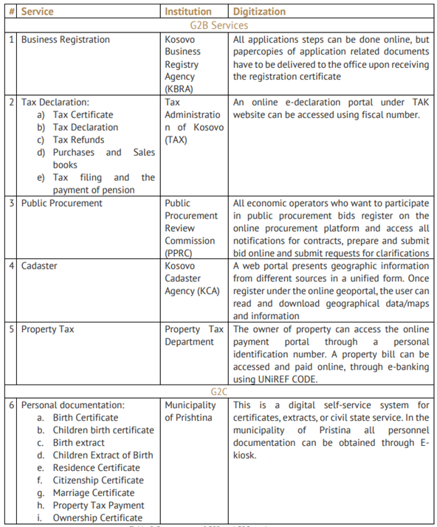**The e-Kosova portal is aiming to be the main and only address of the e-governmental services**. For instance, a widely used category which has been added recently is the electronic payments of the public services that will be offered as a service in e-Kosova by the end of 2021.

Although e-Kosova is becoming the main address of the provision of e-government services, **many other public services remain under the website of the state-institutions, or agencies.** Key institutional platforms in Kosovo that continue to provide their services online remain the Tax Administration of Kosovo, the Business Registration Agency, to name a few (please see the graph). While there is no clear data on how many e-governmental services are provided online in the country, some of these services are met with technical issues during the process of obtaining them.

Below is the data behind the users and services of the e-Kosova portal as provided by the AIS (as of March 2022)[19]:

* **+648,939 registered users (citizens and businesses)**
* **+1,300,000 platform visits**
* **+693,109 citizens and businesses have received services (from 8 service categories)**
* *409,117 citizens received services (Health - regarding the COVID-19 vaccination)*
* *114,730 citizens received services (Family - new mothers)*
* *84,182 citizens received services (Taxes)*
* *64,219 citizens received services (Police)*
* *9,490 citizens received services (Public Administration)*
* *4,239 citizens received services (Residence Permit)*
* *2,998 citizens received services (Education)*
* *4,134 citizens received services (Public Grants)*

**e-Commerce**

Kosovo follows EU standards for eCommerce and consumer protection. As a result of the COVID-19 pandemic, more companies in Kosovo are now experimenting with using e-Commerce.

Compared to the countries of the Western Balkans, Kosovo is behind Serbia, but before North Macedonia, Bosnia and Herzegovina and Montenegro in percentage of the population that does online shopping[20] (available data from 2020).

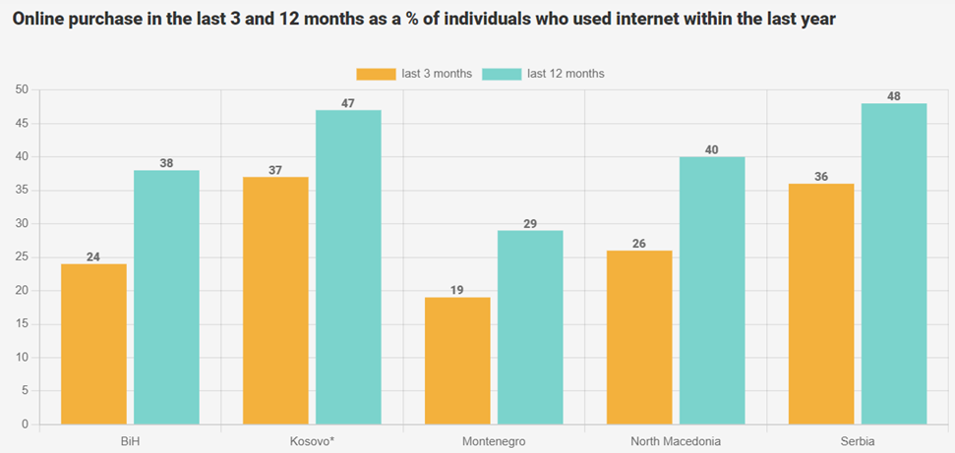

Well-known eCommerce websites – including Amazon, Aliexpress, and ASOS – ship limited goods to Kosovo. According to data from the Kosovo Statistics Agency, the majority of online purchases in Kosovo are made through E.U. and U.S. retailers. Payment methods for eCommerce transactions include e-banking, credit cards (Visa and Mastercard), and cash-on-delivery for the domestic market.

**Digital Databases, Interoperability, Data Exchange**

According to the Agency of Information and Society (AIS) data, most of the public institutions in Kosovo have their own database consisting of collected data (electronic records). Additionally, some of the institutions have a well-developed system which enables them the management of documents and the respective data.

AIS oversees the server where the public data is stored. AIS is also set to support the institutions which lack the databases or digital processes in such terms. Institutions in the country which provide electronic services are reported to have their own databases, such as the Tax Administration of Kosovo (TAK); Kosovo Business Registration Agency (KBRA); Kosovo Pension Saving (KPST); Electronic System of Non-Governmental Organizations (ESNGOs), etc.

**The existing institutional databases, and the number of data stored in these databases should be linked through the interoperability platform in order to ensure data exchange between all institutions**. The interoperability platform links together the electronic systems of institutions (currently counting 24 systems), which enables the data-exchange among them. For instance, the Civil Registration Agency (CRA), and other institutions which are key in the provision of digital services in the country, are already a part of this platform.

With regards to the state portal of e-kosova functions through the interoperability platform, as per AIS data, the platform as such should list other institutions which are currently not a part of it, in order to foster communication and enable data exchange among all of them, because this would ease the process of data exchange from one source.

**Addressing the lack of interoperability among the institutions is an issue** which continues to be tackled through the KODE project funded by the World Bank. This is expected to advance the interoperability platform in place.

Regarding the secure data exchange, the Law on Data Protection allows citizens to access their data which is shared with the data controllers, as well as it legally binds the latter entities in providing additional information to the data subject (individual) about the processing of their data in case it occurs.

**Legal Framework for e-Governance**

The current legal framework which supports the implementation of e-governance in Kosovo is considered to lack a few important details which would ensure a proactive approach when referring to the implementation of the e-governance plans. For many public services available in the country, citizens are required to show up to the respective institutions in order to receive the wanted documents. The state portal of e-Kosova has in its plan to digitize important services, such as obtaining documents regarding the civil status; as well as the registration of vehicles, seen as one of the most required services among the citizens. Agency of Information and Society (AIS) is working towards this process, ensuring the technical infrastructure through e-Kosova.

The administrative guidelines to regulate the provision of civil status online has been drafted already. Yet important details were missing in the legislative level which would enable the digitalization of public services in the country such as the electronic identification as well as cybersecurity regulations. However, during last year in 2021 after the initiating of the Draft-Law on Electronic Identification and Trusted Services in Electronic Transactions, this law has been approved by the Assembly of Kosovo. This is a huge step in the legal framework of the country in regulating the eID, and the rest of the digital services.

**Law No. 08/L-022 on Electronic Identification and Trust Services in Electronic Transactions.**

According to the Official Gazette of the Republic of Kosovo the recently adopted law on Electronic Identification and Trust Services in Electronic Transactions in terms of e-governance regulates the following:

* Identification method and electronic identification schemes
* Conditions on the use of electronic signature, electronic seal, electronic time stamp and equipment for creating them
* Electronic registered delivery service for judicial proceedings and other proceedings
* Conditions for issuing and using qualified certificates for service certification and website authentication
* Trust services in electronic transactions and electronic documents

As the Article 2 of this law points out, electronic identification schemes and electronic transactions services providers will be beneficiaries of this law. In line with this, responsible institutions responsible for the provision of electronic transactions services now have the legal basis in conducting their practices for the provision of services which shall include the public ones as well.

The law also regulates the Digital Signature which will enable even more convenience when it comes to obtaining the set of electronic services. In line with this, the Electronic Stamp, as well as the Electronic Documents are set to enable citizens easy access to services provided electronically and shall save a lot of time.

Considering that this law has recently been adapted, time will be needed in order to see the effects of its implementation among the relevant institutions, and the impact it will have towards the public services.

Moreover, regarding the eIDAS regulation, Kosovo is committed to transform the eIDAS legislation and other corresponding standards set by the EU into its own legal framework. Now that the law on Electronic Identification and Trust Services in Electronic Transactions is in place, it is expected that the country will reach a readiness level for cross-country interoperability. The implementation of this part is expected to be monitored in the upcoming years.

**Digital Government Good Practices in Kosovo**

Below we present selected Good Practices of how Digital Government is applied in Kosovo**[21]**.

|  |
| --- |
| [1] **Kosovo’s platform for public participation and consultations** seeks to promote collaboration and contains interactive catalogues of proposals in which citizens can vote or promote ideas or initiatives. This is primarily aimed at solving issues relating to infrastructure (e.g., roads, lighting, playgrounds, etc.). Here, citizens are not only reporting problems but also becoming directly involved in policy formation and community services.    [2] **Kosovo’s digital driver’s license became the world’s first nationwide mobile driving license service**. The citizens of Kosovo can use an app to show their driver’s licenses on their smartphones. To verify the license, public authorities need to use a matching app on their smartphone.    [3] **Kosovo’s e-Kiosk was first developed to print forms and certificates.** However, it has developed into a more integrated service where citizens can pay their taxes, indicating that the adding of new layers upon existing services can further mature and extend e-government provisioning through existing means.    [4] **Kosovo’s e-Certificates allows citizens with a registered civil status certificate and residency** in one of Kosovo’s municipalities to access and print dated and signed certificates needed to apply for certain public services.    [5] **Kosovo’s Judicial Council is an online portal that allows citizens to easily access information about all the courts in Kosovo and more**. The portal provides information on Council decisions, disciplinary decisions and statistics, judgments, and job opportunities in the Council. |

### Understanding the ToR

The ToR provides a clear description of the scope of the work which has to be carried out as well as of the expected results which has to be achieved. The overall and specific objectives of the project are clearly mentioned in the ToR also. The ToR provides also the identification of the tasks under each expected result offering in this way a good view on how the work shall be structured within the assignment. Apart from the ToR, the documents produced by the Technical Study Prepa**ration for implementation of e-IDAS in Kosovo** developed under the project **EuropeAid/139756/DH/SER/XK** provides an excellent starting point for the evaluation of the current situation as well as for the further design and development of the Digital Identity Service software. The main recommendations, technical concepts, technical architectures, business and functional requirements described in the mentioned technical study are the baseline on which we built our implementation strategy and on which we will proceed to the implementation in case if we will be awarded with the contract.

It is also important to mention that our organisation & methodology takes into consideration assumptions and risks which, in our view, are associated with the activities of this project. When proposing this organisation and methodology we took into consideration the assumptions and risks described in the ToR but we added also additional information based on our experience and knowledge. We consider as assumptions those conditions which are outside our control. We have as a foundation for our organisation and methodology the fact that the assumptions are reasonably met.

Our view on the ToR is that the required work that is expected to be carried out is relevant for the respective target groups and is coherent with the expected results.

We fully understand the ToR and we developed or organisation and methodology accordingly. We are also sure that we can deliver the expected results within the requested timeframe and at the highest possible level of quality.

#### Objectives

| OVERALL OBJECTIVE | OUR UNDERSTADING AND COMMENTS |
| --- | --- |
| To increase efficiency and productivity of the private sector through increased use of ICT, create proper e-business/e-commerce ecosystem, and improve electronic service delivery for citizens and businesses. | It is already known that a good eGovernment system has as one of the building blocks the Digital Identity Services together with a proper implemented „Once-Only” (and Single Sign On) principle. The successful Estonian model as well as the services provided under each and all EU/EC websites (and there are many more examples) demonstrates without any doubts the statement formulated by the overall objective of the project of which this contract will be a part. Using eServices and digital signature the efficiency and productivity of the private sector will increase and the satisfaction of the users towards the services provided by the Government will also increase. On the other side, such Digital Identity Services will also help the authorities to be more efficient when it comes to anti-money laundering fight or tax evasion.  From the businesses perspective, the last years of pandemic situation led to a boom of on-line/electronic/e-business/e-commerce services and this trend will not be reversed. Making everything easier and safer in relation with the authorities through Digital Identity Services will clearly increase the efficiency and will also encourage new businesses to start.  Eliminating (or at least significantly reduce) the physical papers from the relation between the citizen and the Government together with the proper implementation of „Once-Only” principle and the legal acceptance of digital signature will increase the level of trust and the satisfaction of the citizens.  As founded out from our research regarding the current situation in the field of the project, Kosovo made already important steps towards the introduction of digital services at large scale. The logical next step is to have in place the Digital Identity Services that will allow further positive evolution on the digitalisation path. |

| SPECIFIC OBJECTIVES | OUR UNDERSTADING AND COMMENTS |
| --- | --- |
| To contribute to Kosovo government efforts to digitalise and increase competitiveness and profitability of Kosovo businesses | As earlier mentioned, Kosovo made already important steps towards the introduction of digital services at large scale and this assignment will create the grounds for future developments. From the way in which the ToR was conceived, we believe that this assignment offers the possibility to fully implement a performant Digital Identity Service since it covers all aspects related to this subject matter, not only the technical ICT aspects.  This will allow us, as Contractor, to deliver a solution that will be fully compliant with the local legal and organisational environment, being, in the same time, aligned to the EU legal/technical framework and consistent with the best practices in the field and with the experience of other countries.  We will be able to review and suggest amendments to existing documents while designing, developing and deploying a technical solution that will perfectly fit into the legal and business environment. This will have a good contribution to increasing the level of adoption of the Digital Identity Services with a positive effect on increasing competitivity and profitability while setting also solid grounds to future developments of Kosovo digitalisation. |
| To improve performance of businesses by increased ICT usage | The main characteristics of a Digital Identity Service is that it is 100% digital, so each of its future users (natural persons as citizens or representatives of businesses) would need to make use of basic digital skills in order to be able to use the service.  That alone will be a major step ahead in increasing ICT usage. Things will evolve even more on the positive path when the citizens and businesses will gradually discover how convenient is to use e-Government services or other electronic services provided by the businesses.  On the businesses side, the good implementation of the Digital Identity Service together with the proper connection/integration with existing information systems (such as tax payment or eBanking) will lead them towards the digital transformation path, having as direct consequences the increased usage of ICT but also the need for qualified employees able to use the ICT and generating a positive impact on the educational system and also on the ICT business environment. |

As it will be described later in this Technical Proposal, our strategy and methodology follow a logical approach which is combined with world-wide recognised methods, tools and methodologies. This approach will prove that the expected results can be achieved and that there is a logical link between each activity, deliverable and the expected results. Our organisation and methodology will also explain how each element from the project work breakdown structure will contribute to the achievement of the expected results and what will be the input of each expert and consortium member

#### Outputs/Results

When proposing the strategy and methodology for implementing the project we took into consideration a series of key success factors for the achievement of the expected results. We consider that these key success factors can be met by the close collaboration between the Contractor and the main stakeholders and with implementing a fast decision-making process during the implementation period.

Table 10 - Key Success Factors

| Outputs | KEY SUCCESS FACTORS | |
| --- | --- | --- |
| Revision and update of documents, development of basic algorithm | * availability, amount and quality of existing data and information about the subject matter * good collaboration between relevant stakeholders in order to facilitate the access to necessary information | * proper schedule and timely communication of the needs to access information sources |
| Digital Identity Service | * availability, amount and quality of existing data and information about the existing information systems that needs to be integrated/connected with the Digital Identity Service * timely approval of the technical solution and detailed design | * proper schedule of procurement and timely availability of IT equipment * consistent involvement of relevant stakeholders in testing the Digital Identity Service software before deployment into production |
| Capacity building at national and local level | * timely approval of the training session calendar | * consistent involvement of all relevant stakeholders in ensuring the participation of their employees to the training session |
| Awareness raising | * timely approval of the C&V Strategy * timely approval of the video materials | * timely setup of the distribution channels (YouTube, Social Media, Websites) |

#### Key issues

The research on the current project context presented in section 1.2 Project context revealed a series of key issues which needs to be taken into consideration and addressed accordingly during the project implementation. It is important to mention that the research presented in the above mentioned section was performed based on the data and information available at the date of submission of this Technical Proposal and a very in-depth analysis of the context will be made by the project team within the first part of the inception phase.

**Technical issues**

Table 11 - Key Technical issues and challenges

| Description | Response |
| --- | --- |
| Limited operational capacity of the key stakeholders to contribute to the implementation | We have a view of the current capacity of the key stakeholders related to the needs for the implementation of the project. The assessment of current capacity will be carefully detailed in the inception phase. Although our research revealed that the expertise exists, we are aware that each key stakeholder has limited resources and skills to be involved in the implementation.  We are also aware of the situation on the labour market and on the migration of the labour force (with a special accent on IT&C skilled resources). This is the reason for which, we will put significant effort in ensuring the fastest and the most structured possible way of communication between all parties involved in order to allow all stakeholders to participate as they are available and to limit the constraints related to a rigid planning of stakeholder involvement and participation. |

**Management issues**

Table 12 - Key Management issues and challenges

| Description | Response |
| --- | --- |
| Management structure and decision-making mandates for relevant managers from the key stakeholders | Some of the critical activities will need inputs from the teams belonging to key stakeholders and will also require from these teams to carry out some actions in order to provide the inputs. It is important that the relevant managers to be fully aware of what they (together with their teams) must achieve for the successful implementation.  Our Stakeholder Analysis and Stakeholder Involvement Plan will contain detailed information about these managerial aspects and the project team will involve the related managers in the project implementation. These persons will be informed, and their opinions and feedback will be considered when planning the implementation activities. To the maximum possible extent, the managers will be involved in the decision-making process in order to gain their commitments and ownership for the activities they need to carry out. |

**Relational issues**

Table 13 - Key Relational issues and challenges

| Description | Response |
| --- | --- |
| Collaboration between institutional stakeholders involved in the implementation and further responsible for the operation of the Digital Identity Service | One of the difficult obstacles in projects involving institutional stakeholders is the collaboration between these institutions during and also after the implementation for securing long term results. This project involves several institutions at central and local levels. That is why, we will involve all key stakeholders making them aware of the needs of collaboration and integration.  We will also make it clear even from the earliest stages of the project about the resources they have to make available for the project implementation. During the project implementation we will keep the CAUT, IAUT and PSC informed about the progress and about potential difficulties.  Moreover, using our dedicated methods and tools for the management of the risk, we will be able to inform the decision makers about potential problems we can face during the implementation and about our proposals for actions to be performed in order to not experience delays or to obtain lower level of quality.  It is also important to mention that the Project IT environment we will make available for the stakeholders during the implementation will allow fast and innovative communication, problem tracking and solutions identification. |

### Risks and assumptions

**Assumptions**

Table 14 - Assumptions

| Assumption | Mentioned  in the ToR | Comments | Responsibility |
| --- | --- | --- | --- |
| Political commitment for developing private sector through ICT remains high. | **Y** | General assumption  The current political situation in the country is stable and the forecast does not reveal internal threats. However, CAUT, IAUT and Contractor shall have the responsibility to timely evaluate the situation (mostly with relation to the potential external threats) and to raise potential issues as they foresee it. The CAUT and IAUT shall be responsible to get the commitment from the Beneficiary in case of any change of the situation. | * CAUT * IAUT * Contractor |
| Efficient institutional capacities for the implementation and operation of the Digital Identity Service | **Y** | General Assumption  We believe that the general knowledge for establishing the Digital Identity Service is present within the institutions that participates to this project. However, it is possible to identify some difficulties mostly on the side of connecting/integrating existing information systems with the new Digital Identity Service due to various reasons such as lack of existing documentation, not updated source code, technological barriers. For this reason we will perform a very detailed analysis of the existing information systems during the Inception Phase and we will raise the potential issues if will be the case. We will also suggest possible remediations and it will be the task for the IAUT and related Beneficiaries to adapt the current information systems (when needed) to the new Digital Identity Service | * Contractor * IAUT * Beneficiaries |
| Effective measures for improvement of business environment in Kosovo. | **Y** | General Assumption  In the last years Kosovo made important steps for improving the business environment. However, the pandemic situation, as in the rest of Europe, was shifting the focus from improving the business environment to preserving it, saving jobs and keeping companies (mostly SMEs) alive. We are aware of this situation and we will mitigate the potential issues with a good planning of all activities and good communication with all stakeholders. CAUT and IAUT will be duly informed about potential issues and the PSC will be always updated accordingly in order to be able to adopt the right decisions. This is also one of the reasons for which we proposed to hold Quarterly PSC meetings. | * Contractor * PSC |
| Necessary institutional resources exist.  Adequate and sufficient beneficiary resources to the project implementation. | **Y** | General assumption  We do not foresee blocking issues here. However, we are aware that there is a shortage of resources in Public Administration all over Europe and Kosovo is not an exception. Potential issues can be mitigated with advance planning and proper communication with the stakeholders. For this reason we adopted transparency and online tools as a major pillar of our strategy for stakeholder involvement, so all involved parties to be informed in advance about the needs of resources that they have to mobilise. This is also another reason for which we proposed to hold Quarterly PSC meetings. | * IAUT * Beneficiaries * Contractor |
| Readiness of Kosovo institutions to collaborate in order to strengthen e-business, e-commerce and e-IDAS based on EU standards.  Interest of businesses remains high. | **Y** | General assumption  We believe that this assumption is strongly valid. The pandemic period led to an accelerated advance of e-Business and e-Commerce. Also Public Institutions started more and more to deliver e-Services to the population. This trend will not be reversed and it is now the time that the basic infrastructure for e-business/commerce/services to be put in place (Digital Identity Services are one of the building blocks for this infrastructure). However, we will monitor the situation and will promptly inform CAUT and IAUT about potential issues. | * Contractor * CAUT * IAUT |
| Availability of data related to business environment. | **Y** | General assumption  We are aware of the fact that there may be a lack of updated information about the business environment. We will identify this during the Inception Phase and will inform CAUT/IAUT and PSC. However, we believe that a potential situation as such, will not impact the proper implementation of the Digital Identity Service. It may have an impact on the future adoption of the services by the businesses on a large scale. Although it will be the responsibility of the Government to encourage/enforce the use of Digital Identity Services, during this assignment we will put a relevant accent on the Capacity Building and Awareness Raising implementation chapters. | * Contractor (for CB and AR implementation chapters) |
| Availability of relevant information about existing Information Systems | **N** | Particular Assumption  We assume that the relevant information about the current information systems that will be connected/integrated with the new Digital Identity Services is available at the Beneficiaries. This is a key success factor for implementing an effective service. Without connecting different information systems (such as tax payment) to the Digital Identity Service, the service will partly fulfil its purpose and there will be a little change in good for the citizens and businesses. The information that we may need and we will request access to during the inception phase include (without being limited to) technical design documents, software source code, implementation details. We are aware that this assumptions may turn easily in a high risk. For this reason we will create an inventory of such candidate existing information systems very early in the Inception Phase, we will ask CAUT/IAUT and PSC (after the appointment of the PSC) to facilitate the signature of the needed Confidential Agreements as early possible and to mediate the fast involvement of all related Beneficiaries that shall provide us with the information. At the end of the Inception Phase we will submit for approval to the PSC the list of suitable candidates for connecting/integrating with the new Digital Identity Services. | * Contractor * CAUT * IAUT * PSC * Beneficiaries |
| Availability of Technical Specifications for the IT equipment needed for the deployment of the Digital Identity Services  Timely launch/contracting/delivery/commissioning of the IT equipment | **N** | Particular Assumption  We assume that the Technical Specifications for the IT equipment needed for the deployment of the Digital Identity Services are already drafted and we only need to revise and adapt them to the specific of the proposed technical solution (this will be carried out during the Inception Phase). We also assume that the involved parties are aware of the normal duration of an EU funded supply tender and also are aware of the shortages in the supply chains that all manufacturers are experiencing in this period. However, even within the TP we made clear of the importance of timely availability of the equipment and also presented an indicative time schedule for this activity (see section 5 - Timetable of work). We will monitor this aspect during the implementation, will raise the issues (if will be the case) to CAUT and PSC and (when possible) will adjust the planning accordingly. | * Contractor * CAUT * PSC |

**Risks**

The list of risks mentioned in the table below are selected from the ToR and identified by us when drafting this Technical Proposal. Will be one of our tasks within the Inception Phase to update and the list of risk and assumptions. One of the important sources for performing this task will be to verify and update the validity of the risks identified by the previous assignment related to the subject of eID (EU Support for the Competitiveness of Kosovo’s ICT Sector - EuropeAid/139756/DH/SER/XK), see Technical Study – Outputs 2 & 3 (Activities 3.3, 3.4, section 8)

Table 15 - Risks

| Risk | Mentioned in the ToR | Probability | Impact | Mitigation measures | Responsibility |
| --- | --- | --- | --- | --- | --- |
| The Beneficiary develops inaccurate expectations (believe that the project will achieve something not in the requirements, plan, etc) and (or) fails to politically and operationally support the project and (or) inputs from beneficiary are of low quality | **N** | **M** | **H** | Scope management, Stakeholder involvement  Our Project Management methodology embedded in our strategy will have a strong component dedicated to the scope management. This will include (but will not be limited to) detailed description of the outputs from each activity in order to allow the Beneficiaries to clearly understand what to expect. All this information will be available in the Inception Report and will be submitted for approval to the CAUT/IAUT and for review to the Beneficiaries. Moreover, the Stakeholder Map and Involvement Plan (annexes to the Inception Report) will provide the information needed in order to allow the Beneficiaries to carry out necessary actions to provide the inputs at expected quality. | * Contractor * IAUT * Beneficiaries |
| Requirements. When requirements are misinterpreted by the project team, a gap develops between expectations, requirements and work packages | **N** | **L** | **H** | Stakeholder involvement, Requirements Engineering  Stakeholder Analysis and professional Requirements Engineering methodology are the key success factors in order to avoid the occurrence of this risk. In our strategy, both components are strongly defined together with the specialised tools which will allow the project team to manage the expectations vs. the requirements definition and to maintain the traceability over the general scope of the work. | * Contractor * IAUT * Beneficiaries |
| Insufficient communication between the Contractor, the Contracting Authority, the Implementing Authority and the Beneficiaries | **N** | **H** | **M** | Stakeholder involvement, Communication Procedure  The detailed Stakeholder Analysis will be translated in a sound and efficient Communication Procedure which will also be implemented in the Project IT Environment in order to allow permanent exchange of information between the all the parties in a structured and fast way. | * Contractor * CAUT * IAUT * Beneficiaries |
| Cross organisational analysis cannot be fully performed due to a lack of involvement of all relevant institutions  Lack of stakeholder cooperation | **Y** | **M** | **H** | Stakeholder involvement  The Stakeholder Map and Stakeholder Involvement Plan will be available in the Inception Phase. The detailed and updated timetable of work will include the necessary time to prepare the participation of all involved institution and the Project IT Environment will make available modern, structured and fast communication means. | * Contractor * CAUT * IAUT * Beneficiaries |
| Availability of relevant information about current information systems that needs to be connected/integrated with the Digital Identity Services | **N** | **M** | **M** | Inception Phase  We will schedule the creation of the inventory of potential candidates for connection/integration as one of the first activities from the Inception Phase and will ask the CAUT/IAUT/PSC to facilitate the signature of the related Confidential Agreements and the involvement of the related Beneficiaries. By the end of the Inception Phase we will have the first conclusion with relation to the current information systems that can and shall be connected/integrated with the Digital Identity Services. We will promptly inform CAUT/IAUT/PSC about potential obstacles that we may encounter further, during the implementation and will ask for the decision of PSC about how to proceed. | * Contractor * CAUT * IAUT * Beneficiaries |
| Availability of the IT equipment needed for the deployment of the Digital Identity Services | **N** | **M** | **H** | Inception Phase  The IT equipment shall be available (fully installed and configured) when the deployment of the Digital Identity Services will start. Even from this TP, we performed a „reverse engineering” exercise considering the timetable proposed for this implementation, see section 5 - Timetable of work, setting out an indicative calendar for making the equipment available. We will revise the existing Technical Specifications for the related supply tender during the Inception Phase and we will monitor very carefully the progress during the next phases of the implementation. If needed, to the best of the actual situation, we will re-plan the activities accordingly. Will be the responsibility of the CAUT to timely organise the procurement procedure and the responsibility of the IAUT to execute the supply contract. When and if needed, we will provide assistance | * Contractor * CAUT * IAUT |
| Availability of persons that needs to be trained for working with the Digital Identity Services | **N** | **L** | **H** | Capacity Building  Well training of the persons who will work with the future Digital Identity Service is crucial for increasing the level of adoption of the new system by its users as well as for securing long term results. As shown in section 5 - Timetable of work, we planned in advance the preparation of the 10 training sessions in order to allow the beneficiaries to ensure and commit for participating to the training sessions. We will monitor the progress through direct communication with the beneficiaries and (if needed) we will timely escalate potential issues to the IAUT, CAUT and PSC that will have the responsibility to facilitate and mediate the relation with the beneficiaries. | * Contractor * IAUT * Beneficiaries |

Abbreviations

|  |  |  |  |  |  |  |  |  |  |
| --- | --- | --- | --- | --- | --- | --- | --- | --- | --- |
| **Y** | YES | **N** | NO | **H** | HIGH | **M** | MEDIUM | **L** | LOW |

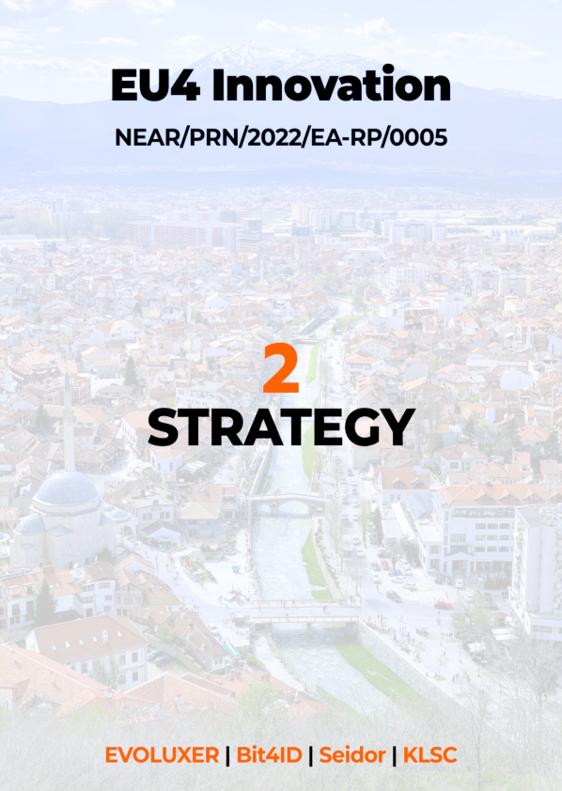

## Section 2 – Strategy

In this section we define the proposed strategy for the project implementation, the project’s intervention logic, the structure of the workplan and the methodological tools that will be employed. Subsequently, the project components and the proposed activities are presented in the next sections of this Technical Proposal. While section 2.1 - **Project approach** will demonstrate **HOW** we will implement the activities and what methodologies/tools/procedures we will use, section 2.2 - **Project organisation** will show the logical structure of the project and the **RESOURCES** that we will make available, section 2.3 - **Scope of the Work** will explain the **FORMAL SPLIT** of the work, section 2.4 - **Activities** will offer detailed information about **WHAT** we will do, section 5 - **Timetable of work** will demonstrate the **feasibility to implement the strategy** within the required deadlines and section 6 - **Log Frame** will explain the way to **EVALUATE THE RESULTS** of the implementation.

### Project approach

#### Overview

Our approach for implementation of the project relies on state-of-art methods for the provision of Technical Assistance (TA) in the context of EU-funded projects, building upon over 25 years of experience. On top of these, we will approach the software development and deployment component of the project using the best practices and tools in the industry while having as one of the goals to establish a transparent way of communication not only inside our project team but among all key stakeholders. To the maximum possible extent we will automate the processes using advance continuous integration/continuous deployment (CI/CD) pipelines and we will provide all the needed instruments to the stakeholders in order to be able to express their feedback as it may be necessary.

Last but not least, given the complexity of the assignment that involves multi-disciplinary tasks and considering the limited timeframe that we have, we believe that the optimal solution is to have, as the building block of the future Digital Identity Service, a well-known and mature eID software platform, with proved EU references (we will name it “**base eID platform**” or “**base platform**”) on top of which we will develop and deploy the new Digital Identity Service of Kosovo. This will ensure not only the full compliance with the ToR requirements[22] but also the full integration with the local environment (languages, APIs, connection with existing relevant information systems, business environment, etc.)

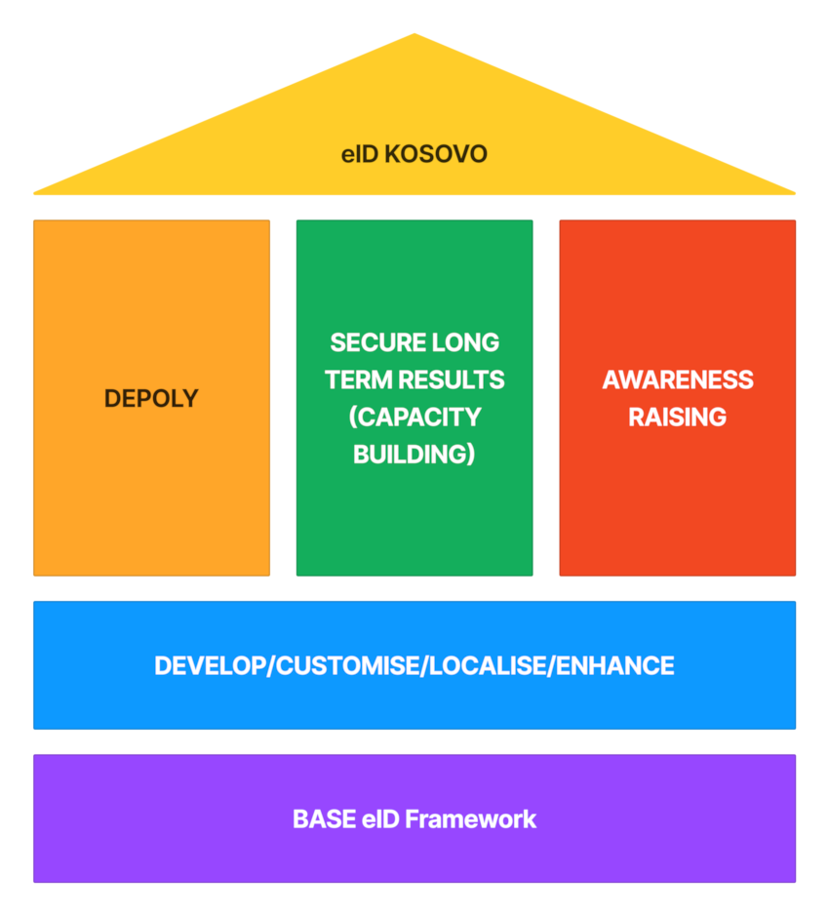

Figure 2 – Strategy outline

Our project Strategy relies on a number of key principles that we consider to be critical for the successful implementation of the project:

**Building commitment and trust:** demonstrating a clear understanding of the needs addressed by the project, the current situation including the institutional set-up and the relations, capabilities and potential of the organizations involved. While we believe that the practical experience of our Project Team is important, the involvement of the project’s main beneficiary institutions and target groups (project stakeholders) in the process is crucial in developing trust and building commitment.

**Promoting project ownership:** this is essential for successful technical assistance projects, based on our longstanding experience and state-of-art methods. Participation starting from initial planning through to informal and formal working groups, ensure that the project’s activities are planned and designed together with the beneficiary and that implementation is carried out with their full involvement. Ownership of project results by the Project Beneficiary is the vital ingredient for ensuring future sustainability of project achievements.

**Learning by doing** involvement of stakeholders in the process is especially important in sustaining the project’s results. Our approach is to always ‘leave behind’ a core group of persons that are well-prepared to continue the work and ensure that results will be sustained in the future. Hence, not only training but also involving local actors in the day-to-day work of the project will bring the effect of learning by doing, creating 'change agents' for the future.

#### Specific methodology

Our Consortium has a realistic understanding of the challenges and conditions under which the project is to be implemented and have developed our specific approach and methodologies accordingly. The guidelines that will guide our activities are presented below:

Table 16 - Main principles of our strategy

|  |
| --- |
| **Consistent integration and coherence with the country strategy/policy and efficient learning from EU experience** |
| As it is clear from the ToR and from the analysis we performed, this project will contribute to the **increase efficiency and productivity of the private sector through increased use of ICT and create proper e-business/e-commerce ecosystem and improve electronic service delivery for citizens and businesses**. Some actions are already made (we can mention here the extensive Technical Study **Preparation for implementation of e-IDAS in Kosovo** recently developed under the project EuropeAid/139756/DH/SER/XK) and our strategy and approach are to build on the mentioned actions in order to produce the expected results in the most efficient way. It is also important to **connect this project with the experience of other EU countries** which we will achieve by using as building block a mature European eID base framework[23]. As described in this TP, a **key success factor for the implementation of the project will be the involvement of the stakeholders**. Having as a starting point the ToR and this TP, during the inception period, our project team will revise and update a detailed list of institutions and organisations impacted by the project to ensure their representation and involvement. |
| **Involvement and close collaboration** |
| As described in the section corresponding to the stakeholder analysis, we will perform an in-depth analysis of all party’s involvement and we will use recognised methods and tools for evaluating the interest, impact and importance of each stakeholder. Using the tool of stakeholder mapping we will achieve a collaborative and participatory approach to project implementation through: **INFORM**: keeping all interested parties informed; **CONSULT**: bi-directional flow of information will create closer dialogue with the target groups; **INVOLVE AND ENGAGE**: involving representatives of key stakeholders in making decisions; **PARTNER**: key stakeholders takes the initiative to carry out their own activities to support the project |
| **Experienced, integrated and highly competent team of experts** |
| We offer a team of experts having outstanding experience both in the knowledge of EU experience in relation with establishing national eID systems design but also proven excellent practical results in implementing similar projects in several EU countries. It is also important to mention that these experts have a very **good knowledge of the region** and they also have relevant experience both in previously working in the public administration or EU relevant bodies but also as experts in different projects. Thus, their inputs in the projects will be, from the first day of their deployment, **100% focused on practical results**. Moreover, **we already have a pool of experienced potential other experts** to be involved in the project as we consider that one important challenge and key point for the success of the project implementation is the **rapid mobilisation of the team and quick deployment of experts**. The international experience of the expert’s team is doubled by outstanding local experience of one of the consortium member and by the deep involvement of the local experts. This will improve the communication and will eliminate potential barriers during the implementation. |
| **EU convergence** |
| The **local stakeholders** (mainly from IAUT and beneficiary institutions) **will play an important role** for the achievement of the expected results. Our team of experts will work together with the experts from local stakeholders in order to assess the current situation, revise the information presented in the ToR, adding new information as this information will become available after the contract start date. Our strategy is also based on a **realistic view** on implementing the recommendations for EU convergence (e-IDAS compliance) within the duration of the project. |
| **Lessons learned** |
| Our Consortium brings into the project very important **lessons learned from the experience of other EU countries** referring both pre-accession period but also continuous efforts made after EU accession. Difficulties and different issues related to the design, implementation and operation of efficient national wide information systems have happened during all implementations, including in the projects were our team of experts was involved, **but innovative solutions were found**. This experience is part of the lessons learned we will bring into this project, mostly in relation with the foundation on which the project will be implemented: **collaboration and communication between key stakeholders having decisive impact in the area of the project**; **the way in which the political factors are supporting the implementation of an efficient Digital Identity Service**. |
| **Efficient and effective backstopping** |
| A key success factor for the implementation of the project is **setup of the backstopping services made available by the Consortium Members**. For this Project the Consortium will create the multi-disciplinary backstopping structure which will support team of experts. Under the co-ordination of the Project Director and with the input from the experts, the multi-disciplinary backstopping team will establish also the necessary working procedures which will be applied during the implementation. Having in mind that the project will be implemented by a team of experts seated in Kosovo and other countries, we will give a significant level of attention to the electronic means of communication and information exchange. During the inception period, a **project IT environment will be put in place**.  A very important characteristics of our backstopping structure is **integration**. Each Consortium Member will allocate **dedicated persons** to be part of the backstopping team. The roles and responsibilities will be well defined for each person and the **backstopping team will act as a unitary entity** with all needed functions/"departments" able to handle the different aspects. The proposed backstopping structure will also have its **own management and hierarchy**. The backstopping structure will be mobilised and will be in place in the first week after the award in order to provide the experts and the PD with all needed support for the activities within the Inception Phase. At the moment of the contract signature, besides the PD, the backstopping staff will be already appointed and they will be already familiar with the ToR and the Technical Propososal so they could start their activities in the same time with the PD. |
| **Securing long-term results** |
| We are aware that our role in the project will not be only to implement the tasks and activities and produce the deliverables. We also have the role to create the grounds for securing long-term results of the implementation of an efficient eID system in Kosovo, thus ensuring the sustainability of the results achieved by this project. Guiding our implementation on principles like **CONTINUOUS IMPROVEMENT** and **CONSULTATION APPROACH** we will ensure the **proper transfer of knowledge to the key stakeholders and individuals so this knowledge to be further transferred to any other new stakeholder or individuals** who will be involved in the aspects of operating, administering and maintaining the eID system. |

1. **Base eID Framework**

As it was mentioned earlier, we will base our implementation on a **reliable and verified READY-MADE** eID framework[24] that will allow us to develop on top the new Digital Identity Service of Kosovo. When proposing the eID base framework we had as main goals the following:

* Full compliance with recommendations/specifications described in the Technical Study for **Preparation for implementation of e-IDAS in Kosovo**
* The required Scope of the Work described in ToR and the defined use cases[25]
* The normal evolution of a Digital Identity Service towards covering all areas/scope of e-IDAS
* Full compliance to e-IDAS and capability to become connected to the European eID
* e-IDAS scope
* maturity of the framework and availability for customisation/localisation/enhancements
* implementation priorities set out by ToR[26]

The experience of our Consortium members (two of the Consortium members having excellent track record in the field of the project) allow us to select and propose a state-of-the-art eID framework on top we will develop and deploy the Digital Identity Services while ensuring in the same time the maturity, stability and reliability of the framework.

The framework has a modular structure that allows multiple customisation and can be deployed on an infrastructure that respects the recommendations made in the technical study. It fully supports the ID-card and mobile eID carriers and use a reliable core PKI component.

Our main goal when proposing the software solution that will be the base eID framework was the full compliance with the requirements of the ToR and with the recommendations described in the Technical Study.

The second important goal when prposing the software solution for the base eID framework was the preparedness of this solution for further developments such as adding eServices that currently are not available and to stay compliant with future developments in the domain.

As an example, it is stated in the ToR that “Implementation of desktop environments for the main use cases and APIs for service providers should have the highest priority**, while mobile environment can be introduced in second phase**”[27].

The software solution that we propose as base eID framework is already prepared for the named second phase and beyond. In the same time we are also ready for EIDASv2 and the near adoption of Self-Managed Identities in the EU.

Some of the features of the proposed solution are not required by the ToR or are mentioned to be implemented in future phases but:

We believe that proposing a ready-made fully fledged software platform as base eID framework, including the fully preparedness for the implementation of the next phases of eID in Kosovo, is the normal way of approaching this implementation because, doing so, we will contribute to securing long-term results of this implementation while offering to the key stakeholders in the same time the opportunity to not be caught within strict boundaries and to be prepared and able to evolve together with the eID system towards a fully functional eGovernment system in Kosovo, complemented with all needed features necessary to integrate services provided by the private sector.

Concluding on this aspect, we can confirm that the overall compliance of the software solution proposed as base eID framework for this project is as presented in the table below:

Table 17 - General compliance matrix

| **Requirement** | **Compliance** |
| --- | --- |
| **Use cases:**  1. Enrolment of End-users – identity verification  2. Identity credentials issuance  3. Level of assurance “high” authentication  4. Qualified electronic signatures  5. Management of accounts of end-users  6. Creation of a new CA, and/or Integration with an existing CA  7. Validation authority |  |
| Enables authentication corresponding to level of assurance “high” and electronic signing corresponding to qualified electronic signatures according to EU eIDAS Regulation |  |
| Enable full compliance with foreseen updates of eIDAS |  |
| All software versions should be Albanian, Serbian and English |  |
| All proposed software licenses must have at least 3 years upgrade without any additional costs |  |
| Open platform able to accommodate current integrations with existing information systems as well as future enhancements by adding new eGovernment services and services provided by the private sector |  |
| Fully prepared to be used with all eID carriers (the eID card and mobile eID carrier) |  |
| Fully covering the workflows related to all its user’s categories (citizens, businesses, CA, RA, etc.) and fully respecting “**easy-to-get**”, “**easy-to-use**” principles |  |
| Fully supporting OOP (“**once-only-principle”)** and adding a performant SSO (“**single-sign-on**”) support |  |

**Full details about the compliance of the proposed solution are further presented within this section, at point C - Compliance of the proposed eID Base Framework.**

It comes with an out-of-the-box API that can be further extended to accommodate the specific needs for eID in Kosovo and full integration with existing information systems as well as for providing the services providers with needed functionality for eID connection. The main functionalities/modules for CA and RA are also included and are fully compliant (CA) with the provisions of e-IDAS which makes the process of CA auditing and certification to become smooth, predictable and easy to be achieved.

As a brief example of the modularity of the framework, the following figure briefly shows the modules for the eSignature use cases (creation/verifications).

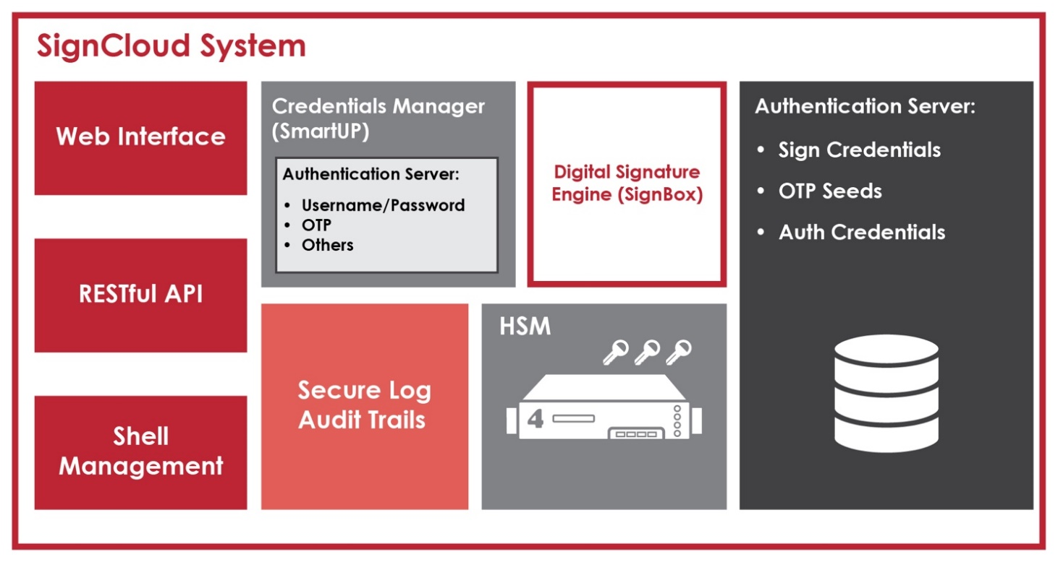

Figure 3 - eID Base Framework: Digital Signature Modules (summary)

We are aware of the fact that the final technical solution is subject of approval by the Beneficiary and CAUT[28], thus our approach will be to present, discuss and demonstrate in very details all the aspects related to the base framework of the technical solution in the earliest possible stages of the project, immediately after the Kick-Off meeting.

However, it is important to mention that we already come with a strong technical framework and we are fully aware of what has to be added to the framework. This means, on one hand, that the process of finalising the technical solution will be very fast (as it should be considering the overall timeframe of the project) and all the collateral information (cost/effort/time) are already estimated.

The following figure illustrates the conceptual structure of the basic framework with the main purpose to show that, as part of the strategy, we will have as building-block of the implementation a very reliable framework and, as part of the methodology, the framework is structured in such way that, not only will cover the SOW described in the ToR, but will create solid grounds for future enhancements.

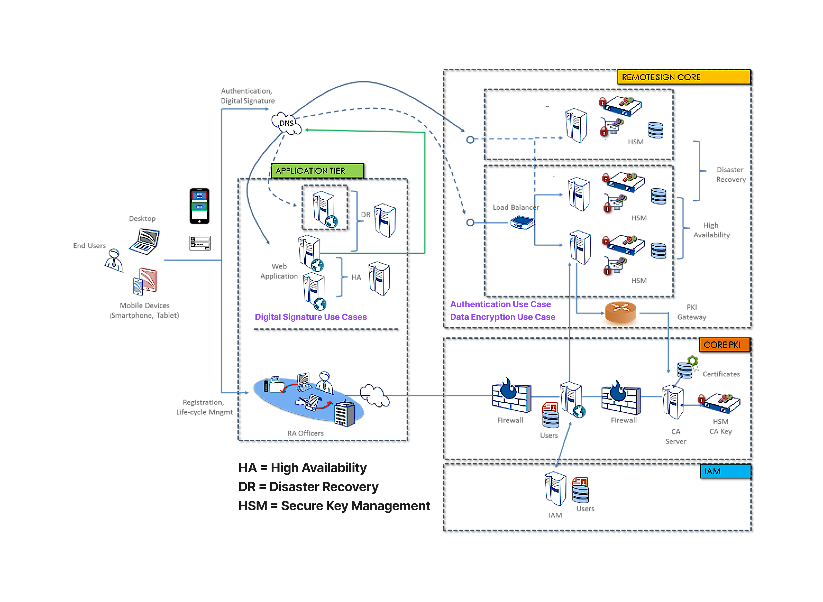

Figure 4 - eID Framework: Concept Structure

1. **Detailed description of the proposed eID Framework**

This section presents in more detail the read-made solution that we propose as base eID Framework. The functionalities and modules are described first and we will conclude this section with the compliance analysis against the related requirements formulated in the ToR[29].

**Overview and solution references**

The base eID framework is built on the solution created by Bit4id Group.

For almost 20 years Bit4id have been leading digital transformation by providing the best technologies for electronic signature, online authentication, cybersecurity and all other services based on the concept of digital identity.

The international presence of Bit4id is one of our strengths. The group has offices in Europe, South America and Asia for a global market coverage. Among multiple awards recognising the competence in building and delivering eID solutions, in 2016 the group was awarded with Quality label for the “**PKI as a Service**” project presented as part of the SME Instrument initiative, to support innovative companies in Europe. Founded and headquartered in Italy, the group delivered similar solutions in Italy, Spain, UK, Portugal, Ecuador, Peru and India, demonstrating a solid experience and expertise in building and delivering complex eID platform not only in EU but worldwide, thus illustrating the compliance with existing regulations in different countries/regions across the world (including EU e-IDAS).

Among the relevant references of the group and of their eID platform and related products, we can mention:

* design and implementation of the Public Key Infrastructure in Ecuador
* supply of 650,000 readers for the identity card in Spain
* supply of 500,000 readers for the health card of the Lombardy Region, Italy
* supply of the digital signature to the Ministry of Finance of the state of Haryana, India
* eID services for healthcare workers in hospitals in Veneto and Lombardy (authentication, single-sign-on and digital signature)
* Over 20 million citizens use Bit4id software for digital signature and smart card authentication to access to Public Administration services
* supply of 100,000 ID card devices in Georgia
* supply of the Time Stamp Authority of the Post Office of Macao
* The group (through one of its subsidiaries) qualifies to operate in Italy as a TSP (Trusted Service Provider) for the issuance of digital certificates of signature, seals, CNS and time stamps
* providing cloud services of "platform TSP as service" to operators from various countries, including Peru, Ecuador, Guatemala, Costa Rica
* supply of the software systems for the identity card in Jordan and the supply of the national identity system of the government of El Salvador
* supply of the Security Framework of the Health System of the Veneto Region, in Italy

**Introduction**

The Digital Identity Service Infrastructure described in the following enables Mobile Qualified Digital Signature and Authentication; it is based on the modular PKI architecture of BIT4ID. The main products used to build the architecture are the **smartCMS** for the identification and the registration of End-Users and the management of the credential issuance process, and the **SignCloud**, which allows the implementation of extremely rich and varied cryptographic services that are already designed for application integration.

To give legal value to the remote signature operations, the exclusive possession (sole control) of the credentials to access the signature key and the explicit will of the signing must be guaranteed through strong authentication tools that allow to verify with undeniable certainty the identity of the person and the controlled unlocking of the transaction.

**The proposed solution adopts state of the art technologies** that can be used to make new paperless processes and enabling automation of document processing stages while guaranteeing full legal validity to the managed documentation. The adoption of standard components already deployed by Bit4id in similar contexts, for the provision of the digital signature services, ensures short installation times and full control of the project phases.

As described in more detail in the following of the document, sign Cloud is able both to perform raw signatures leaving the task of the hash calculation and the management of the document to an external application or may provide all the functionalities required for the creation of a complete digital signature (enveloping) and for the preparation of the signed document.

SignCloud allows to digitally sign any document from any platform (desktop and mobile) exploiting a remote Hardware Security Module, typically hosted in a specifically certified Cloud environment, thus releasing the End-User from the burden of dealing with a smart card or PKI token and giving him the control of his digital ID through mobile phone.

Sign Cloud has been developed with modular and scalable state-of-the art architecture offering best-in-class security thanks to the FIPS 140-2 lev3 and Common Criteria EAL 4+ certified HSMs used for the protection of the digital identities. SignCloud can be easily integrated with any existing PKI infrastructure both on the client-side and on the server side thanks to well-known standardized digital signatures protocols and interfaces.

SignCloud is a product for electronic signatures intended to be used as a Qualified Signature Creation Device (QSCD) in a secure operational environment. It implements a usage scheme that is compliant with the following eIDAS standards:

* EN 419 221-5: Protection Profiles for TSP Cryptographic Modules - Part 5: Cryptographic Module for Trust Services
* EN 419 241-2: Trustworthy Systems Supporting Server Signing - Part 2: Protection profile for QSCD for Server Signing

When used in combination with qualified certificates Sign Cloud generates qualified electronic signatures as defined in the Regulation (EU) No 910/2014 of the European Parliament and of the Council of 23 July 2014 on electronic identification and trust services for electronic transactions in the internal market (eIDAS).

**EIDASv2 and the near adoption of Self-Managed Identities in the EU**

The European Council presented in June 2021 a draft proposal for the "eIDAS 2" (aka European Digital Identity Framework), the legal framework at the EU level to regulate the issuance of secure public electronic identification (e-ID) through the official entities designated by the member states, to provide people with control over their identity and data online, as well as to allow access to public, private and cross-border digital services, including enhanced authentication and remote digital signature services.

This e-ID initiative will be mandatory recognition by all the organizations of the Member States of the Union, at the same level as with digital certificates with the current eIDAS regulation (and by the way, it will also be mandatory for private companies in strategic sectors such as Health, Banking, Insurance, …). The planned deadlines point to its approval by the European Parliament at the end of 2022 or early in 2023, being mandatory one year later. Therefore, it would be highly recommended that a project of this magnitude by the Government of Kosovo ensure that the deployed systems will also be aligned with EIDASv2, given that its approval will surely overlap with the deployment of the current project.

That is why we have included for Remote Digital Identity on Mobile Devices the inclusion of decentralized identities as they are being considered for EIDASv2, based in the SSI paradigm including an EU EBSI ID Wallet in the proposal.

This new framework is based on the paradigm of self-managed identities (SSI: Self-Sovereign Identity) decentralized thanks to blockchain technologies, and verifiable and reusable credentials that the citizen obtains, manages and shares under his absolute control with the different processes of business; and that allows the establishment of programmed processes that automate the validation of credentials and the continuity of the process without requiring human verification.

With this decision, the European Commission advances in ensuring the identification and authentication of the user in a simple way from their mobile, using a cryptographic wallet that, under the exclusive control of the person, allows them to acquire different credentials and digitally signed attributes, but without the complexity of the digital certificate.

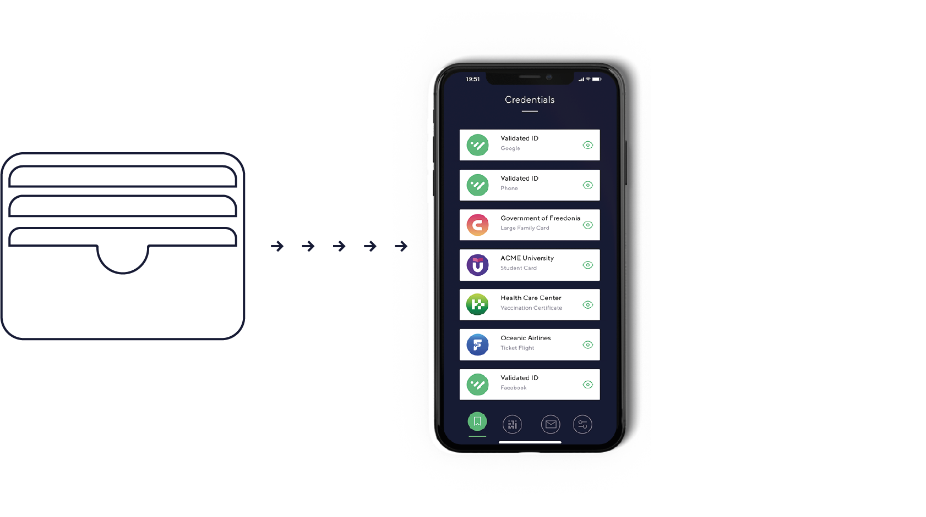

To facilitate its deployment, the CE has launched the EBSI[30]/ESSIF[31] project that will support not only the digital identity as we could understand it, to facilitate its understanding, as an authentic but programmable copy of our digital certificate; but to accompany it with all kinds of attributes that, under the same verifiable credential format, we can manage from the wallet, accrediting our family, professional, financial, academic situation, etc.

The proposed eID base framework is built on three main functional modules **smartCMS, Sign Cloud and SignBox** which will be further described in the next sections. the other functionalities (such as mobile eID, Wallet, self service Portal, etc) are built on top of these backbone modules. These modules are also described in the next sections.

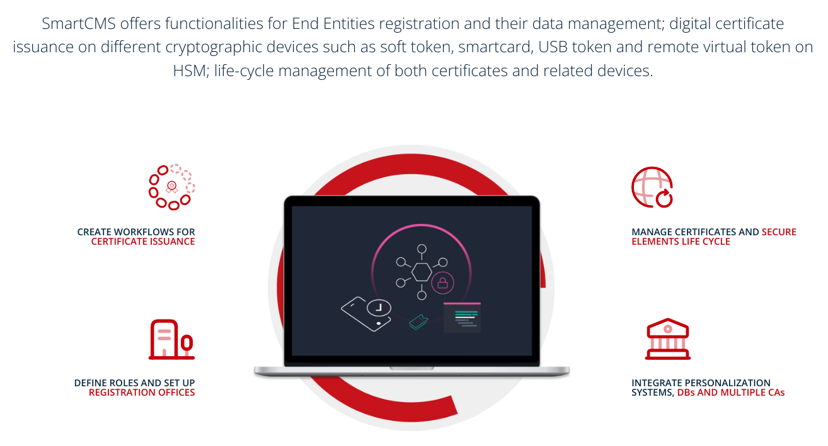

Figure 5 - smartCMS overview

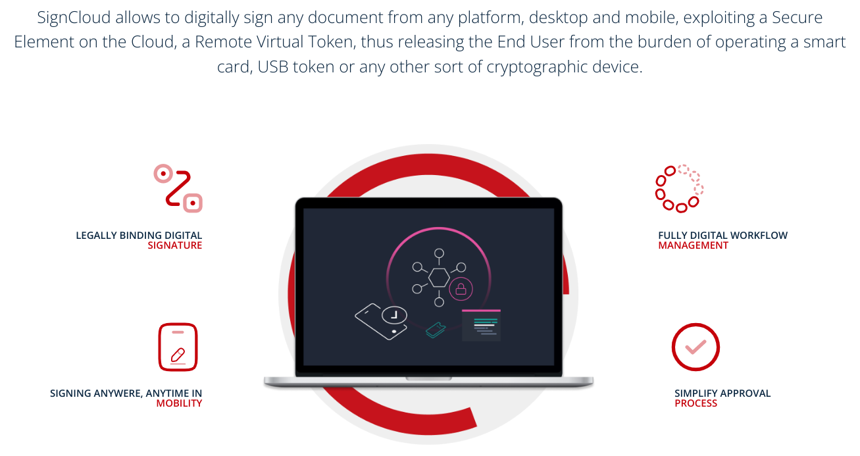

Figure 6 - SignCloud overview

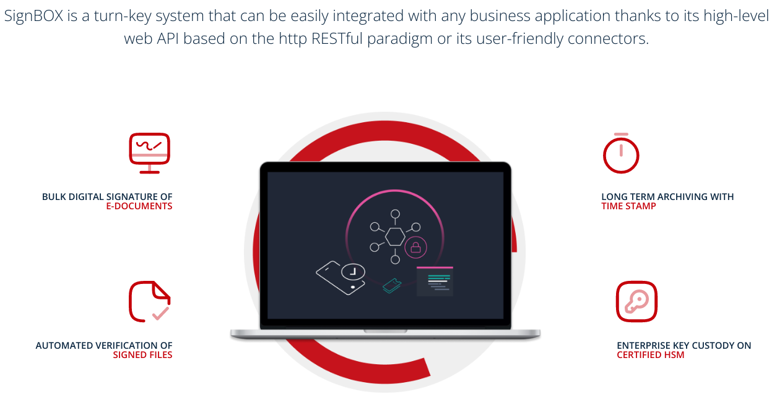

Figure 7 - SignBox overview

Verification and validation of signed documents is another important out-of-the-box functionality that will come with the proposed base eID framework.

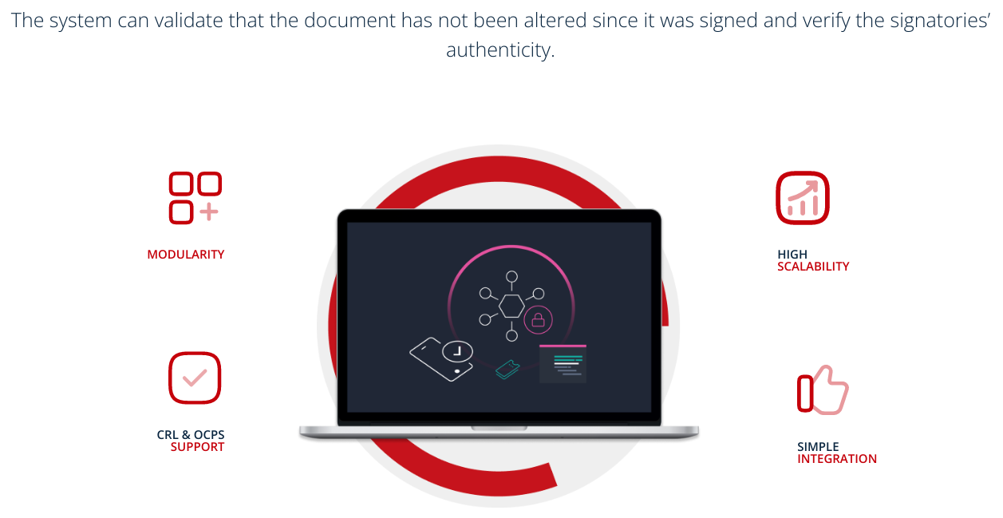

Figure 8 - Verification/Validation for signed documents overview

The base eID platform provides native support and engine for integration of the current information systems that will be identified during the inception period as being necessary to be connected to the future Digital Identity Service.

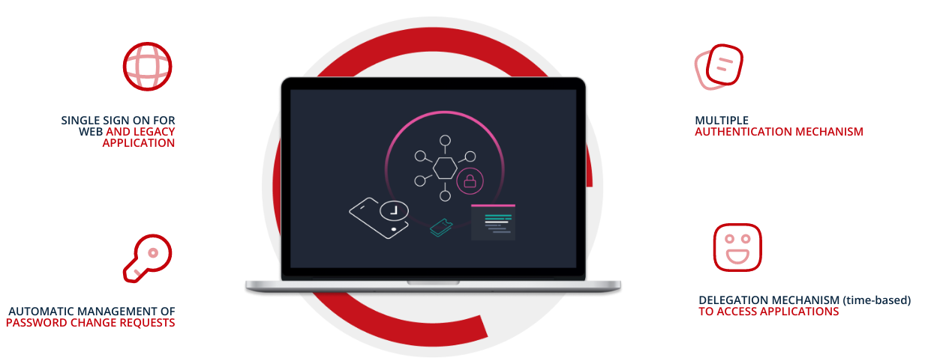

Figure 9 - Integration with existing information systems - overview

One of the most important features that any modern eID system shall provide is the possibility to record all operations and to maintain full traceability of the operations in order to be able to identify at any time how the system is working and (if the case) what was not working as expected and the reason for any potential flaw. The proposer eID base platforms comes with a native mechanism and dedicated module for logging all the operations in a secure way.

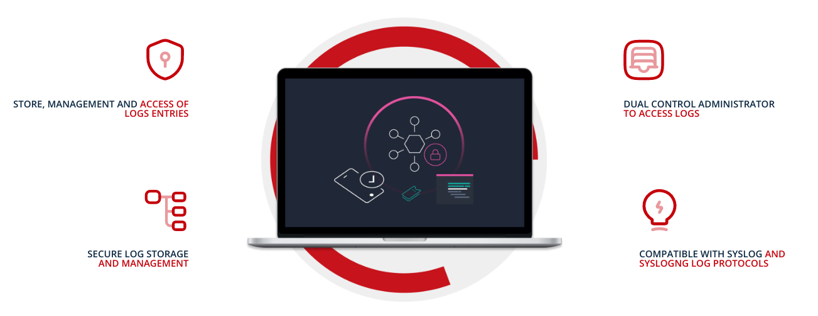

Figure 10 - Logging module

A crucial functionality that brings value to any modern eID system is the ability to allow external service providers to connect their services. Here we are talking about eBanking or eCommerce (from the private sector) or eGovernment services such as eHealth. This functionality is made available through a very performant and secure system of API (application programming interface) that is native integrated into the proposed eID platform.

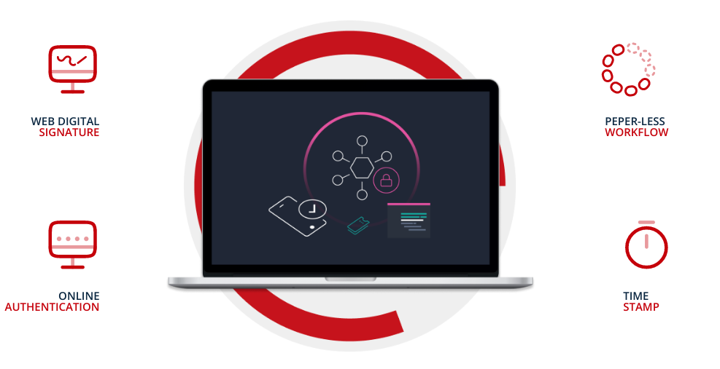

Figure 11 - API overview

Apart of providing all required functionality (and even beyond the required functionality), it is crucial that the proposed solution to respect the “easy-to-use” principle, thus providing clear and secured workflows to be used by the different categories of users (citizens, businesses, Government agencies, Certificate Authority (also supporting multiple CAs), Registration Authority and others).

Starting with the entry points to the system (which can be fully accessible from all known devices – desktops and mobile devices, running all major operating systems – Windows, MacOs, Linux, Android, iOS), the workflows implemented and provided by the proposed eID solution are intuitive and easy to be used (being both self-explanatory and designed according to the latest progress in User Experience (UX) practices).

Some of the workflows provided “out-of-the-box” are presented in the next figures.

A key feature of the proposed solution is automation of processes which is implemented at one of the highest levels in the industry and significantly higher when comparing with other similar solutions on the market, including with solutions that currently are in use in EU countries. This feature will even make more evident the implementation of OOP and “EASY-TO-GET”, “EASY-TO-USE” principles providing even the users with no-IT knowledge with all needed means to use the Digital Identity Service.

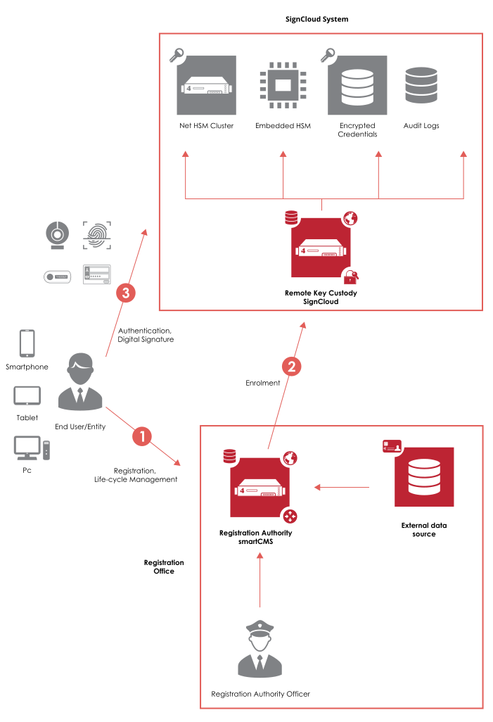

Figure 12 - eID: Main workflow

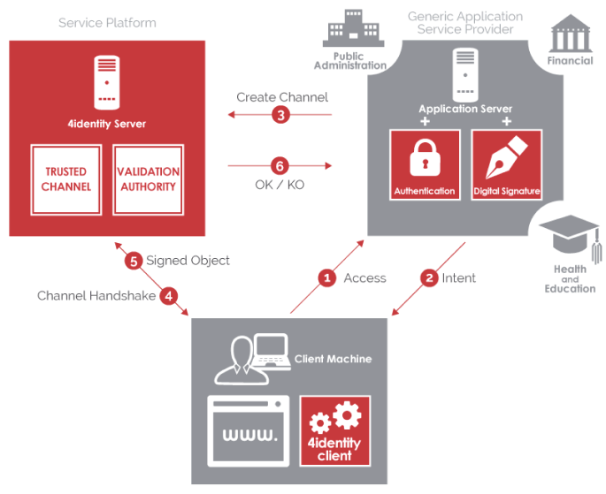

Figure 13 - Web signature flow

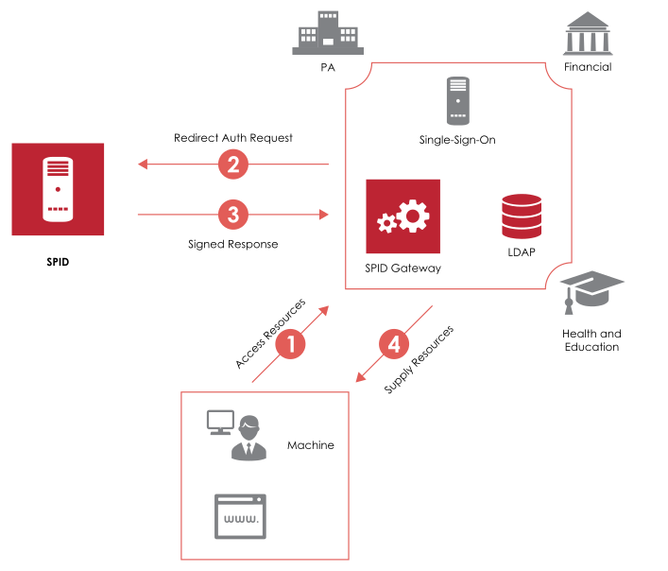

Figure 14 - integration Flow

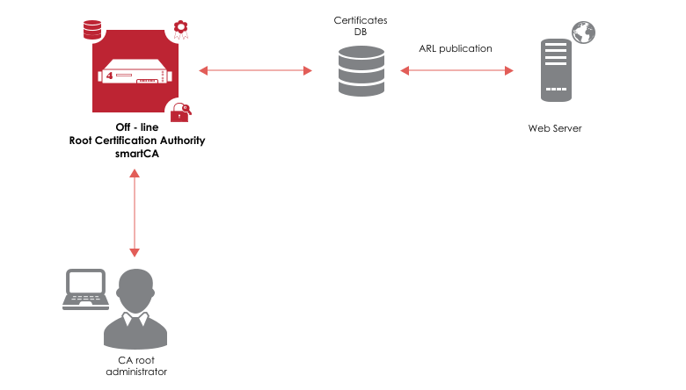

Figure 15 - Root Certificate Authority Flow

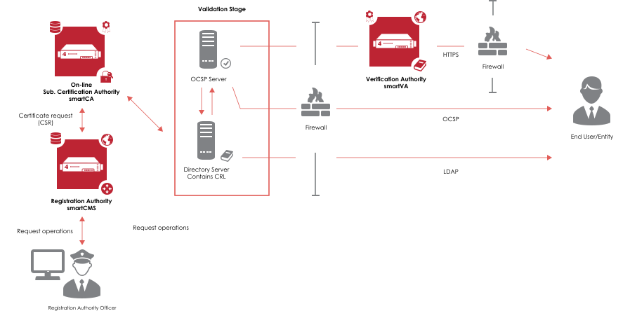

Figure 16 - Additional CA flow

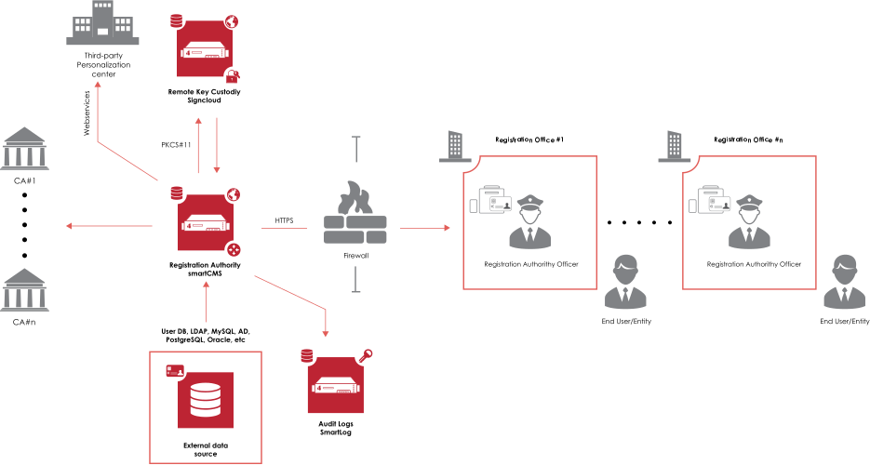

Figure 17 - Registration Authority Flow

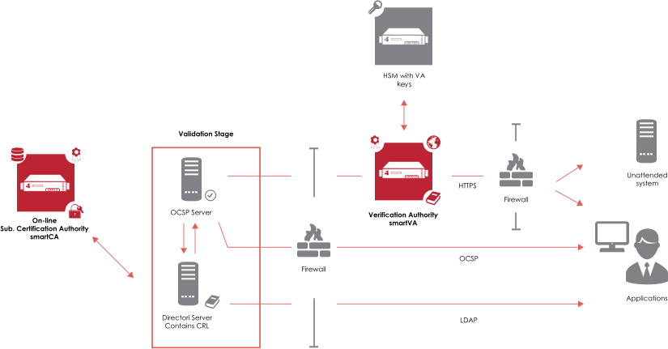

Figure 18 - Validation Authority Flow

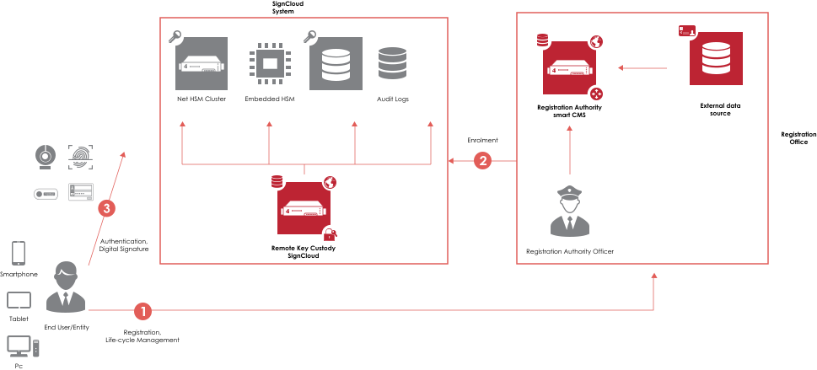

Figure 19 - Time Stamping Flow



Figure 20 - Securing Keys Flow

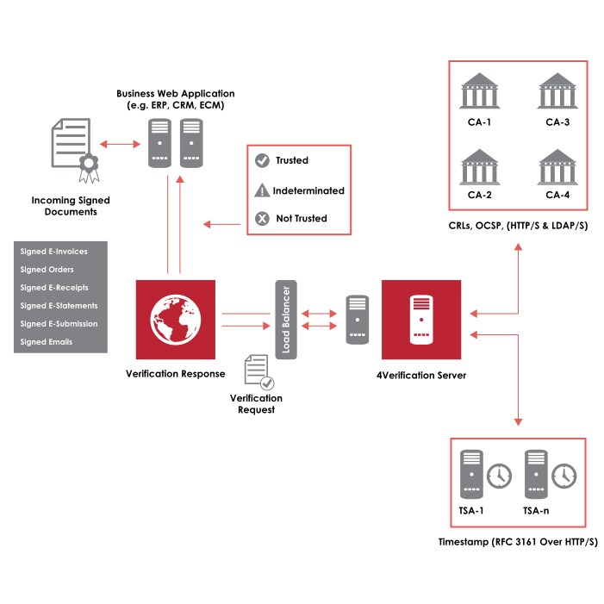

Figure 21 - Verification and Validation Flow

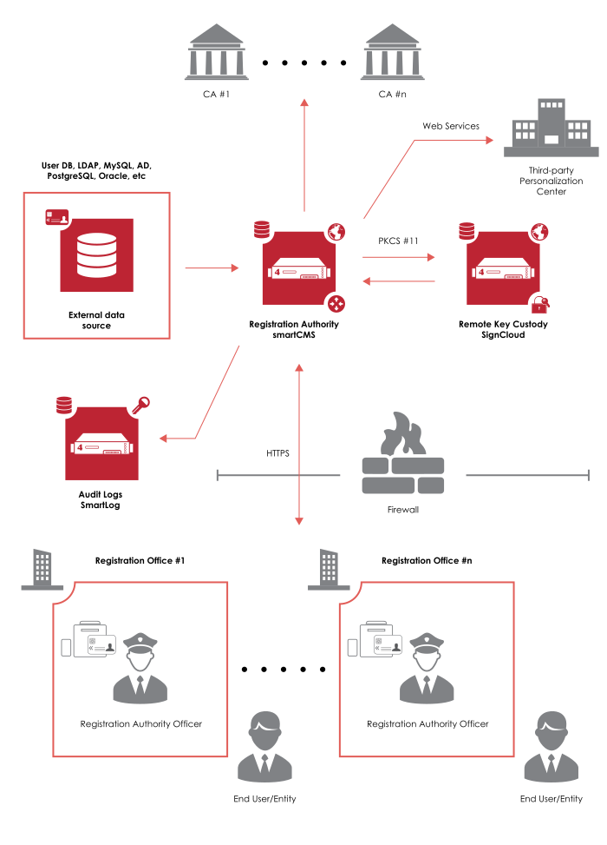

Figure 22 - Digital Certificates Management Flow

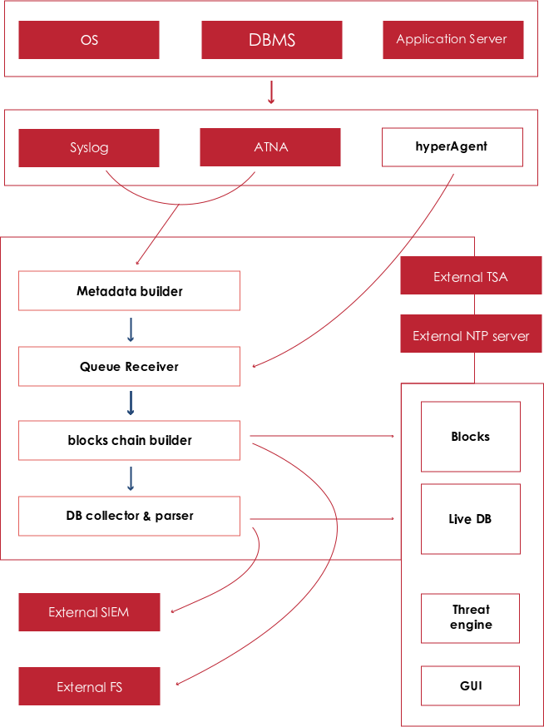

Figure 23 - Audit and Log Flow

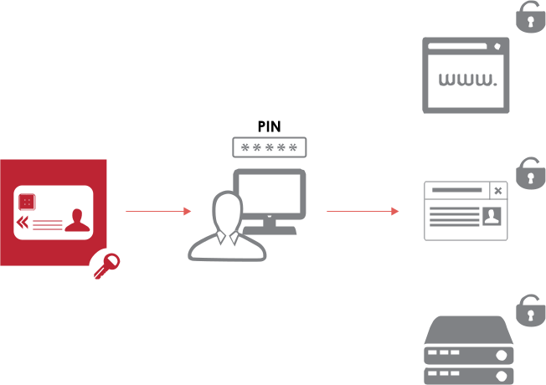

Figure 24 - Connect existing ICT (Single-Sign-On) Flow

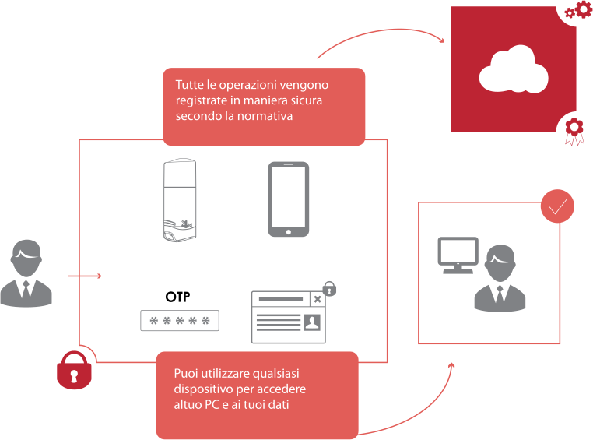

Figure 25 - Personal Data Protection Flow

**Infrastructure**

In this paragraph we briefly describe the overall architecture depicted in Figure **4** - eID Framework: Concept Structure, a more detailed explanation of the building blocks will be provided in the rest of the section. As already mentioned in a previous paragraph, the BIT4ID architecture is a very modular PKI architecture comprising several modules. In the sketched architecture it is possible to find an application tier populated by the web applications of the Service Providers that will join the mobile ID project. At the same level we also find the Registration Offices or Kiosks where the End-Users will be identified in person by means of a biometric match before the issuance of the Mobile Digital ID.

The registration offices communicate in the back-end with the smartCMS that is the application server responsible for the user registration, credential issuance and life-cycle management. The smartCMS in turns can optionally import data from an external authoritative data source like an IAM, LDAP or another existing CMS. Moreover, it is responsible for generation of the pkcs#10 CSR for the mobile digital ID. Those CSR are addressed to the existing CA software (National PKI) that might be potentially already in place or to a specifically built PKI Infrastructure for the project.

The CSR is generated as a consequence of the key pair generation process initiated by the smartCMS on the SignCloud platform that exploits an HSM for every cryptographic operation. The architecture has been presented to show high availability, load balancing and disaster recovery options.

For what concerns the web applications of the several Service Providers, they communicate in the back-end through APIs with the SignCloud modules belonging to the Remote Sign Core. The Remote Sign Core has the duties of secure custody of mobile digital IDs on HSM and of exposing all the functionalities for vouching the digital identity of End-Users towards Service Providers as well as digital signing the files on behalf of intended recipients. An optional module of the architecture is the SignBOX, this is a virtual appliance that could be installed at the Service Provider data center to hash files before they are sent over the SignCloud for digital signature. This might be necessary to optimize the performances in cases of high rate of digital signature transactions or high bandwidth required.

The Sign Cloud system is assisted by a CA Gateway component that greatly simplifies the process of issuing certificates by providing to application services a single interface and mode of integration towards the CAs. Thanks to this solution the component is capable of:

* Operate simultaneously with different CAs.
* Make the services exposed by CA transparent to the client applications

**SignCloud**

SignCloud is an enterprise-grade client-server **solution ready for deployment on customers infrastructure** in order to expand a PKI infrastructure with remote digital signature functionality.

SignCloud provides several options to interoperate with remote digital certificates: a) RESTful APIS; b) a lightweight desktop agent, named Universal Key Chain (UKC); c) a mobile application for the remote signature on mobile devices. The key differentiator of the solution is the UKC client that enable the end-user to interoperate seamlessly with any web browser, third-party desktop application and across different operating systems through widespread and well accepted digital signature standards (MS CSP, PKCS#11, tokenD/CryptoTokenKit). SignCloud makes remote digital signature possible in the widest range of mobile and non-mobile scenarios.

The SignCloud server, as represented in the next figure, integrates the following functionalities:

* Credentials Manager.
* Digital Signature Engine.
* Secure DBMS.
* HSM.
* Log and Audit System



Figure 26 - SignCoud Server

SignCloud can work with existing PKI infrastructures and Credential Management Systems, thanks to the integration with RESTful APIs or alternatively, as far as they can interoperate with PKCS#11-compliant devices, thanks to the RA Client Connector (UKC for RA), which extends the RA functionalities to enrol new remote certificates and key-pairs on the SignCloud platform. The platform is natively integrated with Bit4id’s Credential Management System (CMS).

SignCloud is scalable both vertically, by integrating a more powerful HSMs, and horizontally, by clustering the SignCloud servers to ensure not only increased performance but also fault tolerance and load balancing. SignCloud features an advanced secure logging system to keep track of performed transactions.

SignCloud stores signatures credentials on a SQL database using a secure mechanism natively provided by the Entrust nCipher HSM for storing private keys in encrypted form outside the HSM in a database, the so called cyphered blob.

The number of credentials managed by a Remote Digital Signature system is heavily dependent on the cryptographic device used. One of the factors that impact on the number of credentials that can be managed by each different HSM device is how and where these are saved.

In case of HSMs that store the signature credentials in an internal protected memory area, the number of managed credentials is typically low (usually no more than a few thousand) and hardly scalable.

In the case of cryptographic devices that save the credentials on external storage systems, the maximum number of credentials depends on the type of storage, its capacity and access speed.

For credentials saved to an external storage device, the private key protection mode is an important aspect that must be designed to ensure the impossibility of access in plain text outside of HSM.

The SignCloud system uses the Entrust nCipher HSM nSHIELD family that provide a secure mechanism for saving private keys outside the HSM.

SignCloud stores the signature credentials, exported by HSM in a blob format, on a SQL database, a feature that allows managing a large number of credentials. The protection of private keys is based on the Security World encryption mechanism that is certified according to the FIPS 140-2 Level 3 and Common Criteria EAL 4+.

In summary, the SignCloud module uses the following private key protection mechanisms:

* A master key, generated within the SCDev (Signature Creation Device) during system installation, is used to protect each SCD (encryption and HMAC).
* A "login" authorized by the Operator Smart Card, is used to activate the SCDev.
* A security PIN for each SCD (Signature Creation Data), set during the generation process, which enables the access and use of each SCD. The security PIN is validated through the Entrust nCipher nSHIELD ACL within the SCDev internal mechanism.
* An OTP code, optionally associated with each SCD for remote signature, which enables the use of a specific SCD.
* Each SCD is generated and encrypted inside the SCDev.
* The SCD can be exported only in its encrypted form; the value of the encryption key is derived from the SCDev master key. The information on the credential (the state, and the OTP device information) is stored within the encrypted blob that contains the private key.
* The change of the protection PIN of the SCD is made within the SCDev and requires decryption of the SCD using the master key, the old PIN verification, verification of a possible OTP, the assignment of the new PIN and saving of the SCD with the new PIN (and its encryption).
* The signature process is performed within the SCDev by decrypting the SCD using the master key, the PIN verification (inside the SCDev), the possible OTP verification and final encryption of the hash of DTBS (Data To Be Signed) using the decrypted SCD.

Every cryptographic operation such as key generation, encryption, and decryption of the SCD are implemented within the SCDev, using a specific software module based on Entrust firmware. The master key of the SCDev is stored on smart cards, in order to have the possibility to restore a damaged SCDev or to enable the use of multiple SCDev operating in a high availability and load balancing configuration.

**SignBox**

Digital signature is a complex operation carried out in several steps starting from the takeover of the data to be signed.

Briefly we can say that in a signing operation the following activities must be carried out:

* acquisition of data to be signed
* treatment of data to calculate hash
* setting of envelopes in Pkcs#7 format with data and signature
* interfacing of the cryptographic device to calculate the signature hash
* optional timestamp management
* envelope composition and encoding in the required format
* other controls and complementary operations.

Similarly, in the signature’s verification operations, it’s necessary to perform a significant number of operations involving data, the certificate and the signature in the envelope.

The digital signature process requires several operations to process data to be signed and a limited number of accesses to the cryptographic device, which is essentially required to "encrypt", with an RSA algorithm and a private key, the hash of the data that you want to be signed.

The data processing operations are carried out by SignCloud (that takes care of parsing for the incoming requests) that, having prepared the requests of lower level, submits them to the underlying interfaces in order to ensure the proper flow of execution of the operation.

In consideration of the volume of data that the different stages of the operation elaborate, consider that:

* signCloud operations can handle also large amounts of data (depending on the size of the documents to be signed)
* operations involving the cryptographic device are not directly influenced by the size of the processed documents

The first step is justified by the fact that the calculation of the hash of a document requires an elaboration that involves the entire contents of the input data.

Operations on the cryptographic device, in order to avoid an excessive load, require only the use of information of known size. For example, the amount of security to be calculated to obtain a digital signature of a document is given by the cryptographic hash of the document itself.

Since the size of the hash does not depend on the size of the document from which this is calculated, we can say that the load on the cryptographic device does not depend on the amount of data to be signed. In all situations where you need to manage significant amounts of data, the performance evaluation of a digital signature system cannot be separated from considerations on network traffic.

In particular it should be kept in mind the traffic produced by the transfer of the data from the machine hosting the application to the security server. SignCloud server, having received the data, does the work of processing the documents to be signed and interface the cryptographic device.

If the documents to be signed are too heavy, even a high-speed network can introduce significant transfer times, and these influence in important measure the total number of signature operations manageable per unit of time.

A similar problem arises when the communication network that connects the application with the security server does not have an adequate performance. Typical case are the geographic networks that connect offices away from each other and that are often slow or with a very high latency (network transfer time of a single package).

In order to offer a good solution to these problems SignCloud provides a special configuration in which the server module can be installed on a different system from the one hosting the cryptographic device.

The remote requests occur at SignCloud Pkcs#11 interface and allow to locate the server module on the same network that hosts the application. The cryptographic device can be installed at a remote site, even connected at a low speed.

In this way the exchange of large amounts of data is maintained in a controlled environment with guaranteed time, while the final processing of the cryptographic device is started by transferring to the remote module only the minimum number of possible data (see Multi host configuration diagram).

The application continues to use SignCloud Client module that is able to target multiple SignCloud security servers. SignCloud that manages the data exchange with SignCloud Client is in version SignBOX and uses a particular Pkcs#11 module that can redirect incoming requests from upper modules to another SignCloud server, in this case the COD version, which hosts the cryptographic functionalities.

The functions performed by SignBOX are not operationally affected by the presence of the Pkcs#11 remote module. This has the same interface of modules which operate on the external cryptographic devices and simply delegates the execution of the operation to the remote server to which it is combined. The application part is not modified.

Having already said that the data required for the execution of cryptographic operations are a predefined amount and, in any case, limited, the interaction with SignCloud can also be performed on networks not particularly fast, regardless of the size of data to be processed at the interface SignCloud Server level. Even if using the interaction between SignBOX and SignCloud it’s possible to use techniques of redundancy and load balancing to achieve the necessary performance and reliability characteristics.

It’s possible to provide a suitable number of SignBOX to support application, established on the number and size of files to be signed. All SignBOX will then lean to a different number of SignCloud dimensioned, instead, on the number of signatures to be performed and credentials to be stored on installed cryptographic devices.

Due to the structure of the solution and in particular the use of a SQL database external to HSM devices for storing users’ credentials**, the proposed system is designed to support a maximum number of active users of the order of millions, ensuring high level performances even with the increase of users**.

**Digital Signature Functionalities**

Features include:

* qualified digital signature and/or advanced electronic signature added to any electronic document
* verification of a signed electronic document including the verification of validity of the certificate, by CRL or OCSP (certification path of the Certification Authority that issued the certificate, time validity, verification of profiles and validity of the certificate, certificate status)
* the calculation and verification of single, multiple, and parallel signatures and countersignatures
* adding a time stamp
* automatic document signing
* authentication of the owner for access to the credentials (private signing keys).

The proposed solution provides for the availability of a complete set of signing and verification functions via programming interfaces API and Web Services.

The approach adopted in the definition of the API is to make interfaces as easy as possible using a high level of abstraction (ideally one call per function) and minimizing the number of parameters to be used in the call.

Supported digital signature standards:

* RSA PKCS # 7
* ISO 3200 PDF signature
* XMLDSIG
* ETSI CAdES
* ETSI PAdES
* ETSI XAdES
* ETSI ASiC.

Supported digital signature algorithms:

* RSA (512, 1024, 2048, 4096 bit)
* ECDSA.

Supported hashing algorithms:

* MD2 e MD5
* SHA-1, SHA-256, SHA-384 e SHA-512
* RIPEMD-128 and RIPEMD-160.

In the case of PDF documents both the hidden signature and the visible signature as well as the management of signature fields are supported. Within the signature fields data or images related to the user that adds the signature or to the type of document / signature transaction can be added.

SignCloud supports access to time stamping services offered by Time Stamp Authorities through the protocols and formats described in RFC 3161 (<https://www.ietf.org/rfc/rfc3161.txt>).

The product manages the time stamp to be affixed to a signed document in accordance with the specification RFC 3161, to a generic document in accordance with RFC 5544 (https://www.ietf.org/rfc/rfc5544.txt) and in detached mode via TimeStampToken or TimeStampResp.

Supported digital signature algorithms for the time stamping:

* RSA (512, 1024, 2048, 4096 bit)
* ECDSA.

Supported hashing algorithms:

* MD2 e MD5
* SHA-1, SHA-256, SHA-384 e SHA-512
* RIPEMD-128 and RIPEMD-160.

**Digital Signature Engine**

The digital signature engine is the component that handles the interaction with the customer applications and is intended to carry out document processing activities.

The main functions performed by the system are:

* credential management
* access to strong authentication service
* signature and signature verification service
* certificate status verification service.

SignCloud functionalities are perfectly in line with the requirements of eIDAS regulation and presents remarkable features on every qualitative and quantitative aspect, both in terms of system and as regards the development support.

Among the main features we include:

* support of every signing mode required by law for the digital signature (Single Signature, Multiple Parallel Signature, Countersignature)
* encryption using the following formats: CMS Enveloped Data - RFC 3852 and PGP Encrypted Data - RFC 2440 (PGP format)
* support of all formats required by law (P7M-CAdES, PDF-PAdES, XML-XAdES)
* full-featured verification of signatures and certificate status regardless of the issuing CA using revocation lists (CRL) or online protocol (OCSP)
* automatic CRL caching mechanisms to optimize traffic and performance
* support for the time stamp both for signature and verification phase
* elaboration of documents and envelopes (hash calculation, data extraction from the envelopes, transformation attached / detached, etc.)
* integration with CA for enrolment certificates.

Regarding the integration and development aspects:

* full HTTP RESTful API
* Web Services interfaces to sign / encrypt and management functions
* methods and functions with the minimum number of parameters
* access to different environments with different configurations
* high-level functionality with a minimum number of calls per transaction
* intrinsic management in the API libraries of the load balancing and fault tolerance
* customization of the parameters for signing / encryption at the server configuration level, to minimize the need for development and centralize the configuration of systems

From a system point of view:

* able to balance the load autonomously
* fault tolerant with hot management of online servers
* configurable on three levels
* able to manage millions of certificates encrypted on database
* able to store detailed logs and if necessary signed
* integrated with Nagios for service monitoring
* open protocols and market standards (http / https, SOAP, XML, LDAP).

**HSM**

The secure management of keys used for signature and encryption is entrusted to cryptographic HSM devices selected to ensure the right level of performance and features. In particular, the selected HSM have the following characteristics:

* RSA keys are generated only within the device itself
* the keys are unique and of adequate length (SignCloud supports keys up to 4096 bits)
* the private keys cannot be exported in any way outside device in plain text. Archiving to external database takes place only in encrypted form performed within the device, using the master key
* signature and deciphering are always and exclusively performed within the HSM device after verification of the HSM PIN (provided by the user at the time of signature and defined during the generation of credentials)
* the signature is performed only as a result of the signature verification PIN associated with the specific user credential authentication and OTP
* there are no available mechanisms to circumvent the authentication process even by the device administrators.

For a better protection of credentials stored in the HSM, the proposed solution implements a key locking mechanism by means of an internal system PIN that is different from that assigned to the End-User and that is calculated through cryptographic operations performed internally to the system. This masking procedure avoids that by a direct access to the HSM, one can use the credentials to sign a document, bypassing the authentication process.

**Strong Authentication and OTP verify**

SignCloud allows access to signature credentials only after the successful authentication of the user requesting the operation.

SignCloud requests access parameters (alias of the credential and PIN) through which identify the user and the corresponding credential. According to the policy set for the credential, it is then determined the need to carry out the verification by an additional authentication mechanism.

In any case the system is designed to interface various Strong Authentication mechanisms such as SMS and Mobile Token OTP, defined at the level of configuration policies, on the basis of which starts the correct unlock procedure of the required functionalities.

Authentication and signature activities require the exchange of information between systems and applications communicating over the Intranet/ Internet via IP protocols.

SignCloud architecture allows the possibility to manage custom authentication mechanism, implementing specific authentication provider. SignCloud allows the configuration of multiple authentication providers, so it is possible to assign a specific authentication provider to each credential. The final solution allows the configuration of more authentication mechanisms, which could be activated for different group of users.

All exchanged information between internal systems involved in the authentication and signature process are made via Https protocols and/or encrypted communication channel, using 128-bit SSL encryption. Digital certificates exchanged comply with the standard X.509 v3.

The use of SSL encryption allows to protect sections of network on which the communication takes place between the calling application (possibly via authentication API and signature/encryption) and server systems entitled to manage security features.

Features made available by the proposed solution concern in particular the safe management of the unlock PIN of credentials, stored on HSMs.

Transmission of "PIN/OTP authentication" pair is managed in a protected way and is not affected by patterns of MITM (Man In The Middle). To achieve this, authentication data are encrypted directly on the client, using the mechanism called Secure PIN. Secure PIN mechanism can be activated from SignCloud API.

Secure PIN is an encryption mechanism to protect the transmission of PIN and OTP values when submitted from the application to SignCloud. An encryption RSA key pair is generated in the HSM device; the public key is used to encrypt PIN and OTP before their transmission to SignCloud.

The Secure PIN mechanism provides:

* The client application prompts the signatory for the input of PIN and OTP values
* The values entered by the signatory are encrypted by the SignCloud Client module using the Secure PIN public key (the encryption scheme RSAES-OAEP is used to provide a secure padding method for encryption)
* The encrypted values are sent to SignCloud or SignBOX
* In case of SignBOX, the encrypted PIN and OTP values are forwarded to SignCloud
* SignCloud decrypts PIN and OTP values in the HSM, using the decryption credential defined in the configuration and signs the document passed as input.

The Secure PIN protection mechanism ensures that the value of the unencrypted PIN and OTP is not accessible to the modules between the application and SignCloud. To prevent attacks, that could try to reuse an encrypted PIN value, the user PIN value is encrypted together with the OTP value. Thus, the encrypted value will change with each signature request and any attempt to reuse an old encrypted value will result in an authentication failure.

The authentication system is also able to manage and distinguish different authentication devices, even during the signature process: in this way an eventual migration of the authentication system could be gradual and without impacts on the users and their operativity.

**More on security aspects**

The proposed signature system uses the following protection mechanisms of credentials/certificates:

* use of a master key (Security World), internally generated in HSM apparatus during installation of the system, to protect (encryption) all private qualified signature keys stored on SQL database
* use of a PIN, defined during the generation of each single private key, which enables access to and use of a specific key inside HSM
* use of an authentication mechanism, associated and validated during generation of each single private key, that authorizes the use of a specific key
* generation of every single private key performed within HSM
* export of each private key is encrypted; the value of the encrypted key is obtained on the basis of the master key of the HSM
* change of protection PIN of a single private key, implemented within HSM needs decryption of the key using the master key of the HSM, verification of the old PIN, assignment of the new PIN and the re-encryption of the private key
* signature operation, implemented within the HSM, performs private key decryption "on the fly" using the master key of HSM, PIN verification, OTP authentication verification (performed externally to the signature device) and input data signature

In order to prevent any fraudulent use of user’s credentials, through a direct access to HSM device, server implements an authentication mechanism to the HSM device. The authentication mechanism ensures the use of signature credentials only through the server SignCloud.

The mechanism provides that:

* during the generation of each credential SignCloud calculates PIN HSM, performing an algorithm of derived key using a master key already loaded in the software, a unique value of derivation for each installation (included in the software license) and the PIN value specified by the user during key generation
* for each signature operation SignCloud recalculate the value of the PIN HSM through the mechanism of derivation key before sending the request for signature/encryption to HSM device
* in the case in which the signature request was forwarded directly to HSM device, without making the appropriate derivation of PIN, the access to the private key fails.

To prevent brute force attacks to the system, the authentication component traces the invalid attempts of authentication both of PIN and OTP. Reached the maximum number of invalid attempts (configurable) on the PIN, the system does not validate a specific credential for a time of 10 minutes. The block of the OTP mechanism following invalid attempts is delegated to the relative authentication system.

Signature system does not provide the use of PUK or similar information to unlock a credential or to change PIN. The use of PUK is considered a lower level of security in credential authentication as it offers a secondary access mechanism to credential that could be used by unauthorized persons.

Consequently:

* PIN is directly assigned by Customer and/or by user during certificate enrolment
* during SignCloud configuration you can determine the minimum length of the PIN
* change PIN is allowed if the valid PIN is known
* credential that is issued by the user with validation of the associated authentication system is immediately usable (no credential activation needed)
* credential lock to the maximum number of authentication invalid attempts is achieved by setting on the authentication system the maximum number of failed validations
* the system allows the user to lock or reactivate the use of his signature credential through authentication to the system and his PIN and OTP.

SignCloud records on log file all activities carried out by the systems, both in terms of administration and in signature activities. The level of detail of logs can be set at the configuration level. If necessary, it is also possible to sign logs in order to guarantee their integrity. Access to HSM signature server is managed trough authentication system of Linux operating system.

On each HSM there are the following accounts:

* root System Administration
* SignCloud access to the administration console
* operator access to the data log (if kept on the machine itself).

Connection to HSM server is via SSH.

The level of access to SignCloud services is differentiated on three operating figures:

* Console Administrator, configurations administration user
* Api/Web Services, operative requests
* Remote, other SignCLOUD in multilevel architecture.

Connection to different roles is performed by default via userID and password or via SSL/Client Authentication. HSM enabling is performed via Smartcard.

**SmartCMS**

One of the key building blocks of the architecture is the User Registration and Post Issuance management web application that takes the commercial name of SmartCMS.

SmartCMS is a modern multi-tier web-based application for the management of a User Registration organization. SmartCMS offers functionalities for End-Entities registration and their data management; digital certificate issuance on different cryptographic devices such as soft token, smartcard, USB token and remote virtual token on HSM to be used by mobile devices; life-cycle management of both certificates and related devices.

Key features:

* The web application presents a user-friendly interface that is accessible from any browser and any operating system.
* SmartCMS is able to manage registration/approval workflows of any complexity and with any number and kind of officers’ profile involved.
* Admin can create hierarchical structures to better model the business processes of different organizations that need to deploy digital certificates and cryptographic devices.
* Critical events information is stored with a Who-What-When model; possible secure log management with a block chain-based system.
* Enterprise applications can readily leverage all the functionalities offered by the smartCMS thanks to a rich set of convenient RESTful APIs.
* The CA Gateway allows the issuance of digital certificates by different external Trusted Service Providers or to integrate internal Certification Authority software.
* SmartCMS provides both a Registration Officer and a Self-Service Portal where different certificates issuance and help-desk workflows can be configured depending on the needs of the client Organization.

The system provides for different system user categories depending on the granted privileges (which are defined based on the tasks they have to perform). Standard user profiles available are:

* System Administrators (SA).
* Registration Officer (RO).
* Delegated Officer (DO).
* Bureau Officer (BO).
* Help Desk (HD).
* Audit Operators (AO).
* Certificate Holder (CH).

However different profiles can be configured by using the privilege matrix of the system. It is worth to describe in more detail the standard profile of the Registration Officer (RO). This is the person who is appointed by the Organization for the face-to-face recognition of the subscriber (person’s physical verification) and, more generally, to manage part of the relationship with the same. The duties performed by the RO are:

* Face-to-Face recognition of the subscriber.
* Capturing personal information of the subscribers (e.g., ID number, Passport number, etc).
* Data entry into the smartCMS data base of personal information of the subscribers.
* Supervising generation of certificates and end-user PIN entry.

The data visibility for the RO is restricted to the single enrolments that he performed.

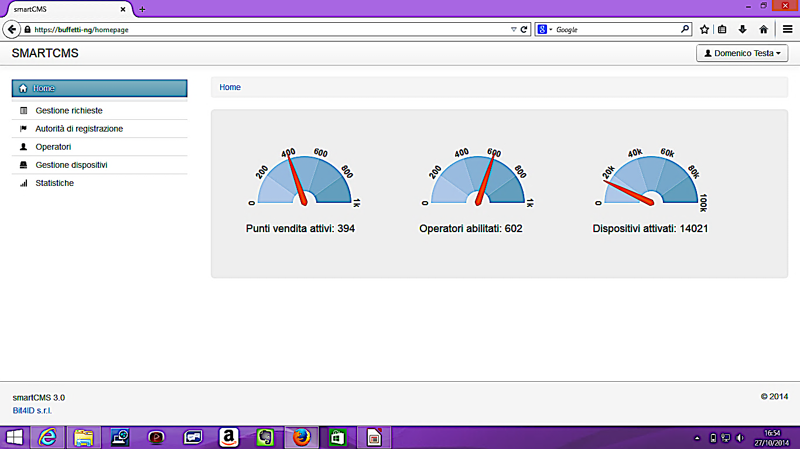

Figure 27 - SmartCMS Homepage

In the following we will briefly describe the web interface and a subset of the available functions from the point of view of a system administrator.

The home page of the system (see figure above) reports some useful statistics on the number of active registration offices, registration officers and issued Digital IDs. Moreover, this dashboard can be customized with the information that the customer considers most useful.

The status of the requests for a Digital ID can be managed by the subsequent sub-menu accessible by the web interface shown in figure below. Here there is a list of the requests entered in the system which are characterized by attributes such as ordinal number, registration office, subscriber name, device type, status of the request (approved, pending, produced, etc.), registration date, production date. These attributes can be used to sort the list by setting different filters.

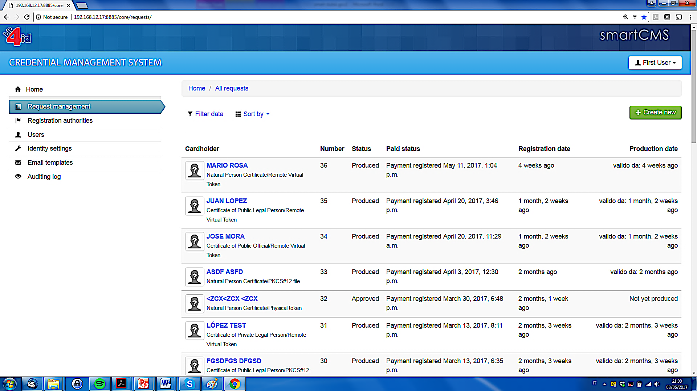

Figure 28 - smartCMS: requests management

On the same page it is also possible to insert a new request for Digital ID or in other words to register a new user by properly filling a data sheet with the details of the user.

The management of personal data of the subscriber as well as of all the people involved in the issuance process is particularly important in security-critical workflows such as that related to the distribution of devices containing certificates of digital identity.

A key point is the way in which the information to be recorded for each individual is entered into the system and the validation rules.

The personal data module of smartCMS (see next figure) can be natively extended through arbitrary mixings. At the initial configuration stage, it is possible to define the list of attributes to be added or modified in the personal data sheet, in devices data sheet and in all the entities that are relevant for the data model, and for each of them specifying the type of data and the validation rules.

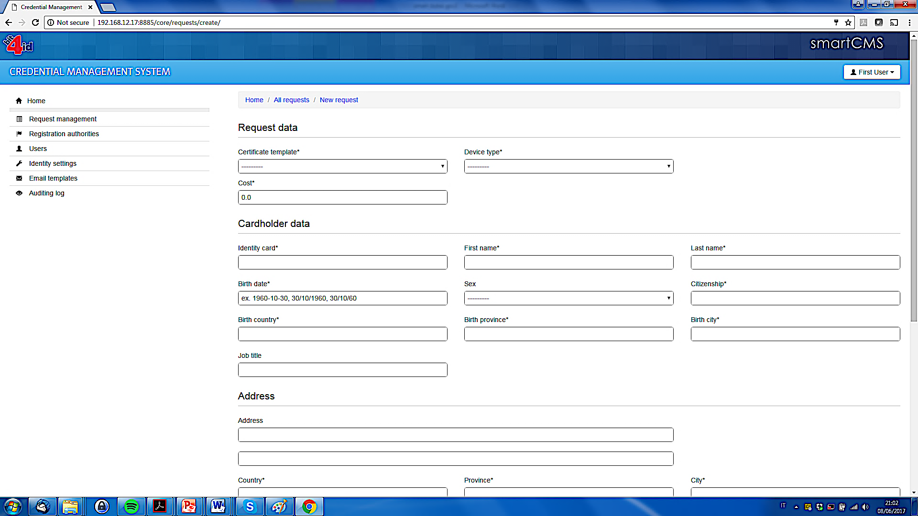

Figure 29 - smartCMS: registration of a new user

The other modules of the system will recognize the new attributes as native, allowing for the visualization in the application screens and for their use with the search filters and in the writing of batch procedures and in the report models.

The personal data module also allows the definition of the external sources (web services, database, etc.) for the use in the system of assisted compiling, when the information in the personal data sheet must be manually inserted by a human operator, or when they need to be integrated during an automatic procedure.

Typical fields available in the personal data module are:

* First name
* Last name
* Unique identifier (e.g., national identification number)
* Date of birth
* Place of birth
* Address
* ID document type and number
* E-mail address
* Phone number

Among the data required for the registration of subscribers, the system expects to receive an email address and phone number of the subscriber for communications, for example to send a notice of expiration of certificates and in general for all other communications from the system such as the OTP number for identity verification.

More functions available on the smartCMS are briefly described in the following list:

* The system administrator can create new organizations and enable different registration offices within a single organization, thus reproducing the real hierarchical structure.
* Different types of security officers characterized by different privileges can be assigned to each organization and/or registration offices in the “Operators” page of the smartCMS web interface.
* Another useful management option is the possibility to have an overview of the issued certificates with information about the serial number, the validity status, and the name of user to which the device is assigned.

**Self-Service Portal**

As already mentioned above, the smartCMS offers also the possibility to set-up a Self-Service Portal (see next figure). Through this one the client organization can make available a set of functions to the end-users/subscribers for autonomous management by their own.

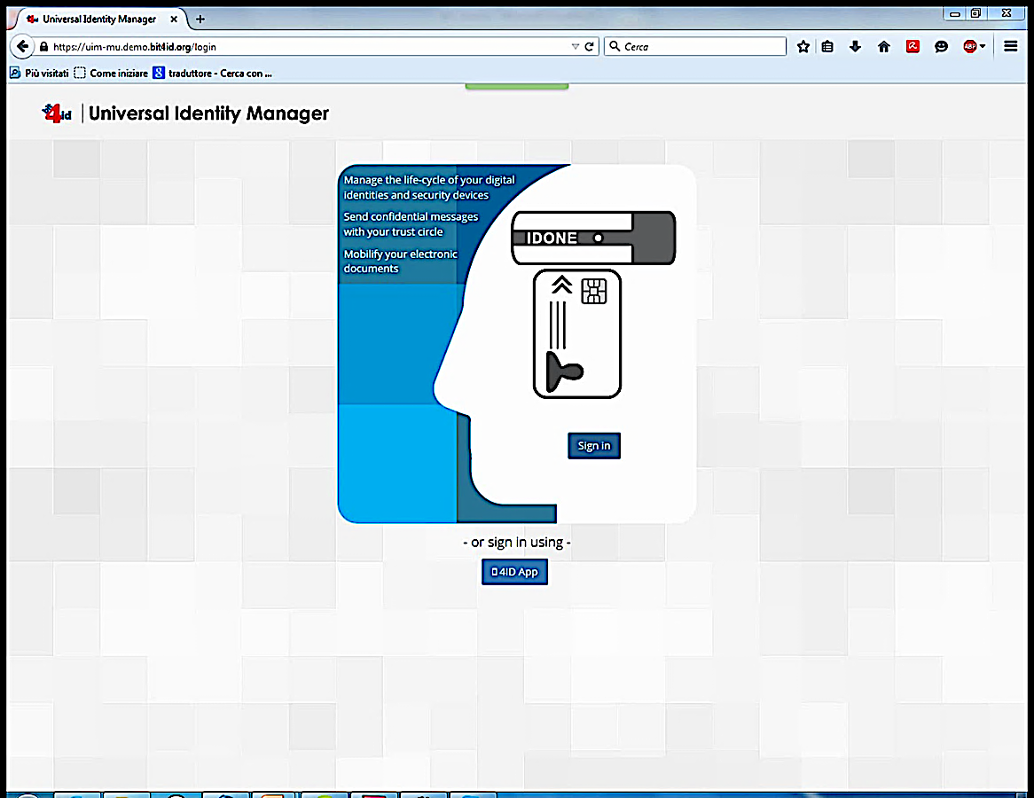

Figure 30 - smartCMS Self-Service Portal

The Self-Service Portal is thought to give access to functions of certificate life-cycle management (suspension, revocation, reactivation, binding of different mobile devices to certificates) and for creation of derived identities only if a strong authentication of the subscriber was first performed using a valid eID card.

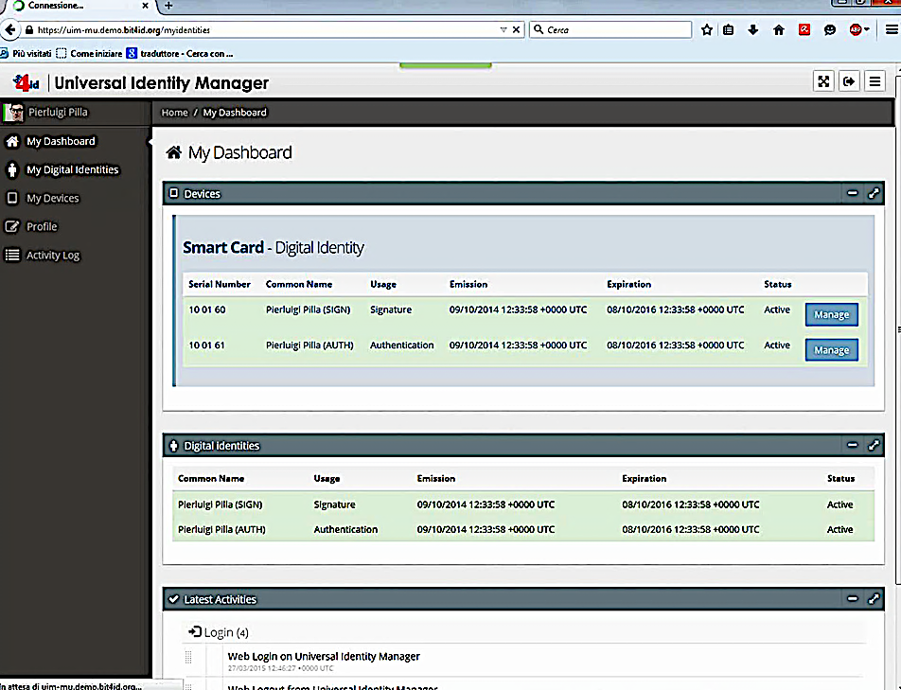

Figure 31 - Self-Service Portal: Identity life-cycle management

The functionality of Self-Service Portal would be integrated with the current Kiosks enabling the users to register for their Mobile Digital IDs. This would provide a seamless experience for already enrolled/registered ID Card holders as well as new registrants.

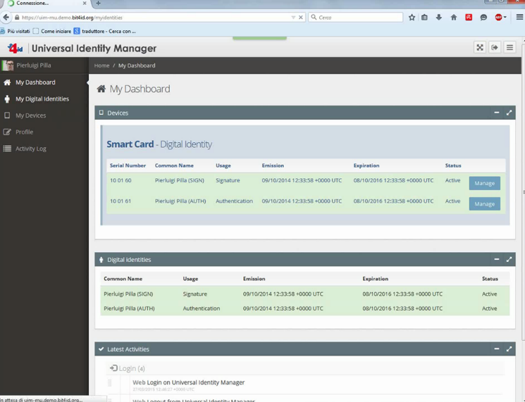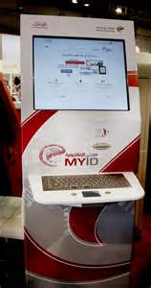

Figure 32 - Self-Service Portal: Integration with kiosks (example)

The current Kiosks might provide the functionality of ID Card Verification and Biometric authentication of the card holder providing the secure identification and authentication of ID card holder. We will extend this functionality to Digital Mobile ID. Existing Users can simply identify themselves using their ID Card to access the Digital Mobile ID Registration Service. Upon successful authentication, the user would be provided the ability to “Bind” their mobile devices. This process is described in more detail in Section #4.

New users can register for their Mobile Digital IDs is a seamless continuation of current ID registration process. This would provide a seamless experience for already enrolled/ registered ID card holders as well as new registrants.

**Remote Digital Identity Enrolment Workflow**

The enrolment procedure to obtain a Remote Digital Identity is designed to be autonomously started by the citizens. Every citizen registered on the e-Government web portal can request the generation of a remote identity. The process is later finalized in a post office, where a face-to-face identification of the user is required to guarantee the highest level of assurance and to be compliant with the most recent security standards.

The system doesn’t allow the user to proceed with further actions until his/her identity is not validated in a post office, together with residency address, mobile phone number and email.

In the post office, the Registration Authority Officer (RAO) validates the identity of the citizen and verifies that all the personal information on the portal is correct. The e-Government portal for the RAO asks to insert an OTP that is sent to the just updated citizen phone number. Moreover, the e-Government portal for the RAO asks a match-on card of the biometric data of the citizen before the remote identity issuance process could proceed. Once the citizen identity is fully validated, the RAO issues, from the RA Agent portal, a remote digital identity for the citizen. The e-Government Portal for the RAO will use an API of the RA Agent (Smart CMS) to ask the issuance of a new remote certificate for the citizen whose identity has been validated.

The RA Agent will receive as payload of the API a set of information useful to identify the citizen, then the RA Agent will connect to the LDAP Portal to retrieve the full set of information useful to complete the registration process into the RA Agent. The RA Agent will then ask to the SignCloud system to generate a key pair on the HSM for the specific user. After the key-pair generation is performed, the public key will be sent back from the SignCloud to the RA Agent that will in turn craft a CSR for the remote certificate profiles and will send the CSR to the National PKI to be signed. The certificate profiles used for the remote digital identities will be defined according to the certificate profiles already in use for the authentication and digital signature certificates stored on the National eID smartcard.

Once the certificate is signed and sent back from the National PKI to the RA Agent, this certificate is stored in the local DB of the RA Agent, and it is also sent to SignCloud that will associate the certificate together with the internally generated key-pair. The remote token stored on the tales and composed of the public-private key pair and of the digital certificate is protected with a PIN code that is generated during the issuance process.

The RA Agent after the issuance of the digital identity, to guarantee the sole control of the certificates to the citizens, sends a PIN code to the citizen on his mobile phone number or on another secure channel like the email address of the citizen.

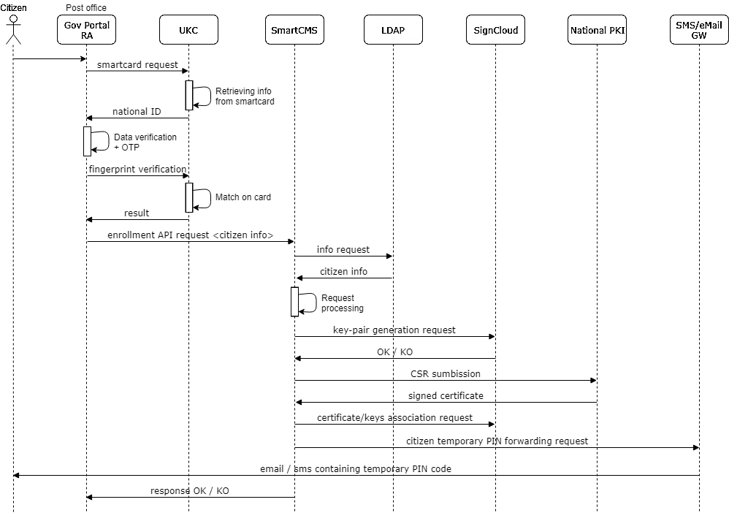

Figure 33 - Flow diagram for the citizen enrolment process

The PIN code is required every time the certificates must be unlocked for strong authentication or digital signature purposes, while the authentication to the remote platform is performed in Sigle Sign On with the e-Government portal credentials and according to the ISAM functionalities.

After the issuance, every citizen can manage the owned digital identities through a self-service RA portal, accessible with the same credentials used for the e-Government portal.

**Remote Digital Identity on Mobile Devices**

As we said in the introduction, the EU Council is promoting the deployment of a decentralized identity system, that will allow the EU Citizens to host their e.ID in an EU EBSI Compliant Wallet mainly for authentication purposes with public administration and strategic private ones, and large internet platforms.

As the ToR requires, we can consider in a separate way use of the mobile device app for signing or use it for easy strong authentication with the highest level of assurance. Therefore, we present two different systems:

* VIDchain for eIDASv2 compliance, support of EU decentralized e-ID and other attestations of attributes using EBSI Conformance VIDwallet
* SignCloud Mobile App for eIDAS Qualified Signatures

**VIDchain and VIDwallet**

VIDchain is currently one of the few proposals that is able to provide a complete SSI architecture, and especially an EU EBSI Compliance Wallet with solvency and guarantees, and maybe the only one provided by a QTSP.

As a matter of fact, as EBSI has published as of March 1, 2022, we can verify in the EBSI Site[32] that Validated ID has been the first company that has passed the conformance EBSI Tests for the scenarios of:

* ONBOARDING: Register a DID in EBSI using the wallet
* ISSUE: Receive an EBSI-issued credential in the wallet
* VERIFY: Present an EBSI credential from the wallet.

Therefore VIDchain provides a complete System to adopt SSI in the EC framework, carrying out PoC and Pilots especially with Public Administrations to experiment with the issuance and validation of verifiable credentials from the services provided to citizens.

VIDchain starts from the classic architecture of the SSI paradigm to simplify its adoption and use, with the following VIDchain architecture, modules and components:

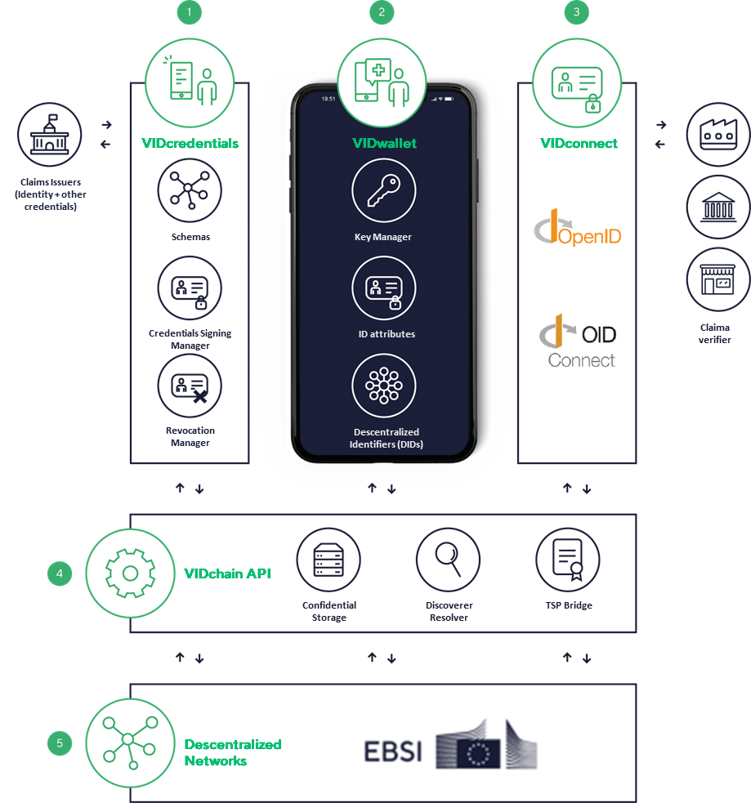

Figure 34 - VIDchain and VIDwallet

**1.** With **VIDcredentials** , entities can issue verifiable credentials through a simple API without dealing with the complexity of SSI.

**2. VIDwallet** is an APP that helps the user to manage all their personal data. The information remains confidential under the control of the user.

**3. VIDconnect** helps entities to interact with users, requesting credentials with a very simple integration. It is compatible, for example, with the well-known OpenID protocol.

**4.** The **VIDchain API** is the core of the solution. It handles all messaging across all components, as well as core operations.

**5.** VIDchain can work with different decentralized networks becoming a ledger agnostic solution, but for AAPP projects, we apply EBSI/ESSIF.

**Verifiable Credential Issuance Module**

The issuance of credentials by the ISSUER (in this case, the organization) is an integration of the VIDchain API with the services to enable the ISSUER to accredit and create the credentials in a portable format and signed in the blockchain, making them available to the holder via push messaging to your Identity Wallet.

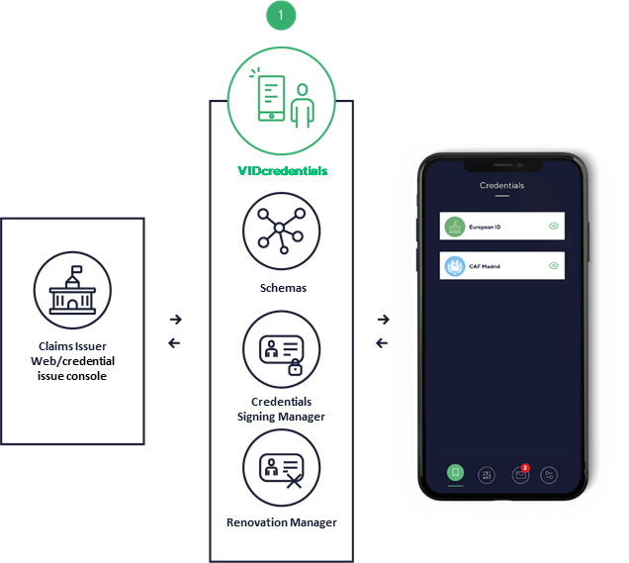

Figure 35 - Verifiable Credential Issuance

This module requires consultancy to define the credentials to be issued, including a feasibility analysis if you want to put it into production. The credential issuance functionality would consist of the development of a credential issuance Portal, a functional website that would be integrated with the VIDcredentials verifiable credential issuance module through a simple API without having to deal with the complexity of SSI.

For each project, different types of credentials will be defined that can be issued to the user's Wallet from the entity so that they can be used in identification/authentication/authorization scenarios, either for internal use or open to the citizen.

Regarding EBSI, we started working in 2019 for the European Commission, especially in the EBSI/ESSIF project, where we have been in charge, above all, of the development of the APIs to enable the Issuing services.

Our issuance module is evolving towards a console that facilitates the issuance of credentials based in authentic fonts, for instance issued by a public servant in face-to-face scenarios at a Citizen Council office , or remote based on the presentation of a qualified certificate to issue that certificate in a verifiable ID Credential format.

[SSI eIDAS Bridge](https://essif-lab.eu/ssi-eidas-bridge-by-validated-id-s-l/) is also available , which allows credentials to be signed, for example, with the entity's body seal, so that validation can be based on the eIDASv1 trust lists.

**Credential Verification Module**

It is the simplest integration that allows validating use cases, allowing interaction with users, requesting credentials or establishing a set of credentials to present from the user's Wallet to verify them and grant access and, if necessary, reuse the presented attributes.

For this, the VIDchain API is accessed to access the VERIFIER services that requires the presentation of the credentials by the HOLDER (possessor or user) of these and that needs to validate the cryptographic evidence immediately, structured and programmable.

In a pilot experience, the integration in an authentication Portal for presentation and verification of credentials would be developed, in parallel to the classic username/password or other means already validated in AAPP for identification and authentication. therefore applied to a functional website in the organization's own environment, for which the VIDchain team, in addition to advice on implementation, will provide a reference implementation to facilitate the work of the internal development team.

For this, the VIDconnect verification module will be used with an integration with the well-known OpenID protocol with an OIDConnect connector. In this sense, we highlight the role of Ivan Basart, our CTO, as Co -author of the [Self-Issued OpenID Connect Provider standard.](https://identity.foundation/did-siop/)

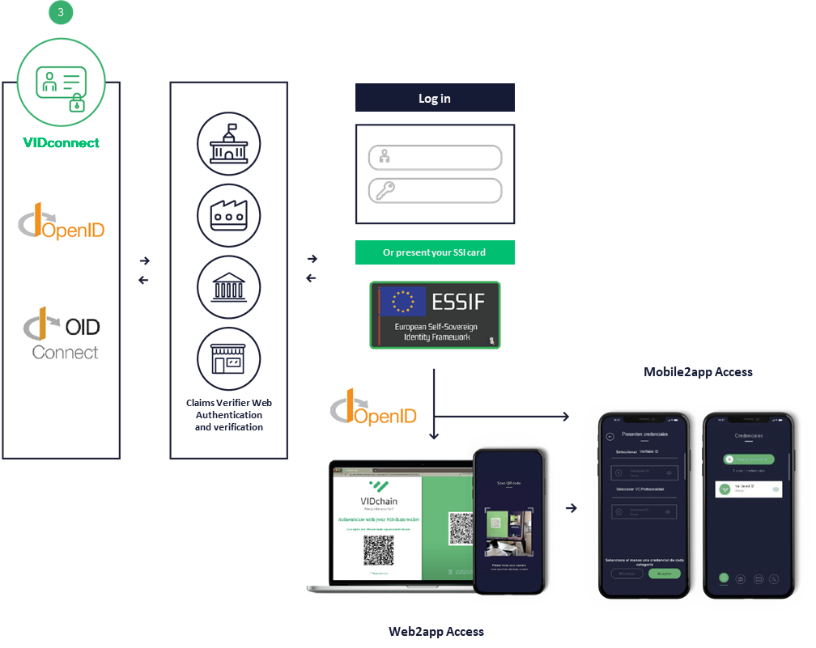

Figure 36 - Credential Verification

**VIDwallet, the VIDchain EBSI SSI Wallet**

And finally, to support the SSI system, a digital Wallet is necessary so that the holder of credentials (HOLDER or user of the Wallet) can request, receive, store and present their portable credentials, in processes of identification/authentication/authorization by part of the portals that accept these credentials.

In addition, VIDwallet can receive and manage all types of self-generated SSI credentials (credentials of owning your email, phone number, etc.) or issued by other ISSUERs within the same DLT method.

In the case of AAPP, it will be necessary to have an EBSI compliant Wallet, providing Validated ID using VIDwallet, developed according to SSI standards, and which communicates perfectly with the VIDcredentials and VIDconnect modules.

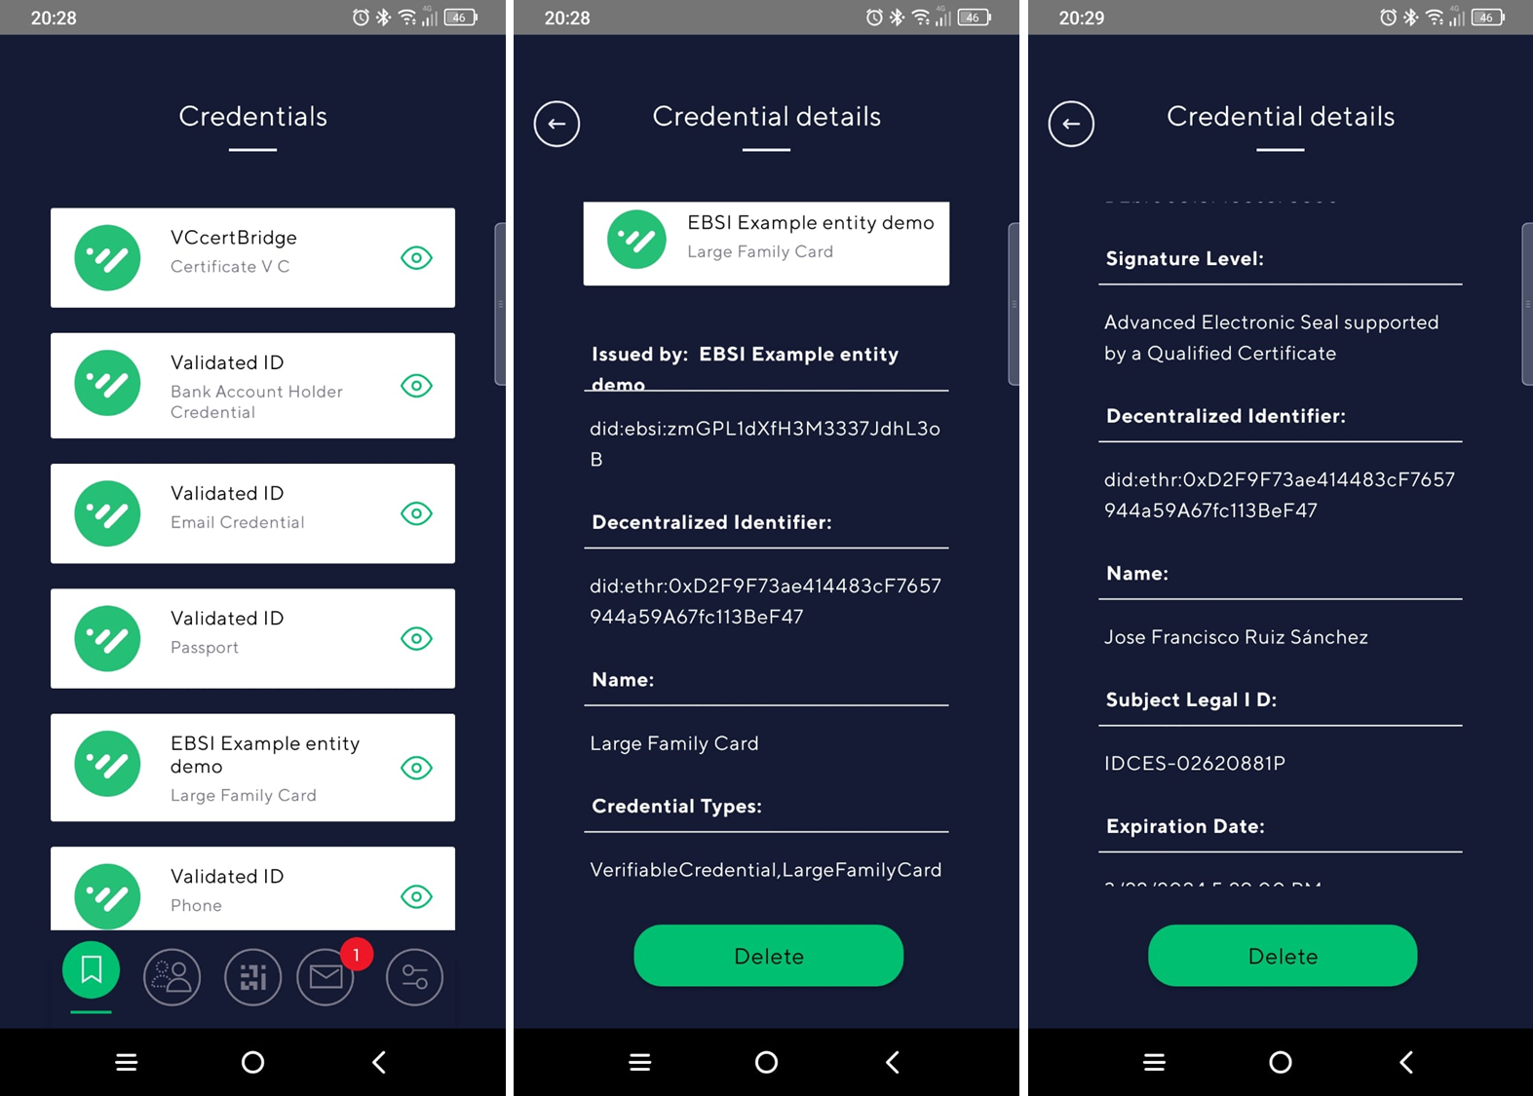

Figure 37 - VIDwallet, the VIDchain EBSI SSI Wallet

VIDwallet is compliant with current EBSI.Requirements We have been the first wallet to pass the EBSI conformance test, and in all use cases.

**List of VIDchain functionalities**

The main functionalities of the current system are the following:

* Verifiable ID – KYC official documents (DNI or passport + selfie)
* Verifiable ID from qualified electronic certificates - [Certbridge.vidchain.net](https://certbridge.vidchain.net/)
* Verifiable ID by appearance in OAC (integrated with VIDsigner BIO)
* VIDchain Credentials Studio Console (Scheduled 3rd Quarter 2022)
* eIDAS Bridge for sealing credentials
* Basic self-issued credentials (mail, phone, google or facebook account)
* PSD2 Financial Credentials
* Revocation of Credentials (W3C standard if supported by the DLT))
* Confidential cloud credential store (W3C standard)
* Multi-DID and Multi-DLT support
* Multi-language support (for now Spanish, Catalan, English and French)
* Integration with Valid and IDCat, AOC

**API Documentation**

VIDchain documentation and exploring our APIs is published at <https://docs.vidchain.net/>

**SignCloud Mobile App for eIDAS Qualified Signatures**

SignCloud functionalities, as mentioned earlier, can also be accessed using a cross platform mobile app. Bit4id has developed a mobile app allowing remote digital signatures on any smartphone or tablet.

Similarly, to what explained for the SingCloud Client, the UKC, the app is connected to the Virtual Token of the End User by TokenID and TokenPassword. The sign in of the End User on the SignCloud platform only makes available the public information of the certificate to the app.

The app allows to select a file from a local folder and to sign it using the remote credentials and according to one of the supported standards (PAdES, CAdES, XAdES). The app also supports advanced graphical signature allowing to add a graphical image to the signed file. The signature activation is performed by inserting the PIN that was set-up under the sole control of the End User as explained in the previous paragraph. On the Apple devices, after a proper configuration procedure, it is possible to opt for the TouchID option instead of typing each time the PIN number. Other functions available are the verification of a signed file and history of the signed files.

It is worth to highlight that the app also works as web browser allowing to predefine a set of web service providers to which is possible to authenticate with digital certificates.

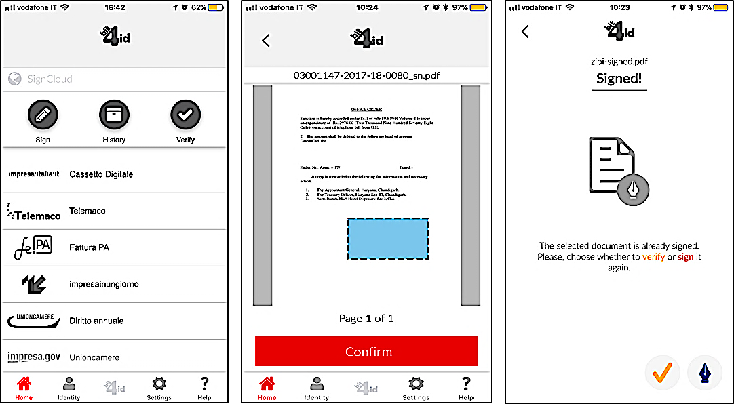

Figure 38 - Remote Signing process with the SignCloud mobile application

**Remote Digital Identity on Desktop**

In the next figure we show the connection of the SignCloud UKC Client to the server, here UserID and Password are required to access the virtual smart card containing the End User certificate.



**1**

**2**

Figure 39 - [1] Connection of the UKC Client to the SignCloud; [2] Display of the available digital identities into the UKC

After successful login (figure above [2]) the certificate information is displayed inside the SignCloud UKC Client that also acts as a typical smart card manager allowing the user to perform typical operations like change PIN/unlock PIN.

Once remote credentials have been enrolled and SignCloud Client has been authenticated by using the credentials of the End User, this can then perform any typical operation involving digital certificates as if he/she would be in possession of a physical smart card, simply by exploiting the remote access offered by SignCloud system.

We show in the next figure a digital signature operation on a Microsoft Word file. As it can be clearly noticed the remote certificate is made available to the application by means of the CSP library installed by the SignCloud client.

By accepting to sign the document, the SignCloud client requires the End-User to authorize the transaction by means of the suitable Authenticator that in this case is the PIN code.

It is apparent how a similar workflow would be in place for any other application requiring the services of the smart card, also those applications that requires a PKCS#11 library (e.g. Firefox, Bit4id Firma4NG, etc.).

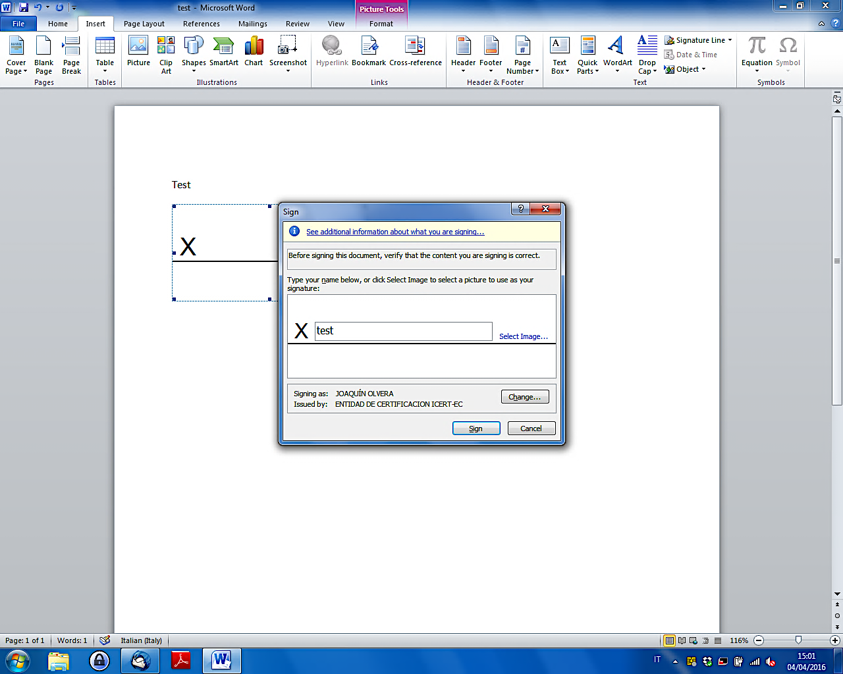

Figure 40 - Adding a digital signature to a Word document

1. **Compliance of the proposed eID Base Framework**

When proposing the base eID Framework (described in detail in the previous section) we performed a deep analysis of the requirements described by the ToR[33] and the attached Technical Study. Our analysis started with the required use cases and general requirements and was followed by checking item-by-item the functional and non-functional requirements. As conclusion, we can confirm that the **ready-made base eID platform** that we propose for this project **provides out-of-the box** all the required functionality and is fully open for localisation in Kosovo, thus **being 100% compliant** with the needs and requirements.

**Use cases and general requirements – Compliance table of our proposed eID Platform**

Table 18 - Use cases and general requirements compliance

| **Requirement** | **Compliance** | **Comments** |
| --- | --- | --- |
| **Use cases:**  1. Enrolment of End-users – identity verification  2. Identity credentials issuance  3. Level of assurance “high” authentication  4. Qualified electronic signatures  5. Management of accounts of end-users  6. Creation of a new CA, and/or Integration with an existing CA  7. Validation authority |  | * See SmartCMS * See SelfService Portal * See SignBox |
| Enables authentication corresponding to level of assurance “high” and electronic signing corresponding to qualified electronic signatures according to EU eIDAS Regulation |  | * See EIDASv2 and the near adoption of Self-Managed Identities in the EU * See SignCloud Mobile App for eIDAS Qualified Signatures |
| All software versions should be Albanian, Serbian and English |  | * The platform is open for full localisation * As described in this Technical Proposal, we provisioned a consistent part of the project for customisation, enhancements and localisation of the base eID platform |
| All proposed software licenses must have at least 3 years upgrade without any additional costs |  | * Our financial proposal contains all related costs for at least 3 years upgrade. |

**Architectural composition**

Table 19 - Architectural composition compliance

| **Number** | **Compliance** | **Requirements** |
| --- | --- | --- |
| **F01.001** |  | The digital identity solution MUST be usable on a smart mobile device and it MUST be easy to install, easy to use, and user friendly. |
| **F01.002** |  | The digital identity solution MUST support the following types of smart devices: (1) Android phones and tablets with Android version at least 6 and (2) Apple phones and tablets with at least iOS version 12.0. |
| **F01.003** |  | The digital identity solution MUST be independent of specific telecom operators or mobile device vendors. |
| **F01.004** |  | The digital identity solution MAY require internet access for communication purposes, realised via telecom operator services or with WIFI network access. |
| **F01.005** |  | The digital identity solution's client-side component MUST support the following user interface languages: Albanian, Serbian, English |
| **F01.006** |  | The digital identity solution MUST provide authentication of End-users for online services and digital signing of documents in line with the requirements of EU legislation.  The Solution MUST support the authentication function and the signing function with separate cryptographic keys. |
| **F01.007** |  | The Solution MUST be based on PKI, an asymmetric cryptography system using pairs of keys:   1. public keys which may be disseminated widely, and 2. private key which is controlled only by the End-user.   It must be possible for the Solution to integrate with national PKI, and established PKI as a part of this project, including here public key management done by the Certificate Authority (CA). The communication with the CA and between Solution's other components must be done over encrypted channels. |
| **F01.008** |  | The Solution MUST ensure secure storage of End-users’ private keys in End-user devices without requiring additional special hardware (such as smart cards or SIM cards from telecom operators). |
| **F01.009** |  | The Solution MUST provide at least 100-bit cryptographic security level and MUST be able to easily increase the security level. |
| **F01.010** |  | The Solution MUST support at least 2048-bit cryptographic keys for authentication and signing and there SHALL be a possibility for increasing the length of the key. |
| **F01.011** |  | The Solution MUST support at least SHA-1 and SHA-2 hash algorithms. |
| **F01.012** |  | Bidder MUST provide reference to peer reviewed publications in recognised academic journals of the cryptographic concept used in their submission with a technical description of the security schema and private key management. |
| **F01.013** |  | The Solution MUST mitigate all reasonable security risks related to management of End-user private keys.  Bidder MUST provide reference to peer reviewed publication in recognised academic journals describing how such security risks are mitigated. |
| **F01.014** |  | The Solution MUST comply with the following requirements:   1. MUST NOT use SIM-based or eSIM-based authentication factors. 2. MUST NOT require separate hardware tokens, e.g. pin calculator, USB key, or smart card. 3. MUST secure the private keys of the End-user in such a way, that it is not possible to use the key without the End-user's active knowledge and participation. 4. MUST use multiple authentication factors to authenticate the End-user. 5. MUST have countermeasures against brute-force attempts made on the mobile device, i.e. resist multiple attempts to try a knowledge-based authentication factor. 6. MUST have countermeasures against attacks that clone the mobile device and try to use the app on behalf of the user. 7. MUST NOT depend on mobile device vendors’ proprietary hardware Solutions only available in selected models. |
| **F01.015** |  | Digital signatures created with the Solution MUST conform to the Qualified Electronic Signature (QES) requirements specified by eIDAS and other EU legislation. |
| **F01.016** |  | Digital signatures MUST be technically compliant with the PKCS#1 specification in RFC8017. |
| **F01.017** |  | Digital signature MUST be usable in the ASiC-E container format (further specified in the ETSI TS 103171 and related standards). |
| **F01.018** |  | The user interface MUST support the following languages of Users: Albanian, Serbian, English |

**Registration Process**

Table 20 - Registration Process Compliance

|  |  |  |
| --- | --- | --- |
| **Number** | **Compliance** | **Requirements** |
| **F02.001** |  | The Solution MUST support an “over-the-counter” model of registration, as described above, offering the highest level of assurance (within reason) that the identity associated with the pair of PKI keys is correct and can be trusted. |
| **F02.002** |  | The registration system MUST be fully integrated with the chosen CA where the CA provides the following services:   1. CA provides the time stamping service conforming to the RFC3161 2. CA supports issuing digital X.509 certificates with the PKCS#10 Certification Signing Requests (CSR) conforming to the RFC2986 3. CA supports verification of the certificate validity status via the Certificate Revocation List (CRL) conforming to the RFC5280 and/or via the Online Certificate Status Protocol (OCSP) conforming to the RFC6960 4. CA supports revoking the End-user's certificates via secure API |
| **F02.003** |  | Communication between the chosen CA and the Solution components MUST be done over encrypted channels |
| **F02.004** |  | The registration system of the Solution MUST support the following languages for End-users: Albanian, English and Serbian. |
| **F02.005** |  | The registration system of the Solution MUST support following languages for RA officials: Albanian, English and Serbian. |

**Usage of the digital identity service**

Table 21 - Usage of eID Service Compliance

| **Number** | **Compliance** | **Requirements** |
| --- | --- | --- |
| **F03.001** |  | The Solution MUST provide publicly available and well documented APIs for all services, which are needed for use by RPs delivering secure digital services to their customers. |
| **F03.002** |  | There MUST be no limitations to the number of End-users of the Solution. |
| **F03.003** |  | There MUST be support for JSON/REST style methods for authentication and digital signature methods. |
| **F03.004** |  | The Solution MUST support a standard protocol OpenID Connect (OIDC) conforming to the standard published by OpenID Foundation to provide standardised and well documented access to the authentication service. |

**Technical requirements**

**1: Mobile Based eID Application**

**Functional requirements**

Table 22 - Mobile eID Functional Compliance

| **ID** | **Compliance** | **Requirement in detail** |
| --- | --- | --- |
| R3.01 |  | The Mobile eID solution must be device independent and not based on SIM card or any other hardware and should support multiple simultaneous devices. User must be able to install and use the Mobile eID application from several devices that he or she owns and all those electronic identities must link to the same natural person on a national identity management level. The solution must work even if the SIM card is not installed in the device. |
| R3.02 |  | There must be separate environments for development, testing and production. |
| R3.03 |  | The solution must be based on the known and proven principles of the Public Key Infrastructure (used identities shall be managed with X509 certificates). |
| R3.04 |  | The offer solution must use separate certificates (and private keys) for electronic authentication and digital signature creation in order to legally distinguish these two actions after wards and guarantee that end-user has sole control of certificate usages. |
| R3.05 |  | End-user device must have no or little limitations for hardware/OS used by the end-  user and must be available on all smart phones and tablets supporting Android 5 and newer, iOS11 and newer. |
| R3.06 |  | Appropriate cryptographic measures must be implemented with a minimum  requirement of RSA 2048, SHA-256 hash algorithms. |
| R3.07 |  | The offered solution must have clearly defined API for integration to third party services. |
| R3.08 |  | The offered solution must have support for OpenID Connect protocol. |
| R3.09 |  | The offered solution must , in order to provide seamless experience, allow creation of digital signature in the third party service or in some other application. |
| R3.10 |  | The digital signature created must be standard XAdES, PAdES and CAdES signature and have no limitations for the signing formats. |

**Non-Functional Requirements**

Table 23 - Mobile eID Non-Functional Compliance

| **ID** | **Compliance** | **Requirement in detail** |
| --- | --- | --- |
| R4.01 |  | It would be preferable for the offered solution to have proven usage and existing implementations in EU Member States. |
| R4.02 |  | Proposed architecture must ensure security and non-reproduction of issued private keys. |
| R4.03 |  | Transaction history (key generation, certificate issuance, authentications, signature  operations, PIN-code changes, wrong PIN-code tries, temporary key locking, key deletion) must be visible to user. |
| R4.04 |  | Offered solution must not require any additional devices like code cards or PIN- calculators. |
| R4.05 |  | Solution must ensure that private keys are under user’s sole control. |
| R4.06 |  | Solution must guarantee cryptographically that service provider is incapable of imitating the user actions to third/relying party. |
| R4.07 |  | Electronic authentication and digital signature creation are coherently separated flows. Aim is to distinguish two actions to create legal certainty and facilitate user  understanding of his/her actions. |
| R4.08 |  | Authentication process must comply with two-factor authentication principles. |
| R4.09 |  | Digital signature must correspond to qualified electronic signature requirements set out in eIDAS European Regulation (EU No 910/2014). |
| R4.10 |  | One person may install and use Mobile eID application on several devices and all created electronic identities must be linked to one natural person via unique identifier. |
| R4.11 |  | The offered solution must have High Availability as electronic authentication and digital signature creation are business critical infrastructure components. |

**2: Signing and Signature Validation Application**

**Functional requirements**

Table 24 - Signing/Signature Validation Functional Compliance

| **ID** | **Compliance** | **Requirement in detail** |
| --- | --- | --- |
| R5.01 |  | The solution must enable users to sign document electronically. |
| R5.02 |  | User must be able to sign multiple documents at once. |
| R5.03 |  | Application must support to sign documents at least in ASiC-E XAdES format (based on ETSITS 103171). CAdES (based on ETSI TS 103173) and PAdES (based on ETSI TS 103172) must be considered as optional formats. |
| R5.04 |  | Application must support digital signature validation. |
| R5.05 |  | Application must support to add a new digital signature for the documents already digitally signed by someone else. |
| R5.06 |  | During digital signature creation process, source files and signed containers must be kept inside signers’ environment and must not be sent to third party or external service. |

**Non-Functional Requirements**

Table 25 - Signing/Signature Validation Non-Functional Compliance

| **ID** | **Compliance** | **Requirement in detail** |
| --- | --- | --- |
| R6.01 | |  | For the PCs, applications must be available for Windows, Mac OS X and Linux operating systems. |
| R6.02 | |  | For the mobile phones, iOS and Android and Windows phone must be supported. |

**3: Software (API) for Service Providers**

**Functional requirements**

Table 26 - Software (API) for Service Providers Functional Compliance

| **ID** | **Compliance** | **Requirement in detail** |
| --- | --- | --- |
| R7.01 |  | Simple digital signature creation and authentication API that enables and eases service providers to integrate with the Kosovo Mobile-ID solution. |

**Non-Functional Requirements**

Table 27 - Software (API) for Service Providers Non-Functional Compliance

| **ID** | **Compliance** | **Requirement in detail** |
| --- | --- | --- |
| R8.01 |  | For web services, API’s must be available for .NET and Java. |
| R8.02 |  | For mobile applications, API’s must be available for iOS and Android and Windows phone platforms. |

**4: Administration Module**

**Functional requirements**

Table 28 - Administration Module Functional Compliance

| **ID** | **Compliance** | **Requirement in detail** |
| --- | --- | --- |
| R9.01 |  | Administration module must keep record of customer applications, devices and transactions. |
| R9.02 |  | Administration module must provide internal audit trails and must allow to uniquely identify the author of every change. Internal audit trails must support methods against intended or unintended deletion of records through time-stamping, chaining or other  provable methods. |
| R9.03 |  | Administration module must be connected to Certificate Authority and able to change certificate status. |
| R9.04 |  | Administration module must provide Self-Service portal to: |
| R9.04.1 |  | Authentication using Kosovo Mobile eID and Kosovo ID Card based eID. |
| R9.04.1 |  | Allow customer to manage status of the Kosovo Mobile eID (revoke, renew). |
| R9.04.1 |  | Allow user to see the transaction history. |
| R9.04.1 |  | Allow users to view/download the content of the applications for Mobile eID. |
| R9.04.1 |  | Allows requests to customer management like New Contract, Change of Contracts, Change of Validity and Change of Technical Parameters. |
| R9.05 |  | Administration module shall provide Help Desk portal |
| R9.05.1 |  | Based on strong customer authentication (Mobile eID and Kosovo ID Card based eID must be supported). |
| R9.05.1.1 |  | Allows customer support: |
| R9.05.1.1.1 |  | Identify the customer over the phone; |
| R9.05.1.1.2 |  | Find the customer records; |
| R9.05.1.1.3 |  | Manage customer Mobile eID account status according to the request. |
| R9.05.1.2 |  | Possible to connect the single access to data with the customer call, if call registration system exists. |
| R9.05.2 |  | Administration module must support Customer Management: |
| R9.05.2.1 |  | Allows to add e-Services and customer contract data like Contacts, Validity Period and other Technical parameters of the service. |
| R9.05.2.2 |  | Allows to view issued customer reports. |

**Non-Functional Requirements**

Table 29 - Administration Module Non-Functional Compliance

| **ID** | **Compliance** | **Requirement in detail** |
| --- | --- | --- |
| R10.01 |  | Full infrastructure must be in the cluster environment. |
| R10.02 |  | Support for virtualization of system components. |

**5: Messaging Hub**

**Functional requirements**

Table 30 - Messaging Hub Functional Compliance

| **ID** | **Compliance** | **Requirement in detail** |
| --- | --- | --- |
| R11.01 |  | Handles the authentication and signature requests between e-Services and end-customers. |
| R11.02 |  | Has an easy to implement and well defined integration interface for e-Services. |
| R11.03 |  | Issues statistics to e-Services about their activity and is able to handle invoicing for transactions. |
| R11.04 |  | Is integrated with administration portal and CA services (no positive response is given to revoked certificate transactions). |

**Non-Functional Requirements**

Table 31 - - Messaging Hub Non-Functional Compliance

| **ID** | **Compliance** | **Requirement in detail** |
| --- | --- | --- |
| R12.01 |  | Robust scaling possibility to handle additional load. |
| R12.02 |  | Full infrastructure must be in the cluster environment. |
| R12.03 |  | Maintenance of a system is possible without downtime (open sessions may be influenced). |
| R12.04 |  | Supports yearly availability of service on the level of 99.9% and above. |

**6: Certification Authority (CA)**

**Functional requirements**

Table 32 - CA Functional Compliance

| **ID** | **Compliance** | **Requirement in detail** |
| --- | --- | --- |
| R13.01 |  | CA supports for X.509 certificate format which must support using custom extensions in X.509 certificates (including binary values), support UTF-8 encoding of strings and acceptPKCS#10 format as input. |
| R13.02 |  | ECC and RSA are supported cryptographic algorithms. |
| R13.03 |  | Includes OCSP responder. |
| R13.04 |  | Supports multiple RA’s with different policies, both GUI and automated interfaces must be supported. |
| R13.05 |  | Internal audit trails must allow to uniquely identify author of every change. Internal audit trails must support methods against intended or unintended deletion of records through times- tamping, chaining or other provable methods. |
| R13.06 |  | Certificate owners can be notified upon revoking or prior to expiration of their certificate. |
| R13.07 |  | Support for role division and password policy for internal roles. |
| R13.08 |  | Support for various Hardware Security Modules (HSM) vendors. |
| R13.09 |  | Certificate profiles must be version controlled. |
| R13.10 |  | CA must have a separate chain of certificates for testing and development purposes. |
| R13.11 |  | CA must be integrated with Administration portal. |
| R13.12 |  | CA service offered must be audited according to ETSI 3 19 411-2 or similar by an accredited third party auditor. |
| R13.13 |  | CA operations must be certified according to ISO 27001. |

**Non-Functional Requirements**

Table 33 - CA Non-Functional Compliance

| **ID** | **Compliance** | **Requirement in detail** |
| --- | --- | --- |
| R14.01 |  | Software must correspond to CWA 14167-1 Security Requirements for Trustworthy Systems Managing. |
| R14.02 |  | There must be a 24/7 incident management provided. |
| R14.03 |  | Full infrastructure must be in the cluster environment. |
| R14.04 |  | Support for virtualization of key components. |

1. **Assessing the current situation**

One of the important tasks that will be performed during the inception period is to assess the state-of-play of related interventions and actions, government as well as donor funded ones[34]. The **technical study** carried out as part of the project **EU Support for the Competitiveness of Kosovo’s ICT Sector (EuropeAid/139756/DH/SER/XK) - Preparation for implementation of e-IDAS in Kosovo** represents a very well structured source of information and the best starting point for the mentioned task. Preparation for implementation of e-IDAS in Kosovo, Annex 2 – Output 1b (Activity 3.2), section 9.2 summarises very well the main gaps, main findings and recommendations. The study was finalised in 2021, thus our main priority will be to assess the progress on implementing the recommendations. In the same time, the study identifies the relevant target groups and responsible bodies for the implementation of the recommendations. Our methodological approach for this task will be to interview the responsible bodies. The plan for the meetings with these institutions will be drafted immediately after the contract signing and will be submitted to CAUT/IAUT before the Kick-off Meeting. Our expectation is that, at the kick-off meeting, all related stakeholders will become aware of the action plan and will further ensure the availability of the responsible persons, thus allowing us to start the discussions within the next days.

One important aspect related to the assessment of the current situation is related to the evaluation of the existing information systems that may be candidates for connection/integration with the Digital Identity Service. We will prepare the list of institutions operating those information systems before the Kick-Off meeting and we will also propose a draft confidentiality agreement to be signed in order to have access to the information we need for this assessment which will be mainly based on evaluating at least the following aspects: technological platforms, source code, existence of APIs, availability of resources (internal, outsourced) capable to extend the functionality with needed integration. We expect to have the confidentiality agreements entered into force by the end of the first month of the contract.

A summarised graphical view of the assessment components is presented in the figure below:

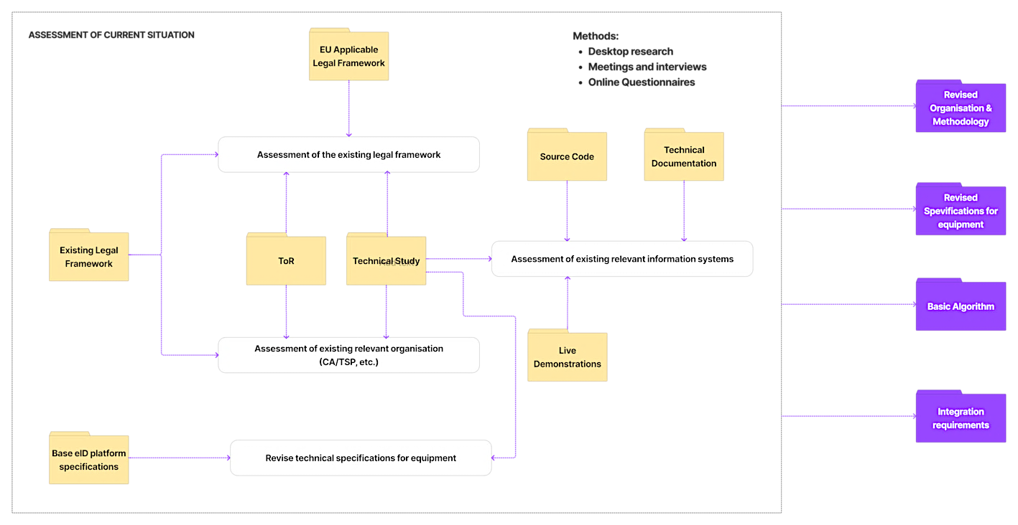

Figure 41 - Methodology: Assessment of current situation

Another important aspect related to the assessment that we will perform during the inception period is related to the technical specifications for the equipment needed for the implementation of the Digital Identity Service. As it will be explained in more detail in section 2.4.1 - **INC - Inception Phase** and emphasized in section 5 - **Timetable of work**, we believe that this task shall be completed as earliest as possible due to the expected duration of the supply tender and, even more important, due to the potential delays in delivery of the equipment because of current shortages on the supply chains experienced by the manufacturers. We will have as starting points the existing specifications[35] and the characteristics of the eID base framework. Any further customisation/localisation will not have a significant impact on the technical specifications for the equipment.

From the methodological point of view, for this phase of the implementation, we will use desktop research and meetings/interviews to collect un-structured information and online questionnaires to collect structured information. The compilation of all collected information will be made using traceability chains and compliance matrixes. To the maximum possible extent we will make available online tools that will allow us to automate the processes and extract the results in an efficient and effective way.

1. **Build and Deploy the Digital Identity Service**

This part of the project is the most consistent and time/resources consuming. Our methodology has one main goals, **FULL SCOPE COVERAGE** that will lead to the full achievement of all objectives. We will implement a well-known practice in the industry that will ensure the COMPLETE TRACEBILITY of all items/artefacts that are involved in the related processes which are **DESIGN**, **DEVELOP**, **TEST**, **DEPLOY**. Again, we consider as a major advantage that we can have as starting point the Technical Study for **Preparation for implementation of e-IDAS in Kosovo**. The processes and the most important functional requirements are well described in the mentioned study[36]. A brief illustration of the proposed methodology for this part of the project is presented in the figure below:

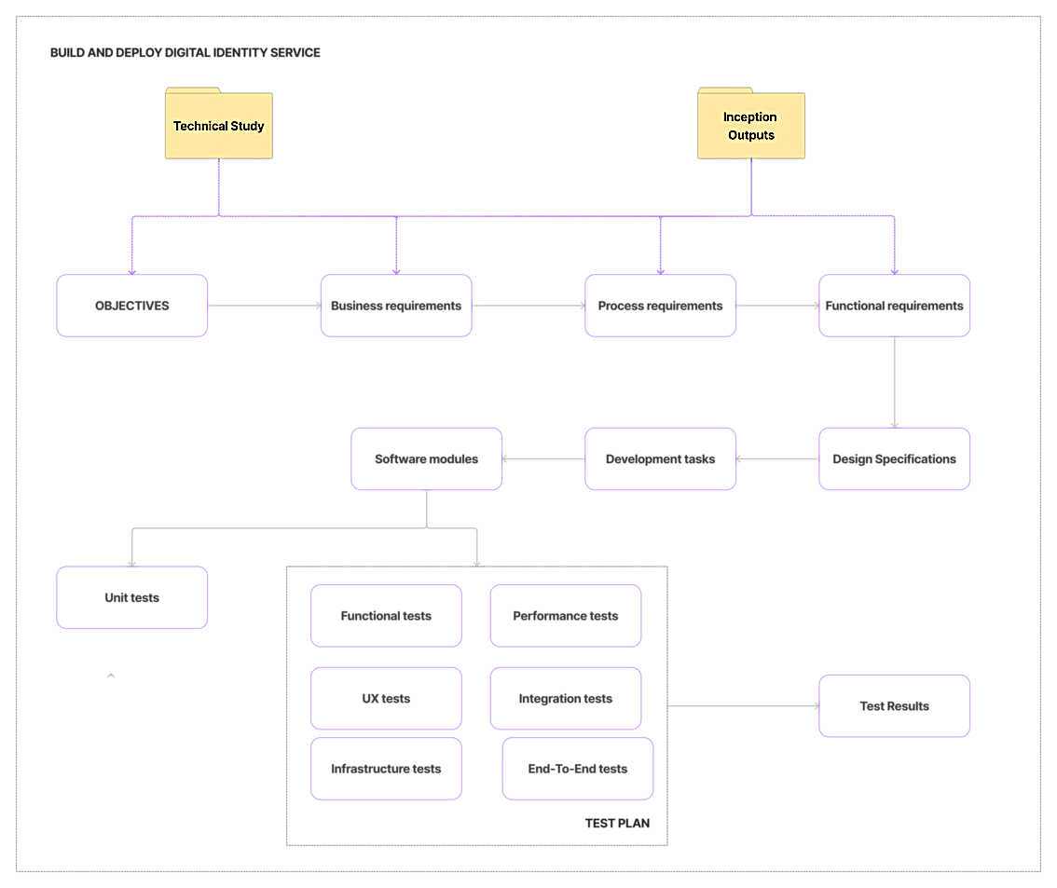

Figure 42 - Methodology: Build and Deploy Digital Identity Service

According to the best practices in the industry, for the build and deploy the digital identity service part of the project, a number of environment will be put in operation, each of them having a well-defined specific role in the whole process. These are:

* **Development and unit testing environment**: used by the development team to produce the code for the software modules and to unit test them during the development process
* **(Factory) Test Environment**: used by our software QA team for running the test plan **BEFORE** any release to beneficiary
* **Pre-Production Environment:** used by our implementation team together with the beneficiary in order to run the test plan BEFORE any release to production; used by our capacity building team (and, in the future, by certified trainers) to train the key users for the operation, administration and maintenance of the system
* **Production Environment:** (made of the equipment purchased through the related supply tender) used by all the end-users of the Digital Identity Service.

As a key point of our methodology, for this part of the project, we will put into operation and integrated system. The Project IT Environment (see section 3.4 - **IT&C support**) that will automate the whole process described in the picture above. The automation will be implemented through various tools (further mentioned in the next section) and through **dedicated CI/CD pipelines**. These pipelines will ensure not only the deployment between the four mentioned environments but also a consistent part of automated testing as well as software development management tools, source control, pull requests and bug reporting. A brief illustration of the automation through CI/CD pipelines is presented in the figure below:

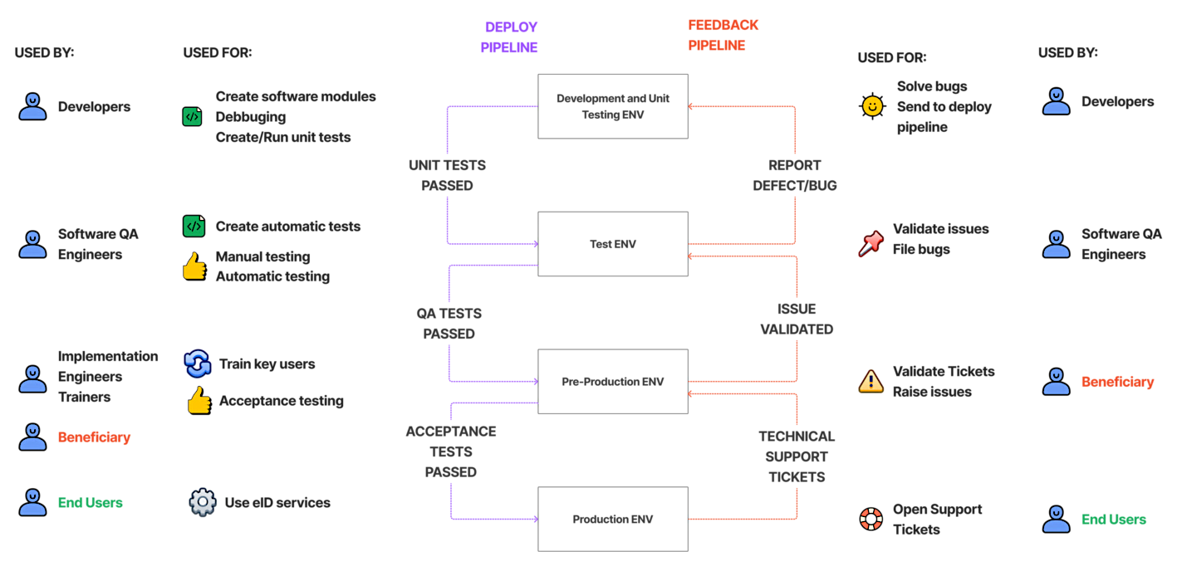

Figure 43 - Methodology: CI/CD Pipelines

Taking into consideration the specific of the tasks for the implementation of the software development activities within this project we will use the **AGILE-SCRUM** as the general framework as being a much suitable than the WATERFALL approach. The AGILE-SCRUM framework will allow the proper integration of the all inputs and requirements. It is also important to mention that each specific process within the framework will be carried out according to its specific methodologies and best practices.

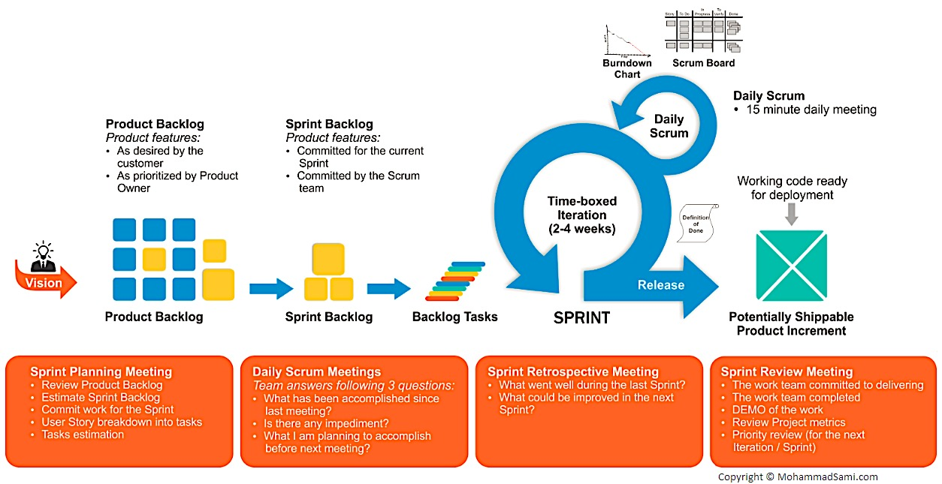

Figure 44 - Methodology: Software development

The actual duration of each iteration (**SPRINT**) will be defined during the Inception Phase (task: Revise Organisation&Methodology) and will be included in the related deliverable (INC.D2) which will be continuously monitored and when needed will be reviewed and updated. However, we do not intend to have the duration of a SPRING longer than 4 weeks as we believe that the dynamics of the development tasks will involve a close monitoring and control.

**Below we present the main features pf our software development methodology and what steps will be followed.**

**Step 1: Requirements analysis**

Our initial steps include performing a requirements analysis of the recommended processes to be covered by the software.

The requirements analysis procedure is further partitioned into the following processes:

* **Identification of requirements from the main beneficiaries.** The purpose of the requirements identification process is to identify and gather the beneficiaries’ raw requirements. A raw requirement is a customer requirement or needs that has not been analysed. It is an imprecise and unstructured initial statement of need for the system intermingled with ideas and suggestions for possible designs.
* **Creation of well-formed requirements.** This process will refine the collection of raw requirements into a collection of well-formed requirements. A well-formed requirement is a statement of software functionality (a capability) that can be validated, and that must be met or possessed by the developed software to achieve the customer objective and is qualified by measurable conditions and bounded by constraints. We will create a detailed Business Requirement Specification Report, which will be the first step of the process of mapping the business problem into a set of computer engineering problems. The very abstract architecture of the software will be sketched, and organisational items/stakeholders will be identified in terms of roles, positions, and units. Following these, functional description of the software will be generated (users’ requirements and development of modules which will cover recommended business processes, development of the relational database, ERA diagram, web service, API and other required elements for programme modules realisation).
* **The organisation of the requirements into a System Requirements Specification (SRS**). The purpose of this process is to structure the collection of well-formed requirements by relating the requirements to one another according to a comparative definition method. The objective is to organise the requirements into an ordered set documented in the SRS. To implement the envisaged software, a comprehensive analysis will be conducted through a review of existing data sets and records to be integrated into the eID system, and interviews with relevant IT professionals from the beneficiary institutions. Based on the functionality defined by the SRS, software components and their precise roles will be identified. As a result of this step, the integration and set-up requirements will be reported. As a result, the software’s functional specification will be mapped to technical requirements and each requirement will be bound to a set of components along with the description of each component’s role in the solution.
* **Validation and approval of the SRS.** The purpose of the process is to express the requirements in a form that is comprehensive both to the customer and to the designers of the software, to validate them, and to gain approval from both the customer and the project team.

The purpose of decomposing the software requirements specification development process into sub-processes is to aid in the full and accurate development of the requirement analysis.

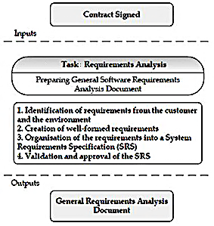

Figure 45 - Software requirements specification development process

The goal of this analysis is to describe what the “software” should do and allows the developers and beneficiaries to agree on that description. To achieve this, the development team will build infrastructure services for supporting application modules. Therefore, for the application modules to work within defined functionality, it is required that certain assumptions be realised. For the application modules to work within defined functionality, it is required that certain assumptions be realised. These are:

* **Availability of the application (both locally and remotely)** – this assumes communication paths for network traffic which is ensured by appropriate communication design. This will include redundant functionality on the level of single device (redundant components of the single device) as well as functional redundancy (redundant ISP links and/or redundant routes through which the traffic can be redirected if the primary route fails.)
* **Application response** – it is not enough to simply enable the proper path of the communicating parties but to make sure the communication is responsive within acceptable level (SLA- Service Level Agreement). Implementing traffic prioritizing and shaping ensures that designated protocols are assigned higher priorities.
* **Application (and other supporting systems) maintenance** – in case any component of the system software dies or is significantly degraded, 24x7 support is available.

These requirements can be fulfilled if the following components of the infrastructure are in place:

* **Networking communication systems** – communication equipment configured properly with available Internet Service Providers links (one or more redundant) which connect different locations (enable IP based traffic). This also assumes interlinks between devices (cables – optical, copper, wireless, ISP links, etc) are of sufficient quality
* **Server systems** – processing capabilities that run applications, control transactions and processing of data, logging relevant parameters, storing/restoring the critical data. Servers need to be carefully designed in order to support the load defined (number of users to be served, number of transactions per second or number of simultaneous connections – these parameters will determine the CPU and memory capacities as well as disk space)
* **Power supply** – in order to ensure the uninterrupted operation, it is important to consider proper way of power supply to the given devices.
* Strong recommendation is using UPS (uninterruptable power supply) which will provide power even if the public electrical network shuts down.
* **Environmental conditions** – it is important to ensure appropriate environmental condition in which devices operate. This means that temperature, humidity, physical characteristics of the environment should be as close to vendor recommendations as possible.

In this respect, we are going to elicit, organise, and document the required functionality and constraints. It also tracks and documents document trade-offs and decisions. Each of the application modules will have corresponding documentation that includes:

* project documentation which will be developed during the software definition
* technical documentation which will specify all elements of developed products (diagrams, specification) in order to enable maintenance later and
* user documentation (instructions) which will facilitate in using programme support properly

**Step 2: Software Planning - Design**

The goal of the Planning / Design step is to show how the system software will be realised in the implementation phase. The development team will build a software that:

* Performs the tasks and functions specified in the use case descriptions
* Fulfils all its requirements
* Is structured to be robust (easy to change if and when its functional requirements change).

The following figure expresses the correlation between analysis and design stage:



Figure 46 - Correlation between analysis and design stage



Figure 47 - Server, business and database tier

Web service can provide data in three most common used formats that allows other services (with appropriate authorization) and applications to read, process and analyse data from the software system.

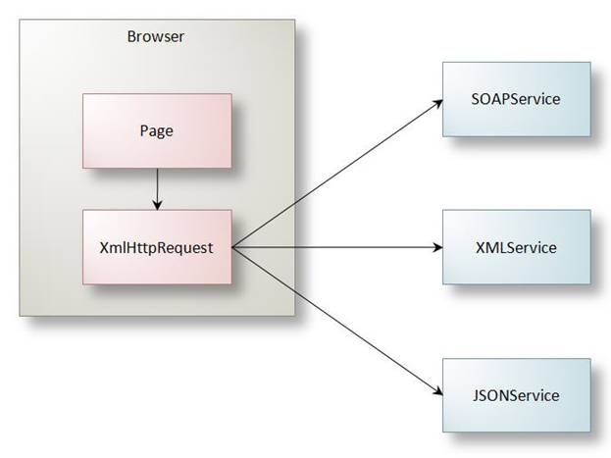

Figure 48 - Web Service

These modules will be designed based on technical approach of the software system. The relational database system will be the core component of the overall architecture since all the valuable information will be stored in it and then be disseminated to the rest of the system. The planning – design stage encompasses the system and subsystems and will develop detailed specifications. There will be two parallel activities in this stage: database design and software design.

**Database Design**

The following figure presents an overview of the processes implemented in the Database Design task:

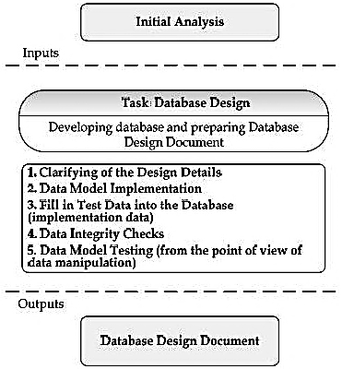

Figure 49 - Processes implemented in the Database Design

**Software Design**

The following figure presents processes implemented in the Software Design stage:

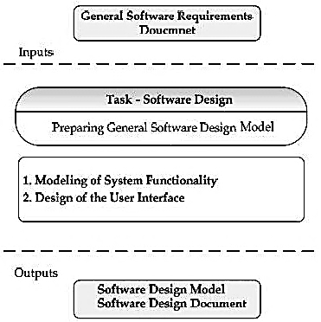

Figure 50 - Processes implemented in the Software Design

Analysis and Design will result in a software design model and, depending on the project size, optionally an analysis model. The software design model will serve as an abstraction of the source code; that is, the design model acts as a “blueprint” of how the source code is structured and written.

The software design model will consist of design classes structured into design packages and design subsystems with well-defined interfaces, representing what will become components in the implementation. It will also contain descriptions of how objects of these design classes collaborate to perform use-cases.

The software design activities will be centred on the notion of architecture. The production and validation of this architecture will be the focus of early design iterations. Architecture will be represented by four different architectural views, namely the logical, process, component, and deployment views. These views will capture the major structural design decisions. Architectural views will be abstractions or simplifications of the entire design, in which important characteristics will be made more visible by leaving details aside. The architecture will be an important vehicle not only for developing a good design model, but also for increasing the quality of any model built during system development.

**Modelling of the System Functionality**

Ultimately every IT project fulfils a set of business needs. To this end we will adopt a methodology that addresses any mismatch between the delivered IT system’s functionality and the business needs by providing a common language and process for both aspects, as well as showing how to create and maintain direct traceability between business and software models.

The key principle of this methodology is to carry out business modelling using Business Use-cases. Use-cases are a fundamental concept in the Unified Modelling Language (UML). Undertaking to develop the business modelling will ensure that an understanding among all stakeholders will be reached about what business process needs to be supported in the organisation by the software. The business use-cases will be analysed to understand how the business should support the business processes. This will be documented in a business object-model.

**Designing the User Interface**

Key component in the process of launching a new software is to gain full and complete understanding of the system’s purpose, structure, functionality and added value. To achieve this goal, planning and conducting an in-depth analysis of the available assets is deemed necessary so that these assets are examined from a variety of aspects to determine the quality level, as well as potential existing problems. As software system applications are becoming more elaborate, supporting more advanced functionalities, and serving more specialized users than ever, the need to design simple and intuitive interfaces is compelling. Web applications will not merely “do the job”; they will, more importantly, present users with the information they need, instead of asking them to retrieve it, and allow them to feel comfortable in using them. In the above context, we will focus on the following three points:

* Recognize and address the importance of User Interface Design as a separate and unique Project development phase
* Engage dedicated, imaginative, and professional experts whose experience and knowledge gamut covers all aspects of User Interface Design ranging from Usability Evaluation, Testing & Ergonomics to Accessibility compliance and extreme coding.
* Actively incorporate user feedback in the User Interface Design iterative process

**User Centred**

The process of design will deal with exploration, discovery, generation and choice of possible solutions, implementation, evaluation, and repetition. The primary aim of design is to be coherent, purposeful, and useful. This will require a major consideration of the possible users from the very beginning of the process. Such an approach is known as User-Centred Design (UCD) and, when implemented successfully, has the following attributes:

* effectively communicates the system’s interactivity and functionality
* defines behaviours that communicate the system’s responses to user interactions
* reveals both simple and complex workflows
* informs users about system state changes
* prevents user error by using techniques such as behaviour-shaping constraints

In that respect, primary information about the possible users, their needs, expectations, and objectives will be deemed necessary. Involving the users throughout the whole process improves potentiality for successful design, eliminates possibilities for errors and inconveniencies and will be considered to improve productivity and acceptance, while increasing usefulness and efficiency.

The first phase of the UCD process regards the exploration and the discovery stage of the design process itself. As a first step towards this direction, it is essential to identify the target audience and develop a complete set of user profiles (personas) and user descriptions prior to this phase. This will assist in defining the representative sample that will participate in the benchmarking studies.

Once the selection of representative users has been completed, a variety of sessions will take place intending to clarify and define the functionality of the application from the user perspective. The users’ feedback on questions regarding their preferences, context of use, functional needs, objectives, expectations etc. will form the entry point for the user task analysis.

While the first phase of the UCD process regards the exploration and the discovery stage of the design process, at the second phase the actual design starts taking shape. The high-level objectives of the representative users will provide insights about how the broadest level of information and interaction should be addressed, as well as assistance on how to fit together the strategic objectives with users’ expectations. This will result in identifying all the key processes and will assist in determining the structural groupings. Based on the above, a trial set of objects and views will be designed to support the main user tasks.

Therefore, the development of a prototype in order to measure the effectiveness of the design solution will follow, tested by participants recruited from the target audience. Their performance, reactions and comments will assist in identifying many design strengths and weaknesses. The above process will be subject to repetitive modification and testing until meeting functional and usability objectives.

Once the results of the above process have been accepted, a working demo of the software will be implemented. This version is supposed to contain all the functions planned for the actual system and will be subject to testing in the same manner as with the prototypes. The information gathered from users of the working demo will guide our TAT in performing any necessary changes on the software before its formal release.

**Test plan**

During this task wet will develop a Test Plan, useful for the development phase, where the produced software will be thoroughly tested. The Test Plan will include detailed test scenarios for each subsystem and process that will be prepared, as well as the necessary data to perform all test scenarios. The tests are divided into the following categories:

* Performance Testing
* Windows / Internet GUI Standards
* Platform Testing
* Localization
* Stress Testing
* Conversion testing
* Parallel Testing
* Installation Testing
* Usability testing
* User’s Guide / Training Guides testing
* Guerrilla Testing
* Security Testing
* Network Testing
* Hardware Testing
* Temporal Testing
* Disaster Recovery (Backup / Restore)
* Input and Boundary Tests
* Acceptance Testing

Quality can be achieved only by testing the system against its requirements. Although unit testing of individual components may be sufficient during the development process, only testing the entire system against its requirements will ensure that the software functions as expected.

Of the many types of requirements, functional and performance requirements are the ones that most often apply to the testing process.

* **Functional requirements** help validate that the system contains specified functionality and should be derived directly from the use cases that developers use to build the system.
* **Performance requirements** will cover any performance standards and specifications identified by the project team, such as transaction response times or maximum numbers of users. These requirements also referred to as service-level objectives (SLOs) — are aimed at ensuring that the system will be able to be scale to the expected number of users and provide a positive user experience.

Both functional and performance requirements will be designed to give the testing team a clear, concise, and functional blueprint with which to develop test cases. Requirements will be grouped according to how critical they are to the project’s mission’s success. The ones that affect the core functionality of the system will be extensively tested, while the not-so-critical requirements can be covered by minimal testing efforts or be tested later in a lifecycle.

**Implementation Plan Design**

The Implementation Plan will describe how the software system will be deployed, installed, and transitioned into an operational software. The plan will contain an overview of the system, a brief description of the major tasks involved in the implementation, the overall resources needed to support the implementation effort (such as hardware, software. Facilities, materials, and personnel), and any site-specific implementation requirements. Within the Implementation Plan information will be analysed concerning:

* **Purpose**
* **Software Overview:** This section provides a brief overview of the software system to be implemented, including its description and its organization
* **Description of Implementation:** This section provides a brief description of the software system and the planned deployment, installation, and implementation approach
* **Major Tasks:** This section provides a brief description of each major task required for the implementation of the software system. The tasks described in this section are not site-specific, but generic or overall project tasks that are required to install hardware and software, prepare data, and verify the system.
* **Implementation** Schedule: In this section, we provide a schedule of activities to be accomplished during implementation.
* **Site Requirements:** This section defines the requirements that must he met for the orderly implementation of the system and describes the hardware, software, and site-specific facilities requirements for this area
* **Post-Implementation Verification:** This section describes the process for reviewing the implementation and deciding if it was successful. It describes how an action item list will be created to rectify any noted discrepancies.

**Maintenance Manual Design**

During the design stage, the Maintenance Manual will be developed. The Maintenance Manual will provide maintenance personnel with the information necessary to maintain the software system effectively. The manual will provide the definition of the software support environment, the roles and responsibilities of maintenance personnel, and the regular activities essential to the support and maintenance of application modules, job streams, and database structures. In this respect, we will provide a maintenance plan that includes procedures for on-site and off-site maintenance during normal hours of operation, for:

* On-site fault diagnostic technique
* Possible remote fault diagnostic techniques
* Average time to arrive on-site at each system site
* Mean time to repair major system components
* Fault escalation procedures
* Supplier maintenance support facilities
* Maintenance logs and Beneficiary’s official authorisation

**Preparation of a user’s manual**

The User Manual will contain all essential information for the user to make full use of the software system. We will prepare user manual for the software in order to equip all user groups with a reference handbook document for the future usage of the software/system.

**Software Documentation**

We will prepare the software documentation when the software module is developed. This documentation will allow understanding individual parts of the program when any modifications and software extensions are done later after some time has elapsed or are done by other developers or other software suppliers. In addition, this documentation will also allow making a retrospective and independent evaluation of the content and quality of the applied software solution and data structure. The Documentation will have the components listed below:

* Description of the programme module content and design
* Description of the Development environment
* Development tools
* Database system
* Operating system
* Description of the application and of individual program modules
* Code lists
* Content
* Method of upgrading
* Data structures
* Database tables, separate tables, other files, description and structure of data files, description of built-in controls for data validity, description of data items, description of keys in tables etc.

**Step 3: Software development**

During this phase the software product design will be implemented, and all the modules will be tested at the unit and functional level and then integrated. In addition, the system test cases are created, and the alpha draft of the product documentation is created and reviewed. Methodology in this process will involve the detailed analysis of the type and nature of data circulating between the stakeholders as well as identifying the data which would contribute the process in some other respect (speed the process up, add other valuable information, automate certain steps, enable more transparent overview of requirements etc).

The first step is to plan the implementation of the features agreed in previous phases. A requirements management tool will be used to define each detailed requirement and assign them to the developing team, including constraints, precedence, and priorities.

To implement a feature/module, the programmers’ team will write the corresponding code using the assigned tools (i.e., Integrated Development Environment [IDE]), and perform manual tests before committing the new code to the code repository. The IDE is configured to automatically format the code according to code standards, analyse and report common programming errors using static and dynamic analysis tools, with the objective to minimize the effort of eliminating them. In parallel, unit tests are also written and used to individually test the written code using an automated environment. This approach ensures, that any new addition of code (it may be a new component or a new version of a previous one) is always validated to work properly.

Another task performed in parallel to writing code and unit test is to write functional tests. Functional tests are used to verify that any new code written fulfils the requirements specified for this part of the application. Functional tests are usually performed when enough code is available (e.g. a module of the solution has been programmed).

Writing of code (it may be for the application, unit testing or functional testing) follows a peer review process; that is, a second member of our team will review the written code and verify it is correct and fulfils Software Quality Standards followed by Consortium. This systematic examination of computer source code allows finding and fixing mistakes overlooked in the initial development phase, improving overall quality of software and the developers' skills.

When tests are validated, the code will be checked into the source code repository, which ensures strict version control. The feature implemented (code, unit and functional tests) will be also checked into the Revision Control System.

A Continuous Integration System (CI) monitors the commits in the Revision Control System. Whenever new code is submitted, a new build is launched. The build compiles the code and runs automated tests (e.g., standards compliance, code documentation, static common bug patterns, unit tests code coverage analysis and continuous testing and integration by means of commit triggered builds). A report of the build is generated, including results from the automated testing tools.

Using a Continuous Delivery (CD) process, once the build is completed without any test failures, it triggers automatic deployment in the QA environment, where the application will be tested with automatic and manual tests before it can be marked as 'ready for release'.

Technical and user documentation related to the online services will describe the applications to help the user getting familiar with the applications features. Technical documentation will specify all elements of developed online services and user documentation contain a description of individual options and processing procedure using menu and push buttons and it will also include a description of the valid data items and the error messages. Moreover, the documentation will constantly be updated whenever a substantial change takes place in online services as well as the indication of the version, with clear reference to the parts that have been altered. Technical and user documentation will be made available in parallel with the help tool incorporated in applications that will in no case substitute them.

Furthermore, upon implementing the application modules we will work on their integration to all levels of the software system, by checking the following parameters:

* **load** – simulates the various levels of load on application and measuring application response. Load may be number of simultaneous connections, number of simultaneous users, number of simultaneous transactions, memory usage, CPU usage, disk usage.
* **functionality** – checks whether all designed functionality is implemented and operational (reports, customization, scheduling, delivery to email/ftp sites)
* **documentation** – alignment of the documentation with actual interfaces/processes of the application(s)
* **interaction(s)** – how well the application integrates with other components of the software system (network bandwidth supported, email systems compatibility, ftp support, operating system resource usage, etc)
* **processing checks** – list with predefined inputs and expected outputs.

We will present our work on a report where it is going to explain how the hardware, the system and management software and the application modules combined and how the interaction is between them.

**Step 4: Software testing**

We believe testing plays an important role in flawless software implementation. For that, we will employ continuous testing procedures that will begin parallel to code development and improvement efforts. We will provide the highest level of support to the development team for providing proper feedback on the software and track progress.

System testing purpose is to verify that each interface between the subsystems works properly in terms of data consistency, time constraints, data validation and error management, focusing on verifying the system as a whole, and aiming at winning the confidence related to the entire system reported to the integration of all of its components.

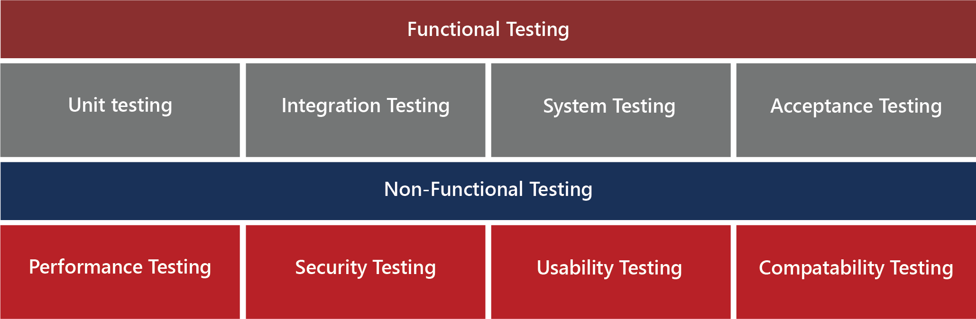

Figure 51 - Components of Software Testing

The purpose of testing stage (as depicted in figure below) is:

* To verify the interaction between objects
* To verify the proper integration of all components of the software
* To verify that all requirements have been correctly implemented
* To identify and ensure defects are addressed prior to the deployment of the software

We will employ an iterative approach, which means that testing is conducted throughout the project. This allows finding defects as early as possible, which radically reduces the cost of fixing the defect. To this end, the test process will be carried out in the following stages:

**Test preparation phase:**

* Based on the initial test plan, the features to be tested will be defined together with the types of tests run and the test approach
* The test plan based on which the phase acceptance will be issued together with the test cases to be run, are defined in this phase
* The hardware and software configuration of the test environment is set up

**Test execution phase:**

* The tests are carried out according to the order and description specified in the test plan
* Test logs are recorded
* Observations resulted from the execution of tests shall be noted

**Test execution analysis phase**

* Based on the results of the tests, decisions for the resolution of issues / observations are issued and the system improvement points are defined.

The testing plan illustrates the approach of our Consortium regarding the system testing, the object of testing effort, necessary activities for testing preparation and execution, testing environment, deliverables, roles and responsibilities, testing procedures and reporting method. The criteria to ensure the appropriate condition for starting the tests, will be as follows:

* All defects have been reported and documented appropriately
* All tests planned have been run successfully
* It is decided by the software development team to finalize the test process based on the analysis of data

Based on the test plan the results of the test process will then be established. The test results will be established based on the following criteria.

Table 34 - Internal Acceptance Criteria

|  |  |  |
| --- | --- | --- |
| **Value** | **Meaning** | **Allocation criteria** |
| **PASS** | The features / properties verified / used are fully functional | There are no run errors or necessary improvement requests |
| **WARNING** | The features/properties verified are available, but there are errors which affect their use, or which can cause errors, but they can be avoided in use | There are errors or improvement requests, but they do not prevent the intentional operation of the verified elements those errors involving the erroneous use or data different from the usual errors which cause errors will also be included in this category |
| **FAIL** | The tested features have errors which renders them fully non-operational | There are run errors which can prevent the intentional use/operation |
| **BLOCKED** | Feature cannot be tested | There are errors which can prevent the full execution of the respective test case; the errors can be missing functional elements or bugs which prevent the execution of the respective steps |
| **NONE** | Test case was not run | This is the default result associated with a test case which was not run. After the run, the value will be switched to one of the above stated values. |

Acceptance criteria related to the test results of all test cases for functional and non-functional tests, will be defined, to ensure:

* All workflows are operational
* All test scenarios associated to the planned functional and non-functional tests have been run
* Opened defects will not block features (the application can be used for the intended purpose) from the list of agreed features
* There are no planned test cases with the FAIL or BLOCKED status (according to the criteria specified above)

In addition to unit testing, the software to be developed by our Consortium will be passed through functional and stress tests before the final user acceptance tests. After the internal acceptance testing (and Smoke testing) is fulfilled, the system will be ready to pass the User Acceptance Testing.

In this regard, we will follow the following subsections in the preparation of the test report:

* **Set Up the Test Environment:** A test environment needs to be set up to support all testing activities. All issues that have long lead times need to be considered as early in the testing process as possible. This phase is the time to get done with any hardware and software procurements, network installation, test environment design, and making any special arrangements that may be necessary during the actual testing phase.
* **Define Test Procedures:** During this stage, it is determined if tests are going to be manual, automated or both. If the test is automated, we need to understand which tools will be used for automation and estimate what techniques and skills will be needed to effectively use these tools.
* **Develop Test Design:** Test design may be represented as a sequence of steps that needs to be performed to execute a test (in case of a manual test), or a collection of algorithms and code to support more sophisticated, complex tests. During test planning, we create a detailed description of each test, as well as identify what kind of data or ranges of data are required for the tests.
* **Map Test Data:** Test-data requirements need to be mapped against test procedures. The testing team will understand what types of data need to be obtained to support each type of test, and how this data could be obtained or generated.
* **Design Test Architecture:** Test architecture helps get a clear picture of the test building blocks and assists in developing the actual tests. Test architecture helps plan for data dependencies, implements the workflow between tests, and identifies common scripts that can potentially be reused for future testing.
* **Communicate the Test Plan:** Once the test cases have been created, it is helpful to create a master test plan and communicate it to the rest of the institution letting them know the areas on which the testing group will be working. Tests will be carried out along three quality dimensions, namely reliability, functionality, application performance and system performance. For each of these quality dimensions, the test case report will describe how to proceed through the test lifecycle of planning, design, implementation, execution and evaluation. The test case report will also define strategies for when and how to automate tests. Test automation is especially important using an iterative approach, since it greatly facilitates regression testing at the end of each iteration, as well as for each new system version.
* **Preparing the Test-Case Report:** The purpose of the Report is to provide a central artefact to govern the planning and control of the test effort. It defines the general approach (strategy) that will be employed to test the software and to evaluate the results of the testing. This report will include test configuration and all test cases and will be provided by the team before the testing phase starts and it will be approved by the CA. The test procedures will cover all functionalities of the system. This Report also supports the following specific objectives:
  + identifying the required resources and provides an estimate of the test efforts
  + identifying the motivation for and ideas behind the test areas to be covered
  + outlining the testing approach that will be used
  + listing the deliverable elements of the test project

The following indicative table will be used for all test cases scenarios. These tables will be filled during the test procedures and delivered with the Test Reports.



Figure 52 - Indicative Table for Test Case ID: Short Description

**Step 5: Software deployment**

After finalization of the implementation phase and completion of the software system integration and configuration the procedure of deployment will begin. The following tests will be used to Verify/Prove Software Operational Functionality against Software Design Specifications.

**Unit testing**

The unit testing will involve testing of the individual software units or groups of related units. A unit is a component that is not subdivided into other components; it is a logically separable part of a computer program. Each unit of code will be evaluated on how well it meets the performance requirements for which it was designed. Timing, memory, accuracy in producing numerical and logical results will be considered as well as the preparation of input and output required for validating program logic, syntax, and performance requirements.

The unit testing conclusions will clearly state if the module under test is ready for integration with the rest of the modules, based on the number of bugs outstanding. Tasks throughout the unit testing will involve:

* Prepare the unit tests
* Define and prepare the unit tests input data
* Set up and configure the unit test environment
* Run unit tests
* Collect and process results
* Prepare and issue the Unit Test Report

The primary output of the unit testing phase will be the Unit Test Report (part of Test Reports) and the corresponding results are presented and analysed.

**Integration Testing**

After the successful completion of the unit testing phase, the integration phase will involve the integration of external systems with the new system and the verification that as each new external system is integrated the integrated product satisfies their assigned requirements. We will create/ load the test databases and execute the integration tests. This is to ensure that program components integrate properly into the subsystems and the subsystems integrate properly into an application.

A prerequisite of the integration testing is the qualification testing of the product that is to be integrated in the system in order to verify its basic performance. Tasks during this phase will include:

* **Generate Integration Test Data -** Building actual data into files, databases, or test harnesses, using values stated in specifications.
* **Conduct Integration Tests** - Performing steps according to scripts, registering timings, printing diagnostics, and noting all significant events.
* **Analyse Integration Test Results** - Revisiting test outputs systematically, checking accuracy and consistency, and identifying non-conformity.
* **Support Corrective Actions** - Diagnosing and correcting faults, re-testing according to standards completing the relevant documentation under configuration management.
* **Integration Test Report** - Evaluation of the complete test process and production of the Integration Test File which will contain information on test log and results analysis, error correction and re-test and final reporting.

Each requirement identified in the Software Requirements Specification will be tested during the integration testing phase. This traceability ensures that the new system will satisfy all of the requirements and will not include inappropriate or extraneous functionality.

**Sub-system/System Testing**

This test checks whether all software requirements are present. If this is the case the software system is completed, and it is ready to be transferred to the beneficiaries and the CA. We will create/ load the test databases and execute the system tests. Any failed components should be migrated back to the development phase for rework, and the passed components will be migrated ahead for security testing.

During this phase the newly developed system components will be integrated within an overall environment in a “clean” machine identical (ideally) to the machine that the institutions will use. Testing involves the critical analysis of the results produced by the Concept, Design, and Development phases. The Testing phase highlights the strengths and weaknesses perceived by all stakeholders. In an ideal situation the content of the site needs to be “frozen” before the final testing begins. Rigorous testing ensures the highest possible level of quality and client satisfaction. Hence, the following factors play a particularly important role during the testing phase:

Figure 53 – Factors to be tested

All tests will be executed via an HTTP proxy that records the interaction between the browsers and the http server in a test log:



Figure 54 - HTTP proxy

The HTTP proxy records all interactions between the client (requests) and the server (responses). Each part of the functionality is tested separately with several test cases. For a web application, a test case is a sequence of interactions (test scenarios) between the browser (client) and the server. The logs (produced by the proxy) of each test scenario will be documented with a brief description of the scenario and the functionality they exercise.

**Security Testing**

Tests focused on ensuring the target-of-test data (or systems) are accessible only to those actors for which they are intended. This test will be implemented and executed on various targets-of-test. We will again create or load the test databases and execute security (penetration) tests. All tests will be documented, like those above. Failed components will be migrated back to the development phase for rework and passed components will be migrated ahead for acceptance testing.

**Acceptance Testing**

The acceptance testing will be done in normal working conditions and using real data. A predefined set of user scenarios will be tested, and the results will be checked against acceptance quality criteria. Our team will create/load the test databases and execute the acceptance tests. All tests will be documented, like those above. Failed components will be migrated back to the development phase for rework and passed components will migrate ahead for implementation. Acceptance quality criteria will use:

* Appropriate definitions for the possible to-be-found defect importance levels
* Precise % levels of acceptable number of errors
* Specific bug fix timing for the found anomalies

1. **Capacity Building**

The key success factors for delivering efficient training sessions are the quality of preparatory actions and the ability to improve the delivery of the training sessions based on the real feedback collected from the trainees.

Our methodology for the Capacity Building implementation chapter involves the careful planning of the training sessions, in advance and allocated enough time in order to allow the stakeholders (beneficiaries) to properly select, allocate and ensure availability of their staff for attending the training sessions.

Our methodology for planning and executing the delivery of training sessions is based on the following principles:

* **Continuous improvement**

We see the training delivery as a continuous process. The main goal of a training is to transfer the relevant knowledge to the participants in order to allow them to apply it to their day-to-day activity. That is why we will continue the process also after the end of the actual training. We will evaluate it; we will continue to monitor the impact and to assess the efficiency and effectiveness of the training delivery. All these are lessons learned which will be used for further improvements of the training plans.

* **Learning-by-doing**

As much as possible we will include practical demo and exercises during the training delivery. Moreover, further monitoring and assessment of the implementation will contain guidance of the trainees.

* **Hands-on training**

The key users/stakeholders will be involved directly in the actual implementation of the topics which are subject for trainings and they will receive hands-on training. Thus, these key users/stakeholders will be able to become the future trainers and will be able to further transfer the knowledge after the end of the project.

* **Train-the-Trainers**

We are aware that one of the methods of securing log-term results is to identify and give attention to the next generation of trainers. Through intensive learning-by-doing and hands-on trainings, the key stakeholders will be able to become the next trainers. We will also involve them in the actual training delivery process and we will involve them in the monitoring and assessment of the trainings.

A graphical illustration of our Capacity Building Methodology is presented in the figure below:

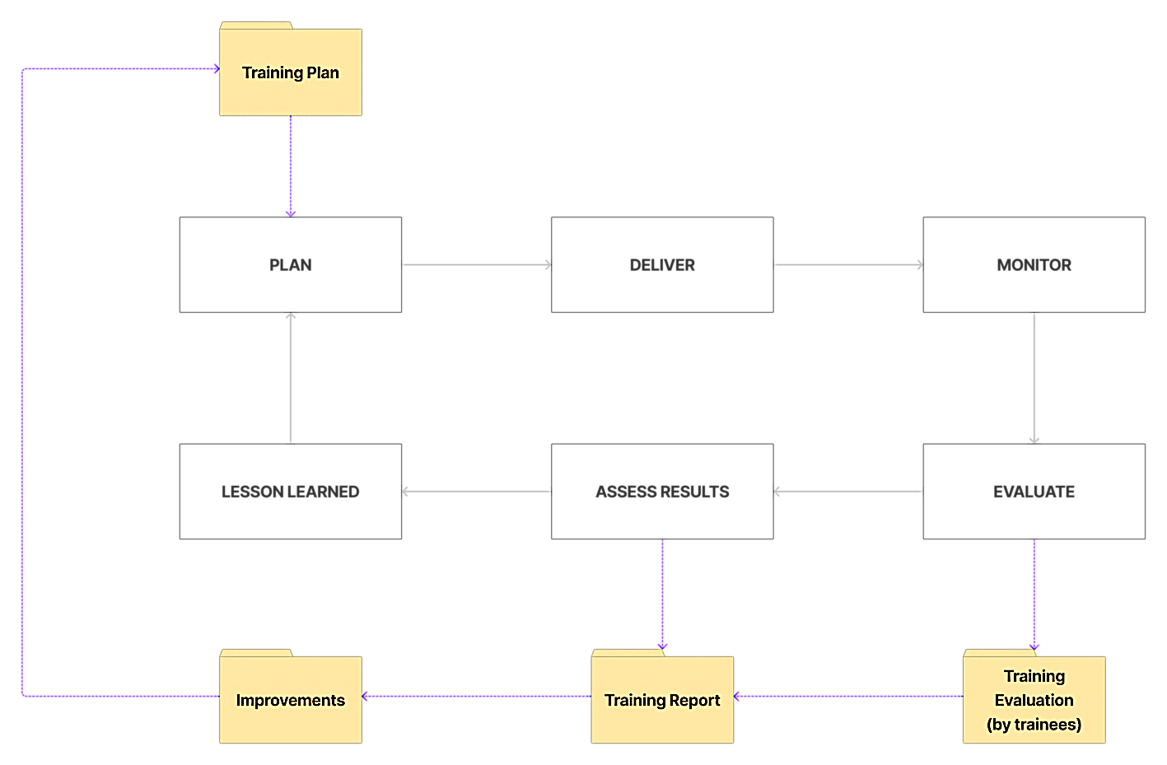

Figure 55 - Methodology: Capacity Building

1. **Awareness raising**

*“Whilst the identity management and eID issuance have solid ground, and the citizen ID card is equipped*

*with the technology to support ID card-based authentication and digital signature, various software*

*components for authentication, digital signature creation and signature validation and time-stamping*

*appear to be underdeveloped significantly though. The current state of play in the provision of e-services demonstrates that the services consist solely of information of the services that entities may offer (with some exemptions), and of the applications that can be downloaded“[37]*

The real advantages brought in by using eID services on a large (national) scale are already proved in many successful implementations across EU. However, we believe that this is not enough to make the future eID service of Kosovo to be used by the citizens and businesses and awareness shall be created/raised using a well-adapted methodology. Our methodology for this implementation chapter will involve, on one hand, good planning (strategy, target groups selection, distribution channels, materials) and, on the other hand, proper monitoring of the impact and penetration rate followed up by relevant improvements.

A graphical illustration of the proposed methodology for this implementation chapter is presented in the figure below:

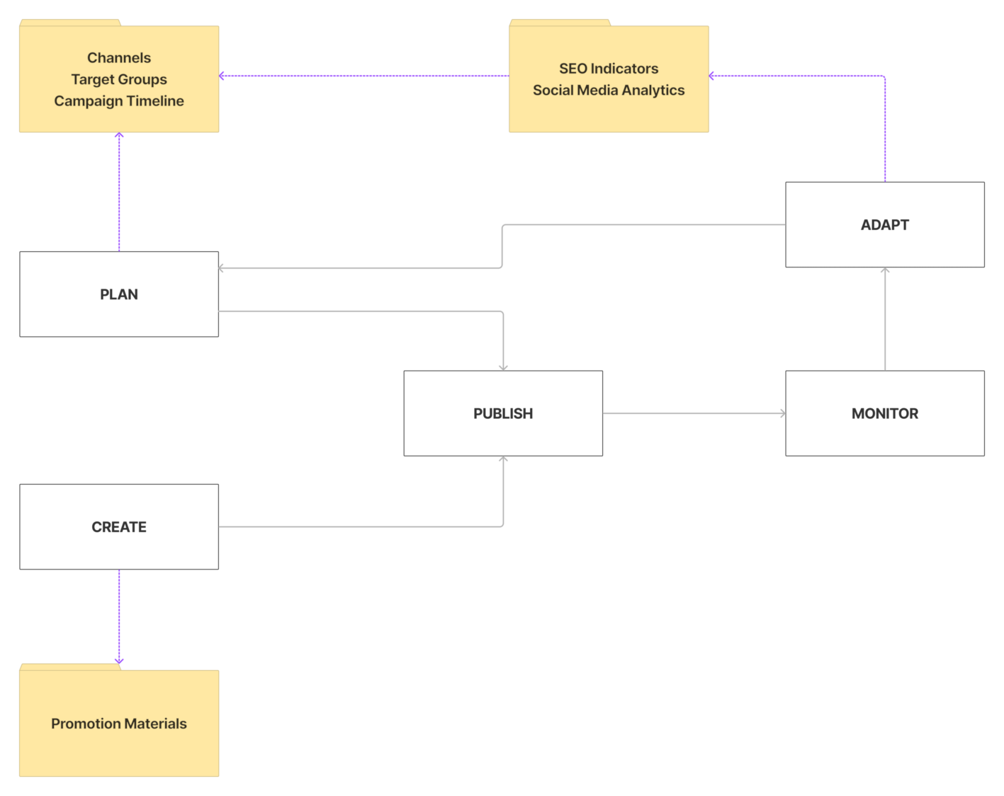

Figure 56 - Methodology: Awareness Raising

Given to the fact that the promotion materials consist in educational videos, the possible distribution channels may be social media, TV and various websites belonging to the key stakeholders (Government institutions/agencies, banks, retailers, etc). Part of our methodology (which will be detailed in the C&V strategy that we will produce) will be dedicated to the proper usage of the distribution channels in order to maximise the audience reach. While social media and websites can be used in a continuous way, the usage of TV channels shall be made close to the moment when the Digital Identity Service will become operational.

When speaking about social media, as per the latest statistics for Kosovo (early 2022), social media is used by 58.2% of the population and Facebook is by far the most popular social media network in Kosovo (being used by 49% of the population and having a potential audience reach of 61% in the target of 13y+ age) followed by Instagram (but at a quite relevant distance). The other social media channels (such as LinkedIn or Twitter) are not significant. This kind of statistical information will be the starting point in configuring the C&V strategy (channels, target groups, campaign timeline).

Another important point related to the awareness campaign is that the citizens of Kosovo are already “equipped” for using Digital Identity Services.

*“… the identity card is obligatory for all citizens from the age of sixteen. Issued Identity cards, by default, contain 4 certificates and 4 key-pairs corresponding to certificates. So, authentication, alias authentication, file encryption and digital signature functions have corresponding certificates and key-pairs. This approach serves as an appropriate, high-level trust foundation, and is deemed to be a solid ground for eID usage … “*[38]

Based on this finding, a possible message that can encourage the future usage of eID service among citizens can be: “**the tools are already in your pocket, we will be happy to see you use them**”.

#### Toolbox

In order to ensure the maximum efficiency and effectiveness of the implementation we will use a set of recognised tools and procedures for achieving the results. These tools and procedures will help the project team to have a better collaboration with the stakeholders, to accelerate the analysis and incorporation of the relevant feedback from them and to apply our strategy to connect the tasks within the project implementation. All the proposed tools and procedures are verified in multiple complex projects and it is already proved that these tools and procedures are part of the best practices.

The tools and procedures are presented in the tables below.

Table 35 - Tools

| Tool | Comments | Advantages | Phase/Activity |
| --- | --- | --- | --- |
| Stakeholder Map | Stakeholder Map is a powerful tool which will allow to have a clear view on the actions we will have to do during the project implementation as well as for securing long-term results for the implementation of eID services and of how the stakeholders shall be involved. | * efficiency and effectiveness for involving the stakeholders * clear action items to be implemented depending on the impact, importance and influence of each stakeholder * allow consistency and coherence in stakeholder involvement plan | 2.4.1 - **INC - Inception Phase** |
| Compliance Matrix | The compliance matrix is a powerful tool used in order to ensure that a specific scope is fully covered. It is also a powerful tool used to translate and further refine requirements starting to the highest levels and ending with specific tasks to be executed by the team. | * Full coverage of the whole scope of the compliance analysis * Allows the full incorporation of all mandatory requirements and corresponding translation into design specifications for the development team * Allows full coverage and matching between the provisions of the EU acquis and the local legal framework | 2.4.1 - **INC - Inception Phase**  2.4.2 - **IMP.BDIS - Build Digital Identity Service Implementation Chapter** |
| Logical framework matrix | The logical framework is a powerful tool which will allow us and the Beneficiary to monitor the outputs of the project and of the specific tasks within the project. It will allow the monitoring of the assumptions and the avoidance of transforming assumptions into risks. | * clear identification of the assumptions on which the implementation strategy is build * clear identification of indicators and measurement means at the task level as well as at the results level and ultimately at the project level * ensure compliance with the approach for EU-funded projects | 2.4.1 - **INC - Inception Phase**  2.4.6 - **MC -** **Monitoring&Control** |
| AGILE-SCRUM framework | The AGILE-SCRUM framework will allow the proper integration of the stakeholder’s inputs and requirements as these requirements becomes available during the project implementation and after evaluating and testing different releases of the products. | * flexibility in integrating inputs as these inputs become available without inducing delays * fit for IT projects in which the delivery shall be made in multiple stages (not all modules delivered in only one release) * flexibility in involving key stakeholders in the development process | 2.4.2 - **IMP.BDIS - Build Digital Identity Service Implementation Chapter** |
| Source control  CI/CD engine  Bug tracking  Online software project management  Helpdesk and Technical Support | These tools will automate most of the processes that will be carried out for creating the Digital Identity Service software. Will also allow the involvement of all key stakeholders based on a well-defined permission schema and will provide valuable functionalities and support for automatic testing and bug/issue tracking. | * well-known and already accepted as standard in the industry * easy to be accessed and easy to use * provides whole range of functionality for the whole development -> testing -> deployment process | 2.4.2 - **IMP.BDIS - Build Digital Identity Service Implementation Chapter**  2.4.3 - **IMP.DDIS - Deploy Digital Identity Service Implementation Chapter** |
| Electronic consultation  Online Questionnaires | Electronic consultation of the stakeholders will allow the best implementation of our participative approach. Using this tool we will be able to collect the feedback and opinions in a structured way and we can also extend this process beyond the framework of the project events. This tool will allow also fast analysis of the feedback with a great positive impact on the decision making process within the project. | * Easy to use, comfortable, structured * Allow the consultation of stakeholders beyond the framework of the event * Embedded reporting and feedback analysis features * 100% responsive and accessible from mobile devices | 2.4.1 - **INC - Inception Phase**  2.4.4 - **IMP.CB - Capacity Building Implementation Chapter** |
| Critical Path planning | The tasks and activities on the project critical path will have reasonable lags in order to avoid any scheduling issues in the case when one or more tasks/activities will slip.  As much as possible the planning will be made in such way that tasks having the highest probability to induce delays shall not be on the project critical path | * flexibility in scheduling the timetable of work * reduce the risks of delays * eliminate unnecessary dependencies between tasks and activities | 2.4.1 - **INC - Inception Phase**  2.4.6 - **MC -** **Monitoring&Control** |
| Project WBS | The Work Breakdown Structure (WBS) is one of the most powerful tool helping both the project team and Beneficiary/CA to easily monitor and control the activities and the outcome of specific tasks and projects. WBS was used when drafting the Technical Proposal and we intend to keep this approach also when updating the project plan and indicators during the Inception phase.  The work breakdown structure is a deliverable oriented hierarchical decomposition of the work to be executed by the project team. | * full and logical coverage of the whole scope of work * easy to monitor and control * clear quality criteria per deliverable * clear identification of the boundaries between project phases/tasks/activities | 2.4.1 - **INC - Inception Phase**  2.4.6 - **MC -** **Monitoring&Control** |
| On-line reporting | The online reporting tool will allow the team of experts to focus on the work rather on administrative reporting tasks. Activity reports, timesheet reporting will much easier to be carried out and all information will be much faster consolidated. This tool will allow also an increased level of transparency in relation with the CA and Beneficiary. | * focus on work rather than on administrative reporting tasks * increased transparency * quick consolidation, increased efficiency in delivering scheduled and/or on-request reports | 2.4.6 - **MC -** **Monitoring&Control** |
| Awareness impact assessment and penetration rate | These tools will allow the evaluation of the awareness raising activities and will allow the adaptation of the C&V strategy in order to maximise the audience reach and impact. We will use well-known tools that provides reliable results such as Google Analytics, Google Search Console, Google Tag Manager, Diib Social media analytics. | * Well-known worldwide and providing reliable results * Multiple options for audience segmentation * Various integration methods with distribution channels such as websites | 2.4.5 - **IMP.AR - Awareness Raising Implementation Chapter** |

Table 36 - Procedures

|  |  |
| --- | --- |
|  | Training procedure  Our training procedure is based on the following key points:   * Continuous improvement * Learning-by-doing * Hands-on training * Train-the-Trainers |
|  | Software development  Taking into consideration the specific of the tasks for the implementation of the relevant activities within this project we propose the AGILE-SCRUM as the general framework as being a much suitable than the WATERFALL approach.  The AGILE-SCRUM framework will allow the proper integration of the stakeholders inputs and requirements as these requirements becomes available during the project implementation and after evaluating and testing different releases. |
|  | Backstopping framework  A key success factor for the implementation of the project is setup of the backstopping services made available by the Consortium Members. For this Project the Consortium will create the multi-disciplinary backstopping structure which will support KE and NKE during the project implementation. This backstopping structure will take into consideration the strenghts of each Consortium Member in order to ensure the most efficient and effective support for the implementation . The multi-disciplinary backstopping team will establish also the necessary working procedures which will be applied during the implementation of the project, including but not limited to:   * Quality Assurance and Control procedure * Risk Management procedure * Communication procedure * Financial Management procedure * Approval flows within the Consortium   Each Consortium Member will allocate dedicated persons to be part of the project backstopping team. The roles and responsibilities will be well defined for each person and the backstopping team will act as a unitary entity with all needed functions/"departments" able to handle the different aspects which will be encountered during the project implementation. |
|  | Risk management  Risks are potential outcomes, actions or events that will have a negative impact on the project. Risk management is the process of identifying, managing and mitigating risks to ensure successful project delivery. In order to identify and to manage potential project risks, the Contractor will adopt a methodology which is a global framework for delivering all aspects of a project - from strategy and assess work through to implementation, operate and review. We will follow the risk management process being a systematic approach, which is designed to ensure adequate assessment and planning support the commitment of resources to manage and treat identified risks. The risk management process can be divided into the following key activities: Establish the context; Identification of risks; Analyse the risks; Treat the risks; Monitor and review. |

### Project organisation

#### Organisation chart

The Project Organisation Chart defines the formal relations and lines of command between the project team, the Contracting Authority, the Implementing Authority and the PSC as well as to the Consortium’s Management Board and Backstopping team. The Project Organisation Chart we propose for this project is presented in Figure **57**. While the Team Leader, who will be full time working on the project, together with the senior experts and the other experts will have primary responsibility on the ground, for ensuring that full support is provided to the Project team, they will be fully backed in this intervention by our nominated Project Director, and our Backstopping Team as shown in **Figure** 58. Detailed infomation about the porposed communication procedure which will be used during the project implementation is further presented in section 3 Backstopping.



Figure 57 - Project Organisation Chart



Figure 58 - Expert Team

#### Project Team

The project team consists in a number of experts that will combine the international experience with the deep knowledge of the local situation. The most important sections of the assignment (technical, capacity building and awareness raising) will be each coordinated by a senior expert, while the whole team will be coordinated by a Team Leader capable to integrate everything and who has a very good knowledge and understanding of all details that are part of the assignment.

While it was of our main concern to cover all needed expert positions (including with backup options), we selected our experts in order to respect 100% the requirements mentioned in ToR, section 6.1.2, as it is highlighted below inside the brief profiles of the experts. As it is shown in **Figure 57 - Project Organisation Chart**, the team of experts will benefit of the support provided by our backstopping team. As a whole, the team covers, without any problem, the whole range of experience and expertise required for this assignment as brefly mentioned below:

Table 37 - Quality of the proposed expert team

|  |  |
| --- | --- |
| FOR ALL EXPERTS | * at least 6 years of experience in their field of expertise * at least a master's degree in fields relevant for their assignment * professional experience of at least 4 years above the required general professional experience |

|  |  |
| --- | --- |
| FOR TEAM AS A WHOLE | * At least 2 projects focused on software development of similar nature and complexity * At least 3 projects in designing and developing IT systems of similar nature and complexity * At least 2 reviews of legal requirements for electronic data collection and processing, including data-protection * Experience in delivery of trainings in use of software tools in at least 2 projects; * Experience in creation of short, targeted video clips in at least 2 assignments * Experience with preparation of technical specifications for supply tender under PRAG rules |

|  |  |
| --- | --- |
| FOR THE TEAM LEADER | * Extensive experience in project management and coordination, project representation, reporting * Extensive experience in coordinate, supervise, manage, monitor and appraise all aspects of the project experts’ output * Deep understanding and proven experience in integrating all the aspects and outputs in assignments of similar complexity and consisting in various fields of implementation (legal, organisational, ICT, public awareness, capacity building) |

The following two sections presents in more detail the initial proposal for the team of experts. It is important to mention that the experts will be allocated to the activities only after the necessary approvals but it is also important to mention that we will be able to ask for the approvals without any delay after the signature of the contract because we already assembled a fully compliant team of experts.

#### Senior Experts

**Team Leader – Florin Hoinarescu**

**Mr Florin Hoinarescu counts with over 20+** years of experience in the industry. **EMBA** graduate of WU Vienna and **Public Safety graduate** of NDU. **10+** years of **PM (TL) in EU funded projects**. Experience in design and implementation of **QA/QC**, **information security**, **protection of classified information** tools and systems. Extensive **knowledge of the specifics of the geographical area**.

Proven experience in **integrating all components** of complex projects (**legal, organisational, technical**). **Mr Hoinarescu counts with over 15+ years General Management experience in different middle, top and CxO positions**, **12+** years International Business Management experience in CEO and Managing Partner positions. Mr Hoinarescu has deep experience in setup and manage international organizations/operations, manage the whole lifecycle for delivery of large-scale international projects.

**He has over 25+ years of experience in Information Technology, 15+ years of extensive experience in Project Management and 10+ years of experience in EU Funded projects as Team Leader and project manager**; Mr Hoinarescu served as Public Procurement Expert (EU, WB, NATO, EBRD) and he is qualified as Project Management (PRINCE2), IT Infrastructure Library, IT service management (ITIL, ISO20000), Information Security and Privacy (ISO27001, GDPR), QA/QC systems (ISO9001, CMMI), Security, Governance and Public Safety, Business Analysis, Certified Trainer, Certified EU Funding Expert, Certified PM for Public Sector.

**Mr Hoinarescu worked previously with Evoluxer in as Team Leader with Evoluxer in technical assistance contracts funded by the EU. Our Team Leader will be full time working for the project implementation**

**Lead Solution Architect – Albert Baucells**

Mr Albert Baucells counts with over 20 years of experience in Software solution architecture. Worked for Itteria giving support in the first stage of the newly created company, with the migration of more than 200 applications from several software companies. Technical interface between about 20 project leaders and the developer teams. NET and Oracle Architect. In charge of attending to technical problems of more than 100 diverse J2EE applications.

Technical leader within Java division and working together with .NET and Oracle Architects and Quality Department to give support to developer teams in the second stage of Itteria company, aimed to the transformation of the applications focusing on improving Java Framework, Application Server. Dealing with SOA architecture with service bus (Oracle)º, for example, in the applications of the Public Health System.

Mr Baucells is in charge of company source code control. Use and best practices design. In charge of conducting developers to achieving java certification. Responsible of the learning path of programmers regarding Enterprise Architecture (JEE). Responsible for the validation of technical documents including UML designs, technical designs… In collaboration with the QA manager, helping developers with the building of unit testing and integration testing. AS for functional testing, architecture of Selenium executable files. Main technologies used J2EE Frameworks: Spring, Struts, Canigó (http://canigo.ctti.gencat.cat/ ) ,SOA,UML, Java ORM: Java, JEE, JavaBeans, JSP, Log4J, Jasper Reports, XML/XSL/XSLT, UML, JDBC, JavaScript, jQuery, ExtJS, Ajax, EJB, JPA, JMS, web services, Junit, JPA, Hibernate, iBatis, Torque, Containers: EJB, PHP Frameworks: CodeIgniter, J2EE Content Managers: Liferay, Reporting and using HP Quality ALM software, Sonar Code analysis, Jenkins, Continuum Integrations, Maven and Gradel (training) automatizing tools, Application server: Oracle Weblogic (8,9,10,11g,12c), IBM Websphere (6,7,8), Apache Tomcat (5,6,7), Oracle OAS and IAS, JBoss (training), Databases: Oracle (10,11,12c), SQLServer, MySQL, Oracle Bus, Code management tools: SVN, CVS, Git, Agile Programming methodologies, XML, SPRING, STRUTS, Web services, Flex, IBM content manager, Documentum, Alfresco, Toad, IIS, Maven, Microstrategy, ETL, CMMI, CLARITY (Project management), (quality management), CAST (software quality), Selenium, Prince2, standards/APIs: XSD, SOAP, JAX-WS, JAXB, JAX-RPC , Ant, SOAP UI, UNIX, shell scripting, Jira, Enterprise Architect, Eclipse IDE, XML/XSL/XSLT, Apache Ant, HTTPs, SSL, Software development methodologies

**Software Architect – Besnik Belegu**

**Besnik Belegu counts with a BA in Computer Science; 15+** years of experience in working in the Information Technology field with acquired experience in large scale software design, integration and development projects and extensive knowledge of a wide range of software technologies and software development frameworks and methodologies. BA in Computer Science of University of Prizren.

Deep experience on developing complex information systems and data management solutions for the judiciary, banking and education sectors. Software development on data management, structuring and managing legal data in the sector of e-government. Experience in software development on judicial open data, court information systems and justice-related platforms.

**Software Developer – Ljupcho Antovski**

**Mr Ljupcho Antovski counts with a PhD** in Information Technology; MSc in Information Technology; BA of Electrical and Electronics Engineering, Major in Computer Science, Informatics and Automation.

**20**+ years of experience as a software and database senior developer, business and database analyst, including gap and requirements analysis, conducting research leading to **the drafting of specifications** and rules, design and implementation, project management, change management and software development.

**MSc** in Information Technology and PhD holder in Information Technology of University Ss Cyril and Methodius. 16+years of experience in IT software development **for projects related to e-governance**, e-learning and online testing, e-commerce, donors’ databases development, custom made IS, capacity building, labour market systems.

Proven experience in design and software development of information systems, databases and IT infrastructure. Certified as Microsoft® Certified Technology Specialist (MCTS), Microsoft® Certified Professional Developer (MCPD) and CCNA and Cisco Networking Academy Instructor.

**IT Trainer – Blerta Berveniku**

**Mrs Blerta Berveniku counts with a MA of Business Administration; BA in Computer Science and over 15+ years of professional experience bridging the gap between business and IT, and leading and managing ICT Projects in judiciary**, financial and social sectors. MA of Business Administration from the College of William & Mary – USA and BA of Arts in Computer Science at the American University of Bulgaria.

Proven experience working with judicial institutions in IT reengineering business processes and the preparation of **Functional Specifications for a Case Management Information System**. A track record of success with several e-government and institution-digitization projects in the role of the team leader of the technical and legal team in establishing a “Law Data” System, an e-government system that enables citizens, legal professionals, judiciary, and others to navigate the legal space by providing access to all legal documents in a consolidated format.

Furthermore, she has an extensive experience when it comes to quality assurance, training and mentoring throughout many work experiences regarding maintaining office network, IT infrastructure, and development/progress reports.

**Data protection – Ljubica Pendarovska**



**Mrs Pendarovska has legal background as Bachelor of Law – International Law of Faculty of Law, University Ss. Cyril and Methodius, Skopje**. Following the graduation from the unversity, Ljubica holds a **Master of Law (LL.M.) – International Law** and a **Certified Information Privacy Professional /Europe (CIPP/E)** from International Association of Privacy Professionals – IAPP, currently being **PhD candidate International Law and Law on European Union.**

She has **12+ years** of practical experience in the field of Data Protection by being involved as expert in various projects funded by EU such as “**Technical assistance for strengthening of the organizational and institutional capacities for personal data protection**” (Directorate for Personal Data Protection of Republic of Macedonia, & Ministry of foreign affairs of Norway) or “**Sustainable system for continuous primary and secondary education for principles of personal data protection**” (IBF International Consulting SA, Brussels, Belgium).

Ljubica has an **outstanding international experience**, being involved as key expert in various projects abroad and as International trainer for the subject matter (**Key Expert in Privacy and Data protection** – „Supporting Systems for GBV Prevention and Protection”, Jordan; **International Trainer** – Data Protection and Privacy - LEORON – Professional Development Institute, Middle East; **Key Legal Expert in Privacy and Data Protection** – “Assessment of the compliance with the EU legislation of the Law on Security of Networks and Information Systems”, DCAF Geneva Centre for Security Sector Governance; **Key Expert - Legal Expert – confidentiality and privacy** – “Legal Study on confidentiality and data privacy matters”, World Bank Group & COFREPECHE Paris).

**Cyber Security – Cristian Serret**

Mr Cristian Serret counts with a Telecommunications Engineering Degree by the Universidad Oberta de Cataluña. Mr Serret currently works as a Senior Cloud Architect leading the technological strategy in response of business and service approaches of Data Center environments int the Communications, Networking and Cybersecurity scopes in Seidor. His main responsibilities fall within the management and evolution of the technological models that govern the infrastructures that respond to the needs in the scope of (Communications, Networking and Security), Lead the execution, supervision and analysis of risk analysis (in terms of technology). Lead and define the current situation analysis (AS IS), the analysis of recommendations (TO BE) and the continuous improvement plan (IMPROVEMENT ASSESS), managing their priority, according to the impact on the business, the environment, and your costs. Lead the supervision and evolution of the processes and procedures for the administration, supervision and management of the environments within the scope of the different response groups to requests and incidents. Lead the communication with the interested parties, key users of each environment with the objective of communicating in a recurrent way where we are, where we are going and how we are to achieve the strategic objectives in the technological field. Previous his experience with Seidor, **Mr Serret worked as cybersecurity engineer for IBERIA Airlines.**

**Communication – Behar Zogjiani**

Master Degree in Journalism; Bachelor of Law; **35+** years of relevant **professional** experience, out of which **more than 25 years** in the capacity of Information and Communication Expert and Public Relations; **Proven experience in designing and implementing overall awareness raising campaigns and communication strategies and** in designing **Manuals on PR** and **delivering training and workshop sessions** in Kosovo, Albania, Macedonia and Montenegro.

#### Other Experts

Our Consortium will select and hire other experts as required according to the profiles identified in the ToR. All experts will be independent and free from conflicts of interest in the responsibilities they take on. The selection procedures used by our Consortium to select these other experts will be transparent, and will be based on pre-defined criteria, including professional qualifications, language skills and work experience (as described in detail in section 3.3 HR management.

|  |  |
| --- | --- |
| Software developers | IT Trainers |
| Legal experts | Cyber security experts |
| Software architects | Capacity Building experts |
| Data protection experts | Communication Experts |

Table 38 – Other Experts Categories

The selected experts will be subject to approval by the CAUT before the start of their implementation of tasks. Without being final, the main categories of the non-key experts is presented in Table 38. At this stage, we cannot provide a final list of NKEs that we might need to deploy, as this will change depending on the progress of the project and the situation on the ground and will be subject to the approvals accordint to the procedure of including experts in the assignment.

What we will do in this section, however, is to provide an indicative list of some of the areas where we have identified the need for experts and suggest some experienced candidates who have the kind of skill profiles we will require. These experts are part of a much larger expert pool that the Consortium can provide as needed.

Table 39 - Indicative list of other experts

| Title | Category | Comments |
| --- | --- | --- |
| Software Architect    Goce Armenski | Software architects | PhD holder in Information Technology ; MSc**.** In Information Technology; **20+** years of experience in designing, leading development teams, maintaining and evaluating web-based management information systems.  **15+ years** of experience as Software Architect. MSc in Information Technology and **PhD** holder in Information Technology of University Ss Cyril and Methodius.  Proven professional experience in ICT area especially in the areas of Internet, e-Learning, Web Based System Development and Information Systems. Strong experience and knowledge in being part and leading numerous international teams of people with different cultural, ethnic and professional background, for the purpose of **designing and development of web-based information and e-Governance systems** funded by donors’ programs and institutions.  Certified as Microsoft Certified Technology Specialist: SQL Server 2008 Database Development, Microsoft Certified Professional Developer: ASP.NET Developer 3.5, specialised in using ASP technologies for over 15 years, and ITIL v3. |
| Solution Architect  67974.jpg  Arben Osmani | Solution Architects | BA in Electrical Engineering; **20+** years of professional experience in the field of ICT with wide range of Information Technology (Networking LAN, WAN, Routing, databases, software, security of systems, monitoring, etc.). BA in Electrical Engineering of University of Prishtina.  Proven experience in high secure systems for **personalization of personal documents and PKI systems**. 15+ years of experience working with numerous donors’ funded projects related to **Biometric ID** cards, **Biometric Passports** and **Driving Licenses**, designing **technical specifications for the eID cards and ePassport projects**, **ID card and passport design and security features**, enrolment station system, AFIS System, **eID personalisation system**, etc.).  Proven experience in designing and development of **WEB security service**, data transferring through systems, enabling e-Governance systems to search and get data from enrolment station systems of Central Civil Registration System, such as for ID cards and Passports, Social Service System, etc. |
| Software Architect  Profile photo of Avni Hajdini  Avni Hajdini | Software developers | **MA** in Computer and Telecommunication Engineering; **15+** years of professional experience in the field of ICT with wide range of experience in Software Project Management, Earned Value Management, Program Management, Project Initiation, Databases, UML, Software Design, Software Engineering etc. MA from the Faculty of Electrical and Computer Engineering - Computer and Telecommunication Engineer (IT) Equivalent in Computer Engineering.  Extensive experience as Programmer and Instructor of Windows and Office 2003 and has been engaged as Project Manager in different projects related with e-government like: Civil Status System - Implemented in Maintenance, Kosovo Job Portal, Health Insurance Fund System - Implemented in Maintenance, Business Registration System in Kosovo - Implemented in Maintenance, etc.  Certificated for ISO 27001:2013 Information Security Management System Certification - World Quality Registrar; CAPM & PMP certification from American University of Kosovo. |
| Software Developer    Aleksandar Josifoski | Software developers | **Master’s in Management of Information Technology**; Bachelor in Electrical Engineering, Major in Computer Science and Informatics; **20+** years of experience in various leading positions, developing strategic plans, managing different projects in the IT related aspects of the justice, **e-Governance and public administration sectors** both at an international level, and in the Western Balkans.  MA in Management in IT and a Bachelor in Electrical Engineering with a Major in Computer Science and Informatics. **15+** years of experience in assessing, designing, developing and implementing complex case management systems, web-based management information systems (MIS), statistical and decision support systems including design and development of relational databases (enterprise level RDBMS).  **Developing Functional & Technical Specifications of IT software and hardware according to PRAG rules**, specifically related to supply of ICT for the relevant sector institutions.  Led teams and projects as part of various donor-funded projects and is very familiar with all stages of Project Cycle Management, specifically related to IT projects in the relevant fields. Currently serves as IT Project Officer at European Commission and TL on e-Governance and Digital Transformation. |
| Capacity building    Devis Fecani | Capacity building | **MA** in Computer Sciences; **20+** years of working experience in the information technology field, including **14 specialized IT capacity building activities** on the civil registration related issues.  Working **experience in designing national identification system** with a high level of responsibility of Director of the National Civil Registry and member of the Chair of Ministerial Working group responsible for drafting specifications of AlbanianID card and e-passport |
| IT Trainer    Zenel Hisenaj | IT Trainers | **MSc**. in Computer Science and Engineering; BSc. in Computer Science; **15+** years of experience in the field of Information, Communication, and Technology. MSc. in Computer Science and Engineering; BSc. in Computer Science.  Proven experience, filled with success stories regarding large scale national software projects in Kosovo and international countries. Possesses a large knowledge when it comes to **software development** and hardware maintenance, database implementation, **security policies**, database design, data analysis, **data quality assurance**, and maintenance of IT equipment, web pages, etc.  Highly **qualified in preparing/reviewing trainings**, and provide SQL database server/ security trainings. Being certified as ORACLE Database 11g, 20762C: Developing SQL Databases and CCNA, has extensive experience in the field of database development and administration, serving in numerous public administration institutions, in particular as Head of System and Database Management Division, managing all the databases of the Civil Registration Agency and Ministry of Internal Affairs, as well as ensuring good functioning, security policies and quality assurance. |
| Legal Expert    Yolanta Christova | Legal Experts | Bachelor of Law; **PhD** in Constitutional Law & Political Science; **35+** **years** of experience in the field of judicial reform, human rights law, judicial ethics, judicial appointments and discipline, **development of databases for case management**.  Bachelor of Law gained at Sofia University and PhD in Constitutional Law & Political Science, gained at Bulgarian Academy of Science. Extensive experience in leading positions in justice sector institutions.  Proven experience as TL in conducting assessments in relation to establishing criminal conviction recording systems and monitoring and advising beneficiaries on the establishment of the criminal conviction database.  Supported and advised the establishment of CMIS/database in the judiciary of BiH and establishment of case management system/database in the free legal aid system. 30+ years of experience in **providing substantive legal and political advices** in judicial reforms, definition of policies and strategies in judicial reform, structure of court system, etc. |
| Legal Expert    Bardhyl Hasanpapaj | Legal Experts | Doctor Iuris Candidate on the Europe Competition Law; **Master of Law** on European and International Law; Bachelor of Law; **8+ years** of overall experience in the field of justice, rule of law and judiciary.  Doctor Iuris Candidate on the Europe Competition Law and Master of Law on European and International Law. **15+years** of experience as legal advisor supporting judicial institutions on the legislative process and policy drafting.  Currently serves as key expert in the framework of the EU Project “National Centralised Criminal Records” providing technical assistance on the legislative framework of the judicial institutions and establishment of the efficient and transparent judiciary service, delivering details specifications and legal advices for the functionality of the case management system for courts.  Proven experience in the field of non-judicial human rights and gender equality related to the institutional mechanisms on the property rights.  Proven experience in legal assessment and implementation related to judicial open data, court information systems and justice-related platforms. |
| Legal Expert    Bonita Saliu | Legal Experts | Master’s Degree in Comparative Business Law; Experience withworking in the areas of Justice and Home Affairs, rule of law, and judicial reform. Currently she is managing ‘’National Centralized Criminal Records (NCCR)’’ an EU Funded project.LLM in Comparative Business Law.  Her area of expertise is primarily concentrated to business, commercial and contract law, including here competition law and intellectual property.  Additionally, she has served as a legal expert in various projects, while her contribution was primarily related in assessing the legal framework for electronic data collection and processing, data protection, data security etc.  She also contributed in legal drafting and approximation with EU Acquis. |
| Communication & PR Expert    Ereza Vela | Communication and PR | **Master of Arts** in Political Communication; **15+ years** of professional experience in public relations, communications, marketing, television and TV show production, event management, programme management, for clients such as the EU Office in Kosovo, governmental institutions and organizations, international bodies, and the private sector.  MA in Political Communication of Goldsmiths University, London UK. 9+ years of experience in team leading and management, for projects of various scales as Project Manager, Communication Expert, Project Account Director, Project Director, Team Leader, Project Leader, and Communication Officer for several projects in the country.  Recent proved experience under the EU for Kosovo Communications Services Project, objective of which is to raise public awareness in Kosovo about the EU values.  Experience in the management of media and outreach campaigns(since 2007), being responsible for the management of over **15 media and outreach campaigns in Kosovo**, aimed at the general public. |
| Communication & PR Expert    Besnik Vasolli | Communication and PR | Bachelor Degree on Economics and is Candidate for Executive Master’s Degree on Business Administration; **Executive MBA** of Sheffield University.  Experience in leading and facilitating communication and PR-related processes and activities numerous high-level institutions in Kosovo, such as Prime Minister Office, Ministry of Public Administration, Ministry of European Integration, etc.  **15+ years** of experience in working with numerous donors’ funded projects related to communication and visibility, media outreach and campaigns, communication assessments and strategies, etc.  Proven experience in professional and institutional capacity building activities related to communicationand PR programs and strategies development, etc. |
| Communication & PR Expert    Birol Urcan | Communication and PR | **Master Degree** of Arts in Journalism and Communication; 20+ years of overall experience in Journalism, Public Relations, Film Directing and communication business. MA in Journalism and Communication graduate of KIJAC (Kosovo Institute of Journalism and Communication). Experience in broadcast media, film directing and communication business. 10+ years of experience as a reporter, producer and news editor.  Substantial experience in communication and visibility while working in the UN mission in Kosovo and as a Head of PR at the Kosovo branch of Publicis.  **Produced and directed a number of short feature movies** and documentaries as part of his studies at film directing faculty In the University of Pristina.  7+ years of experience working with EU funded projects on Local Governance, Census, Capacity Building for Public Administration, Regional Economic Development, Agriculture and Cross Border Cooperation. |
| Cyber Security Expert    Rina Basholi | Cyber Security | Having **6+ years of practical hands-on** experience in the field of cyber security, Rina holds **a MSc. (Master) in Advanced Software Engineering in Cyber Security and Forensics** from the University of Sheffield.  As cyber security and forensics professional, Rina was involved in developing Information Security, Compliance, Security Risk and Cybersecurity Strategies and creation of Information and Cyber Security related ISO Materials with International Standards, forinstitutional and individual certifications (US, Canada, Kosovo) as well as she was responsible for the management of physical andpersonnel technological infrastructure, including technology deployment.  As part of her research activity and experience, Rina was involved in Identifiyng and address existing challenges in the field of Cyber Security and DataProtection, taking into account the field of regulatory and legal framework in Kosovo and beyond. |
| Cyber Security Expert    Albion Bikliqi | Cyber Security | More than **27 years** of experience, combined in Information Technology and Information Security with diverse industry experience.  Recognized for accomplished tasks in time and with responsibility such as: **leading the team of engineers in Technical Department within United Nations Mission in Kosovo**; known among the peers in EULEX for **solving different problems with databases and systems in the War Crimes Unit especially**; implementing the **strategy for Cybersecurity and Information Security in TRECCERT GmbH**, or gathering and **leading the engineer team for the TEGO Cyber Inc** projects.  **Proven track record in accomplishing the Information Security Policies and Procedures in the Canadian Company** - PECB Inc.  Records of proven accomplishment, **establishing the Cybersecurity department in CACTTUS J.S.C**. – a privately owned company in Kosovo, as well as leading the team of Engineers from initial steps to finalization of the project founded by UN Women in the witness protection Kosovo Police and Prosecutors office.  **Proven skills in Cybersecurity Framework** and the importance of it, in Securing the Information of Public and Private Sector. |
| Data Protection Expert    Damir Softic | Data protection | Currently serves as **Senior Associate, Cybersecurity Governance**, CEE for PwC CEE, Bosnia and Herzegovina.  Having a **strong legal background**, Damir holds a Master in Information and Communication Technology Law from University of Oslo and a Master in Information Security from University of Srajevo. He also holds a Chevening Cybersecurity Fellowship from Cranfield University – British Postgraduate Research University related to cyber security or cyber policy in the Western Balkans.  Damir has **12+ years of experience with the legal frameworks related to cyber security and data protection in Western Balkans and has a deept knowledge of the EU related legal framework**.  During his professional career, Damir was holding different positions both in the private and public sector in his home country and abroad. In his current poition, Damir works directly withi his customers from public and private sectors for:   * Addressing public and private sector needs in the area of cybersecurity * Policies and procedures * Regulatory compliance and alignment (cybersecurity and GDPR) * Internal (organisation-wise) cybersecurity strategies and action plans * Cybersecurity awareness raising practice benchmarking and high-level campaign strategy design |

#### Teamwork

The Consortium was brought together on the basis of its complementary skills and its capacity to efficiently and effectively implement all aspects of the project. The Consortium Members shares the same values and vision related to the implementation of this project and are committed to work together in a very flexible and responsive way and to deliver the expected results.

Unlike a temporary grouping, the Consortium will work as a stable, well-structured and integrated team. At the same time, it will be sufficiently flexible and responsive in order to deliver high quality results.

A system of procedures which will be operational for the project implementation will create the integration needed among the backstopping team.

**Shared Vision**

**Clearly Defined Roles and Responsibilities**

**Proven outstanding knowledge and access to high quality experts**

**Effective and Efficient Communication**

### Scope of the Work

#### Overview

The ToR anticipates a comprehensive set of tasks to be carried out, which are associated to **4 main outputs** that needs to be produced, as described in ToR, sections 2 and 4.

The methodology proposed for this assignment is intended to address the issues raised in the ToR and contribute to the outputs through connected deliverables. It is important to mention that **we combined the Logical Framework Approach** **with specific Project Management tools (WBS)** in order to provide a clear and logical method to monitor and control the progress of the project.

Summarising, our approach on the delivering the Scope of the Work is presented in the Figure 59 below

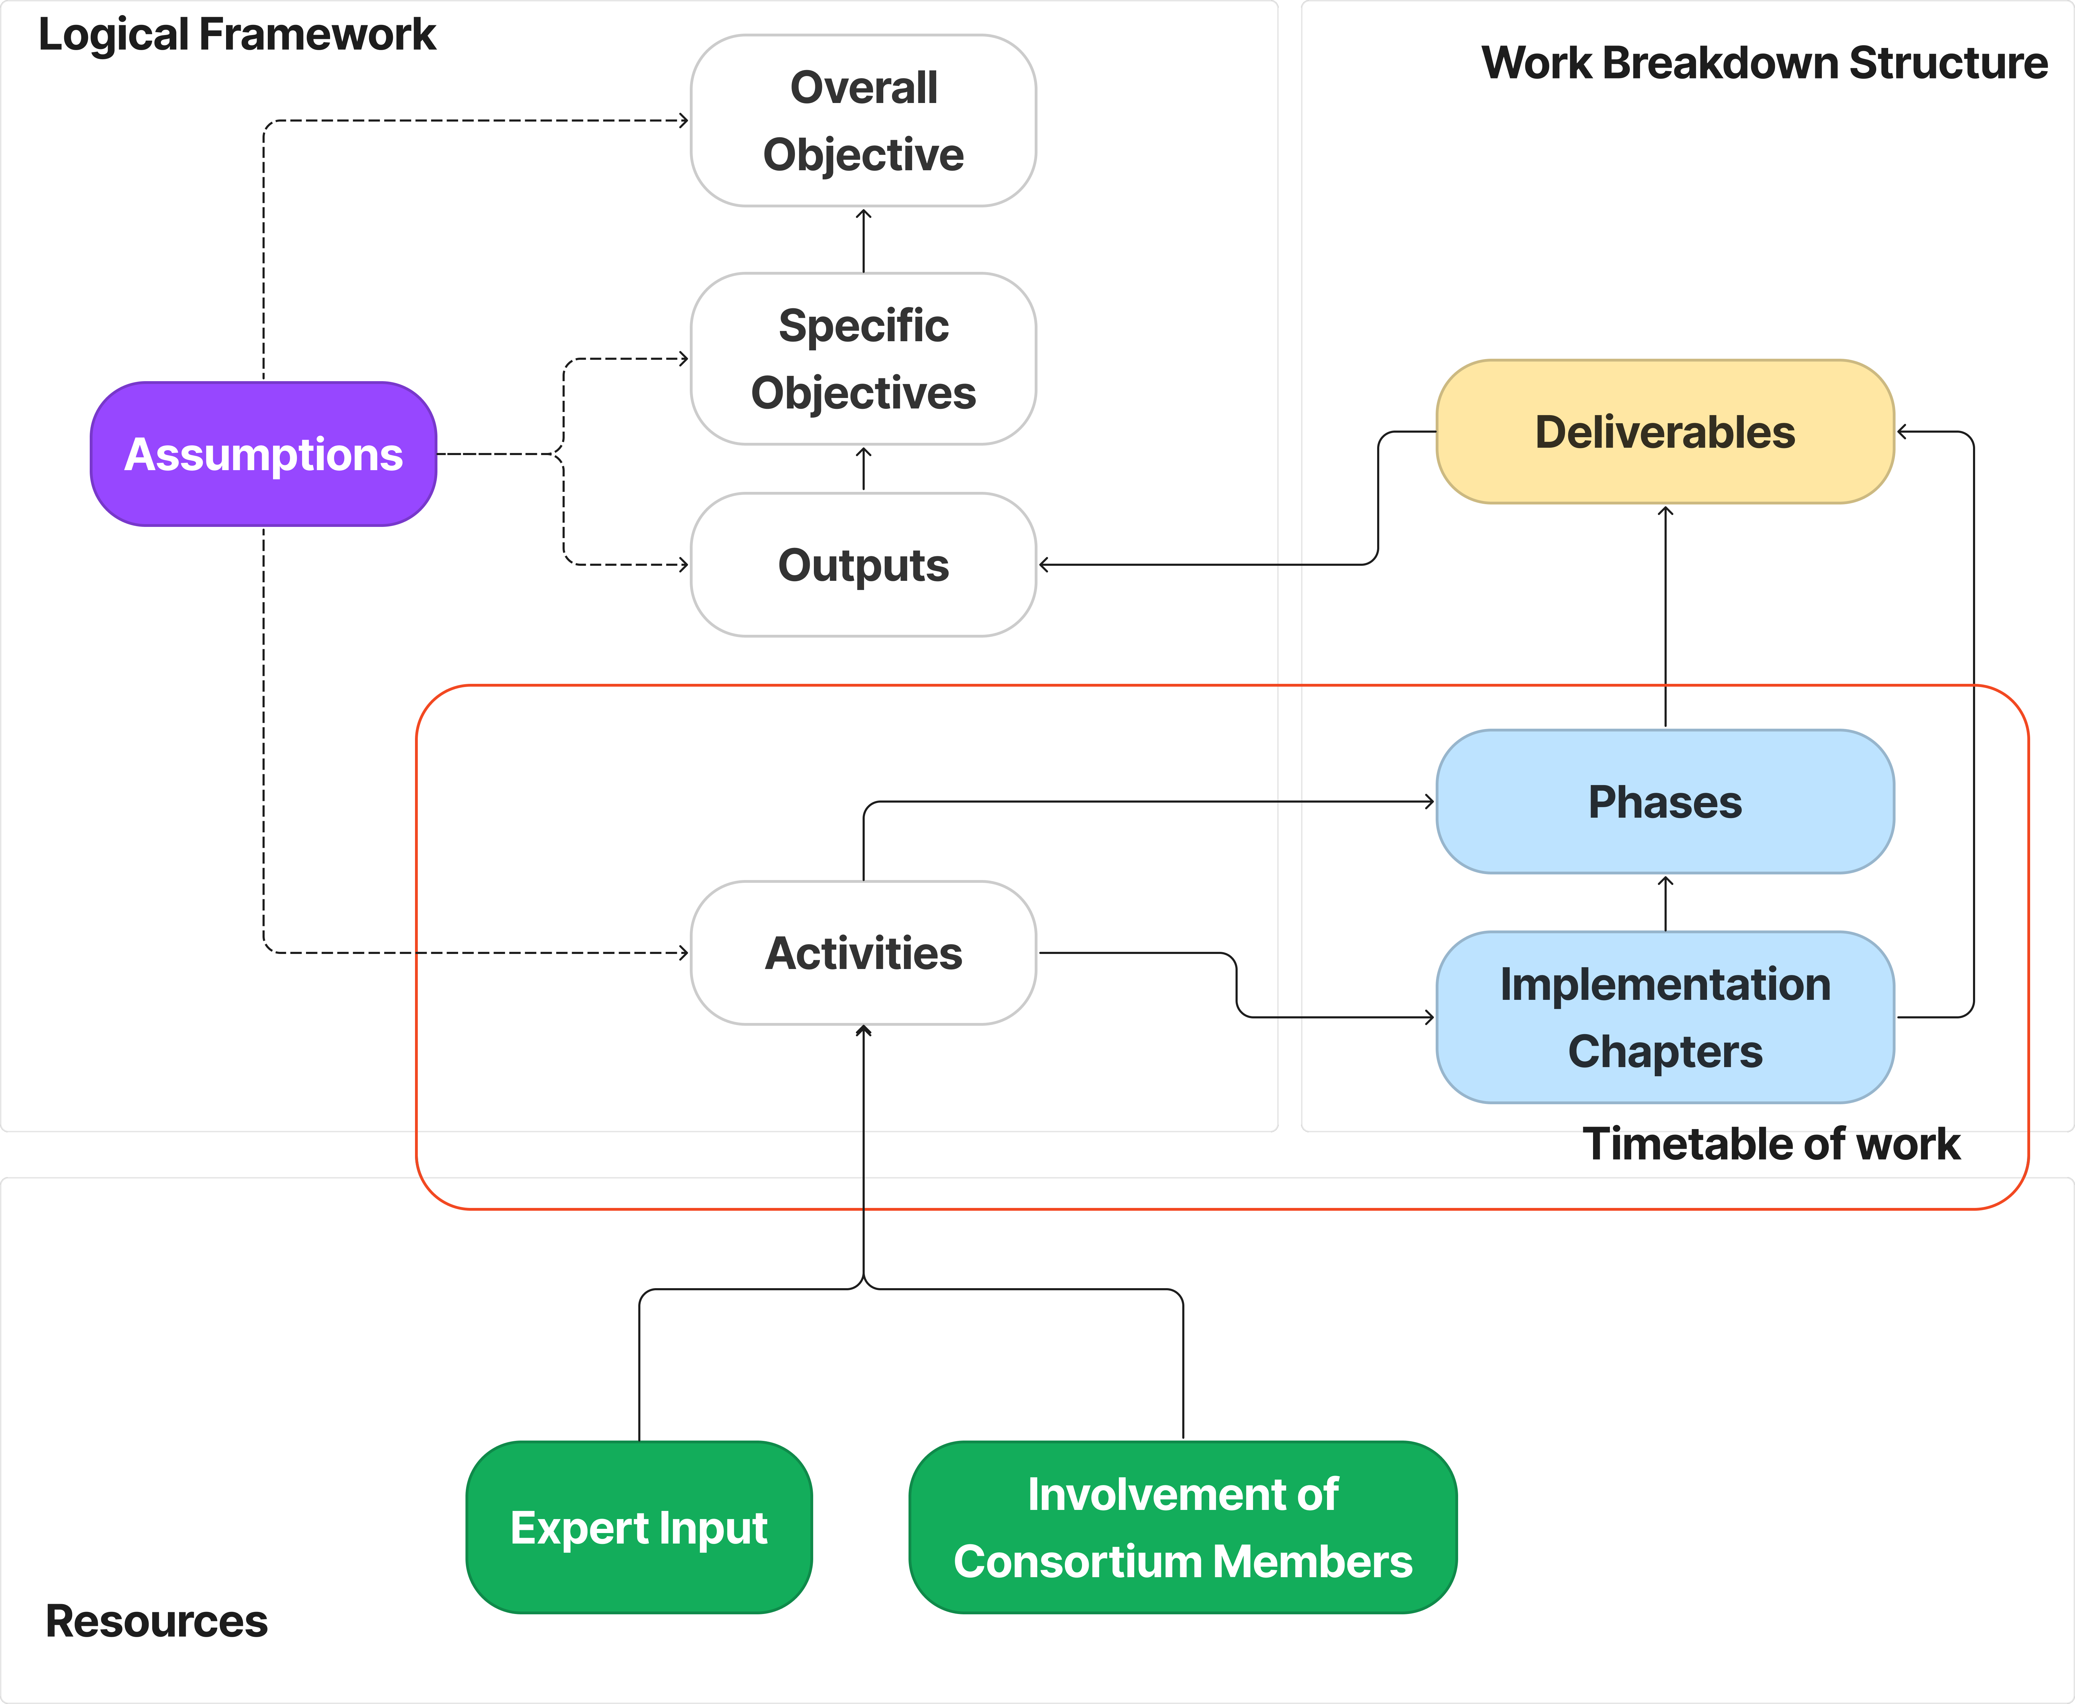

Figure 59 - Approach to deliver Scope of Work

As it is presented in the figure above, the Logical Framework approach shows that, considering the assumptions, the activities will be carried out and will produce deliverables. Deliverables will produce the expected outputs which will contribute to the specific objectives that, further, will contribute to the overall objective.

On the Project Management side (approach), the activities are grouped in implementation chapters which are further grouped in phases. Deliverables are connected to the Implementation Chapters and Phases. Together, the Implementation Chapters, Phases and Deliverables are forming the project Work Breakdown Structure (WBS). Further, the activities, Implementation Chapters and Phases forms the project timetable of work.

As shown, our overall approach for the implementation of this assignment will ensure that all dimensions related to the implementation and to the management&control of the implementation are fully covered and always synchronised. Our approach for defining the Scope of the Work for the project is a combination between the methodology illustrated in the Project Cycle Management Manual[39] and recognised Project Management methodologies (such as PMI and PRINCE2). While **keeping the logical framework approach**, we used our extensive experience in implementing complex projects and our **knowledge of PM methodologies** in order to refine the elements described in the ToR and to offer a full view on our understanding of the project as well as of each element which is part of the project.

In accordance with the ToR, we have organised our project around the four expected outputs, and we clearly marked the Inception phase, a dedicated phase for the monitoring and control of the project and a final phase to cover the closure of the project. Thus, the project will be implemented over 4 phases and 4 Implementation Chapters as presented in table below:

Table 40 - Project Phases and Implementation Chapters

| No. | Type | WBS Code | Name |
| --- | --- | --- | --- |
| 1 | Phase | **INC** | Inception Phase |
| 2 | Phase | **IMP** | Implementation Phase |
| 2.2 | Implementation Chapter | **BDIS** | Build Digital Identity Service |
| 2.2 | **DDIS** | Deploy Digital Identity Service |
| 2.3 | **CB** | Capacity Building |
| 2.4 | **AR** | Awareness Raising |
| 3 | Phase | **MC** | Project monitoring and reporting |
| 4 | Phase | **CL** | Project closing |

Considering the project work organisation presented in the table above, together with the expected outputs and deliverables[40], the following figure illustrates the full coverage of all activities required in the ToR for this assignment.

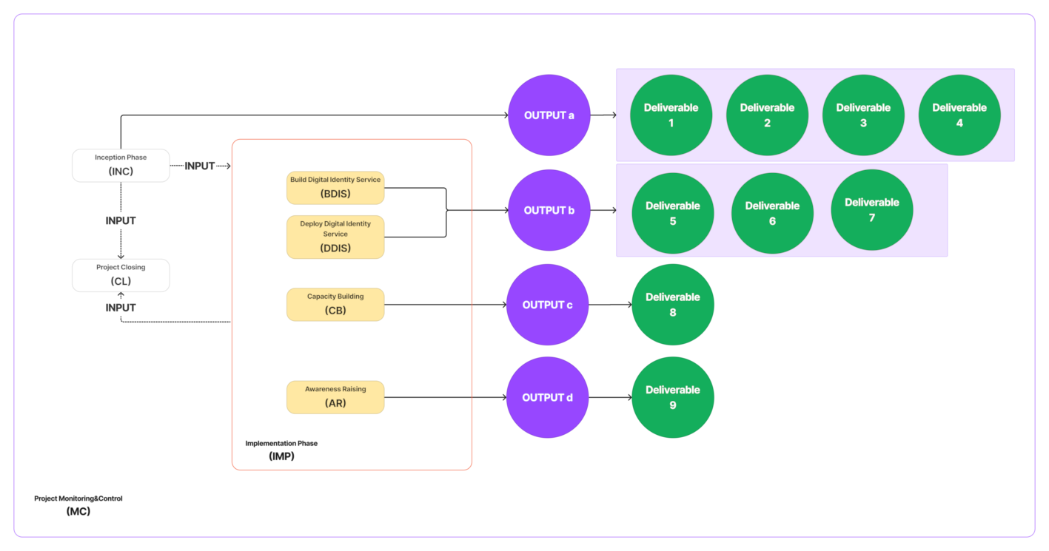

Figure 60 - Project Phases, Implementation Chapters and Deliverables

The next step in defining the final project work structure was to clearly identify the full set of deliverables, having as starting point the minimum list of deliverables defined in the ToR at section 2.3. Considering the complexity of this assignment, we believe that the optimal structure of deliverables can be obtained by further detailing (when needed) the list described in ToR. In order to maintain a consistent coding convention (the WBS code), we used **„D”** as deliverable identifier, followed by the related number form ToR (**1-9**) and further folowed by a subsequent number in the form of **„-X”** when additional refinement of the deliverable was needed. All deliverables were prefixed with thhe phase (and implementation chapter where applicable) WBS code(s) in order to provide more clarity about each deliverable by simply reading the logic of its code. As a result, the coding convention for a deliverable is:

**<phase WBS Code>.[<implementation chapter WBS Code>].D.<1-9>[-X]**

**Examples:**

* The Inception Report is coded as: INC.D1 (phase WBS Code is INC – see Table 40 – and deliverable number is Deliverable 1 – see ToR, section 2,3, Output a, pg.9)
* The detailed technical solution for the digital identity service is coded as: IMP.BDIS.D5-1 (phase code is IMP – see Table 40 -, Implementation Chapter code is BDIS – see Table 40 -, deliverable number is 5 – see ToR, section 2.3, Output b, pg. 10);

In order to maintain the consistency of the work breakdown structure, we also identified the other necessary deliverables that are mentioned in the ToR, section 7 – Reporting. We used the „**PR”** code for Interim Progress Reports, **„(D)FR”** for the (draft)Final Report, **„MOM”** for Minutes of Meeting and **„ORR”** for On-Request-Reports. We used different codes for these deliverables in order to avoid the confusion with the **„D”** code that is used only for the deliverables that are clearly marked as such in the ToR ar section 2.3.

Considering all of the above, the following table presents the full **Project Work Breakdown Structure (WBS)**:

#### Project Work Breakdown Structure - WBS

Table 41 - Project WBS

|  |  |  |  |
| --- | --- | --- | --- |
| **Phase WBS Code** | **Phase Name** | | |
| **INC** | **Inception Phase** | | |
| **Deliverable WBS Code** | **Description** | **Deliverable WBS Code** | **Description** |
| INC.D1 | Inception Report | INC.D3 | Updated Technical Specifications for the related Supply tender of IT equipment |
| INC.D2 | Revised Organisation & Methodology | INC.D4 | Basic algorithm |
|  | | | |
| **Phase WBS Code** | **Phase Name** | **Implementation Chapter WBS Code** | **Implementation Chapter Name** |
| **IMP** | **Implementation Phase** | **BDIS** | **Build Digital Identity Service** |
| **Deliverable WBS Code** | **Description** | **Deliverable WBS Code** | **Description** |
| IMP.BDIS.D5-1 | Detailed design of the technical solution | IMP.BDIS.D5-3 | Test Report |
| IMP.BDIS.D5-2 | Test plan |  |  |
|  | | | |
| **Phase WBS Code** | **Phase Name** | **Implementation Chapter WBS Code** | **Implementation Chapter Name** |
| **IMP** | **Implementation Phase** | **DDIS** | **Deploy Digital Identity Service** |
| **Deliverable WBS Code** | **Description** | **Deliverable WBS Code** | **Description** |
| IMP.DDIS.D6-1 | Correction Report | IMP.DDIS.D6-3 | Acceptance Report |
| IMP.DDIS.D6-2 | Installation and Configuration Report | IMP.DDIS.D7 | Product Documentation (User Manuals) |
|  | | | |
| **Phase WBS Code** | **Phase Name** | **Implementation Chapter WBS Code** | **Implementation Chapter Name** |
| **IMP** | **Implementation Phase** | **CB** | **Capacity Building** |
| **Deliverable WBS Code** | **Description** | **Deliverable WBS Code** | **Description** |
| IMP.CB.D8-1 | Training Report - Session1 | IMP.CB.D8-6 | Training Report – Session6 |
| IMP.CB.D8-2 | Training Report – Session2 | IMP.CB.D8-7 | Training Report – Session7 |
| IMP.CB.D8-3 | Training Report – Session3 | IMP.CB.D8-8 | Training Report – Session8 |
| IMP.CB.D8-4 | Training Report – Session4 | IMP.CB.D8-9 | Training Report – Session9 |
| IMP.CB.D8-4 | Training Report – Session5 | IMP.CB.D8-10 | Training Report – Session10 |
|  | | | |
| **Phase WBS Code** | **Phase Name** | **Implementation Chapter WBS Code** | **Implementation Chapter Name** |
| **IMP** | **Implementation Phase** | **AR** | **Awareness Raising** |
| **Deliverable WBS Code** | **Description** | **Deliverable WBS Code** | **Description** |
| IMP.AR.D9-1 | Awareness Video(s) | IMP.AR.D9-2 | C&V Strategy |
|  | | | |
| **Phase WBS Code** | **Phase Name** | | |
| MC | Monitoring&Control | | |
| **Deliverable WBS Code** | **Description** | **Deliverable WBS Code** | **Description** |
| MC.PR-1 | Progress Report Q1 | MC.PR-5 | Progress Report Q5 |
| MC.PR-2 | Progress Report Q2 | MC.PR-6 | Progress Report Q6 |
| MC.PR-3 | Progress Report Q3 | MC.PR-7 | Progress Report Q7 |
| MC.PR-4 | Progress Report Q4 | MC.PR-8 | Progress Report Q8 |
| MC.MOM | Minutes of Meeting | MC.ORR | On-Request Reports |
|  | | | |
| **Phase WBS Code** | **Phase Name** | | |
| **CL** | **Closing** | | |
| **Deliverable WBS Code** | **Description** | **Deliverable WBS Code** | **Description** |
| CL.DFR | Draft Final Report | CL.FR | Final Report |

The graphical representation of the project WBS is shown in the figure below:

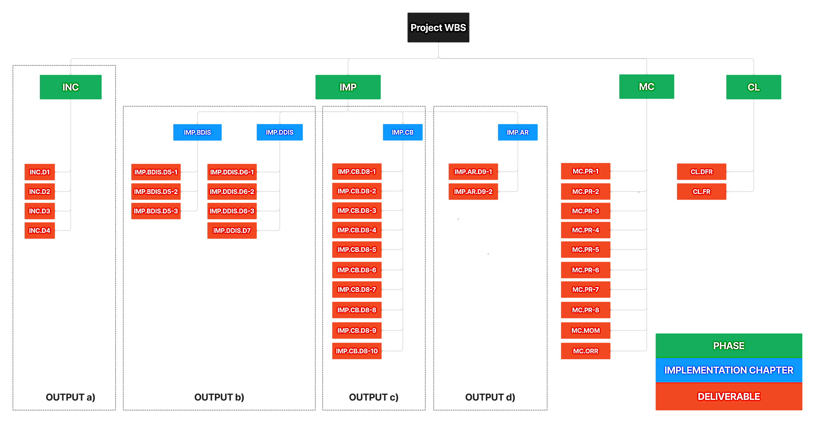

Figure 61 - Project WBS

### Activities

This section of the Technical Proposal will describe the implementation activities that we foresee having in focus the way in which we propose to execute these activities.

We will not insist here on the methodologies and tools that we propose to use in order to achieve the expected outputs of the activities since these methodologies and tools were described in detail in sections 2.1.2 - Specific methodology and 2.1.3 - Toolbox.

AS HIGHLIGHT OF THIS SECTION, WE MENTION THAT HERE WE DESCRIBE WHAT ACTIVITIES WILL BE PERFORMED AND THE LOGICAL LINKS AND CONNECTIONS BETWEEN ACTIVITIES, WHEREAS THE VERY DETAILED DESCRIPTION OF HOW WE WILL PERFORM THE ACTIVITIES IS PRESENTED IN SECTIONS 2.1.2 - Specific methodology AND 2.1.3 - Toolbox.

THIS SECTION DESCRIBE ALSO THE LOGICAL STRUCTURE OF THE MOST IMPORTANT ACTIVITY OF THE PROJECT, THE DEVELOPMENT AND DEPLOYMENT OF THE DIGITAL IDENTITY SERVICE SOFTWARE. THE VERY DETAILED INFORMATION ABOUT THE SOFTWARE SOLUTION AND THE COMPLIANCE ANALYSIS IS PRESENTED IN SECTION 2.1.2 - Specific methodology, A - Base eID Framework, B - Detailed description of the proposed eID Framework AND C - Compliance of the proposed eID Base Framework

#### INC - Inception Phase

| ***§ ToR Reference*** |
| --- |
| * ToR, §2.3 a) – Expected outputs to be achieved by the contractor * ToR, §4.2 a) - Specific work * ToR, §7.1 – Reporting requirements / Inception Report * ToR, §5.2 – Start date & period of implementation of tasks * Technical Study: Preparation for implementation of e-IDAS in Kosovo, Annex 1 – Output 1a (Activity 3.1) * Technical Study: Preparation for implementation of e-IDAS in Kosovo, Annex 2 – Output 1b (Activity 3.2) * Technical Study – Outputs 2 & 3 (Activities 3.3, 3.4) |

|  |  |  |  |  |  |  |  |  |  |  |  |  |  |  |  |  |
| --- | --- | --- | --- | --- | --- | --- | --- | --- | --- | --- | --- | --- | --- | --- | --- | --- |
| Phase Code: | INC | | | Phase Name: | | | Inception Phase | | | | | | | | | |
| Expected Deliverables | | | | | | | | | | Tasks | | | | | | |
| INC.D1 | Inception Report | | | | | | | | * Team mobilisation * Setup the project work environment * Kick-Off Meeting * Stakeholder Analysis * Update Organisation&Methodology * Develop Basic Algorithm * Analysis of the current situation and systems * Produce Inception Report | | | | | | | |
| INC.D2 | Revised Organisation & Methodology | | | | | | | |
| INC.D3 | Updated Technical Specifications for the related Supply tender of IT equipment | | | | | | | |
| INC.D4 | Basic algorithm | | | | | | | |
| Timeline | Jan | Feb | Mar | | Apr | May | | Jun | | | Jul | Aug | Sep | Oct | Nov | Dec |
| 2022 |  |  |  | |  |  | |  | | |  |  |  | **◆1** | **◆2** | **◆3** |
| 2023 |  |  |  | |  |  | |  | | |  |  |  |  |  |  |
| 2024 |  |  |  | |  |  | |  | | |  |  |  |  |  |  |
| **Activity Description**  **◆1** Kick-Off Meeting  **◆2** Draft Inception Report  **◆3** Inception Report  The logical approach of the inception phase is presented in the figure below:    Figure 62 - Inception Phase  The figure above presents the logical approach of the described activity and not the time planning. All details about the time planning and about the major milestones within the described activity are presented in section 5 - Timetable of work.    **Mobilization of the Project team and Project office set up**  The Technical Assistance Team (TAT) will consist of six main experts, which will take the role of Key Experts, one Team Leader and our backstopping team. The Key Experts will be mobilised on day 1 of the Project after the commencement order is issued by the Contracting Authority. An important aspect is that, at this moment, the team of experts (as it is described in section 2.2.2 - **Project Team**) will be only a team of proposed experts that needs to pass the usual approval process in order to be assigned on tasks. For this reason, we will start the preparations of the required documents even before the contract signature and we will submit these documents for approval to the CAUT together with the signed copy of the contract. The main goal would be to have at least the team of Seniors ready to start at the commencementd date of the contractIt is also important to note that the Consortium Partner, KLSC, has country offices established in Pristina, which collectively adds up to 10 people. Therefore, we will be ready to provide necessary backstopping services during the establishment of Project office. Our existing infrastructure in Kosovo, knowledge of Project Management Processes and experience in multiple EU projects/operations will allow for a rapid and smooth deployment.  Taking into consideration the duration of the inception phase and the requirement of delivering the Inception Report, the team of experts will start immediately to process all documents and information available at that moment in order to speed-up the activities related to the Stakeholder Analysis, Update Organisation&Methodology, and Analysis of the current situation.  **Coaching on PPM and developing Internal Procedures**  The experts will be supported by administrative staff to be assigned to the project implementation. In the Inception Phase, in accordance with our ‘Professional Project Management’ guiding principles, the TAT, being a team of professionals experienced in project management, will be coached in addition on teamwork and effective communication by the Consortium back stoppers. This will not only ensure their internal efficiency and effectiveness, but also their maximized co-operation and communication with the Beneficiary, EUD and other stakeholders of the Project.  Further to the above, during the first week of the project, the TL will develop a Manual of Internal Procedures which will be used, as a basic PM tool not only by the KE, but also by the NKE, once they are selected and appointed. The Manual will be shared with the Beneficiary for comments, if any, before its official use.  **Operationalizing the Project Office**  The establishment of the Project office will be completed by the end of the 1st week of the Inception Phase, prior to which procurement of the office equipment will take place upon contract signature. The office will be located within walking distance from the Ministry of Economy and Energy. The office will contain;   * approximately 10 square metres area for each expert working on the contract * desks for all experts and backstopping personnel * all other necessary furniture and office equipment * all necessary technological and communications facilities, * adequate room for Project meetings,   It is also important to note that the Consortium Partner KLSC’s office is established in Pristina. Therefore, the Consultant will be ready to provide necessary backstopping services during the establishment of the operation office in the country via immediate deployment of their backstopping support services.  **Establishing the Project Structure**  While establishing the project structure, the Consultant will define the working relationships between the TAT including the project director, backstopping staff, key expert and non-key experts, MoEE, EUOK and other stakeholders.  The working groups that we propose to establish within the scope of this Technical Proposal will be elaborated with respect to their composition, indicative members, the frequency of meetings, their roles and functions, and expected outputs. We will touch upon all these arrangements in the Inception Report.  Based on our experience in various projects, establishing the basic systems from the first day of the project have great significance. Reporting and translation is very basic but vital elements of the implementation.  **Initial meetings with the MoEE and stakeholders**  At the beginning of Project implementation, we propose to organise initial meetings to ensure effective flow of information and communication among the Project team and stakeholders:   * Official Kick-Off Meeting * Introductory Meetings with all key stakeholders * Weekly Meetings with the Beneficiary   **Kick-off meeting**  Firstly, the Project will officially start with the organisation of a Kick-Off Meeting with the attendance of the core Project stakeholders: the TAT and Consortium representatives, MoEE, EUOK, representatives of core stakeholders such as Ministry of Internal Affairs, Central Bank of Kosovo, and a representative of NIPAC as observer. The organisation of the Kick-Off Meeting will be undertaken by the Contractor in consultation with the MoEE and EUOK. The Kick-Off Meeting will have the below indicative agenda:  Graphical user interface, text, application  Description automatically generated  The MoEE, EUOK, as well as the TAT will have the opportunity to raise any issue or focus on specific topics which may pose crucial importance in terms of the Project implementation. The Kick-Off Meeting will be the first gathering of all core implementing bodies of the Project in which main project management and implementation rules / procedures are reviewed. Furthermore, this meeting will be the initial meeting to establish the management structure of the Project such as creating a common platform to review the roles and responsibilities of the core Project stakeholders to ensure smooth implementation of the Project from the very beginning. For successful and effective implementation of the Project, synergy among all stakeholders is considered a must. Thus, the aforementioned meeting will achieve all these intentions.  **Introductory Meetings With Key Stakeholders**  Following the Kick-off Meeting, informative and consultation meetings/workshops will be organized with all the key stakeholders in order to engage co-operation and ownership of the relevant authorities in the operation. The information, ideas and common understanding gained from these discussions will serve as the foundation for all activities during implementation. Firstly, TAT will organize separate meetings with;   * Ministry of Economy and Energy * European Union Office in Kosovo * Central Bank of Kosovo * Financial Institutions * Private companies * Representatives of other institutions directly or indirectly involved in the implementation of this contract if deemed necessary   During these meetings, the related activities will be presented as will be subject to the contract and any revision requirements will be sought with specific to the participants’ expertise from the MoEE. After these individual meetings organized by TAT in the first week after the Kick Off, 1 more common meeting will be held at the second week together with all staff.  **Weekly Meetings with MoEE**  We are aware that the beginning of a project is a very intense and busy time for all parties involved in the implementation process. Therefore, we strongly believe in the benefit of holding regular meetings, with the participation of the MoEE members to review the Project progress, upcoming activities and issues to effectively manage this period. These meetings will not only facilitate smooth implementation but also will help in Project objectives, activities, roles and responsibilities to be understood by the stakeholders.  One of the main purposes of these meetings will be figuring out the framework and intervention logic of the Project in order to develop a full and common understanding of the Project objectives as well as to comprehend the current situation of the programme. Therefore, we find these meetings critically important to initiate a first step contact and Project introduction to the stakeholders so that proper support is provided during implementation.  To have a smooth implementation weekly meeting will be held with the MoEE during the Inception Phase. All meeting minutes will be recorded by the TAT and to be shared with MoEE members in 2 days. In case of any comments or revision on the reports they will be revised and shared with the participants.  **Preliminary analysis of current situation**  While the Inception Phase remains a very tight time frame for the initiation of the Project, we believe that a preliminary analysis of current situation in the field, related Projects and programmes, achievements so far and relevant laws and legislations are important. Such analysis will enable TAT to fully understand the current state of affairs at the local level identifying strengths and weaknesses and undertake the necessary preparatory work for the implementation of the Project activities.  This is one of the most important activities of the Inception Phase. In the Rationale of this Technical Proposal, we described our understanding of the current state of affairs and progress made by the MoEE and other relevant institutions. However, it is crucial that this understanding is brought completely up to date so that the Project assists the MoEE and stakeholders to move forward seamlessly from the current stage of development while ensuring also that the contribution to enhance the competitiveness of the composite material and technical textile sectors by fostering networks and strategic partnerships and clustering among the stakeholders.  Special focus will be given to the outputs and documentation produced by the project: “**EU Support for the Competitiveness of Kosovo’s ICT Sector**, **EuropeAid/139756/DH/SER/XK”**. Additional sources of information will be (without being limited to) the information about related actions (Government and/or other donors), the best practices in EU, and the detailed information about the curent relevant information systems.  It is important to mention that the detailed information about the relevant current information systems is crucial for the successful implementation of further activities (mostly in the implementation phase). For this reason, we will grant a high priority to producing the inventory of those systems and to present this to the CAUT and IAUT as soon as possible (even before the Kick-Off Meeting) in order to allow CAUT and IAUT to facilitate the signature of the related Confidentiality Agreements with the Beneficiaries of the mentioned information systems.  This analysis will entail review of available documentation, reports, data and statistics prepared by the MoEE, EUOK, MoI, CBK, related donor financed projects, etc. on the on-going situation of eID systems in Kosovo. Moreover, institutional and structural analyses will be made parallel to these assessments.  During conducting these analyses, the Consultant will work in close coordination with the MoEE. Further, the mentioned analyses will both entail desk work (review of reports, strategies, documents, previous projects, etc.) and meetings with the representatives of stakeholders. There are three objectives of the desk research:   * Better understanding of the context, in which the project is set, and understanding the subject matter. * Analysis of the objectives, scope, means and instruments of the project, as planned with this proposal and making sure that the instrument proposed are fit for purpose. * Developing a first idea of the project reach and relevance, and how it will contribute to existing knowledge and builds-up key competencies of the beneficiary.   The desk research will be the basis for all the other methodologies of both data collection and data analysis. It will underline the areas to be investigated in the research and the orientations to follow in the subsequent phases of the project.  **Coordination with other Projects**  Coordination with the other related projects currently under implementation is also of crucial importance. We have already presented a list of what we believe to be most related projects in the field, however upon the project commencement, this list will be verified and expanded.  By having synergies with other initiatives in the sector, we will build trust, collaboration and ultimately and hopefully co-creation, which helps to create better effects and results. It will also help generate better solutions to problems and achieve the project’s vision and mission. The synergies that can be created by building on the results of completed projects or working together with complementary parallel projects in order to avoid duplication and plan the resource utilization more effectively.  To this end, the project team will meet with the on-going initiatives, both national and donor funded and discuss the project planning in order to early detect possible duplications and correct the same. Further to the above, together with the MoEE and EUOK, the Project Team will also review all the outcomes of the : “**EU Support for the Competitiveness of Kosovo’s ICT Sector**, **EuropeAid/139756/DH/SER/XK”** project and build upon the deliverables and results, if that is the case. In order to maintain the effective resource management, such coordination meetings will be organized throughout the project implementation as well.  **Mapping the Stakeholders**  Most commonly, the projects and action plans fail because of inadequate stakeholder involvement. As the Consultant, we are well aware of the importance of stakeholders’ involvement, intervention and cooperation areas. In the very beginning of the Inception Phase, a detailed Stakeholder Analysis will be conducted in order to identify primary, secondary and key stakeholders in order to assess their role, knowledge, interests, positions, alliances, and importance related to the environment in which the new eID platform should be developed, as well as their potential infesters and contributions to the project implementation. Therefore, every effort should be made to encourage broad and active stakeholder engagement in the implementation of the Project. Therefore, the stakeholders analysis represents a crucial activity that we will carry out during the Inception phase of the project. The inputs to the Stakeholder Analysis will be:Kick-Off Meeting Report, related documentation made available from the date of submission of the Technical Proposal and the contract start date, Minutes of Meetings held with key stakeholders during the inception phase. First we will carry our specific tasks in order to identify the stakeholders and to obtain the complete list of stakeholders. Second we will apply a set of techniques and tools in order to classify the stakeholders. Third step will be the usage of Stakeholder Mapping tool (shown in the figure below) in order to have a final view on the actions we will have to do during the project implementation with regards to the stakeholders.  Our focus will be on the stakeholders from the first line of the matrix having the highest level of influence on the project and/or the highest level of interest (from the "INVOLVE/ENGAGE" and "PARTNER" areas of the matrix). For this stakeholders we will develop and further apply a dedicated involvement/engagement plan in order to gain their involvement and fulfil their interests. These stakeholders will be part of the different working groups and will actively participate to the process of shaping the activities within the project. **By default, all stakeholders which already operates information systems that needs to be connected to the Digital Identity Service will fall into "PARTNER"** **category**.  We will also give a good level of attention to the stakeholders from the "CONSULT" area of the matrix. These stakeholders will be always asked to express their opinion in relation with the activities carried out for the project implementation and their inputs will be taken into consideration and included as much as possible in the project implementation. The remaining stakeholders (from the "INFORM" area of the matrix) will be kept informed about the activities carried out for the project implementation using the tools that we will make available such as Project IT Environment.    Figure 63 - Stakeholders Map  The matrix will be helpful in communicating about stakeholders and define their roles. After conducting the analysis, a stakeholder map will be prepared by the Consultant and a database where all information can be found will be created.    Similar stakeholder analysis will be conducted for each of the Project activities in order to increase the success of the Project. And each stakeholder defined during the operation activities will be registered to the new developed stakeholder database. This envisaged stakeholder database will be a living tool for the project to enhance its communication of the actors as well as to implement successful activities.  Furthermore, initial meetings with the MoEE and EUOK, who were involved in the design/planning phase of this project, will also provide inputs to the preliminary analysis of current situation. Apart from the stakeholders involved in the project design, the PT will also interview targeted companies, in order to gain better perspective of their needs and problems and plan the activities accordingly.  Upon the completion of the current situation analysis, the TAT will integrate the finding into the Inception Report. The preliminary analysis of the current situation will enable the Consultant to gather the most recent information and data in order to revise the Project planning provided in the Technical Proposal.  **Design and development of Project Corporate Identity and initial awareness raising tools**  Branding, identity and logo represent the Project’s mission and vision in the first place and define the way that the MoEE and EUOK communicate the development and further use of the eID platform will be a critical aspect for the success of the project and its impact. Thus, a unique and consistent branding and identity will contribute to the success of the implementation through linking all the communication activities that will be designed in the Inception Phase and will be used in all the administrative and written materials and awareness raising tools. The proposals for branding, identity and logo will be submitted together with the Inception Report to the Beneficiary for approval.  **Preparation of Project Communication Plan**  The Communication Plan will outline precise tasks to ensure quality of the actions to be implemented during the project implementation, as well as precise and quantified target audiences.  The Communication Plan will cover:   * Methods of communicating with identified target audiences * Project events for identified target audiences. * Written materials. * Visibility materials. * Press monitoring.   The Communication Plan will include other important elements such as:   * Visibility information to be provided to MoEE on a regular basis and how this will be communicated. * The logos and visibility standards: Approved logo to be used whenever possible, such as press conferences, workshops and seminars for publicity purposes (invitations, banners, stands, signing, power point presentation templates etc.). * Resources: The visibility will identify incidental expenditures for the visibility plan activities, as well as responsibilities within the Project team for visibility that will define the roles of TL and NKEs, as well as the project beneficiaries. * Monitoring mechanism: The TL will review the actions taken under visibility while preparing the six-monthly Interim Reports.   The Project Communication Plan will be submitted by the end of the Inception report for comments and approval. Once endorsed, the project team shall, with the support of stakeholders, proceed to implement the actions outlined in it, in conjunction with key stakeholders.  As stipulated and as defined by the Communication Plan, the project logos and visibility standards to be developed will be the first action to be implemented. The Team will to this end, develop a set of logos to be used whenever possible, such as press conferences, workshops and seminars for publicity purposes (invitations, banners, stands, signing, power point presentation templates etc.), out of which the beneficiary will choose one. Further to the project identity, the team will also develop visibility templates to be further utilized for the reporting purposes, as well as templates for the different types of outputs including power point presentations, letterheads, business cards, invitations, training materials, etc.  **Preparation of draft Inception Report**  Once we will complete the stakeholder analysis, we will start immediatelly to approach the Stakeholders, the highest priority being granted to those stakeholders that currently operates information systems that needs to be connected to the Digital Identity Service because the real value of a Digital Identity Service is to be able to be integrated with existing systems and the collection of information related to these existing systems is (on one hand) time consuming and (on the other hand) may lead to potential technical obstacles for which we will have to provide a solution.  Once we have all the information collected from the Analysis of the current situation and Stakeholder Analysis tasks, we will produce the draft Inception Report and we will present it to the key stakeholders. Having the related relevant inputs from each Consortium Members, the expert team will work under the coordination of the TL in order to integrate all the above mentioned information and to develop the Inception Report. After the integration of the potential remarks/comments/observations received from the stakeholders, we will deliver the final version of the Inception Report that will be approved by the CAUT and IAUT and will be considered (together with the Revised Organisation&Methodology) as being the new baseline of the project.  **Update on the Current Situation**  The complex and participatory extensive consultative process of the Inception Phase will precede the preparation of the Inception Report. It will result with the update on the data provided within this proposal in respect to the project background, the immediate policy and legal surroundings, as well as the status of institutional arrangements between the stakeholders.  Further to the above, the updated current situation will look into any changes that might have occurred in the period prior to contract initiation, as well as the interactions between the project and other related initiatives. In this respect, mapping of all synergies will be done, including potential areas of cooperation.  **Update of the Methodology, Logframe And Planning**  When updating the project Organisation&Methodology we will apply a set of tools and planning methodologies derived from the best practices and Project Management frameworks, worldwide recognised. Moreover we will take into consideration and review all constraints and dependencies identified during the Inception phase having as starting point the constraints presented in section **Timetable of work**. As much as possible we will identify measurable numerical outputs of the tasks and activities and we will propose indicators calculated based on mathematical formulas. When not possible, we will use the achievement of the milestones of the project as very simple and precisely measures of the indicators. The first version of the indicators that will be used to assess the fulfillment of the activities and the compliance of the deliverables is presented (as required by the ToR[41]) in this Techical Proposal and are integrated in the Log Frame matrix (see section 6 - **Log Frame**). This will be the baseline for further detailing the indicators in the Inception Report and for further monitoring of the progress during the Monitoring&Control phase (Progress Reporting).  One important task that will be perfomed during the inception phase is the review and update (if needed) of the technical specifications already drafted[42] for the supply tender that will be organised for the purchase of the needed equipment for the deployment of the Digital Identity Service. This task is crucial not because of the complexity but because any delay on releasing the final technical specification may have a major negative impact on the overall meeting the deadline of this project. There are two aspects that can have a significant influence: one is related to the imposed timeframe of a regular supply tender organised under PRAG and the second is related to the well known shortages that all equipment manufacturers experience nowadays due to the delays on supply chains causing, sometimes, really long delivery time for the equipment. For these reasons we see this task as one major milestone and we performed in this Technical Proposal a „**reverse engineering**” exercise having as main goal to establish the maximum deadline for releasing the final technical specifications. All these information is presented in section 5 - **Timetable of work**).  In the same time we are aware that the final technical specifications for the equipment depends on the characteristics of the software solution that will be implemented. Our strategy (based on the customisation and localisation of a verified EU eID base framework which, basically, dictates the requirements for the equipment) will allow us to timely deliver the necessary output of this task in order to not put in danger the overall deadline of this project.  Based on the above, a detailed Risk Mitigation Plan will be developed, including additional risks identified during the meetings. Our approach to risk mitigation, from the very beginning onwards, will be based on tracking risks through a risk register as part of risk response planning. The risk register will be shared with the MoEE and the EUOK and finalised before the submission of the Inception Report based on their comments and feedbacks. We will reflect our transparency in our communication with the beneficiary and project stakeholders concerning the identification of risks and risk management strategies.  All in all, no matter how well and timely risks are identified or how good a risk register is filled in, one common basic principle of our approach will be to continuously monitor risks through following up with and updating the risk register on an on-going basis. This will ensure mitigating any potential risk once they are identified and reflecting changes in the management plan of the project in general and in the work plan, logical framework, inception report etc. in particular.  We provide below a short summary and the Table of Content of the detailed Risk Mitigation Plan.    **Conducting Inception Report Review Workshop**  A picture containing text, metalware, gear  Description automatically generatedAlthough not required in the ToR, we find it of great benefit for all stakeholders of the Project to organise a workshop dedicated to review the Draft Inception Report before full-blown implementation begins. Following is the presentation of the tasks to be implemented.  The upfront implementation of this workshop with the participation of the 10 representatives of the MoEE, EUOK and the stakeholders will enable the Project to be carried out with an ensured level of understanding, ownership and co-operation that also results in efficiency and effectiveness throughout all major activities.  The workshop will be delivered as a one-day working session, which will elaborate in detail the findings of the project team and will look into the stakeholders’ opinions and suggestions. Prior to the workshop delivery, the PT will ensure that all the logistical arrangements are completed, including managing the invitation process, ensuring suitable workshop venue and preparing the workshop materials.  The workshop is recommended to be one full day activity with the following tentative agenda:   | **Indicative Workshop Schedule for the Review of Draft Inception Report** | | | | --- | --- | --- | | Morning Session  9.30 – 12.30 | General Project Management Principles  General Communication Plan  Project Implementation Strategy  Project Overview  Roles and Responsibilities  Project Management Tools  Performance Indicators | 20 min  30 min  10 min  20 min  20 min  20 min  20 min | | Afternoon Session  13.00 – 17: 00 p.m | Inception Report Outline  Logical Framework Review  Workplan Review  Project Performance Indicators and Monitoring Principles  Risks and Mitigation Strategies  Closing Remarks | 15 min  40 min  90 min  20 min  15 min  20 min |   During the workshop, TAT will gather the comments and feedback on the Draft Inception Report. The feedback received from the participants will be utilised during the Inception Report finalisation process.  In addition to the Inception Report Review Worksop which will be dedicated to the revision and finalisation of the Inception Report, the Consultant proposes to deliver a two-days workshop to the representatives of the MoEE. This workshop will cover Project Management (PM) & Project Cycle Management (PCM). We believe that the delivery of training on PM and PCM training will be of great use for the representatives of MoEE who will actively be involved in the management of this Project. This training is scheduled to be delivered in the very beginning of the Project, and will benefit the trainees in the following ways:   * Enhance the existing capacities of the MoEE; * Provide the correct project management tools, which can be utilized during the entire implementation of this Project; * Motivate the trainees at the very start of this Project via transfer of knowledge in project management; * Raise awareness of the MoEE regarding PCM approach which is a common technique utilized in each and every EU-funded project; * Enable the training participants develop projects in the future via providing knowledge on PCM.   The training will be conducted in Belgrade and approximately 5 relevant staff members of MoEE   |  |  |  | | --- | --- | --- | | **Session** | **Day 1** | **Day 2** | | **1** | * Introduction to project management * Process groups in project management   + Initiation   + Planning   + Executing   + Monitoring | * EU Financial Assistance   + EU Funding: IPA Components   + IPA II | | **2** | * Process groups in project management   + Executing   + Monitoring/Controlling   + Closing | * Project Cycle Management   + Why PCM?   + Introduction to PCM   + Logical Framework Approach | | **3** | * Knowledge areas in project management   + Integration Management   + Scope Management   + Time Management   + Cost Management   + Quality Management | * Analysis   + Stakeholder Analysis   + Problem Analysis   + Objective Analysis   + Strategy Analysis | | **4** | * Knowledge areas in project management   + Human Resource Management   + Communication Management   + Risk Management   + Procurement Management   + Stakeholder Management | * Logical Framework Matrix   + Objective Levels; Overall Objective, Project Purpose, Results, Activities * Logical Framework Approach   + Assumptions, Risks, Pre- conditions * Objectively Verifiable Indicators   + Sources of Verifications |   **Finalisation and Submission of Inception Report**  As stated in the ToR, a second draft Inception Report will be prepared and submitted by the end of 2nd Month after the revisions noted in the Workshop have been reflected. The Inception Report will incorporate the findings from the review of the ToR, the outcomes of the current situation analysis, the meetings conducted with the relevant parties, the guiding principles of Project management, working methodology and work schedules for the Project. The TAT will also submit the detailed Implementation Plan, Monitoring Plan and the Logical Framework together with the Inception Report.  Upon submission of the Inception Report, a presentation will be made to highlight its key points. Following the presentation, and after receiving comments from the beneficiary, the report will be finalised. It will then be submitted to the CA for final approval. The approved Inception Report will then serve as the basis for activities during the life cycle of the Project. Indicatively the table of contents of the Inception Report will be as follows:  Graphical user interface, text, application  Description automatically generated  **Incorporating Comments**  After the organisation of the workshop on the review of Draft Inception Report, the TAT will integrate the comments received and finalise the Report. The Work Plan and Logical Framework will also be revised – if needed – based on the feedback received from the workshop participants  The Inception Report will be prepared both in English and Albanian. After the finalisation of the Inception Report, it will be submitted to the MoEE and EUOK for approval. Consequently, the approved Inception Report will serve as the basis for activities during this Project’s life- cycle.  The Inception Report will be submitted by the end of the 2nd Month of the Project. It is expected that TAT will have an approved Inception Report together with its all annexes before the Implementation Phase of the Project starts.  **Development of basic algorithm**  Since we will use the same inputs as for the Inception Report, in the same time with the activity of drafting the Inception Report, we will start the development of the Basic Algorithm. Moreover, we would also start performing the preparatory tasks and activities for the next phase. As it can be seen in section 5 - **Timetable of work**, we propose to start the **IMP.BDIS - Build Digital Identity Service Implementation Chapter** after the delivery of the draft Inception Report and before the end of the inception phase. This approach is feasible due to our strategy based on the customisation and localisation of a verified EU eID base framework and will allow us to start the detailed design of the system as earliest possible. Our main goal is that, at the end of the inception period to be one-step-ahead and to have the detailed technical design to that level which will allow the start of development activity. The basic algorithm is one component of the detailed technical design and, as earlier described, we will start the work on this task in the same time with drafting the Inception Report. | | | | | | | | | | | | | | | | |

#### IMP.BDIS - Build Digital Identity Service Implementation

| ***§ ToR Reference*** |
| --- |
| * ToR, §2.3 b) – Expected outputs to be achieved by the contractor * ToR, §4.2 b) - Specific work * Technical Study: Preparation for implementation of e-IDAS in Kosovo, Annex 2 – Output 1b (Activity 3.2) * Technical Study – Outputs 2 & 3 (Activities 3.3, 3.4) |

|  |  |  |  |  |  |  |  |  |  |  |  |  |  |  |  |  |
| --- | --- | --- | --- | --- | --- | --- | --- | --- | --- | --- | --- | --- | --- | --- | --- | --- |
| WBS Code: | IMP.BDIS | | | Name: | | | Build Digital Identity Service | | | | | | | | | |
| Expected Deliverables | | | | | | | | | | Tasks | | | | | | |
| IMP.BDIS.D5-1 | Detailed design of the technical solution | | | | | | | | * Produce the detailed technical design * Produce the Test Plan * Develop the software * Perform system testing | | | | | | | |
| IMP.BDIS.D5-2 | Test plan | | | | | | | |
| IMP.BDIS.D5-3 | Test Report | | | | | | | |
| Timeline | Jan | Feb | Mar | | Apr | May | | Jun | | | Jul | Aug | Sep | Oct | Nov | Dec |
| 2022 |  |  |  | |  |  | |  | | |  |  |  |  |  |  |
| 2023 |  |  | **◆1** | |  |  | |  | | |  |  |  |  | **◆2** |  |
| 2024 |  |  |  | |  |  | |  | | |  |  |  |  |  |  |
| **Activity Description**  **◆1** Detailed Technical Design  **◆2** Start testing  **IC**  - Implementation Chapter  The logical approach of the this implementation chapter is presented in the figure below:    Figure 64 - Build Digital Identity Service  The figure above presents the logical approach of the described activity and not the time planning. All details about the time planning and about the major milestones within the described activity are presented in section 5 - Timetable of work.  As earlier mentioned (see activity 2.4.1 - **INC - Inception Phase**), due to the fact that we foresee to have relevant information available earlier in the inception phase and because our strategy is based on the customisation and localisation of a verified EU eID base framework, we will be able to start the development phase before the official end of the inception period. The impact of potential remarks/comments/observations to the documents produced during the inception period will not dramatically affect the start of the detailed design for de Digital Identity Service software. With this parallel approach we will be able to use the implementation time in a much more efficient way. One main goal of the detailed technical design is to produce the development specifications that will be used later in the process by the development team. The second main goal of the detailed design is to produce the first version of the test plan that will be used later to test de Digital Identity Service software.  The detailed design of the digital identity service software, together with the estimated effort/cost/time information will be presented to the IAUT and Beneficiaries for approval. Given the crucial importance of this aspect (since a potential rejection may have a significant negative impact on the whole project), we plan to have an active involvement in this activity for all key stakeholders. For this reason we will extensivelly use the functionality of the Project IT environment (see section 3.4 - **IT&C support**) in order to stay in permanent contact with the relevant stakeholders, collect and integrate their feedback, having as main goal a smooth process of understanding all aspects of the technical solution and a fast approval process for the technical solution/effort/cost/time.  It is a common practice in the industry to produce the first draft of the test plan during the detailed design activity. By doing so, we will bring more clarity to the developers during the software development activities and we will allow them to perform the mandatory **UNIT TESTING** in a more efficient way, thus reducing the development time and increasing the quality of the outputs. Moreover, during the development activities, we will be able also to identify potential flaws in the design (and consequently in the first version of the test plan) and we will be able to timely apply corrective actions and to update the documents accordingly. The expected result will be to have a higher quality software and a reliable test plan at the end of the development activity.  Following the development activities, we will start the testing of the Digital Identity Software. This activity will be performed together with key staff from the IAUT and Beneficiaries since it is required to validate the results of the development. **These tests will be made on the pre-production environment.**    It is important to mention here the difference between the specific software testing activities. While the **UNIT TESTING** is performed by the development team on the **DEVELOPMENT ENVIRONMENT**, the client TESTING is performed on the **PRE-PRODUCTION ENVIRONMENT**. Unit testing is a mandatory activity that will be performed by our team before any release to pre-production and is part of our software development methodology (it is also one of the best practices in the industry).  Another important part of our QA/QC[43] activity is the so-called “**FACTORY ACCEPTANCE TESTING**” (or **FAT**). These tests will be performed by our software QA/QC team (specialised software testers) on the **DEVELOPMENT ENVIRONMENT**, according to the test plan, against all the development specifications and before the release to pre-production and the start of the testing activity with the IAUT and Beneficiaries. FAT includes automatic and manual testing.  The testing activity will be concluded with the Test Report that will contain all minor non-compliances identified by running the test plan. These will be corrected in the next implementation chapter, before the deployment to the production environment.  It is important to mention here that the **test report cannot contain blocking and/or major failures** for the simple reason that, at the first blocking/major failure, the whole test plan fails, the failure is corrected and the whole test plan is started again. That’s why we put so much accent on QA/QC activities and on the AGILE development methodology, unit testing and FAT testing. These will provide the maximum probability to encounter only minor defects when running the test plan together with the IAUT and Beneficiaries. | | | | | | | | | | | | | | | | |

#### IMP.DDIS - Deploy Digital Identity Service Implementation

| ***§ ToR Reference*** |
| --- |
| * ToR, §2.3 b) – Expected outputs to be achieved by the contractor * ToR, §4.2 b) - Specific work * Technical Study: Preparation for implementation of e-IDAS in Kosovo, Annex 2 – Output 1b (Activity 3.2) * Technical Study – Outputs 2 & 3 (Activities 3.3, 3.4) |

|  |  |  |  |  |  |  |  |  |  |  |  |  |  |  |  |  |
| --- | --- | --- | --- | --- | --- | --- | --- | --- | --- | --- | --- | --- | --- | --- | --- | --- |
| WBS Code: | IMP.DDIS | | | Name: | | | Deploy Digital Identity Service | | | | | | | | | |
| Expected Deliverables | | | | | | | | | | Tasks | | | | | | |
| IMP.DDIS.D6-1 | Correction Report | | | | | | | | * Debugging and Remediations * Install and configure on production * Perform acceptance testing * Produce the product documentation | | | | | | | |
| IMP.DDIS.D6-2 | Installation and Configuration Report | | | | | | | |
| IMP.DDIS.D6-3 | Acceptance Report | | | | | | | |
| IMP.DDIS.D7 | Product Documentation (User Manuals) | | | | | | | |
| Timeline | Jan | Feb | Mar | | Apr | May | | Jun | | | Jul | Aug | Sep | Oct | Nov | Dec |
| 2022 |  |  |  | |  |  | |  | | |  |  |  |  |  |  |
| 2023 |  |  |  | |  |  | |  | | |  |  |  |  |  |  |
| 2024 |  |  |  | | **◆** |  | |  | | |  |  |  |  |  |  |
| **Activity Description**  **◆** Production version ready (clear of all bugs and fully corrected)  **IC**  - Implementation Chapter  The logical approach of this implementation chapter is presented in the figure below:    Figure 65 - Deploy Digital Identity Service  The figure above presents the logical approach of the described activity and not the time planning. All details about the time planning and about the major milestones within the described activity are presented in section 5 - Timetable of work.  Following the development of the Digital Identity Service (2.4.2 - IMP.BDIS - Build Digital Identity Service Implementation Chapter) we will start the deployment to the production environment. Having as input the Test Report from the previous implementation chapter, the first activity will be to correct the defects mentioned in the report. This will be made on the DEVELOPMENT ENVIRONMENT and following the same procedure of **development -> unit testing -> factory acceptance testing -> release to pre-production -> test**. This activity will be concluded with the Correction Report.  The next task will be the installation and configuration on the PRODUCTION ENVIRONMENT. This task will be executed by our dedicated implementation engineers. In the same time we will produce the product documentation which will include all the manuals needed for the operation, administration and maintenance of the Digital Identity Service software.    It is important to mention here that the **PRODUCTION ENVIRONMENT** consist in all the equipment purchased through the earlier mentioned supply tender. At the moment when we will start the installation and configuration, this equipment shall be fully functional (100% delivered, installed, tested and commissioned). More details about the importance of this aspect are described in **section 5 - Timetable of work**.  The installation and configuration on the production environment will be concluded by the Installation and Configuration Report. This report, together with the Correction Report and the Test Plan are the mandatory inputs to the most important activity of this implementation chapter - the **ACCEPTANCE TESTING**. The acceptance testing will be executed on the production environment, together with the IAUT and Beneficiaries. The mentioned inputs are mandatory, in this way we will ensure the fact that all pre-requisite steps were properly executed before starting the acceptance testing. The acceptance testing will be executed against the same Test Plan and will be concluded with the Acceptance Report which will mark the fact that the Digital Identity Service is fully functional, is operational and can be officially used. | | | | | | | | | | | | | | | | |

#### IMP.CB - Capacity Building Implementation

| ***§ ToR Reference*** |
| --- |
| * ToR, §2.3 c) – Expected outputs to be achieved by the contractor * ToR, §4.2 c) - Specific work |

|  |  |  |  |  |  |  |  |  |  |  |  |  |  |  |  |  |
| --- | --- | --- | --- | --- | --- | --- | --- | --- | --- | --- | --- | --- | --- | --- | --- | --- |
| WBS Code: | IMP.CB | | | Name: | | | Capacity Building | | | | | | | | | |
| Expected Deliverables | | | | | | | | | | Tasks | | | | | | |
| IMP.CB.D8-1 | Training Report - Session1 | | | | | | | | * Plan and prepare the training sessions * Deliver training sessions | | | | | | | |
| IMP.CB.D8-2 | Training Report – Session2 | | | | | | | |
| IMP.CB.D8-3 | Training Report – Session3 | | | | | | | |
| IMP.CB.D8-4 | Training Report – Session4 | | | | | | | |
| IMP.CB.D8-4 | Training Report – Session5 | | | | | | | |
| IMP.CB.D8-6 | Training Report – Session6 | | | | | | | |
| IMP.CB.D8-7 | Training Report – Session7 | | | | | | | |
| IMP.CB.D8-8 | Training Report – Session8 | | | | | | | |
| IMP.CB.D8-9 | Training Report – Session9 | | | | | | | |
| IMP.CB.D8-10 | Training Report – Session10 | | | | | | | |
| IMP.CB.D8-11 | Study visit to Italy | | | | | | | |  | | | | | | | |
| Timeline | Jan | Feb | Mar | | Apr | May | | Jun | | | Jul | Aug | Sep | Oct | Nov | Dec |
| 2022 |  |  |  | |  |  | |  | | |  |  |  |  |  |  |
| 2023 | ● |  |  | |  |  | |  | | |  |  |  |  |  |  |
| 2024 |  |  |  | | **◆** | ●●● | | ●●● | | | ●●● | ● |  |  |  |  |
| **Activity Description**  **◆** Training Plan approved  ● Training Session  ● Study Visit  **IC**  - Implementation Chapter  The logical approach of this implementation chapter is presented in the figure below:    Figure 66 - Capacity Building  The figure above presents the logical approach of the described activity and not the time planning. All details about the time planning and about the major milestones within the described activity are presented in section 5 - Timetable of work.  Capacity building is the most important activity that will have a major impact on securing long-term results for this project, thus it is crucial to prepare and deliver it with the maximum possible impact. For this reason we divided this implementation chapter in two major activities, **Prepare training sessions** and **Deliver training sessions**.  There are a number of constraints that drives the planning and execution of the Capacity Building implementation chapter. First of all, the **trainings must be delivered on the final version of the software and on the pre-production environment**. That is why, in the picture above it is shown that the pre-requisites for starting this implementation chapter are the Correction Report (which proves that the software is final and installed on the pre-production environment) and the Acceptance Report (which proves that the software is free of defects and compliant with the requirements). Only after these, the delivery of the training sessions can start.  Second, considering the complexity of this project and the number of key stakeholders involved, the delivery of the training sessions requires proper planning. For this reason, in the figure above it is shown that the stakeholder analysis is the main input for the preparation of the capacity building implementation chapter. In order to prepare and plan the training sessions it is not needed to have the final version of the software installed on the pre-production environment, thus this activity can start earlier as it is explained in section 5 - **Timetable of work**. The only constraint here is that the completion of planning and preparation is a pre-requisite to start the delivery of the training sessions as it is shown in the figure above. The training and preparation activity will be concluded with a training plan.  The key success factor for the capacity building is to involve the right persons from the key stakeholders. For this reason we explained earlier (see 2.4.1 - **INC - Inception Phase**) that we will give a great attention to the Stakeholder Analysis and we will conduct it according to a well-known methodology and using recognised tools in order to obtain the most relevant results. Of course, considering that there will be a significant number of months between the moment of the stakeholder analysis and the moment when we will start the preparation of the training sessions, before starting the preparation we will first revise the Stakeholder Analysis under the aspects of the list of relevant stakeholders and the list of persons that will need to attend the training sessions.  Another key success factor is the actual participation of the nominated persons to the training sessions. As it is shown in section 5 - **Timetable of work**, we allocated enough time for the preparation (3 months). This will allow the key stakeholders to plan in advance the allocation of their staff and will also allow us to better prepare the training materials and tools and to discuss these topics with the beneficiaries in order to reach the maximum effectiveness of the trainings.  Last but not least, it will be very important to keep the pace of the training sessions and stay inside the schedule (also considering that the current planning is placing the sessions during summertime). As it is shown above and also in section 5 *-* **Timetable of work**, we scheduled to deliver 3 training sessions per month, which means one at each 10 days. Logistics is important for this and our backstopping team and local support staff (see sections 3.9 - **Logistic support team** and 3.10 - **Local support**) will play a crucial role in organising everything what is necessary for the training sessions. Nevertheless, the involvement of the IAUT/CAUT and Beneficiaries is also of maximum importance in the sense that these stakeholders shall ensure that their staff will be actually available and will attend the training sessions. However, as it is shown in the timetable of work, we have a provision of around one month (the last month of Capacity Building implementation chapter has only one training session scheduled) in the case when something will not go as planned in the previous months. This will allow us to accommodate at least 2 additional training sessions in the last month in the case when will not be possible to deliver all scheduled sessions in the previous months.  Each training session will be concluded with a training report that will summarise the activities carried out during the sessions, will evaluate the results of the training session, will collect and present feedback from the trainees and will formulate potential recommendations for future necessary trainings.  Each training session will be concluded with a training report that will summarise the activities carried out during the sessions, will evaluate the results of the training session, will collect and present feedback from the trainees and will formulate potential recommendations for future necessary trainings.  Our overall training methodology is presented below:  **Step 1. Conducting training needs analysis (TNA).**  TNA will be an integral part of the development and delivery of training programmes. We will assess the current knowledge of stakeholders’ staff while considering practices and guidelines for effective and credible eID delivery in Kosovo. This analysis will enable us to identify strengths to build on, and gaps, weaknesses, and challenges to be addressed with training programmes. This analysis will help us to understand current needs and gaps and address our support efficiently.  **TNA methodology**. We will first, prepare the TNA methodology which will outline objectives and results to be achieved, data collection and analysis tools and methods. The methodology will also outline a timeline of the TNA process, especially for data collection, analysis, drafting the TNA report and stakeholder consultation.  **Data collection**. Following the finalisation of TNA methodology, we will initiate data collection, using standard analytical techniques, such as desk studies, semi-structured interviews, surveys, workshops, participatory methods. Involvement of the beneficiary is critical to identify actual needs and perceptions as well as gathering their expectations from the training activities. We, therefore, propose to organise several face-to-face interviews.  **Data analysis**. We will analyse, compare, and triangulate the qualitative and quantitative data collected. The data analysis will extract valid information on the details of the training programme, most importantly, for training topics (specific and horizontal). We will also identify training type (smaller/larger groups, short/long modules), training level (induction, beginners, medium, advanced), training urgency and optimum timeframe (very urgent to be organised, urgent, not urgent), training effective delivery methods (lecture, case studies, workshops, coaching, mixed groups to strengthen links between units, where appropriate etc.), and other capacity-building exercises/actions.  **Training Needs Assessment Report**  1. Executive Summary  2. Introduction  3. Aim of the Project  4. Training Indicators  5. Purpose of the Study for Analysis Training Needs Assessment  6. Method Applied  7. Conducted Studies and Analysis  8. Achieved Results and Recommendations  9. Implementation Plan  10. Training Plan (as an annex of this report)  Annex: 1 TNA Questionnaire  **TNA report**. Based on the findings of the data analysis, we will draft a TNA report. This will present information regarding the findings of the TNA process and recommend an approach to the training programme for capacity building. This study will also support us in what has been done, what has worked, and what did not along with the further needs. The report will also provide a tool for monitoring and evaluation of the progress, through which the beneficiaries will be able to assess the needs met, the needs pending to be met and arising needs that should be met in the future.  **Step 2. Development of the Training programme**.  We will the prepare the related training program with detailed coordinates of the training modules to be organised. However, the development of the training programme will start from a verified baseline that delivered good results in similar assignments.  **Training methodology**. We propose to follow a blend of methods to reach a greater number of learners. We will provide a variety of training methods, including formal training as applied as possible by using engaging participatory learning techniques. Since we will develop training modules matching the needs and expectations of the participants, we believe this will ensure opportunities for the participants to participate in training. We will also make sure that the training modules include practical examples and case studies.  Using innovative methods to boost interaction.  We will use various IT and mobile applications for continuous communication and to update the participants on a regular basis between the capacity building programmes, and thus they will not lose focus and stay committed. We will regularly inform workshop participants on the progress achieved with regards to the studies and occasionally seek advice and recommendations through polls administered on IT tools.  We will also incorporate innovative informal training/learning methods, such as knowledge networks, staff exchanges, coaching, mentoring, on-the-job learning, peer learning, hands-on training, and interactive workshops that mix training with work tasks.    Online methods for capacity building activities will also be available and used if needed, previous consultation and approval from beneficiary and contracting authority  **Training curriculum**. The training programme will state rationale learning objectives and the expected results of the training modules to be delivered in general, as well as specific to each training module. As for the training materials, their development will enable faster, qualified, and standardised delivery of training programmes.  They will include training agenda, trainer guide, slide presentations, training hand-outs, reading notes, written instructions, questionnaires, exercises, pre-test & post-test. Training materials, as well as the training modules themselves, will be prepared and delivered in English and local language, depending on the previously assessed capacity of the target group, difficulty level and agreement with the beneficiaries and the CA.  **Training arrangements**. Before and during the implementation of training modules, we will ensure all logistical arrangements. These arrangements will indicatively include type of training delivery (physical, online or hybrid), identification of venue & related service providers if necessary, finalising the list of participants, preparing invitation letters, and collecting RSVPs, development of training and promotional materials, identification of trainers, organisation of pre-briefing meetings with trainers, translation, and interpretation services, if needed. In addition, we will ensure collecting evaluation forms for the training programme and finalising the arrangements of the participants.  A picture containing text, metalware, gear  Description automatically generatedCapacity building activities will comprise 10 training sessions of 2 days each for 20 participants each. We also propose to organise 2 further training sessions for 5 staff of the Ministry of Economy and Energy to build capacities on handling and maintaining the eID system. Moreover, 5 staff of the Ministry of Economy and Energy will participate in a Study Visit to Italy  **Step 3. Delivery of the Training programme**.  Delivering the training programmes constitutes an important part of training efforts to be undertaken within this project. We will enhance the delivery of training modules through on-going technical and logistical supports in close consultation with the stakeholders.  **Training delivery**. We will provide on-going support to maximise learning effect and enhance efforts throughout the process with the annual adjustments. We will determine the exact number of the sessions and days required for training sessions with the approved training plan. Before starting the delivery of training modules, we propose to organise a start-up training to ensure that all target groups have a similar understanding of the key terminology concerning each training module/topic.  This training will aim to increase understanding of the module scope and objectives, why we should care, and how we should handle each issue. Moreover, the overall aim of the training programme will be presented to increase awareness and interest of the relevant participants. We will pay maximum attention to the “applied/practical” aspects of the training delivery method. The purpose of all trainings will be to endow the staff in target countries with knowledge and tools to immediately apply in their work life.  Our consortium is therefore committed to implement all mainstream trainings, on the job trainings in a face to face manner. However, should the COVID-19 pandemic restrict gatherings or travelling, we are committed to continue the capacity building mixing e-learning and presential learning tools. We have large experience in organising e-learning capacity building components within the last two years, and our experience shows e-learning brings equal level of competences and ensures proper knowledge transfer to targeted audiences.  Graphical user interface, application, Teams  Description automatically generated  **Teaching methods**. All training modules will include a combination of theoretical information and relevant practical examples/case studies. The training modules will be handled in the right and accurate way to be as effective and efficient as possible. At this point, we envisage to make use of, among others, the following training delivery methods:   * **Discussion groups** (either with the whole group moderated by the trainer or in subgroups, reporting of the results back under guidance of the trainer and the whole group) * **Brainstorming (**to generate ideas and to promote teamwork in the classroom) * **Practical assignment/group exercises** related to very specific topics - presentation of participants on the outcomes of the exercises, assignments, simulations – review and feedback from the trainer * **Knowledge transfer** by trainer’s presentations and concrete examples of other countries * **Simulations/role plays** (e.g., negotiation simulation, dispute settlement and etc.) * **Online sessions.** We will use ICT tools to mitigate any risk of delay of training component which may be caused by restrictions imposed by COVID 19 pandemic. Online sessions will be previously approved by contracting authority   An indicative training plan format will cover the following issues;   * The objective of the training * Expected output of the training * Who should attend (definition of target groups) * Type of training (seminar, workshop, on the job training etc.) * Training time * Duration of training * No of attendees * Priorities (medium, high or low) * Training content * Comments * Information about trainers   **Training themes**. We will design demand driven training courses in line with our proposed training strategy and plan, results of the TNA, consultations with the beneficiary and other related stakeholders.  Training courses shall empower participants with the required skills and understanding to effectively introduce and manage technical electronic identification systems in their own organization for better security, data management and ease of operations.  The topics covered through this course shall support the participants to understand the working of the proposed solution of electronic identification systems in the country. Training courses must build skills and expertise in working with electronic identification and provide secure and reliable services from the public and private sector perspective. The **primary objective** of this training course is to empower professional participants with:   * The required skills, confidence, and capabilities to handle and work with electronic identification systems * In-depth understanding and experience to introduce and customize electronic identification systems as per the requirements of your organization, thereby building credibility and potential for further opportunities * The necessary understanding and information work with electronic identification system and related features to suit the purpose * The skill and confidence to train other professionals on effectively using electronic identification systems * Train participants on the potential to mitigate maximum risks through readily available data and information through the identification systems * Adequate knowledge and a complete skillset to work with electronic identification system to make optimal use of them, thus increasing scope of opportunities for career growth and progression * The ability to use the data through these systems for trend analyses and effective decision making * Sufficient understanding of technical aspects of electronic identification systems and advanced methods used therein for effective use in organizations of Public and Private sector   As main guidelines, the training programme will follow the indicative agenda below   | **Indicative Agenda** | | | | --- | --- | --- | | **Day** | **Time** | **Topics** | | 1st | 10-16h | * + Welcome and introduction of the objectives of the day.   + Introduction of trainees and trainer   + Session 1: Introductory information on electronic identification   + Theme 2: Specific training for CA/RA and trust services   + General provisions   + Supervision   + Qualified trust services   + Electronic signatures   + Electronic seals   + Electronic time stamps   + Services for electronic registered delivery   + Website/Mobile authentication   + Case study on electronic identification   + Session 3: Procedure and contents of an audit of trust services according to eIDAS and training on specific technical points that are necessary for eIDAS compliance/integration   + Theme 4: Specific training on maintenance, configuration and troubleshooting   + Case study on maintenance and troubleshooting   + Discussion of the main open issues for clarification. | | 2nd | 10-16h | * + Summarize the achievements of previous training day on the relevant topics and set the objectives for the day.   + Introduction of objectives of the day   + Session 5: Specific training on system administration   + Session 6: Specific training on using the system as different category of users together with the dedicated methodology to further deliver trainings to future users, administrator, etc. (train-the-trainers)   + Case study on system administration   + Session 7: Dedicated technical trainings for further integration of external information systems   + Session 8: Dedicated technical trainings for future electronic services   + Case study on external information systems   + Discussion of the main open issues for clarification.   + Closure meeting |   In summary, our proposed training plan would cover:  **Course tittle**  **Capacity building on functionalities, scope and use of the system**  **Duration**  10 sessions for 2 days each  **Location**  Pristina  **General Information about the Course**  In-depth training of staff of relevant public institutions, banks, financial institutions and private enterprises on the functionalities, scope, and use of the system.Training courses shall empower participants with the required skills and understanding to effectively introduce and manage technical electronic identification systems in their own organization for better security, data management and ease of operations  **Prerequisites and Requirements**  Permanent placement at Ministry of Economy and Energy, Ministry of Interior, Central Bank of Kosovo, Financial Institution and Private Enterprise with direct responsibility on eID systems  **Who should attend?**   * Staff of MoEE * Staff of MoI * Staff of financial institutions * Staff of Bank of Kosovo * Staff of private companies   **Course output**  By the end of this course, the participants will have the practical knowledge in the functionalities, scope and use of the system  **Content of the Course**   * Theoretical lessons * Case studies * Discussions * Practical exercises   **What do I get?**  Instructor guideline, course materials, and participation certificate.  **Study visit**  A picture containing text, metalware, gear  Description automatically generated  As an extra activity, we propose to organise a study visit for 5 staff of the Ministry of Economy and Energy for three working days to Italy or Denmark. The main objective of the Study Visit is to share the good practices of the consortium partner Bit4ID in the design and implementation of similar eID solutions in Italian and Danish Public Administration. We will organise logistics and contents with Bit4ID and the relevant Italian institutions, as well as a detailed programme as a host for this study tour. Italy and Denmark have been implementing eID solutions for over 10 years so transfer of knowledge and share of good experiences will be based on lessons learned approach. The study visit will be organised within the first Interim period and before the work of designing of the eID has begun.  Objectives of visit   * Increase the knowledge and skills of Ministry of Economy and Energy on eID solutions and functionalities; * Share good practices on eID solutions similar to what would be designed within this project   **Step 4. Evaluation of the Training programme.**  We strongly believe that the evaluation of training activities is crucial for future developments, especially for improving the quality of training, approach/methodology and tactics and the follow-up that is needed, such as coaching.  Evaluating the training programmes will help us learn from each of the training and modules delivered and modify/update our practices in forthcoming capacity building activities in terms of content, methodologies, logistics, and so on. In addition to the individual evaluations after each workshop session, our TA team will perform an overall review and assessment of the sessions. This will ensure proper evaluation and feedback to future similar activities and sustainable retention of the knowledge gained in these workshops.  At the end of each session, we will prepare an Evaluation Report. The training moderators, under the supervision of our experts, will prepare a report for each capacity building programme that include information on training techniques, materials and methodologies used and training themes and schedule, among others. Each report will also cover relevant documents such participant lists, photos, slides, handouts, etc.  One of the most important goals that we have ahead during such implementations is to secure the long term results of the project. Of course, a crucial contribution to this goal will be brought in by the reliability and stability of the eID software that we will implement and by the ability of the platform to be further enhanced and integrated with other systems. But, the second major contribution will be brought in by the **proper transfer of knowledge** to the future stakeholders that will operate the system. This is the major role of the Capacity Building implementation chapter.  However, we believe that **we need to do more than is required by the ToR** and **to go one step ahead** for a much **better preparedness** of the future key users and stakeholders. For this reason we will use the Capacity Building preparation period for delivering intensive trainings to the key persons that will be part of the Beneficiaries team during the implementation (our counterparts). These persons will be deeply involved in the implementation even from the early design activities and we believe that they should receive intensive training in order to be able to further train other users. This method is usually called **train-the-trainers** and we intend to use it once the system will be ready in the pre-production environment.  We will train the trainers in two stages. First stage will be to provide them with at least 5 days of intensive training once the system is ready in its final version. The second stage will be to involve them to the required training sessions in order to learn them how the trainings should be delivered to the other users. By doing so we believe that, at the end of the implementation, there will be enough knowledge inside the institutions that will be responsible with the **operation of the future eID system in order to ensure future transfer of knowledge and the actual transfer of knowledge from us to the beneficiaries’ team will be much more efficient and effective.**  Training Course Evaluation Questionnaire  At the end of each training session the trainees will complete a Training Course Evaluation Questionnaire. The content will be discussed and agreed with MoEE and other potential training beneficiaries.  On the basis of the questionnaires completed by each trainee and the assessment of the relevance of the training for his/ her future role, an in-detail evaluation of the training will be prepared. After each training course a test will be conducted and the trainees who have attended the course and passed the test will receive a certificate which serves to endorse the curriculum and the test to ensure the quality of the training courses.    Our experience from previous projects in issuing a certificate to those trainees passing a test has been very positive. It increases the motivation and interest of trainees and enhances the evaluation of the training.  In addition to the training course evaluation questionnaire, we will design knowledge tests where appropriate, which will be used before and after training to allow us to assess the increase in participants' knowledge of the subject matter. As an example, we would use the tables below:  Topic discussed:_____________________  Content   |  |  |  |  |  |  | | --- | --- | --- | --- | --- | --- | | 1. Relevance of the topic to your job | Not relevant | | | | Relevant | |  | 1 | 2 | 3 | 4 | 5 | | 2. Clarity of the module's objectives | Not clear | | | | Very clear | |  | 1 | 2 | 3 | 4 | 5 | | 3. Level of instruction | Too basic | | | | Too advanced | |  | 1 | 2 | 3 | 4 | 5 | | 4. Lecture coverage | Inadequate | | | | Very comprehensive | |  | 1 | 2 | 3 | 4 | 5 | | 5. Time allotment | Too short | | | | Too long | |  | 1 | 2 | 3 | 4 | 5 | | 6. Emphasis on details | Too brief | | | | Too detailed | |  | 1 | 2 | 3 | 4 | 5 | | 7. Organization and direction | Disorganized | | | | Well organized | |  | 1 | 2 | 3 | 4 | 5 | | 8. Treatment of the topic | Abstract | | | | Practical | |  | 1 | 2 | 3 | 4 | 5 |   Training aids and handouts   |  |  |  |  |  |  | | --- | --- | --- | --- | --- | --- | | 1. Effectiveness of teaching aids | Not effective | | | | Very effective | |  | 1 | 2 | 3 | 4 | 5 | | 2. Readability of | Not readable | | | | Very readable | | ____________________* | 1 | 2 | 3 | 4 | 5 | | 3. Clarity of message of | Not clear | | | | Very clear | | ____________________* | 1 | 2 | 3 | 4 | 5 | | 4. Appeal of | Not appealing | | | | Very appealing | | ____________________* | 1 | 2 | 3 | 4 | 5 | | 5. Usefulness of | Not useful | | | | Useful | | ____________________* | 1 | 2 | 3 | 4 | 5 |   * Here you would insert the names of instructional aids used: handouts, slides, videos, overhead transparencies, etc.  Instructor effectiveness   |  |  |  |  |  |  | | --- | --- | --- | --- | --- | --- | | 1. Mastery of the subject | Not knowledgeable | | | | Knowledgeable | |  | 1 | 2 | 3 | 4 | 5 | | 2. Ability to transfer/communicate information and knowledge effectively | Very poor | | | | Excellent | |  | 1 | 2 | 3 | 4 | 5 | | 3. Ability to arouse and sustain interest | Very poor | | | | Excellent | |  | 1 | 2 | 3 | 4 | 5 | | 4. Openness to ideas of trainees | Not receptive | | | | Receptive | |  | 1 | 2 | 3 | 4 | 5 | | 5. Encouragement of trainee participation | Did not encourage | | | | Encouraged | |  | 1 | 2 | 3 | 4 | 5 | | 6. Time management | Very poor | | | | Excellent | |  | 1 | 2 | 3 | 4 | 5 | | 7. Speed in talking | Too slow | | | | Too fast | |  | 1 | 2 | 3 | 4 | 5 | | 8. Clarity of speech | Not clear | | | | Clear | |  | 1 | 2 | 3 | 4 | 5 |   General  1. Please state the three most important ideas or concepts that you have learned from this session  _________________________ 2. Suggestion(s) to improve the session  _________________________ Training logistics/administration   |  |  |  |  |  |  | | --- | --- | --- | --- | --- | --- | | 1. Quality of the meals | Very poor | | | | Very good | |  | 1 | 2 | 3 | 4 | 5 | | 2. Quality of accommodation if applicable | Very poor | | | | Very good | |  | 1 | 2 | 3 | 4 | 5 | | 3. Quality of transportation if applicable | Very poor | | | | Very good | |  | 1 | 2 | 3 | 4 | 5 | | 4. Contact with staff members | Very poor | | | | Very good | |  | 1 | 2 | 3 | 4 | 5 | | 5. Quality of training facilities | Very poor | | | | Very good | |  | 1 | 2 | 3 | 4 | 5 | | | | | | | | | | | | | | | | | |

#### IMP.AR - Awareness Raising Implementation

| ***§ ToR Reference*** |
| --- |
| * ToR, §2.3 d) – Expected outputs to be achieved by the contractor * ToR, §4.2 d) - Specific work |

|  |  |  |  |  |  |  |  |  |  |  |  |  |  |  |  |  |
| --- | --- | --- | --- | --- | --- | --- | --- | --- | --- | --- | --- | --- | --- | --- | --- | --- |
| WBS Code: | IMP.AR | | | Name: | | | Awareness Raising | | | | | | | | | |
| Expected Deliverables | | | | | | | | | | Tasks | | | | | | |
| IMP.AR.D9-1 | Awareness Video(s) | | | | | | | | * Produce C&V Strategy * Produce Video Materials * Activate the distribution channels * Publish and follow-up | | | | | | | |
| IMP.AR.D9-2 | C&V Strategy | | | | | | | |
| Timeline | Jan | Feb | Mar | | Apr | May | | Jun | | | Jul | Aug | Sep | Oct | Nov | Dec |
| 2022 |  |  |  | |  |  | |  | | |  |  |  |  |  |  |
| 2023 |  |  |  | |  |  | |  | | |  |  |  |  | **◆** |  |
| 2024 |  |  |  | |  |  | |  | | |  |  |  |  |  |  |
| **Activity Description**  **◆** Delivery of C&V Strategy  **IC**  - Implementation Chapter  The logical approach of this implementation chapter is presented in the figure below:    Figure 67 - Awareness Raising  The figure above presents the logical approach of the described activity and not the time planning. All details about the time planning and about the major milestones within the described activity are presented in section 5 - Timetable of work.  As it is shown in the figure above, we divided the Awareness Raising implementation chapter in two main sections. The first section consists in the preparation of the C&V strategy and of the video materials, while the second section consists in activating the distribution channels, publishing and following-up the penetration rate of the published posts/materials.  **Developing Communication and Visibility Strategy**.  We will start by drafting the C&V strategy to serve as a basis for addressing target groups of various public awareness activities. The C&V strategy will guide implementation of the communication and awareness-raising activities hand-in-hand with the utilisation of appropriate and high-quality tools for visibility and publicity of the activities and outputs at every stage of implementation. This strategy will provide a framework for the delivery of public awareness-raising activities. We will make adequate information available for each result simultaneously while implementing related activities. Moreover, we believe that at every stage of the project implementation process an effectively managed communications both internally with all stakeholders and externally with all targeted audience is the key to the success of delivery of these stages. Having the visibility and publicity in the heart of the project activities, a strategic approach for communication input in this TA Project will ultimately add value to the outputs of the project, leading to widen its reach and strengthening its impact on the target audience.   * **Stakeholders and target audience analysis**. We will conduct a detailed stakeholder and target audience analysis to meet the specific needs and expectations of the audience in terms of messages, content, and communication tools. * **Developing key messages**. We will determine key messages required for each target audiences. We will develop clear messages describing the aim and need for designing and implementing key reforms that will support the eID service launched in the country. We will develop communication messages containing interesting facts, in context, and with proof and purpose. These messages will be adapted to different target groups. * **Communication channels, tools, and outputs**. We will also determine how we will deliver relevant activities. Some of the main information channels will be websites of the EUD, beneficiaries and social media accounts, online platform of the project, media interactions and press briefings, publicity, and visibility materials, etc. The standard EU visibility guidelines and other related documents will serve as a reference point, and all messages and tools will be created in compliance with these guidelines.   **Development of the short video clips.**  Video materials are effective and long-lasting communication and promotion materials, attracting thousands of audiences and raising greater awareness and appreciation of the topic. The two main success criteria for such productions are (i) how relevant and attractive these would be to the targeted audience, i.e., how the content and messages were conveyed through the video spots and (ii) when and where these are broadcasted through.  We will allocate a considerable amount of time for the production of the videos based on our experience in the implementation of very many similar activities. We will ensure production of a high-quality production of the video with sectoral standards and broadcasting through mainstream channels. For that, the following steps will be taken:   * **Preparation of video creative brief**. A creative brief will be prepared, which will include proposed topic(s), target audiences and channels; Outline scenario(s) and script ideas; Draft content and messages; Expected results from the videos; Input required (e.g. interviews or graphics). Based on approval or revision of the creative brief by the beneficiary and CA, we will then proceed with filming and production of the video. All required EU visibility elements will be incorporated into the video. * **Production of the video**. We will identify experts to participate at the shooting locations and put forward all necessary arrangements. In addition to these we will ensure that relevant local authorities are informed about shootings and all necessary permissions are taken.   We will also discuss and determine with the CA and beneficiaries during the Inception Phase regarding the development of other versions of videos for different people with disabilities.  To agree on the post-production details, we, if agreed with the CA and beneficiary as well, will have an overview meeting to go through the completed shootings and agree on the overall postproduction details. The completed version (short and long versions, which will be determined in the Inception Phase) will be submitted to the CA and beneficiary for revisions.  Taking into consideration the constraints described in the ToR[44], we believe that the fisrs section can start even before the development implementation chapter (2.4.2 - **IMP.BDIS - Build Digital Identity Service Implementation Chapter**) ends, thus the C&V strategy to be delivered/approved at the beginning of the testing phase. The same approach we will apply for producing the video materials as it is shown in section 5 - **Timetable of work**). The main goal is to have everything ready before the start of deployment to the production environment and to have enough time to create the awareness by the end of the deployment phase and to create also the momentum that will lead to the start of the system usage.  The second section of this implementation chapter will have as inputs the C&V strategy and the video materials and will consists in the activation of the distribution channels (as will be described in the C&V strategy), publishing the materials/posts and following-up reactions through social media channels statistics and SEO indicators.  As video hosting platforms, we plan to use the ones with the most significant penetration rate (such as YouTube). The social media channels will be selected based on the statistics related to the penetration rate in Kosovo. A summary snapshot of the most relevant social media channels in Kosovo is presented below[45]:  Table 42 - Social Media in Kosovo   |  |  | | --- | --- | |  |  | |  |  |   As it is shown in the statistics (and also as it was expected) the most popular social media channels are Facebook and Instagram and these will be in the focus on our targeted social media promotion campaign having as main audiences categories the target groups that will be the main users of the Digital Identity Service (natural persons having the right to hold digital ID cards and the legal right to use digital services based on their eID and businesses).  Another important distribution channel consists in webistes belonging to the key stakeholders. These stakeholders will be asked to include the promotion materials into their content and we will monitor the SEO indicators, providing also advise to the stakeholders in order to improve the penetration rate of the promotion materials. There is a number of online tools that we can use for SEO monitoring and improvement, starting with the general ones provided by Google (Analystics, Search Console, Google Tag Manager), but also there is a number of much more targeted and specialised tools (such as diib.com) that allow a better monitoring and improvement actions. The actual tools that we will be using for monitoring and improving the penetration rate of the promotion materials will be agreed with the IAUT and Bneficiaries. However, using such monitoring tools will involve the usage of so-called tracking tags which raises the issue of privacy. Together with each site owner we will revise their public privacy/cookies policy in order to accommodate the aspects related to the usage of the monitoring tools in accordance with EU provisions in the matter and with the local legal framework.  It is important to mention here that one good web promotion channes that we plan to use is the public section of the Project IT Environment (see section 3.4 - **IT&C support**). The main reason is that this website will provide much more information than a simple visualisation of a video material since will be 100% dedicated to the process of implementation of eID in Kososvo.  Promotion on TV channels is also a powerful tool. We will advise the IAUT about the most effective time when to use it since we do not believe that TV promotion shall be carefully used near and after the moment when the Digital Identity Service will be fully operational and can have a significant impact in increasing/maintaining the momentum.  **Social Media Management**  Social media is powerful communication tool for the promotion of the awareness of the eID services. For sharing the announcements and news, social media will be activated and “Facebook, Instagram, Twitter, LinkedIn” accounts will be constituted. These platforms, throughout the project, will be used to meld the public opinion. In order to be able to use at the end of the project, **one staff will be trained** throughout the project. This activity will be performed by the social media expert of the TAT. The messages will be used in social media will be developed in consultation with both the beneficiary and contracting authority.  **Opening and closing events**  A picture containing text, metalware, gear  Description automatically generatedWe propose to organise an opening and closing event that will serve as awareness tools and will be milestones in the project promotions. The events will be organised in Pristina at least four-star hotel with the participation of 50 people of target groups and all stakeholders.  In order to disseminate the project to a wider audience, correspondents from local and national media will be invited and the news of the project will be published at the media. For the press members, press corner, press bulletin and press folder will also be prepared.  We will carry out all organisational tasks related to the events, including, but not limited to;   * Preparation and distribution of the invitation list and getting the confirmations, * Designing and distribution of a project presentation brochure during the event * Preparation of the venue, in accordance with visibility rules and procedures, * Technical arrangements * Arranging welcoming drinks and lunch * Arranging groups of visitors into the facility and informing them about the benefits of using the services as part of the promotion strategy. * Coordination and management of suppliers, service providers and related technical agencies such as hotel for the accommodation of guests coming outside Pristina, host/hostesses, registration, consecutive translation, sound system, photography, video recording, etc. * Arranging and coordination the public and press relations in order to ensure a wide media coverage of the project both in the local and national press.   The program presentation will be conducted by a professional presenter and will be announced to the most extensive audience. The Consultant is planned to conduct the opening event in the beginning of Month-3 of the Project after completing the Inception Report, and the final event at Month 23. | | | | | | | | | | | | | | | | |

#### MC - Monitoring&Control

| ***§ ToR Reference*** |
| --- |
| * ToR, §7 – Reporting (except for Inception and Final Reports which are subject to other project activities) * ToR, §8 – Monitoring&Evaluation * ToR, §4.3 – Project Management |

|  |  |  |  |  |  |  |  |  |  |  |  |  |  |  |  |  |
| --- | --- | --- | --- | --- | --- | --- | --- | --- | --- | --- | --- | --- | --- | --- | --- | --- |
| WBS Code: |  | | | Name: | | |  | | | | | | | | | |
| Expected Deliverables | | | | | | | | | | Tasks | | | | | | |
| MC.PR-1 | Progress Report Q1 | | | | | | | | * Progress Reporting * Steering Committee Meetings * Ad-hoc reporting * Project meetings | | | | | | | |
| MC.PR-2 | Progress Report Q2 | | | | | | | |
| MC.PR-3 | Progress Report Q3 | | | | | | | |
| MC.PR-4 | Progress Report Q4 | | | | | | | |
| MC.PR-5 | Progress Report Q5 | | | | | | | |
| MC.PR-6 | Progress Report Q6 | | | | | | | |
| MC.PR-7 | Progress Report Q7 | | | | | | | |
| MC.PR-8 | Progress Report Q8 | | | | | | | |
| MC.MOM | Minutes of Meeting | | | | | | | |
| MC.ORR | On-Request Reports | | | | | | | |
| Timeline | Jan | Feb | Mar | | Apr | May | | Jun | | | Jul | Aug | Sep | Oct | Nov | Dec |
| 2022 |  |  |  | |  |  | |  | | |  |  |  |  |  | ● ● |
| 2023 |  |  | ● ● | |  |  | | ● ● | | |  |  | ● ● |  |  | ● ● |
| 2024 |  |  | ● ● | |  |  | | ● ● | | |  |  | ● ● |  |  |  |
| **Activity Description**  ● Progress Reporting  ● Steering Committee Meeting  The logical approach of this phase is presented in the figure below:    Figure 68 - Monitoring&Control  The figure above presents the logical approach of the described activity and not the time planning. All details about the time planning and about the major milestones within the described activity are presented in section 5 - Timetable of work.  Monitoring and control are important parts of our Project Management methodology. Moreover, this assignment involves a various range of activities that needs to be integrated. Starting with analysis activities performed mostly during the inception period, continuing with specific software design-implementation-deployment, providing capacity building and creating public awareness. All these shall be well synchronised, thus we paid significant attention to planning the monitoring and control activities in order to achieve maximum possible effectiveness in implementation and fast decision support.  The Monitoring&Control phase will start immediately after the contract start date and will continue for the whole duration of the implementation. The activities will be carried out in parallel with the implementation activities (see **Figure 60 - Project Phases, Implementation Chapters and Deliverables**) and will be the responsibility of the TL who will collect the information from the other experts and from the stakeholders.  One of the main goals of the planning of this phase is to support fast decision making from the Project Steering Committee being aware that the PSC needs accurate information in order to make decisions. For this reason, as it is shown in the picture above and in more detail in section 5 - **Timetable of work**, each Progress report is scheduled to be delivered before a PSC meeting in order to allow PSC to discuss the potential issues mentioned in the PR and to reach a decision.  Considering the complexity of the whole assignment, we propose that progress reports to be delivered quarterly and, consequently, the PSC meetings to be organised accordingly. These aspects will be, however, discussed during the inception period and a final decision about the schedule will be made then. Nevertheless, we suggest that progress reporting and PSC meetings to be planned for periods that will not exceed 6 months (as mentioned earlier, we believe that quarterly reporting and meetings are the optimal solution).  Apart from the progress reporting and PSC meetings, we provision in the MC phase the possibility to deliver ad-hoc (on-request) reports when the CAUT/IAUT will request such reports. There is no pre-defined schedule for this kind or reports, we will deliver them when we will be requested to do so.  We also included the project meetings in the MC phase as being one useful instrument to track the issues and action plans. Like for the on-request reports, there is no pre-defined schedule for these meetings although we propose that the Contractor/CAUT/IAUT to hold regular informative meetings each month.  Steering Committee Meetings  Within the project management structure, a Steering Committee (SC) will be established by the MoEE and EUOK. The PSC provides strategic and technical guidance to the project, monitors the progress and assists where possible in overcoming any difficulty during the implementation. The PSC shall be chaired by a high-ranking official of the MoEE.  The PSC members shall include representatives from the relevant stakeholders (as deemed appropriate), such as:   * Ministry of Economy and Energy; * EU Office in Kosovo; * Ministry of Internal Affairs; * Central Bank of Kosovo; * Representative of the NIPAC, as observer, * Representatives of other institutions directly or indirectly involved in the implementation of this contract if deemed necessary * Other relevant stakeholders (e.g. civil society organisations, business community, banks or other   financial organisations).  The role of the SC will be;   * Monitoring of the progress of the implementation of the contract by reviewing, discussing and providing prior agreement before the approval by the Contracting Authority of the inception, interim and final reports; * Ensuring close co-operation among the institutions involved; * Providing strategic guidance and support in resolving problems affecting proper implementation of the contract, including fulfilling assumptions and mitigating risks; * Coordinating with other EU projects related to this field and with other relevant donors’ projects to promote synergies and integration. * Supporting, monitoring, and guiding the implementation of the project activities, based on the presented project reports and action plans; * To assess the project's progress and strategically guide the work of the project and give endorsement and recommendations on the project outputs; * To comment and discuss the Contractors reports (inception report, interim reports, draft Final and Final Report); * To assess the performance of the Contractor and quality of outputs; * To jointly discuss any critical points/ issues/ bottlenecks for further project implementation and   propose remedy actions/ measures to overcome any problems/ obstacles;   * To guide the development and monitor the implementation of individual schedules and/ or work plans of the project, and jointly take decisions affecting timing or project contents; * To ensure close co-operation between the relevant stakeholders and ensuring transparency. * Monitoring all activities of the project and suggest corrective actions. * Supervising and ensure that the project is implemented in accordance with sound, verifiable and transparent reporting and auditing standards; * Overseeing the management of the Project to ensure that objectives are met measurably and verifiably; * Addressing and settle all policy, administrative, coordination and financial matters related to project implementation; * Issuing comprehensive meeting minutes with details of attendees, an overview of project outputs, a summary of progress, constraints and outstanding issues; * Providing recommendations on the project management reports. * Ensuring efficient and timely cooperation between the stakeholders involved.   The TAT will ensure proper functioning of the PSC meetings and act as a secretary during the SC meetings. In this regard, the TAT will convoke the PSC sessions, draft PSC internal regulations, agendas, minutes, recommendations, lists of participants, presentations of activities (progress reports and action plans) and all other documents necessary for proper functioning and efficiency of the SC. The TAT will share the minutes of the SC meetings with the participants within 3 working days following the organisation of each SC meeting.  We propose to organise the first PSC meeting following the submission of the Inception Report in the 2nd Month. Following this, it will be useful and efficient to organise these meetings in parallel to the submission of the Progress Reports, which are to take place every 6 months, as well. | | | | | | | | | | | | | | | | |

#### RP – Reporting

| ***§ ToR Reference*** |
| --- |
| * ToR, §7 – Reporting / Final Report |

|  |  |  |  |  |  |  |  |  |  |  |  |  |  |  |  |  |
| --- | --- | --- | --- | --- | --- | --- | --- | --- | --- | --- | --- | --- | --- | --- | --- | --- |
| WBS Code: | RP | | | Name: | | | Reporting | | | | | | | | | |
| Expected Deliverables | | | | | | | | | | Tasks | | | | | | |
| RP.IPR | Project Interim Progress Report | | | | | | | | * Produce Interim Progress Reports * Produce Draft Final Report * Amend Draft Final Report * Deliver Final Report | | | | | | | |
| RP.FR | Final Report | | | | | | | |
| Timeline | Jan | Feb | Mar | | Apr | May | | Jun | | | Jul | Aug | Sep | Oct | Nov | Dec |
| 2022 |  |  |  | |  |  | |  | | |  |  |  |  |  |  |
| 2023 |  |  |  | | ● |  | |  | | |  |  |  | ● |  |  |
| 2024 |  |  |  | | ● |  | |  | | |  |  | ● |  |  |  |
| **Activity Description**  ● Interim Progress Report  ● Final Report  The logical approach of this phase is presented in the figure below:    Figure 69 - Closing  The figure above presents the logical approach of the described activity and not the time planning. All details about the time planning and about the major milestones within the described activity are presented in section 5 - Timetable of work.  **Reporting**  The Reporting requirements of the Projects are defined by Article 26 of the general conditions of the Contract. Based on the contractual minimum reporting requirements and our experience with managing EC financed contracts, we are presenting below the type of Reports, as well as the associated tasks to be performed during the Contract implementation.  The overall responsibility for the Reporting requirement will lay with the Team Leader. However, the NKE will partially contribute to the reports, trough delivering of their individual deliverable (in most cases presented as Annexes to the Reports) and trough submitting their Monthly mission reports.  Monthly Management Meeting & Monthly Reports  A picture containing text, metalware, gear  Description automatically generatedAlthough it is not required by the ToR, we are planning to organise Monthly Management Meetings (MMM) with the participation of the Consultant, MoEE, EUOK and the representatives of the main stakeholders on a regular basis to:   * Review monthly progress, * Identify and solve potential bottlenecks, * Tackle timely decision, * Discuss the technical aspects of implementation as needed.   We propose to organise the first MMM from the 3rd month onwards.  The relatively short duration of the project, with merely 24 months of implementation, for the wide tasks to be implemented makes it extremely important to tackle any deviation on time, and thus the need of the MMM, in order to advance any issue which may arise.  The TAT will assist via secretarial support, and logistical arrangements if needed, for the organisation of the meetings. MMMs will be organised on a monthly basis unless stated otherwise by the MoEE and/or the EUOK. The TAT and the backstopping team will share the minutes with the participants in line with the format to be agreed with the beneficiary and CA.  Following each MMM, MMM Reports, which include a concise review of progress achieved in the reporting period and activities planned for the subsequent month, will be circulated among the participants no later than 5 working days from the end of each calendar month. The Report will provide short description of project progress and plan of activities for the next month. The monthly report will also include the inputs and resources utilized of the NKE.  **6 months Interim Progress reports**  After the first 6-months of implementation, a 6-month Interim Progress Reports will be prepared and submitted throughout the Project Implementation Phase. The report will provide a short description of progress (technical and financial) including problems encountered, planned work for the next 6 months. Given the duration of the project, we envisage to submit just 3 months Interim Progress Report. The report will also provide sufficiently detailed information which accurately reflects the progress of the programme in the light of its objectives, indicators and the work plan.  The 6-month Progress Report will present the information on at least the following:   * The progress of the project activities with the descriptions of the main difficulties and the results achieved, * Assessment of success and major constraints per activity and tasks, * Overall achievements of the programme, * Recommendations for future actions to ensure sustainability to the programme activities.   Below is an example of a typical content structure for the technical part of the 6 months report:   * Executive Summary * Objectives, Results, Target Groups and Beneficiary * Project Progress including Results and Difficulties * General Comments and Progress against OVI * Implementation Phase Activities * Project Management Activities * Planned Activities and schedule for the next reporting period * Key performance indicators * Maintaining Sustainability * Conclusions   As required by the ToR, three (3) copies of the reports will be submitted to the Project Manager identified in the contract. The report will be submitted in English, Albanian and Serbian no later than 1 month after the end of each 6-month implementation period  **Final Report**  The last task of the project implementation will be dedicated to the production, delivery and approval of the Final Report. The activities related to this task will overlap with the last month of project implementation. The Final Report will contain a full review of all activities carried out during the project implementation.  The primary responsibility for producing the Final Report will be to the TL. Together with the TL, the experts will perform a full review of all tasks/activities, deliverables, outcomes and results. Each expert will be responsible for the review in his area of expertise. It will be the responsibility of the TL to integrate and consolidate the information in the Draft Final Report, including the specific information related to the Project Management activities, indicators of the project, quality assurance and control items asd well as a full assessment of the way in which the procedures of the project were functioning during the implementation.  Together with the expert team, the PD will contribute to the Lessons Learned section of the report. The draft of the Final Report will be submitted to the CAUT and IAUT no later than one month before the end of the provisions of the services by the Contractor. The PD will propose a meeting with CAUT/IAUT and Beneficiary in order to present the Draft Final Report (and its annexes) and to collect the feedback and comments.  The feedback and comments will be integrated in the int the Final Report. The responsibility of the PD will continue with organising the last PSC meeting and with the activities related to issuing the final invoice. The Final Report (final version) together with the final invoice will be submitted to the CAUT/IAUT within the next 10 days from reveiving the feedback and comments and the Final Report shall be officially approved in the last PSC Meeting | | | | | | | | | | | | | | | | |

Considering all the information presented in sections 2.4.1 - 2.4.7, a summarised graphical representation of the logic of the most important reporting milestones of the project is shown in the figure below:

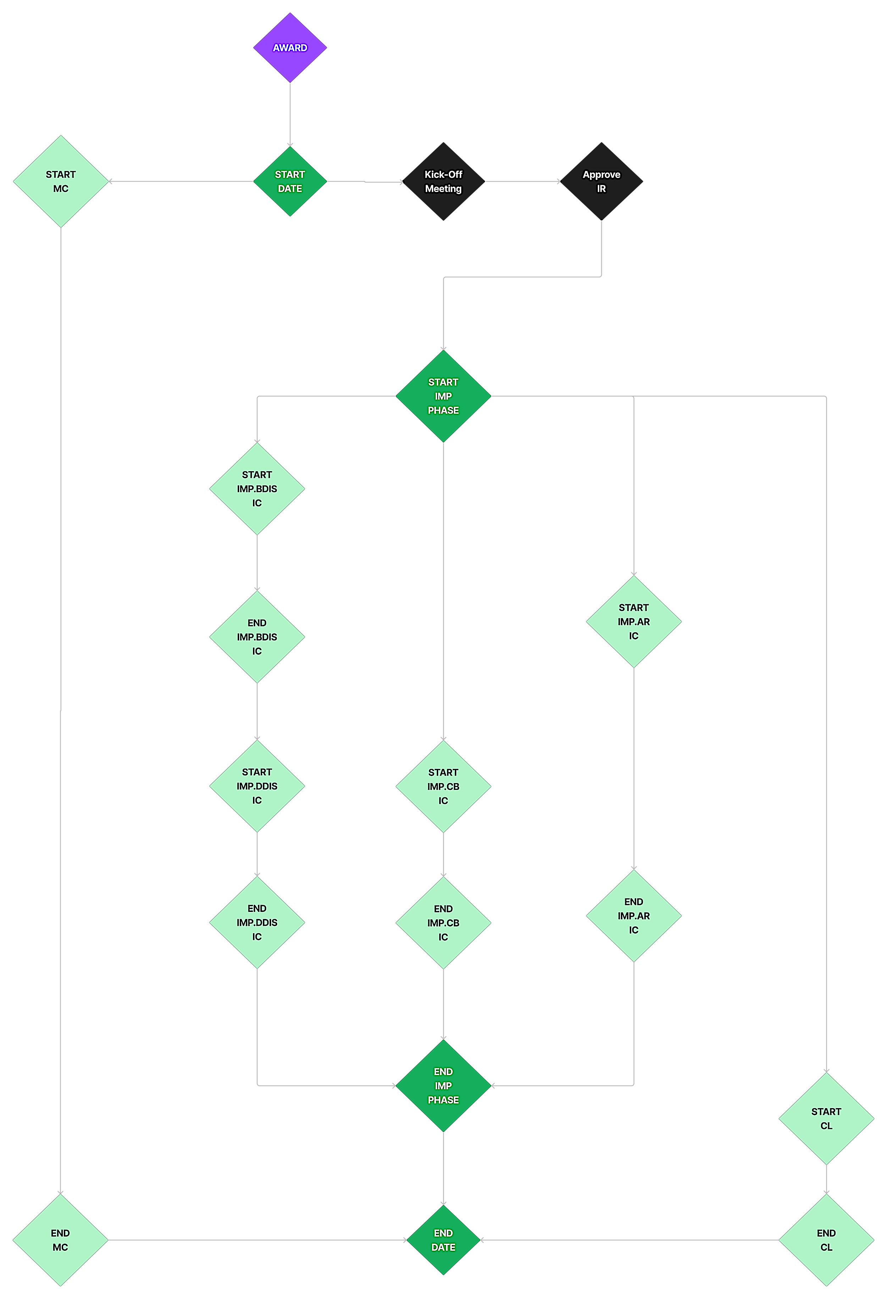

Figure 70 – Reporting milestones of the project

The figure above presents the logical representation of the most important moments of this project. It also may suggest a time wise arrangement of these moments during the implementation. **However, all details about the time planning and about the major milestones within the described activity are presented in section 5 - Timetable of work.**

#### CL – Closing Phase

| ***§ ToR Reference*** |
| --- |
| * ToR, §8 – Closing Phase t |

|  |  |  |  |  |  |  |  |  |  |  |  |  |  |  |  |  |
| --- | --- | --- | --- | --- | --- | --- | --- | --- | --- | --- | --- | --- | --- | --- | --- | --- |
| WBS Code: | CL | | | Name: | | | Closing Phase | | | | | | | | | |
| Expected Deliverables | | | | | | | | | | Tasks | | | | | | |
| CL.PH | Project Handover | | | | | | | | * Carry out project handover * Produce project archive | | | | | | | |
| CL.PA | Project Archive | | | | | | | |
| Timeline | Jan | Feb | Mar | | Apr | May | | Jun | | | Jul | Aug | Sep | Oct | Nov | Dec |
| 2022 |  |  |  | |  |  | |  | | |  |  |  |  |  |  |
| 2023 |  |  |  | |  |  | |  | | |  |  |  |  |  |  |
| 2024 |  |  |  | |  |  | |  | | |  |  | ● ● |  |  |  |

**Activity Description**

● Project Handover

● Project Archive

**Project Handover**

The scope of this activity is to ensure proper phasing out and handover of the project results. The TAT will ensure that all project outputs / deliverables and methods developed, material collected and processed, IT tools and data, training material etc. are passed over to the MoEE and EUOK in a way that can be promptly transferred also to other potential audiences. Our ample organizational and project management provisions will ensure the successful response to this need.

A further aim of this activity is to transfer the knowledge produced and the experience gained during the entire project to the widest possible range of stakeholders and parties involved or interested to be involved in future similar project development and implementation processes as a means to support the future sustainability of the project.

We undertake the commitment to prepare a visual presentation for this purpose, under the directorship of the TL and the participation of the PD presenting a final global assessment, namely the achievements versus objectives, difficulties faced, risks arisen or undertaken, the mitigation measures, and the entire lessons learnt. The above report will be delivered to the EUOK as an appendix to the Final Report and distributed to as many addressees as indicated by the EUOK.

Additionally, during this activity, a final version of the project Sustainability Plan (initially drafted along the Inception Report and updated with the Progress Reports) will be defined. The Sustainability Plan shall contain a final of sustainable project results, the updated sustainability objectives and the proposed actions and responsible actors for ensuring the future use and continuity of sustainable project results. The updated Sustainability Plan will be provided as an appendix to the Final Report.

Moreover, within the scope of this activity, the Draft Final Report will be prepared and submitted (no later than one month before the end of the implementation period). It will contain a short description of project achievements including problems encountered and recommendations.

The Final Report will be submitted within one month of receiving comments on the draft final report. The Final Report will contain:

* A short description of overall achievements including problems encountered and recommendations;
* A final invoice and financial report accompanied by the expenditure verification report

**Establishment of Project Archive**

Regarding the finalization of the Project activities, the TAT will ensure that all deliverables will have been submitted to the Beneficiary before the end of the Project. Starting from the beginning of the Month 23 of the Project, the TAT will start closing the Project documentation and archiving. An archive plan will be agreed with the MoEE which will list the documents that will be archived and the number of the copies.

The Consultant suggests the establishment of an effective ‘archive system’ for the MoEE, which will ensure easy access to all relevant Project materials. This will also contribute to the sustainability of the outputs. On the other hand, regarding the logistical, administrative and financial side, the Consultant will mobilize all backstopping resources for a smooth and successful closure of the Project. TAT will hand over the Project outputs and establish an archive at MoEE premises. All the outputs and documents will be archived in hard and soft copy for future use and reference. Not to mention, the electronic versions of the visibility materials will be submitted to the Beneficiary for future duplications.

Under the scope of Closure activities, all the ICT tools, platforms and portals, including all e-learning material and on-line content, with all its functionalities, will be transferred to the MoEE for use and future maintenance. Therefore, the Consultant will prepare a ‘transition plan’ for the software. At the end of Project implementation, all IT tools will be transferred to the Beneficiary after some adaptation and customization for future updates. The above transition will be done by the IT NKEs at the end of the Project and subsequently sustainability will be ensured.

**Project indicators table**

As baseline for the evaluation of the achievements of the results, we will use a set of indicators, having as starting point the ones presented in the table below and further defined in the logical framework.

| Project Phases | Indicator |
| --- | --- |
| **Inception Phase** | * Each gap identified in the assessment of the current situation shall be classified in one of the following categories, organisational; technical; legal * The inventory of existing information systems that will be integrated with the eID system is complete (approved by IAUT and CAUT) and there is a clear integration solution for each of them * The supply tender for IT equipment can be launched by the CAUT * The inventory of existing information systems to be connected/integrated with the Digital Identity Service is complete and agreed by the relevant stakeholders * The Inception Report and Revised O&M reflects the findings from the Inception Phase and provides a detailed image of the next activities * The revised Basic Algorithm reflects the findings from the Inception Phase |
| **Build eID system** | * All use cases[46] to be covered in the design of the final eID solution * Each use case shall be linked to at least one technical gap identified during the assessment of the current situation performed in the inception period in order to maintain full traceability from the project objectives to the technical solution * The technical design covers business requirements->functional and non-functional requirements->design specifications->development tasks and full traceability shall be made in order to ensure the coverage of the required scope * All tests for blocking functionality passed with success * All functional tests passed * All performance test passed * UX tests may have comments * The Contractor has enough relevant information about the corrections that shall be made |
| **Deploy eID System** | * All potential non-conformities were corrected in the final version of the system (the version that will be deployed on the production environment) * The system documentation covers the whole scope of the system (use cases, regular users, CA users, RA users, administration, maintenance) * All corrections/remediations resulted from the testing activity were completed * The system is installed and configured in the production environment * The product documentation is complete and delivered to the relevant stakeholders |
| **Capacity Building** | * The planning of the training session is completed and approved before the installation/configuration on the production environment * Number of training sessions organised – at least 10 sessions for 2 days each. At least 2 extra sessions organised for staff of Ministry of Economy and Energy * Number of trainees – at least 20 participants per session. At least 5 staff of MoEE trained in extra training session. * Number of study visits organised – one study visit for three days to Italy or Denmark * Number of participants in study visits – at least 5 staff from MoEE * Each training session is carried out as planned * All training sessions are completed by the end of the deployment to production |
| **Awareness Raising** | * C&V strategy delivered before the start of the testing phase * Video materials produced, discussed and delivered before the approval of the C&V Strategy * Distribution channels (YouTube, Social Media, Websites) established before the approval of the Video materials |

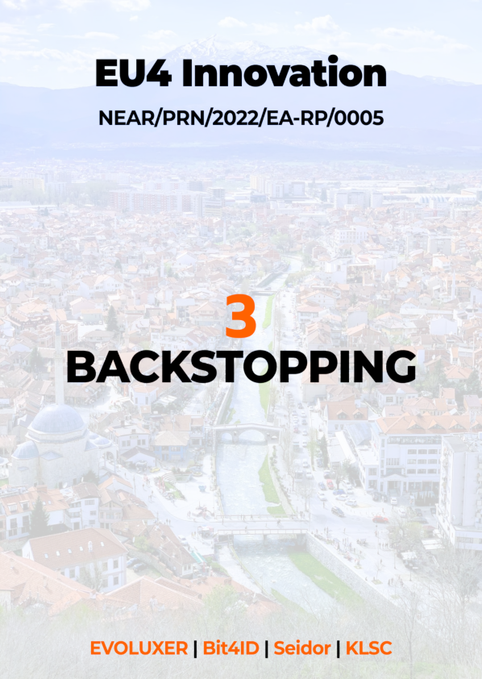

## Section 3 – Backstopping

The first part of the Backstopping section of our Technical Proposal presents in detail our approach and organisation of such structures. The next sections, 3.1 – 3.12 presents in detail how we will adapt the approach and structure to the specifics of this assignments, presenting also our proposals for the key postions in the Backstopping team.

1. **Approach**

In our approach to backstopping, we describe the support services that we will provide during project implementation, demonstrate our capacities to perform designated project activities with emphasis on quality systems and knowledge capitalisation methods and tools. Our backstopping approach is based on achieving synergy between the Project Team (PT) and the Management Team which is essential for smooth and timely implementation of the project and its objectives. Management and backstopping will be primarily performed by EVOLUXER (ES) with support from the consortium partners. We set high-quality supporting organisation structure and backstopping services in line with the ToR. Our proposed approach will ensure robust, highly effective project management coupled with high quality; creative outputs delivered to an agreed timescale. We believe that our Consortium is exceptionally placed to deliver the project successfully.

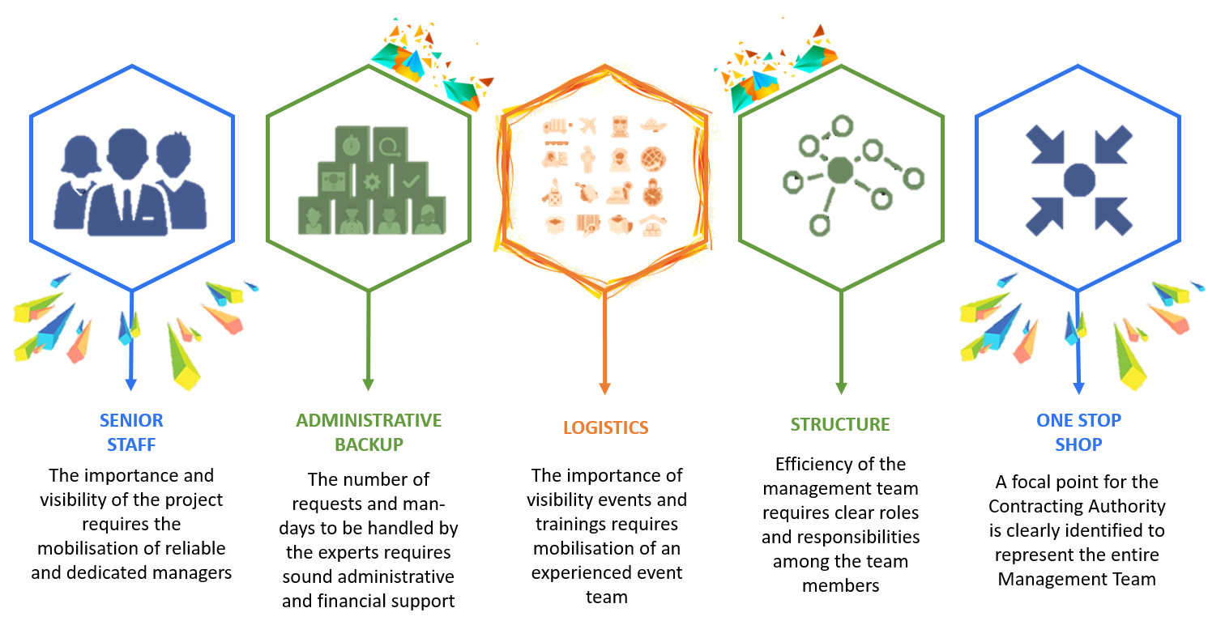

Figure 71 - Principles underlying the set-up of the management team

Our backstopping management approach, has been specifically developed in order to deliver projects for the Institutions and it is integrated into our way of managing business. It is based on extensive experience, best practices, industry-wide standards and the principle of continuous improvement. The management approach combines the key aspects of the European Commission’s PM2 Project Management Methodology (Open edition) with the key aspects of the Project Management Body of Knowledge (PMBOK – 5th Edition). Furthermore, our approach integrates our ISO 9001:2015 compliant policies, processes and procedures for quality management systems and is fully aligned with the ISO 20700:2017 guidelines for management consultancy services.

We have invested significant time and effort in developing, testing and fine-tuning this approach as we are a project-based business and we thrive on the successful delivery of projects to the EU Institutions. Furthermore, this approach and the methodology behind it embodies out focus on delivering quality, ensuring reliability and building trust, it is a key part what makes us an excellent partner for you

The management approach consists of three distinct, yet integrated layers.

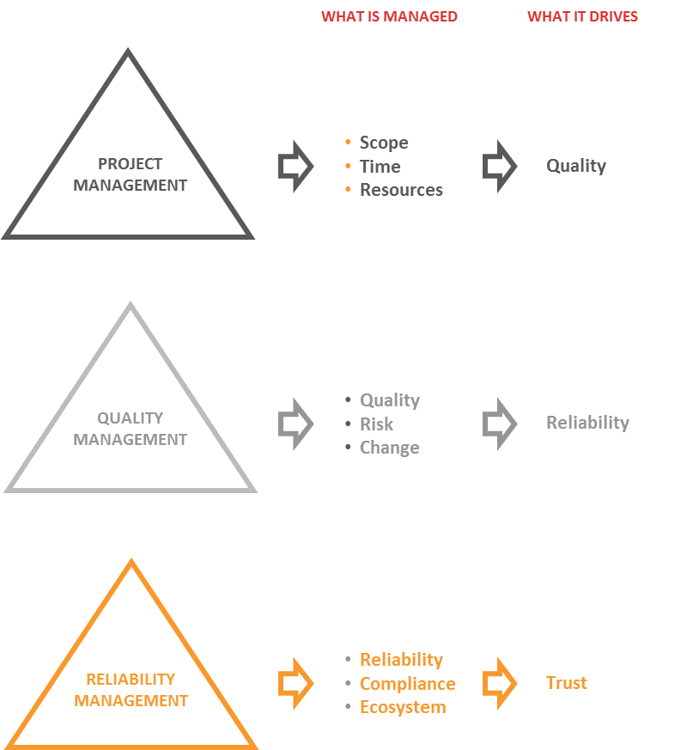

Figure 72 - Management approach basics

Project Management is the first layer under our management approach and it is under the responsibility of the Project Director, who as a part of this, manages scope time and resources, which all drives quality.

Quality Management is the second layer of our approach and is under the responsibility of the Quality Manager. The layer includes managing quality, risk and change, the management of which drives reliability.

Reliability Management is the third layer of our management approach and is the responsibility of every member of the team. Reliability, compliance and the project ecosystem are managed as a part of this, driving trust.

All these activities are supervised by the Project Executive and supported by the project team.

Our management approach separates each project in different process groups or phases. In each phase, the three different layers from the model above, are managed. However, we perceive project management as a continuous process, in which each phase provides the foundation for the next.

**Project phases**

The classical approach to Project Management laid out for instance in PMBoK®, PM2 and relevant ISO standards (ISO9001, ISO20700 and ISO21500) has five process groups, which are: Initiating, Planning, Implementing / Executing, Controlling / Monitoring & Controlling and Closing. Our approach (illustrated below) is an adaptation of this (as it is explained also in Section 2 - Strategy), but is still aligned with the aforementioned standards and practices. Our approach can be illustrated as seen in the following figure.



Figure 73 - Project Phases

We integrate the initiation and planning steps into an inception phase, a kick-off meeting and the elaboration of the inception report.

**Inception phase**

The inception phase is the start of the project and typically takes place from the moment the contract is awarded (and then signed) to the inception meeting and report. Naturally, depending on the contract, the phases may be an official part of the assignment or not, but regardless, these phases exist. This is important, because it includes:

* **Kick-off Meeting** – to discuss any changes in the state-of-play since the proposal was prepared and to discuss any changes that the beneficiary may like to see to the approach
* **Internal preparation**[47] - including for example:
  + - Project management work plan
    - Quality Plan
    - Risk and change Logs
    - Stakeholder lists
    - Communications plan
    - Status Dashboard
* **Inception report and slide set** – A document largely based on the proposal, but taking feedback from the kick-off meeting into account and integrating the different artefacts from the three layers of management
* **Inception Meeting** – presenting the content of the inception report and relevant materials from the internal preparation (e.g. updated planning, risk log, etc.)

The inception phase is the preparation for the execution of the actual tasks, which takes place in the implementation phase.

**Implementation Phase**

The implementation phase consists of the main body of work of the project. Regardless of the nature of the project, there are a number of different steps that we take, which include:

* **Internal preparation** – the Project Director ensures complete alignment of the team with the Inception report and latest approach and sets out expectations
* **Data collection** – The Team Leader launches the data collection process ensuring that the right methods and tools are used and that they are deployed correctly in order to collect the best possible data – in this case, this includes desk research, interviews, surveys and focus groups.
* **Analysis** – The Project Director ensures that the right tools are available for the analysis that the right resources are made available and that the instructions for the analysis are clear and that everyone is fully aligned as well as being aware of and documenting any assumptions that are made and any limitations of the methodology.
* **Conclusions & solutions** – The Team Leader ensures that the conclusions are directly linked to the findings and that any proposed recommendations or solutions are solid and build upon the conclusions.
* **Reports** – The Team Leader ensures that the reporting is in line with the requirements and expectations of all stakeholders: CAUT/IAUT, main beneficiary of the project in terms of structure and content as well as presentation, respecting the guidelines and visual identity.
* **Meetings & workshops** – The Team Leader ensures that all the relevant individuals are invited to the meetings, the proper preparation is carried out (e.g. presentations) and that minutes are taken and validated.
* **Implementation** – Implementation is prepared by the Team Leader and a monitoring system is put in place in order to facilitate future evaluation of the implementation of the project activities.

**Closing Phase**

During the closing phase, all pending issues related to outputs / deliverables are finalised. In addition, personnel and experts are discharged or reassigned to other projects. An internal evaluation is carried out, logging lessons learnt as well as individual evaluations of the different team members. Furthermore, an external evaluation takes place to provide feedback on the performance and following that a letter of satisfactory completion (as this is sometimes required for other tenders). Finally, all administrative issues are closing and project documents are archived, in order to be available for other assignments.

1. **Working Structure**

Our management structure will facilitate and support the daily work of our experts and staff on site or mobilised for specific assignments. Such integrated structure is advantageous for the effective implementation of the Project for two reasons. On the one hand, project team members work more efficiently because they feel part of a broader supportive Management team. Indeed, they are secured by structural mechanisms (internal communication, insurance, financial management, EU coordination). On the other hand, the close monitoring allowed by our management structure also makes the project team members more accountable, challenging them to deliver high quality outputs.

1. **Working Process**

The experts involved in the project will be provided with an updated version of our Project Management Manual. This will allow them to familiarise with the key process of our working system, as adapted to the specificities of this project.

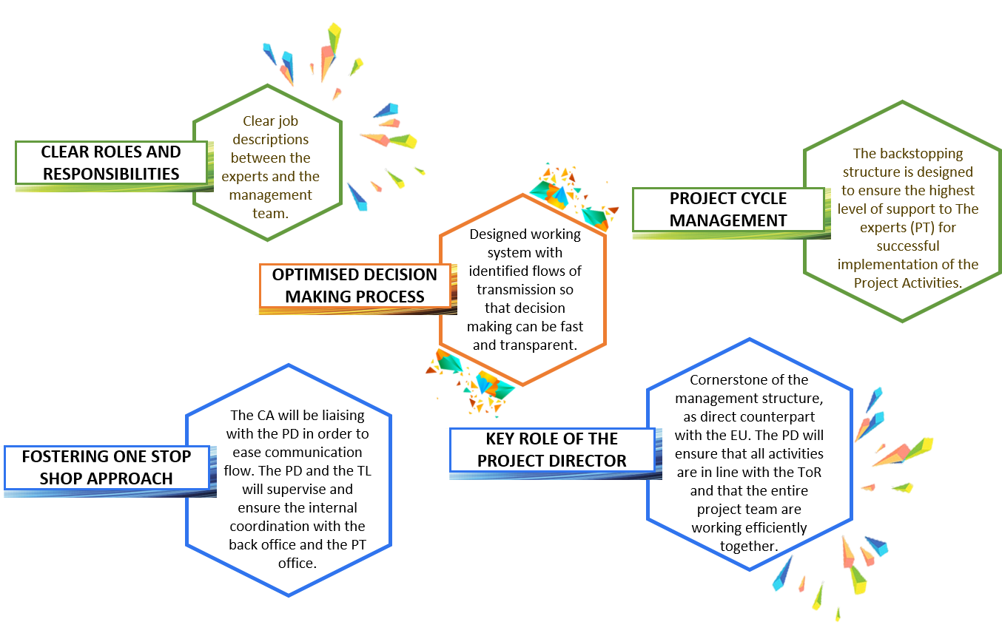

Figure 74 - Principles of our Project Management Manual

All our Consortium partners are integrated in the backstopping working process according to their clearly defined role:

* **The experts (the Project Team)** are crucial for the working process. Therefore, the backstopping structure is specifically designed to ensure the highest level of support to the implementation of the Project activities
* **Operational and Technical Backstopping** will be channelled through our designated teams, under the coordination of PD together with the DPD and quality control manager.
* **The Project Management Process** is crucial for disseminating learned lessons as well as ensuring quality standards throughout the whole implementation of the Project.

1. **Working with the key stakeholders**

In order to simplify and guarantee efficient lines of communication with the key stakeholders, our consortium follows the concept of “**one face to the customer**”. However, given the complexity of the tasks required, we are installing a contract management team with one representative of each consortium member, as described in the next section.

Therefore, for issues related to the contract, all members of the consortium board should be involved. They will always be the contracting authority’s first contact, also in charge of ad-hoc inquiries from the client. For the CAUT and IAUT, having the consortium board responsible for the overall organisation of the contract means that there is always someone directly responsible for activities. The CAUT has a direct line to the relevant people who are always up-to-date on the status of all current projects and can be briefed about requirements. This guarantees efficient communication structures between the contracting authority and our consortium, and forms a basis for the successful implementation of all specific contracts.

The day-to-day communication with the CAUT and IAUT by the responsible Team Leader will be based on a number of measures:

* **Regular status calls and emails** (can also be supported by video conference);
* **Regular quality reports** during different stages of organisation;
* **A shared project plan** with the contracting authority, detailing all responsibilities of the individual team members, including key deadlines and milestones.

**Our aim is for our clients to be always kept informed**, and to have input whenever they wish, without having excessive interaction. The results of the kick-off meeting should be thorough enough for our team to operate independently, keeping the contracting authority up-to-date, but not having to clarify every single issue.

This means that the level of client involvement is dictated by the client. To ensure that our working methods are under continuous scrutiny, the project leader will keep the contracting authority regularly up-to-date on the status of the project and of all deliverables. The contracting authority is also able to contact us directly, should any issues arise on their side. Most communication between the project leader and the contracting authority will be conducted via email, phone and video-conference, rather than face-to-face meetings. This will, however, in no way limit the scope of information provided to the contracting authority, or the contracting authority’s capacity to contact our project teams whenever necessary.

**Approvals**

One of the important points to be clarified at the outset of project implementation is the workflow for deliverables which require input both from our consortium and the contracting authority. For example, the contracting authority's approval would be required for an overall event design before this is applied to any materials.

Another point is a website, which should be approved by the contracting authority before it is activated. For all such deliverables, the input required from the contracting authority will be clearly indicated in a shared project plan, including time for feedback, revision and approval. We also recommend establishing a standard timeframe for approvals at the kick-off meeting, so that all parties can plan appropriately and so that there are no unexpected delays. To reflect this, approval periods of one week are included as standard in all time schedules, for amendment in exceptional circumstances.

**Managing complaints**

A key indicator of high-quality staff performance and product/service delivery is a low number of complaints. Our professional problem resolution and complaint management system includes the following three steps: before the project, during the project and follow-up.

1. **Project Management**

Three main cornerstones of project management constitute the Project Management Trifecta: **scope, time and resources**. “**Scope**” defines what the end result should be and what is covered by the project. “**Time**” is about how long is needed to produce an output / deliverable and the required deadlines, while “**Resources**” is about the work effort and the cost required

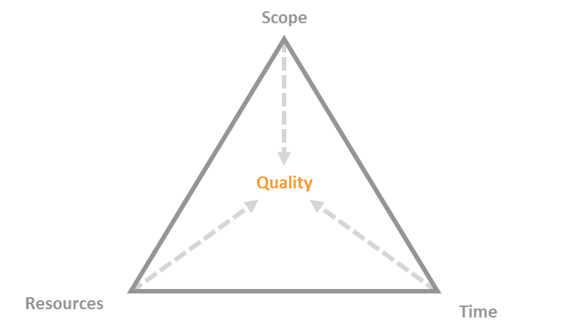

Figure 75 - Project Management Trifecta

As a part of managing these aspects, performance indicators are developed, in this case they are:

* Management of the work-packages and activities to planned milestones
* Timely and successful launch of the preliminary mapping
* Timely and successful organisation of the workshops and the events
* Number of and attendance at the expert workshops and the events
* Compliance with project aims, scheduling and budget
* Timely delivery of results, reports on progress and deliverables
* Effectiveness of integrated management[48] - working together across teams.

The approach to Project Management and the different elements described within the scope, time and resource management sections below are aligned with and cover all the key elements of PMBoK©, PM2, ISO 21500 for project management and ISO 20700 for Management Consulting services. Project Management and all its aspects are under the responsibility of the Project Director, who is supported by the Project Team.

1. **Scope management**

Scope setting is considered as the first and most decisive step for delimiting the broadness and the depth of a project. Project scope management, eventually, is defined as the process ensuring that a project comprises exactly all the work required this is important in order to ensure that the focus is not diluted by scope creep, which can lead to the project either no providing the level of detail and quality required (in case the scope is broadened) or that the full breadth is not covered (in case the depth is not covered)[49].

We treat scope management as an iterative process. While the project will be implemented, its scope should be continuously reviewed and updated, in order to ensure that it accurately maps the main project aspects in line with the services required and the objectives to be achieved.

Our experience in the execution of all kinds of projects is that it is exceedingly useful to present the most important attributes of the study through a logical framework matrix (logframe). The advantages of such a presentation are notably:

* At the bid process or at an early stage of the project launch the log frame provides a summary of key project elements in a standard format and can be used as a basis for discussion
* During implementation the log frame provides an overview that allows to ensure that we are always working toward the actual objective and that there is not a deviation from that. Furthermore, it reminds us of the indicators of successful implementation

In the context of scope management and for setting the boundaries of each specific project, it is first and foremost based on the proposal, which derives from the Terms of Reference. Based on this and the discussions with the beneficiary, we improve the logframe, thus refining the scope. Furthermore, the logframe helps define the objectives and create a common understanding and vision for the project. The LogFrame of the project is presented separately in Section 6.

The scope is thus a very important aspect to manage in itself, naturally, so it the timely delivery of the project.

1. **Time management**

Time management is another important aspect as a lack thereof can lead to delays in deliverables and in the completion of the project. A delay in one task can lead to delays in a dependent task. For this reason, the work breakdown decomposition is important, the logical dependencies and sequence between tasks and activities is defined (this is done at proposal stage and updated during the inception). In addition, the duration of tasks and activities is estimated taking into consideration the start and end date of the contract.

We use the Critical Path Method (CPM), which is a scheduling technique that calculates the necessary path of tasks and / or activities, hence the shortest possible duration of the project from its initiation until its completion. Often tasks and / or activities may have a delay margin and can, therefore, be slightly delayed without affecting the project completion date. A task and / or an activity is marked as critical and thus, it cannot be delayed, when one of the following stands:

* **Its delay margin is zero**, as in the case of the events that will be planned well in advance and it will not be possible to change the date once the event organisation is launched the then there is zero margin, so the content and speaker arrangements have to be finished on time – as is often the case in the project.
* **There is a mandatory starting or end date**, for example in the case of broader stakeholder engagement and consultation or where data needs to be collected before the summer period in order to ensure the availability of interviews, survey respondents, etc.
* **The task end date coincides with the date for the termination of the project**

Critical tasks and activities are therefore prioritised and special emphasis is put on them in order to shorten the duration of the critical path by compressing the critical path activities, allocating more resources and implementing more activities in parallel. However, in practice it is a combination of techniques that is being applied, in order for a realistic and useful timetable to be drafted, which to the extent possible contains buffers to allow for potential delays. The planning is illustrated in a Gantt chart.

In developing the planning, we do not only rely on the work breakdown, but also on experience and best practices, taking into account historical data on how long specific tasks and activities take (e.g. how long surveys need to be open in order to ensure sufficient responses). The Gantt chart and overall planning is then discussed with the team in order to ensure that everyone is aware of the planning and the critical paths as well as to make sure that everyone agrees that the assumptions, upon which the planning is based, are realistic.

The Project Director is responsible for updating the Gantt chart during the inception phase and then maintaining it throughout the project, ensuring that it is up-to-date and that measures are taken to mitigate any risks of delays. The Gantt chart and related data in terms of Time management are presented in Section 5 of this proposal.

As a part of managing time, the Project Director continuously follows up on the status of the different activities and updates the Status Dashboard, which is used as a basis for the monthly status calls. Delays can be caused by a number of different things, such as lack of individuals willing to help fill the mapping database or technical issues. In order to minimise the risk of delays, mitigation measures are taken for example by having desk research time foreseen to gather initiatives throughout the project.

In case of significant delays in tasks or activities considered critical, whatever the cause, the Project Director will report this to the beneficiaries and the CAUT, along with suggested corrective actions that will be taken. Such corrective actions can for example be:

* Allocating additional resources to the completion of the task / activity
* Ways of increasing the efficiency of the task / activity even further
* Ways of shortening the needed time for subsequent (dependent) tasks / activities or finding ways of already starting those tasks / activities with the preliminary results of the delayed activity (and then adjusting the work once the delayed activity is finalised)

In case there is a delay that cannot be mitigated and which will impact the timeline for completion of other critical activities or which will cause a delay in the completion of the project, the Project Director will set up a meeting or teleconference with the Steering Committee in order to discuss the issue.

1. **Resource management**

Our Resource Management approach consists primarily of our approach and processes for organising, managing and leading the Project Team, but also human resources. First, we introduce the general structure of the team as well as the roles and responsibilities within this backstopping structure. Thereafter we present how we manage capabilities, including the skills that are needed and the team that we propose in order to meet these needs. Thereafter we present how we propose to allocate the team members across the different tasks and activities as well as our approach to ensuring continuity of services.

**Organizational structure**

The figure below, shows the general structure that we will use for the team and project organisation. As mentioned above, we have an assignment of roles and responsibilities at project level. Further to the above, in Section 2 we present the roles and responsibilities of the different people involved in project implementation. Through this, we provide a further insight into how we manage and execute our work.

Table 43 - Main principles of the organisational structure

|  |  |  |
| --- | --- | --- |
| **Reviewing and validating the overall direction and policy of the project; providing guidance on key issues.** | **Steering Committee (SC)**  Members and observers:   * Ministry of Economy and Energy * EU Office in Kosovo; * Ministry of Internal Affairs * Central Bank of Kosovo; * Representative of the NIPAC, as observer, * Other relevant stakeholders (e.g. civil society organisations, business community, banks or other financial organisations * Other stakeholders may be proposed (in consultation with the beneficiaries) as PSC members or observers   **Project Director**  Ensuring overall implementation | **Contracting Authority**  Supervises project implementation; makes final decisions and gives approvals  **Team Leader**  Responsible for day-to-day implementation |
| **A full backstopping service, led by EVOLUXER and drawing on the resources of all consortium partners and capacity providers** | **Backstopping services**   * Including recruitment; financial management; digitisation and IT support and tools; quality assurance and control; event management, visibility and PR support; graphic design * Led by Deputy Project Director, Coordination of the inputs of all consortium and resource providers | **Experts**   * Senior experts * Other Experts * In-house experts |

**Backstopping Structure**

The project Backstopping Structure consists of the Project Director, Project Coordinators and Technical Backstopping Team. Following is a presentation of the same. We follow the general policy that the Bid Director, who reviews and signs off on the proposal becomes the Project Director, similarly, the Bid Manager becomes the Team Leader. We do this in order to ensure that the knowledge acquired during the bid process and the relationships established among the members of the Team will allow its rapid kick-off and efficient implementation of each project.

**Project Director**

The Consortium Board has appointed a Project Director, who will represent the Contractor on all contractual matters and coordinate backstopping of the Project Team for effective management and implementation of the project. The Project Director (PD) will be the single person to represent the Consortium before the CAUT and IAUT. The PD will represent the contractor in strategic and financial relations with the CAUT.

He will be ultimately responsible for the implementation of project activities, the quality of recruitment and outputs, and the efficient use of budgets. And he will take remedial actions when deficiencies are identified. The PD will support the Team Leader (TL), who will be responsible for day-to-day implementation, discussing all relevant matters with her, finding solutions to challenges and ultimately ensuring her performance. He will also support the Project Manager (PM) in ensuring the efficient use of project funds, coordination of recruitment, and delivery of effective backstopping services.

The PD will be present in Kosovo every month and will be available for in person or e-meeting upon short notice. He will maintain contact with consortium partners and resource providers, ensuring their agreed contributions and meeting with them at least twice a year.

**Quality Control Manager**

We attach utmost importance to the development of high-quality outputs in this project. Our quality team will be composed on national and international personnel from our consortium to reflect upon our international technical expertise with national experience.

The Quality Control Manager will oversight of all quality systems, processes, and actions, in close cooperation with the PD/DPD, Project Coordinators, the Team Leader and the internal quality team, and mobilising the quality team for the review of the project outputs (particularly the strategy, roadmap, guidelines, and manuals).

The Quality Control Manager will also develop and maintain the project’s Quality Manual and the required control procedures required during the project implementation. They will ensure proper and timely dissemination of the Quality Manual (and its revisions) to all interested parties.

They will also ensure that deliverables match the requirements, as well as conduct project checkpoint evaluations at strategic points in project lifecycle to assess project status, risk and quality. Finally, the Quality Control Manager will work as a team with the Project Director/Deputy Project Director and the Team Leader in order to assess risks and impacts in the Project Deliverables.

**Backstopping Team**

Our backstopping team is divided in two categories that provide a clear picture of the required skills for project implementation, in terms of project cycle management, administrative and financial skills, as well as technical experience in the eID and software sectors.

We developed a comprehensive methodological set to support the operational and technical backstopping teams; it comprises a list of procedures and guidelines, detailed description of backstopping roles and responsibilities, all aiming to improve the effectiveness of project planning, monitoring and implementation activities. The above have been developed in full alliance with applicable EU rules and procedures.

Respecting the project’s individual characteristics and requirements, the procedures will be further customized during the Inception Phase to fit the expectations of the Contracting Authority, and beneficiaries. To support and facilitate the implementation of the above, a set of IT tools will be employed and customized according to the project’s needs.

Operational and Technical Backstopping guidelines and procedures will be distributed to the Project Team and the entire back-stopping structure on day 1, while again an updated version, tailored to the specific needs of the project, will replace the first one by the end of the Inception Phase. [The Operational and Technical procedures will be incorporated in the Project Monitoring and Quality Control Procedures Manual].

**Project Coordinators from partner organisations**

The primary goal of the project coordinators is to ensure that the work of the Project Team is not disrupted by administrative issues and that all inputs are delivered in a timely and efficient manner. Project Coordinators will take place primarily remotely and onsite with periodic visits of the PD and DPD, and of the Operational Backstopping Team members, mainly for guiding, training, and supporting the experts and support staff. Project Coordinators Team cover quite diverse matters, including:

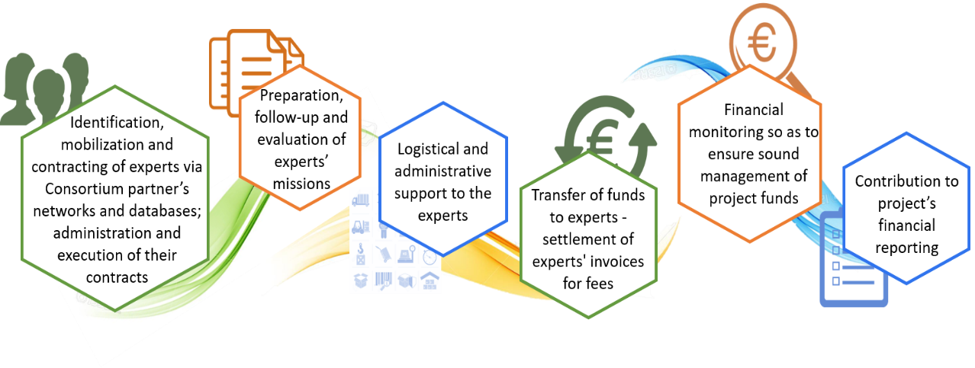

Figure 76 - Project Coordinators’ responsibilities

**Technical Backstopping Team**

The Technical BS Task Force comprises of Technical Backstopping Managers, that will be responsible for providing the Technical Backstopping of the project. Each of the backstopping managers will be responsible to coordinate one technical back-stopping area.

Technical backstopping will be provided timely during on-site meetings as well as remotely (via electronic means, teleconferences) so that all project activities are completed on time.

The primary goal of the technical backstopping is to provide technical advice and support to the experts as well as assuring highest quality of outputs. It will be provided according to the needs of the project and the experts, in close collaboration between the Project Director and the Team Leader.

Technical backstopping will take the form of:

* Providing specialist advice covering all the main aspects of project activity including, support in identification of knowledge sources, state-of-art methods etc.;
* Providing peer review of key deliverables/outputs as part of our Quality Assurance procedures;

In the unlikely event (for example, through illness) that any member of the Project Team cannot participate as planned, identifying a satisfactory substitute.

**Quality Management**

Our Quality Management approach is the second layer in assuring that we provide quality work and deliverables, the second layer is our quality management system and is under the responsibility of the Quality Manager (but of course also implemented by the Team Leader and team).

The approach consists of three main elements; Quality management as well as risk and change management, which help drive quality and ultimately our reliability, as illustrated below.

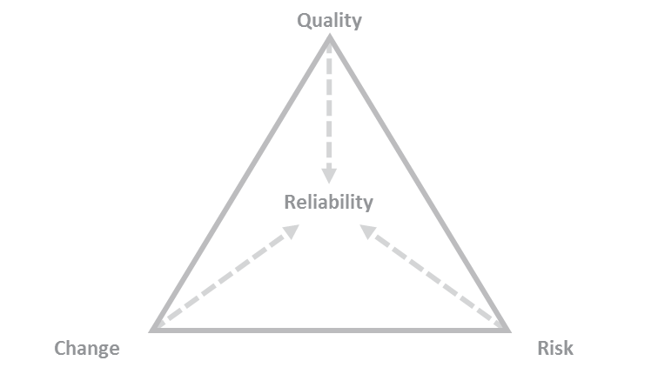

Figure 77 - Quality Management Trifecta

As a part of managing these aspects, performance indicators are developed, in this case they are:

* Quality of the mapping of trends
* Quality of the mapping of initiatives
* Quality of the assessment of impacts
* Quality of the stakeholder engagement
* Quality of the communication and dissemination materials
* Quality of the thematic papers
* Quality of the reports
* How well risks are managed
* How quickly and well the team responds to change

These will be monitored throughout and reported on in the monthly status reports.

The approach to Quality Management and the different elements described within the scope, time and resource management sections below are aligned with and cover all the key elements of PMBoK©, PM2, ISO 9001 for quality management and ISO 20700 for Management Consulting services.

Quality Management and all its aspects are under the responsibility of the Quality Manager, who is supported by the Team Leader and Project Team, all supervised by the Project Executive.

Quality management focuses on the end-user, meaning the outputs and outcomes of the work. The right way to achieve quality outputs and outcomes is to ensure quality throughout the processes that lead to these outputs and outcomes, not only focus on quality of the outputs themselves.

Therefore, quality management for us starts at the recruitment phase, where we hire talented, quality-minded people. It continues through evaluation, feedback and training as laid out in the previous section. Quality is in our company cultures and everything that we do, both in the company in general as well as on projects.

The quality management in the context of projects focuses on the quality of:

* Project management
* Work processes and products
* Outputs (deliverables)

In each of these areas, the Quality Manager provides guidelines and templates, which help pro-actively ensure quality as well as checklists and carrying out monitoring, which helps ensure quality in while work is ongoing. Finally, the Quality Manager carries out reviews at key points.

Making use of checklists carried with it, a risk of too much focus on tick-box approach, so the Quality Manager and Team Leader are also responsible for reminding the team of the bigger picture throughout the work.

**Quality of project management**

**Guidelines and templates**

Rather than being involved in the production of all project management documents and helping in the process, the responsibility of the Quality Manager lies in providing guidelines, templates and checklists as well as monitoring, control (audits) and reviews.

The Quality Manager provides the Team Leader with guidelines and templates for project management[50]. The guidelines consist of the following:

* **Our project, quality and risk management handbook** – This is the basis for our management methodology, it includes the policies, processes, procedures and guidance on how project management should be executed
* **PMBoK 5th Edition and PM2 Open edition and the relevant ISO standards** – As reference material if there should be needed to adapt any aspects of our management approach in order to optimise the specific project
* **Project Status Dashboard** – The dashboard is a key component of the project management as it provides key templates (e.g. Gantt chart, skills matrix, etc.), but also enables the Team Leader to track and manage various aspects of the project as it progresses. Finally, as previously mentioned, it serves as a basis for progress reporting
* **Project management tool** - This tool helps set up a run various internal aspect like the budget, the resource planning and track the timesheets, meaning how much time is spent on what thus allowing for better resource planning, etc.
* **Templates** – This includes templates that are not part of the project Status Dashboard and project management tool, e.g. team evaluation templates, project closure checklist, etc.

The Quality Manager provides these guidelines and templates for the Team Leader to fill in and to use. A number of these are already filled out during the proposal phase and is included in the proposal (e.g. the previously presented resource plan, skills matrix, Gantt chart, etc.). Furthermore, the Quality Manager also provides the guidelines and templates for work processes and products as well as for outputs (further detailed later in the document) so as to be aware and able to align with these (which are provided to the team).

**Checklists**

The Quality Manager is also responsible for providing the Team Leader with the check-lists that are needed in every phase of the project, from the proposal phase to the closing phase. These checklists include:

* **The proposal project management checklist** – This contains all the project management elements that need to be prepared during the development of the proposal in order to be sure that the project can be successfully executed – e.g. the elements included in this chapter as well as the budget, etc.
* **The project inception checklist** – This contains all the items to be updated (e.g. Gantt chart, resource plan, risk log, etc.) as well as all the things that need to be put in place, like checking whether non-human resources are available and operational, etc.
* **The project implementation checklist –** This is a checklist that contains two parts, a part that is checked through at the beginning of the phase (e.g. that roles are clear to everyone) and a part that is repeated on a monthly basis (e.g. ensuring that planning is being adhered to and that the risk log is up to date)
* **The project closing checklist** – This is aimed at ensuring that all the closing actions are taken, like asking for feedback from the CAUT and the IAUT, finalising all closing management documents, storing all the files correctly, etc.

Furthermore, the Quality Manager provides the Team Leader with copies of the checklists for work processes and products as well as for outputs (further detailed later in the document) so as to be aware and able to align with these.

**Monitoring, controls and reviews**

Both at the proposal phase and during the phases of project implementation, the Quality Manager monitors the work of the Team Leader, ensuring that all the needed documents and tools are used and that the processes are followed. This monitoring is carried out based on the checklists that the Team Leader fills out.

Furthermore, at the initiation and closing of each phase, the quality manager does a full review of the documents, ensuring that the relevant templates and tools are used correctly. In addition to this random controls are carried out during the different phases, the controls are random in order to ensure that the tools, templates and procedures are followed throughout. The controls consist of checking specific elements such as:

* Meeting minutes
* The elements in the Status Dashboard
* The project management tool

The controls are planned by the Quality Manager, but the plan is only shared with the Project Executive. In addition to this, the Quality Manager also carried out unplanned controls as the need arises.

**Quality of work processes and products**

The Quality Manager also plays an important role in ensuring the quality of work processes and products (by products we mean outputs that are not deliverables e.g. the interview guides, the **analysis behind the guidelines**, etc.).

**Guidelines and templates**

The Quality Manager makes guidelines and templates available to the team. The guidelines and templates for this project consists of the following:

* Guidelines for:
  + Desk research
  + Current state assessment
  + Preparing and carrying out interviews
  + Conducting field visits
  + Questionnaire design and survey implementation
  + Monitoring and evaluation of project activities
  + Training Needs Assessment
  + Training and services delivery processes
* Templates for:
  + Desk research template (compiling findings)
  + Interview template (both questionnaire and notes)
  + Digital readiness/maturity assessments
  + Monitoring and evaluation framework template
  + TNA Template
  + General word template
  + Training and service delivery manuals

These guidelines and templates help ensure that work processes are executed following clear processes based on best practices as well as that they are executed correctly and with consistency is ensured by using the templates.

**Checklists**

In terms of checklists to help ensure the quality of work processes and products these are naturally related to the execution of the different tasks and thus closely linked with what is provided in terms of guidelines and templates, but also covers aspects for which there are not templates.

The checklists for the quality of work processes and products for this project include:

* Desk research checklist
* Stakeholder engagement
* Interview checklist
* Field visit checklist
* Survey checklist
* TNA checklist
* Training and service delivery checklist
* Monitoring and evaluation checklist

These checklists are filled out by the team it carries out the work.

**Monitoring, controls and reviews**

Monitoring is carried out by the Quality Manager during implementation, based on the checklists. Furthermore, random controls are carried out, verifying that the filled in checklists correspond to the actual work that has been carried out. These controls are planned by the Quality Manager, but only shared with the Project Executive so that they seem random to the team.

Furthermore, reviews are planned and carried out by the Quality Manager at key stages throughout the project. In this case, the reviews of the quality of work processes and products are:

* Inception report
* Interview guide/questionnaire
* Survey questionnaire
* Methodology for analysis
* Monitoring and evaluation framework
* Interim report
* Plans for workshops and the conference
* Final deliverable

Based on these reviews, the Team Leader and Team are provided with feedback on whether the work is of the required quality and possible improvements.

**Quality of outputs**

The Quality Manager is also responsible for assuring the quality of outputs (deliverables), similar to the other areas of quality control, the approach consists of guidelines, templates and checklists as well as monitoring, controls and reviews.

**Guidelines and templates**

In terms of guidelines and templates, these also play an important role for outputs. For this project the relevant guidelines and templates include:

* **Our style guide** – This lays out the style in which outputs should be created, ranging from numbering, tone, tense, visuals, etc. The guide is based on best practices and extensive experience in what works best
* **The Interinstitutional style guide** – This style guide serves as the reference material for all matters not covered by our style guide
* **The instructions for the European Commission visual identity** – Instructions on what documents produced for the European Commission should look like.
* **Report templates** – Report templates following the required visual identity

These guidelines and templates are the proactive step in ensuring the quality of outputs.

**Checklists**

In terms of checklists to ensure the quality of outputs, the Quality Manager leverages the following checklists:

* **Structure and logical sequence checklist** – Aimed at check that the basics sections are all in the document, that they contain the right elements and that the way in which it is structured makes sense to a reader, including e.g. whether the argumentation makes sense
* **Language use and readability checklist** – Aimed at checking language use, grammar, that the text is as easy to read as possible, without oversimplifying the content.
* **Visual identify and formatting checklist** – Aimed a checking that the deliverable is in line with the required visual identity and that the formatting throughout the document makes it visually attractive and easy to read.

These checklists are used by the Team when preparing the deliverables, before they are sent on to the Quality Manager for Review.

**Monitoring, controls and reviews**

During the production of the deliverables, the Quality Manager monitors the quality of the outputs by verifying the checklists. Furthermore, the Quality Manager plans controls (but only shares this planning with the Project Executive). These controls consist of comparing the filled-out checklists with the actual work to make sure that they are aligned, meaning that the items checked have also been carried out. Finally reviews of all the above-mentioned aspects are carried out of all deliverables before they are sent to the CAUT and the IAUT.

1. **Knowledge Management**

The nature of the project requires effective Knowledge Management processes that will support the work of the Project Team.

The knowledge management of the Consortium partners under the leadership of Evoluxer has the in-house capacity to ensure that existing knowledge and best practices relevant to the project are timely available to the members of the Project Team.

Consortium partners contribute to the creation of further relevant knowledge in the process of project implementation. Through their vast project experience and comprehensive network of resource partners, Consortium members and the pool of experts contribute to the effective provision of knowledge and transfer of know-how. Within the project context, the knowledge management (KM) system comprises the following elements:

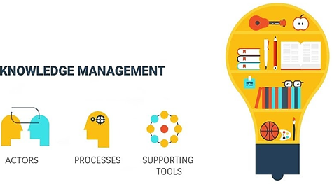

Figure 78 - Knowledge Management

**Knowledge management actors:**

The overall Coordinator of the KM system will be the Project Director. The partners’ Project Coordinators will act as Knowledge Facilitators on behalf of their organization for this project, while the Thematic Advisors will act as Knowledge Thematic Area Managers.

They will interact with technical backstopping members in order to provide and share knowledge on requested areas. In order to address knowledge requests by PT members to appropriate persons, at the outset of the project, the Project Director will map the relevant Thematic Advisor / Knowledge Manager who in his / her turn will respond having capitalized the existing know how both at the partners level (provided through partners’ Project Coordinators) as well as at the Thematic Advisor level.

**Knowledge management processes:**

At the project outset, the main areas and sources of knowledge will be recorded per partner in terms of relevant services and sectors to the project. Following this, a process for managing specialized knowledge related requests from the Project Team will be defined in detail.

It is envisaged that KM requests by experts are first assessed by the Team Leader. In case the requests cannot be addressed by the TL, he will communicate the request to the Project Director who shall forward the request to the relevant Thematic Area Coordinator (keeping the Knowledge Facilitators copied). Thematic Advisor will respond having capitalized the existing know how both at the partners level (provided through the partners’ Project Coordinators) as well as at the Thematic Advisor level.

**Supporting knowledge management tools:**

In order to facilitate the exchange of knowledge and resources both among experts and between the experts and members of the Technical Back-stopping Team, a **web-based collaboration platform will be employed for this project**.

This platform will provide a digital work space to support the virtual communication and cooperation between Project Team members. Through this platform, users will have access to a wide range of tools and features necessary for the successful coordination of project activities, such as e-mail, on-line forums, chat, calendar, message board, document management etc. The platform will support the experts and members of the Technical Back-stopping Team to share project files, exchange and co-create files, share information and material, organize discussions. The collaboration platform will be administered by Evoluxer. An overview of the project’s knowledge sources is presented in the next figure:

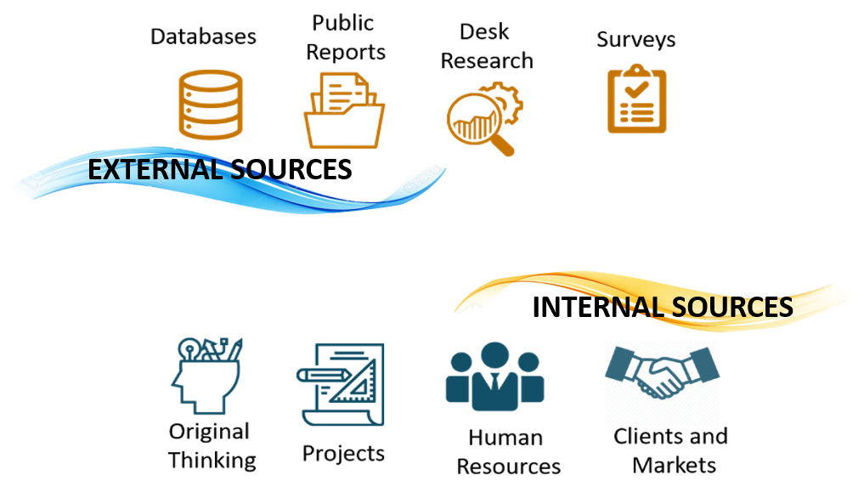

Figure 79 - Knowledge management sources

Methods and tools used include:

* **Interviews and Discussions** during the project management meetings, and meetings with Contracting Authority (to gather their views and relevant information for knowledge capitalization).
* **Advisability Analysis** for determination of the nature and field of crucial knowledge that needs to be capitalized, who has the knowledge, when and how it’s used, risks associated with lack of knowledge capitalization practice.
* **Lessons Learned Log (LLL)** will be prepared focusing on identifying project success and potential project problems, including recommendations for improvement of future performance on projects, concerning the technical, managerial and process aspect of the project. Specific results from lessons learned include:
  + Update of the lessons learned knowledge base;
  + Input to knowledge management system;
  + Updated policies, procedures and processes;
  + Improved business skills;
  + Overall service improvement and
  + Updates to the Risk Management Plan.

Taking into account the importance of knowledge, as one of the most valuable assets, we have developed methods of collecting, managing, operating and transferring/exchanging knowledge. All members of our consortium have well-established quality systems and knowledge capitalization methods and tools, which are playing an important role in everyday quality assurance and prove proper and efficient transfer of knowledge.

1. **Risk management**

The cornerstone of our Risk Management approach is the preparation of a Risk Log, i.e. a registry that records all potential risks and the actions to be taken to deal with them. Therefore, the preparation of a Risk Log starts at the proposal/bid phase, when developing the approach, risks are identified and taken into account in the approach. The draft Risk Log produced during the preparation of each proposal is further improved during inception phase and will be continuously checked, updated and monitored, until project completion.

Our approach for filling in the Risk Log and for using it thereafter as a project management tool comprises the steps presented in the following paragraphs:

**Hazard identification and categorisation**

Early identification and recording of hazards[51] that might have a negative effect on the achievement of project objectives is an important element in our approach for the successful implementation of the project. Hazard identification process takes place at the design stage of the project, i.e. during the bid process and at an early stage of the project implementation, through the following techniques:

* Conducting a structured review of the Tender specifications, as well as of the supporting documents, such as Roadmaps and studies in related work
* Brainstorming of Bid / Project Teams for possible hazards and risks.
* Using standard checklists for potential hazards and risks usually established by historical data and accumulated knowledge in implementing similar projects.

During project implementation, additional hazards will be identified on the basis of the progress of the project and its conformity with the agreed initial plan and therefore, the Risk Log will be updated.

Hazards should, hence, regard both the deficiencies of the project management system per se, as well as the potential negative effects on the outputs / deliverables of each activity.

Moreover, it needs to be noted that when hazards are identified they are also classified using relevant classes. In our approach we try to match hazards with the tasks and/ or activities that need to be performed for each project, so that we facilitate control and monitoring, as well as the cooperation between the Quality Manager and the Bid Manager/ Team Leader.

In the context of this project, hazards are identified for processes relevant to stakeholder engagement, data collection, data analysis and drafting of conclusions. Certain aspects of these processes that require further attention are judged on a project basis, e.g. in a project like this one, emphasising the stakeholder’s engagement, ensuring a high participation level on the platform will be considered substantial and significant and will be dealt with the proper precaution.

Further to the processes related to the delivery of each project outputs / deliverables, the risk assessment and management will also concern the project management procedures and documentation.

**Risk assessment**

Risk assessment (along with the steps below) is one of the critical steps that is performed both at the stage of the elaboration of the initial Risk Log (during the bid process), as well as at the stage of risk control over the proper elaboration of a project. Risk assessment determines the exposure to each hazard based on its likelihood to occur.

The categories used for the definition of risk assessment are:

* High
* Medium
* Low

**Impact identification**

During impact identification we categorise the impacts, with regards to the quality of deliverables and potential schedule delays. Another common practice that we apply is to search the causes of the risks and further use logical deduction to derive possible impacts.

**Impact assessment**

During impact assessment we estimate the severity of any impact and we then categorise the impact as follows:

* High
* Medium
* Low

**Identification of risk management measures**

This step relates to the identification of measures on how a project plan to manage its risks. The response to risk exposure usually falls into one of the following categories:

* **Avoidance - Elimination**: Preventing or controlling the risk with drastic elimination of the causes or by transferring the responsibility to another decision-making level, where experience or responsibility can eliminate the risk.
* **Impact mitigation**: Compromising and realistic strategy that partially accepts the risk but seeks major interventions at the level of the causes, in order to minimise the likelihood of occurrence and the severity of an impact.
* **Acceptance**: This is the less drastic strategy, in which either a risk is accepted as inevitable or its impacts are considered as controllable and therefore no eradication measures are taken.

**Assignment of roles**

During this step we identify the main person (or body, in the case of exceptional and persisting risks) responsible for tackling each risk and who supervises it. Communication of existing or new risks to the responsible persons (or bodies) is substantial for reducing project uncertainty and comprises an integral part of our project governance system.

**Risk monitoring and management**

In all aforementioned stages we use techniques such as those described in hazards identification to have the best possible outcome. All information is recorded in the Risk Log that is continuously updated. New hazards arising from the project implementation are identified mainly through the Status Dashboard. In the Status Dashboard changes to scope, schedule, cost and major problems of each specific task and/ or activity during implementation are being recorded. All potential changes are recorded in the Change Log of the project (see next section for more details).

The main person responsible for the delivery of the Risk Log during the bid process is the Bid Manager. The Bid Manager will submit the Risk Log to the Quality Manager and upon approval, to the Bid Executive for its final approval. At the project stage, the Bid Manager will become Team Leader will be the main responsible for risk control during project implementation, using the Status Dashboard that will be continuously updated.

In a case of deviation from the initial plan, the Team Leader consults Team members and the Quality Manager, if necessary. The latter is informed for any required change in the Risk Log, through a formal change process that will routinely be followed. When a risk management measure is taken, the Team Leader will monitor its implementation and assess it against its objectives, in order to make sure that no additional measures are deemed necessary.

1. **Change Management**

Change management is another very important part of Quality Management, closely linked to scope management (as presented a key part of Project Management). Changes are inevitable in any project, the need for such changes can take many different forms, but can grouped into two main categories:

* **Changes in the external environment** – These can for example be changes in the IPARD regulatory framework, or the political situation in the country.
* **Changes in the project environment** – These can for example be changes due to feedback from stakeholders e.g. a suggestion from beneficiary to change the approach and methodology proposed for a task, which can have significant impacts on the project.

The main difference between the two is that typically in the changes to the external environment, there is typically less control than there is in changes in the project environment and control is an important consideration on when managing the change. However, any changes, regardless of the type, can have an effect on one or more of the following four elements: scope, time, resources and quality. Furthermore, any changes inherently carry risks with them, which has to be managed in any change. Both the external environment and the project environment is continuously observed and monitored for changes. This is done implicitly throughout the project implementation.

However, not all changes, neither internal, nor external require to be managed as not all changes affect the project and its execution.

Therefore, it is important to understand the changes that take place, whether they affect the project and if so, how. So, when changes take place, five steps need to be followed to manage this change, the outcomes of which are logged in a Change Log:

* **Change description** – Describing the nature and extent of the change that has taken place
* **Impact analysis** – Analysing the impact on the project
* **Solution development** – Developing a solution to the change
* **Risk analysis** – Analysing the risks linked to the change and to the solution
* **Change implementation** – Implementing the change

The following sections provide more details about each of these.

**Change description**

When a change is identified through the ongoing monitoring that happens throughout the project or when a change is requested. The change is described, detailing what has changed and how it has changed in order to provide an understanding of the nature of the change and its extent.

**Impact analysis**

An impact analysis is carried out with the purpose of identifying how the change affects the project, meaning looking at what impact it has on the logframe, which of the following is impacted:

* Strategic objective(s) (impact/goal)
* Specific objectives (outcomes)
* Operational objectives (outputs)
* Activities (tasks)

Naturally an impact on any of these levels will affect the project, however, typically, the higher on the list (above) that the change lies, the greater the impact is on the project. Whilst changes are possible at all levels and do occur, the most common ones are at the two lower levels, especially the lowest.

**Solution development**

Once the nature, extent and impact of the change is understood and documented, it is possible to start developing a solution to tackle the change. This step is naturally very closely linked with the previous step in as far as the solution has to be developed at the level of the change as well as the levels below. For example, if the strategic objectives of the IAUT in the area of the project and rural development changes or suffer slight modifications, then the strategic objectives of the study also have to change and as a result, the specific and operational objectives will change and the activities will change. The solution that is developed has to take this into account.

The solution is developed by the Team Leader and the Project Team, exploring different solutions, then based on a risk analysis of the possible solutions, one is selected and a detailed risk analysis is carried out.

**Risk analysis**

The risk analysis of the selected solution is carried out using the approach laid out under risk management, it is put into the Risk log and analysed. Naturally, because the solution developed to deal with the change can have a fundamental impact on the project, special attention is paid to how it affects the scope as well as time and resources required relative to what was originally planned.

This risk analysis is crucial, at the end of this step, the developed solution is discussed with the stakeholders, as it is important that everyone understands the implications of it before agreeing on it.

**Change implementation**

Once the change is agreed upon with the stakeholders, it is implemented. What this means is that the Quality Manager and the Team Leader together update the project and quality management documents. The team is then informed of the adapted change and solution, detailing all of the aspects mentioned above as well as the new work plan.

Furthermore, the Quality Manager provides any addition guidelines and templates that are required. When the change is significant, an internal meeting is called in order to discuss the change and provide a live opportunity for the team to ask questions, etc.

All changes are recorded in the Change Log and are reviewed internally by the Team Leader, Quality Manager and Project Director and then discussed with IAUT and the CAUT.



Figure 80 - Example of change log

1. **Reliability Management**

We include an aspect of Reliability Management, which is focused on ensuring that we are reliable for CAUT, IAUT as main beneficiary and stakeholders of the project. This is the third and final layer of our management approach and it is under the responsibility of every team member, guided and supervised by the Team Leader, Quality Manager and ultimately the Project Director.

The approach consists of three main elements; reliability, compliance and ecosystem management, which help drive reliability and helps build trust, as illustrated below.

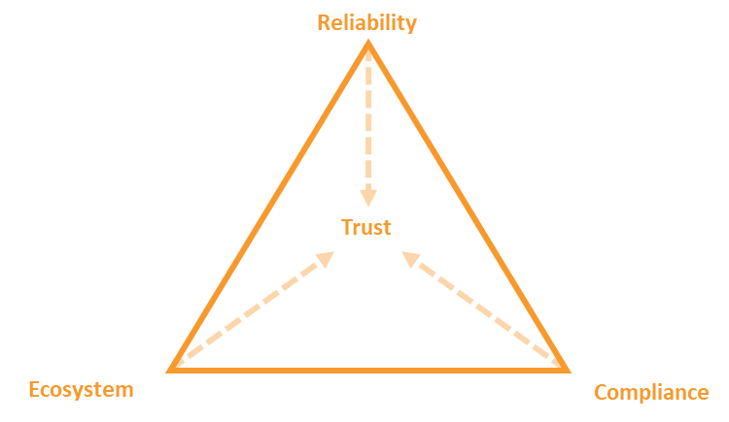

Figure 81 - Reliability Management Trifecta

As a part of managing these aspects, performance indicators are developed. In this case, they are:

* Number of incidents of non-compliant behaviour
* Number of communication issues
* Number of stakeholder issues or complaints

The approach to Reliability Management and the different elements described within the scope, time and resource management sections below are aligned with and cover the key elements ISO 9001 for quality management and ISO 20700 for Management Consulting services that are not covered by Project and Quality Management.

**Values**

We have strong values engrained within our way of working; these include:

* Valour, vigour and vision in face of challenges – all challenges can be addressed and facing challenges, being perseverant and having a vision of how things could be, is key to serving our clients in the best possible way
* Leading the way – it is important to lead the way and to drive innovation in order to continuously further develop ourselves and provide the best possible services
* Expertise and efficiency – only through leveraging expertise and being efficient in the way we work; can we deliver high quality results that represent good value for money
* Uniting in teams – establishing teams that bring together unique skills and knowledge, working together as a team both internally, with experts and with our clients is key to alignment and success

**Ethics**

We work to a clear ethical code, following the highest standards of professional conduct in all aspects of our work, including, but not limited to in our work within our organisations, with our clients and with the stakeholders that surround any project we work on.

The key aspects of these include:

* Honesty – We will always be honest in our interactions
* Integrity – We always act with integrity
* Respect – We respect people and property
* Tactfulness – We behave tactfully in all situations
* Patience – We demonstrate patience in trying situations
* Fairness – We deal with situations and people fairly
* Objectivity – We are objective in all our work, leaving behind personal opinions and bias
* Sustainability – We work on minimising our negative impact on the environment

**Guarantees**

We provide guarantees to all our clients and stakeholders in general and it is not an exception in the case of the beneficiary, the CAUT and the stakeholders for this project. We guarantee that we will always work towards improvement, we will be accountable and take responsibility for our work and our actions. We work in a transparent manner and as a partner with you and we will work hard to accomplish the objectives of the project.

1. **Compliance**

**Awareness of regulatory framework**

Whether specifically required by the Tender Specifications or not, part of our management approach and overall company policies, is to ensure awareness of relevant regulatory frameworks and to be in compliance with these.

Examples of regulatory frameworks that are relevant here are for example regulations related to employment, health and safety as well as the environment. Other key regulatory frameworks that are very important especially in the context of this project relate to data protection and confidentiality as well as protection of intellectual property. These are covered in the next subsections.

We work proactively to make sure that all people working for our organisations are aware of and respect the applicable regulatory frameworks. If needed during the implementation of the project, we organise training of our Team members, if lack of awareness or respect is observed.

Finally, as a part of our code of ethical conduct, our consortium considers the issue of securing the absence of any kind of conflict of interest and of the objectivity and independence of our operations / recommendations and the preservation of confidentiality not as contractual obligations only, but also as ethical professional obligations. All consortium members have preserved these values throughout their professional track record both at company level and at the level of employees and experts they have employed in the implementation of their projects.

The consortium partners abide to high standards of professional ethics and to this end, appropriate proactive measures will be taken to avoid any potential conflicts of interest at both the partners’ and the Project Team members’ levels. If such a circumstance arises, the partner or the potential subcontractor shall inform the Project Executive.

**Data protection and confidentiality**

Data protection and confidentiality are key values in our approach and sensitive data are treated with care. We have dealt with hundreds of projects over the years and are able to adjust our approach to the information security level variations across different types of information that we will deal with during the project implementation. We always respect personal data and treat it with the utmost care.

Access to information that falls under data protection or is confidential is actively managed. Access to project folders have user access control that is managed by the Team Leader, meaning that only individuals who need access have access. Throughout the project, the Team Leader remains responsible for keeping and updating the permission and rights. The Quality Manager is responsible for checking that the permission and rights are in place and being updated, according to the quality management procedures established, as well as for securing the proper archiving of the project files.

Highly confidential documents are marked according, as “confidential” (preferably with a watermark), as this is visually intelligible. Non-disclosure is a standard part of our contracts, but if and when necessary team members sign non-disclosure agreements.

**Protection of Intellectual Property**

We take intellectual property rights very seriously. We put an emphasis on dealing in the best possible way with intellectual property rights, we will ensure that all pre-existing material used by and / or incorporated in the outputs / deliverables are free of claims from creators or from any third parties and all the necessary pre-existing rights have been obtained or licensed. As far as material made available to the project by our team, we will make sure that it is free from intellectual property rights claims. Otherwise, it will be the Team Leader and the Quality Manager responsibility to ensure that there are no pre-existing rights.

In terms of the quotations of existing works mentioned in the reports, we will ensure that all contain the complete reference as appropriate, this also applies to image rights and sound recordings. Regarding the latter, statements shall be taken by the persons whose voice or any other private element recorded in a recognisable manner appears in the output / deliverable.

When pre-existing rights are retained on parts of the results, reference will be inserted to that effect when the result is used, with the following disclaimer: ‘© — year — European Union. All rights reserved.

The aforementioned are responsibility of the Team Leader, while these are double-checked during quality check conducted by the Quality Manager. Finally, it is the responsibility of the Team Leader to ensure that visibility rules for Union funding are applied (including mentioning of disclaimer) and it is the responsibility of the Quality Management to check that those rules are being followed.

1. **Project ecosystem management**

Project ecosystem concerns the framework that enhances effective decision making in the project context and with this regard it is critical to the successful project management implementation and the achievement of project objectives. The main project ecosystem elements regard the following:

* Communications and escalations at project level
* Internal communications
* Stakeholder management

These aspects are explained further in the following paragraphs.

**Communications and escalations at project level**

Communications between contracting parties is important in any context, but perhaps most so when the contract relates to Management Consulting services, such as those that we are proposing to provide the beneficiary with. We specify our relevant procedures at project level, facilitating the communication between the parties involved in the delivery of the suggested services and serves to an efficient and effective project management and implementation process. Not being able to identify the correct recipients or sending information to the wrong person may result not only to interruption of information flows, but also in project delays and missing information and in extreme cases, breach of confidentiality.

Project communications for the daily project management and implementation will take place between the Team Leader and the beneficiary directly; we also foresee a process for escalation at project level, as previously mentioned.

Naturally, the Team Leader keeps a constant open line of communication with the Project Team members. Furthermore, throughout the project implementation there is continuous communication at management level (Team Leader, Quality Manager and Project Director).

In addition to this, there is a clear communication flow between the Team Leader and the Steering Committee, although never expected, in case there is an issue, the Project Director also serves as an escalation point. The figure below illustrates the general applicable communication flow which we will personalise for this project as it will be further detailed in this section of the Technical Proposal.

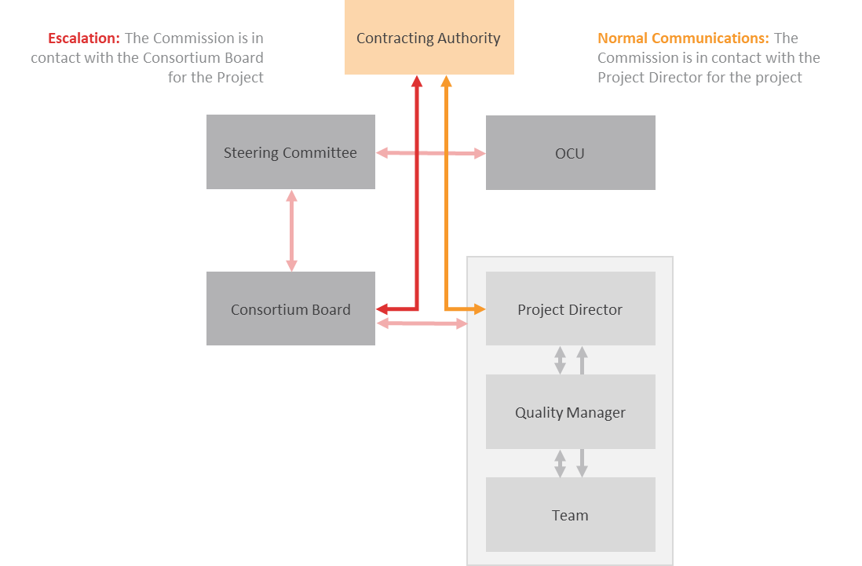

Figure 82 - Communications & escalations at project level

All communications that relate to contractual obligations (change in scope, agreements on approach, etc.) will be documented in meeting minutes if they result from a meeting or will be written or summarised by email.

**Internal communications**

Internal communications, within our organisations and across our organisations is key to successful project implementation. Therefore, we put emphasis on efficient and effective communication and knowledge sharing within our consortium, including updates, roles and responsibilities, timelines, documents, etc.

To this end, we have developed a hub approach to communication and knowledge sharing, as illustrated below.

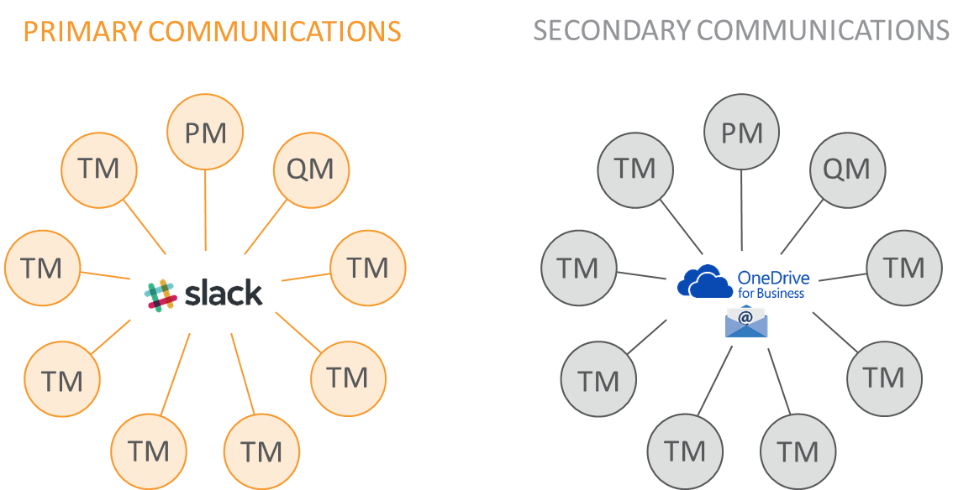

Figure 83 - Internal communications

As opposed to communicating bilaterally via email or in a hierarchical manner (Team Leader to one representative in each organisation), our approach is a hub, meaning that everyone always communicates with everyone. Our primary communication and knowledge sharing tool is slack.

Slack is an online service consisting of persistent chat rooms (channels that you post on and that is visible to all members of the chat room) organised by topic, as well as private groups and direct messaging. Furthermore, it is a file sharing platform and all content in Slack is searchable, including files, conversations, and people. In addition, Slack integrates a large number of third-party services and supports community-built integrations, meaning that we are able to continuously add new features to improve the efficiency and effectiveness of our communications further.

Our secondary communications is also our back-up system is OneDrive for Business combined with email. We use OneDrive as a back-up system for the files and email as an additional means of communication for very important information/communication, which is also sent by email to all team members.

**Stakeholder management**

Stakeholder management constitutes a fundamental and integrated part in all the work that is carried out during all the project and relationships with the IAUT as main beneficiary, other different beneficiaries, stakeholders and the CAUT.

This even more the case in this project because of the heavy stakeholder involvement and great number of different beneficiaries. As part of our management approach, we actively manage stakeholders and their involvement in projects. This has provided us with valuable experience in engaging with and managing stakeholders, which will benefit this project. We have clear internal guidelines on stakeholder engagement and management and a clear approach to many different aspects as detailed in our methodology.

Another example could be our insight into the need for a sound consultation strategy timeline as illustrated below.



Figure 84 - Consultation strategy timeline

With respect to this figure, the Team Leader has to take into consideration all these parameters that define consultation cycle and see how much time and resources should be attributed to each specific activity, this is all a part of the underlying plan behind our stakeholder engagement and management throughout all the stakeholder engagement mentioned in the methodology section.

In general, not only in this project, but across all our projects for the EU institutions, it is the responsibility of the Team Leader to ensure that the team spends time during the inception to:

* Finalise list of stakeholders included in a project
* Decide on aspects of communication and consultation strategy, and customising it according to the specific needs of the different tasks
* Develop a mitigation strategy in case of low turnout rates

The Quality Manager reviews the strategy developed for stakeholder management and engagement.

1. **Management of external suppliers and services**

Our consortium will pay particular attention to ensure that all stages of interaction with suppliers are well structured and professionally managed.

**Identifying and mobilising local suppliers**

This section addresses how the consortium will identify and mobilise local & international expertise and contractors for implementation of the project activities, such as hiring venues, catering, printing, etc.

KLSC, member of our Consortium, is a Kosovar company and it counts with a technical assistance office in Pristina and they count with large experience in implementing contracts in the country, therefore we are aware of the market environment and we will be able to guarantee the performance of the chosen suppliers.

The first sections are dealings with third party suppliers, looking at how we mobilise these suppliers across the EU and in Kosovo, and how we identify which are the most suitable for the project implementation purposes. Thereafter, we address how we work with these suppliers, which steps are taken to ensure a fruitful cooperation and how we provide for back-up possibilities in the event of unsatisfactory service.

**Selection of suppliers - identifying the best service providers**

Based on the services in question, it is possible to identify a selection of suitable providers for each service which have the required characteristics. Here, the consortium’s teams will always ensure that at least three quotations from different service providers are obtained on the basis of a detailed request. This helps to ensure that quality standards are maintained.

For identifying suppliers, we have three sources of information:

* existing supplier databases, maintained by all consortium members, built up over the past 10+ years;
* input from the local consortium partners, which will often have additional information not (yet) included in the consortium’s databases;
* additional research or, at a minimum, a check to confirm the completeness accuracy of existing information, as the organisation landscape, especially in Kosovo is an extremely fast-paced one.

Combining these three sources makes it possible to identify a range of suitable providers for each task. In order to select the most suitable suppliers from those available, the specific Backstopping Manager will look into the procedures, which are designed to enable transparent comparison between the different options:

* Suppliers should ideally have worked with one of the consortium members before and provided high-quality service;
* Alternatively, suppliers should be recommended by another trusted source or be able to provide high-quality references of past work;
* Suppliers should have experience providing services at similar types of activities to that requested by the contracting authority;
* Suppliers should have experience working for European Commission clients;
* Suppliers should be ready to suggest innovative solutions/provide added value in their services
* Suppliers should operate in line with social employment standards - this is particularly applicable to suppliers outside the EU, where government regulation may be less strict;
* Suppliers should be financially stable, to guarantee that there will be no short-fall during event preparation;
* Suppliers’ staff should have a good knowledge of English so that they can communicate with the project team.

Taking all of these factors together, the project leader can weigh up the different options using our objective supplier evaluation table, finding the service provider which represents the best overall choice, as demonstrated in the following table:

Table 44 - Supplier selection grid

| Criterion | Weighting (%) | Supplier 1 | Supplier 2 | Supplier 3 |
| --- | --- | --- | --- | --- |
| Past performance/ references | 15% |  |  |  |
| Experience with relevant events | 10% |  |  |  |
| Experience with relevant clients | 5% |  |  |  |
| Innovation/added value | 5% |  |  |  |
| Can demonstrate social employment standards | 10% |  |  |  |
| Financial stability | 10% |  |  |  |
| (English) language skills | 5% |  |  |  |
| Price* | 40% |  |  |  |

The factor “Price" is only relevant to the contracting authority for reimbursable services i.e. not those falling under the price list positions. Where the service is covered by the price list, this criterion will be removed and the weightings adjusted accordingly.

Using this table, an objective decision can be taken by the project leader on which supplier should be chosen, which is also useful for transparency when communicating the recommendation to the contracting authority as part of the offer. As a rule, a service provider should score adequately in all categories, meaning that there are no major risks when hiring this supplier.

**Working with suppliers**

There are two main aspects to our works with local suppliers, which are required to ensure that cooperation runs as smoothly as possible:

* thorough, step-by-step communication from the start to the end of the project;
* continuous monitoring of the supplier’s performance.
* provisions for addressing shortcomings;
* post-event performance analysis

The consortium has a supplier management policy, which is structured according to our four phases of event management.

**Step 1 - Identification:** With the use of our databases, and additional specific research, a range of suppliers which meet the criteria outlined in the request for services are identified.

**Step 2 - Comparison:** Minimum three offers are collated and compared with one another; includes not only a comparison of prices, but also of the various characteristics and other criteria for each supplier.

**Step 3 - Selection:** The specific event coordinator selects the most suitable suppliers and presents the contracting authority with (in the majority of cases) three options, with an indication of our recommended first-choice, including reasoning.

**Step 4 - Client approval:** The contracting authority approves its favoured supplier.

**Step 5 - Negotiation:** Once the supplier is approved, there is still a chance for final negotiation regarding not only price, but also cancellation conditions and arrangements, penalties agreements in case of sub-standard performance etc.

**Step 6 - Confirmation:** The final order is confirmed with the supplier, including fixed deadlines for deliverables and any other outstanding information.

**Step 7 - Two-way monitoring:** The consortium keeps the suppliers informed of any changes to requirements, services are confirmed, any alterations on the supplier side are communicated to the consortium; ongoing two-way communication ensures that any unexpected developments can be addressed swiftly, preparations continue on schedule; re-negotiation of conditions possibly necessary in case of major alterations to the specifications.

**Step 8 - Delivery:** The supplier delivers the service it has offered - service provided under the supervision of the project leader

**Step 9 - Evaluation:** We conduct follow-up with the service provider regarding performance, and consult the contracting authority regarding its assessment. Our databases are updated with new information regarding the strengths/weaknesses of the suppliers in question.

**Monitoring the work of suppliers**

Two-way monitoring, step 7 in the overview in the previous chapter, is a particularly important one, as this is comprising our opportunity - and our responsibility - to ensure that the supplier we have recommended to the contracting authority is indeed able to provide the service we expect of it. We therefore maintain constant contact with all suppliers to:

* ensure that preparations are underway and deadlines are met. In addition to the consortium’s overall quality management procedures, the following measures are implemented to monitor the work of suppliers and ensure they contribute to the project objectives to the highest possible standards:
* Careful selection of professional and suitable suppliers at the outset, as described;
* Establishment of a fixed contact person at the consortium for each supplier, to ensure efficient lines of communication;
* Continuous communication between suppliers and the consortium on the project requirements, where necessary;
* Inclusion of penalty fees in agreements with suppliers in case deadlines are not met or services are not delivered to satisfaction;
* Suppliers with whom the consortium successfully cooperates are entered into our extensive supplier databases and can be recommended for future events in the same country or city, provided they meet our and the contracting authority’s expectations in terms of quality and reliability.

Should there be any reason for our project leader to doubt the service the supplier is providing, or should a major deadline be missed, then we can draw on a back-up option without compromising the success of the action. More information on fall-back arrangements is given in the next chapter.

**Provision for addressing shortcomings**

Our systems for addressing shortcomings in the service provided by suppliers include the following measures:

* avoid selecting suppliers which do not meet required standards;
* monitor selected suppliers and ensure that service is at expected level
* ensure that back-up options are in place in case of shortfall;
* analyse performance post-event, through participant feedback, client feedback and inhouse evaluation;
* ensure knowledge transfer within the consortium to build on lessons learnt.

The first step to ensuring adequate back-up arrangements is contacting at least three suppliers at the outset of preparation (Step 1, identification). This is our standard practice, even when there is one clear first-choice supplier (e.g. if the contracting authority has worked and been highly satisfied with a particular company). In this way, we always have back-up offers available from the beginning of preparation.

The fall-back arrangements for service providers can be seen as part of our broader framework of back-up procedures, which ensure that the overall success of no specific contract is reliant on the health of any individual or the performance of any supplier. Our basic strategy, which can be applied thanks to the extensive personnel resources within the consortium, is to assign a deputy for each member of the project team, both at our headquarters, as appropriate.

The same basic principle is applied when setting up the fall-back arrangements for suppliers which may unexpectedly prove unable to provide the required services within the timeframe and at the quality standards expected of them. This means: Reserve suppliers are identified early and called upon as may become necessary.

Based on the standard practice and organisation of our Backstopping structure and approach, we adapted it to the specifics of this assignment and we identified the applied backstopping services that we will provide within this project. These services are described in the following (second) part of the Backstopping section of this Technical Proposal.

A key success factor for the implementation of the project is **setup of the backstopping services made available by the Consortium Members**.

For this Project the Consortium will create the multi-disciplinary backstopping structure which will support the experts during the project implementation. This backstopping structure will take into consideration the strenghts of each Consortium Member in order to ensure the most efficient and effective support for the implementation.

It is also important to mention that, under the co-ordination of the Project Director and with the input from the expert team, the multi-disciplinary backstopping team will establish also the necessary working procedures which will be applied during the implementation of the project, including but not limited to:

* Quality Assurance and Control procedure
* Risk Management procedure
* Communication procedure
* Financial Management procedure
* Approval flows within the Consortium

Having in mind that the project will be implemented by a multi-disciplinary team of experts seated in Kosovo and other countries, as well as the fact theat the number of beneficiaries will be significant, we will give a high level of attention to the electronic means of communication and information exchange between the team members. In this regards, during the period of implementation of this task, a **project IT environment will be put in place** to be used by the team members and having as main purpose the implementation of the information flow within the project. This project IT environment will be used as:

* project document library
* project reporting (progress reporting, Timesheets, etc)
* communication environment (email, messenger, etc.)
* project website
* contact information database
* on-line meetings support (such as WEBEX, Skype)

The backstopping structure will be implemented taking into consideration two dimensions:

Horizontal services

general purpose services such as HR, Financial, Quality Assurance, IT&C services

Vertical services

expert services in each area of expertise required for the implementation of the project, having as baseline the results expected to be achieved as well as the strengths of each Consortium Member

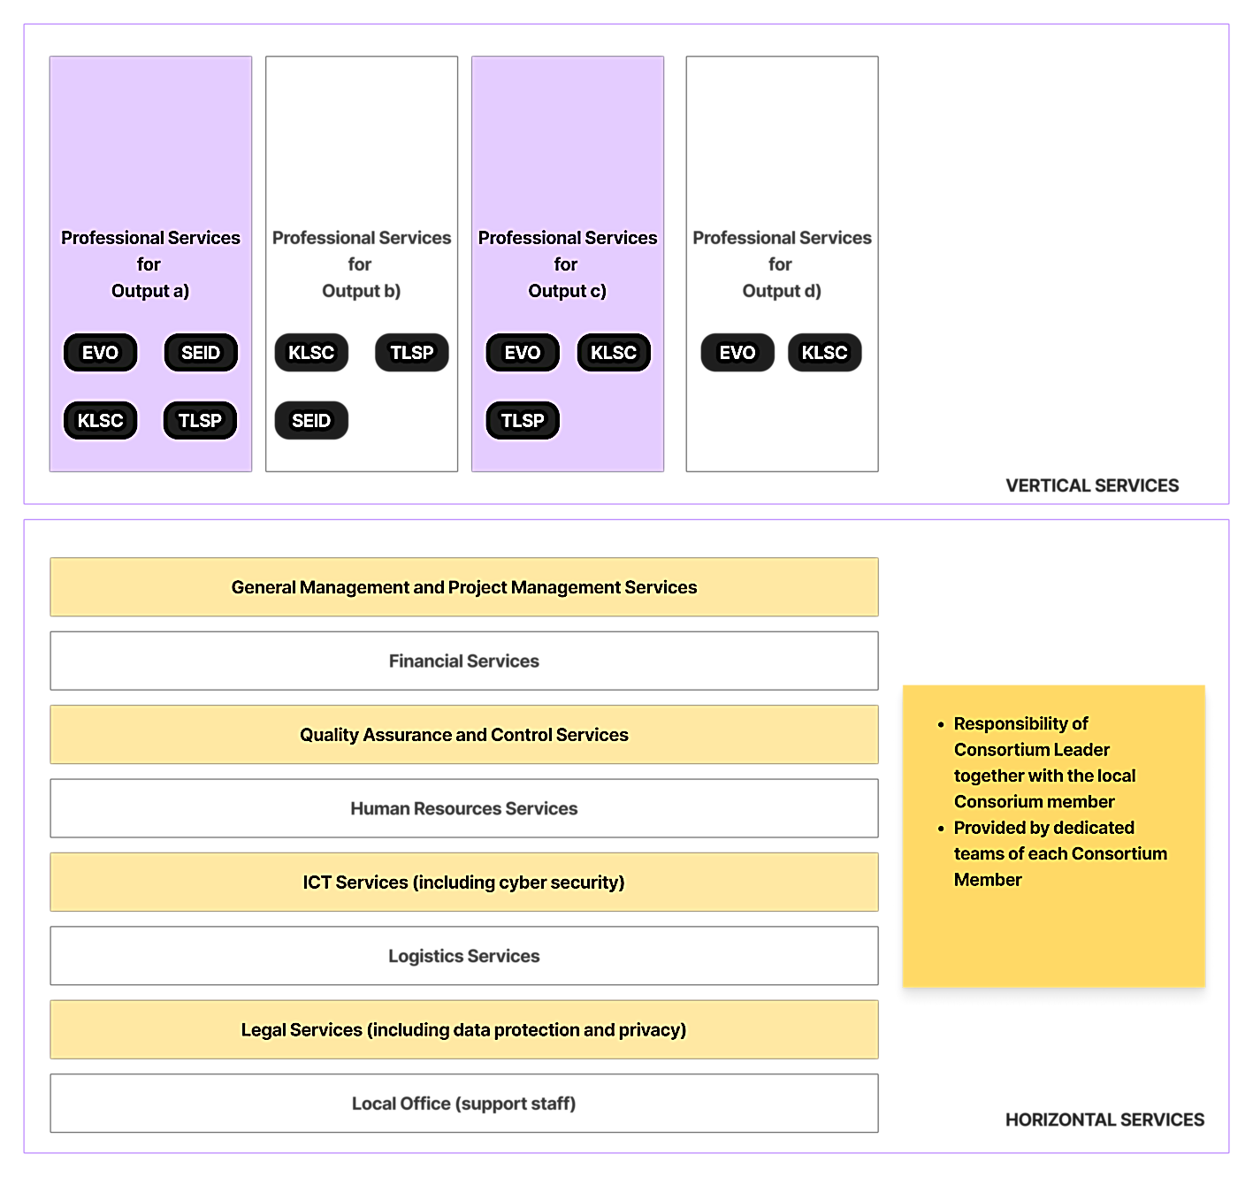

Figure 85 - Backstopping structure

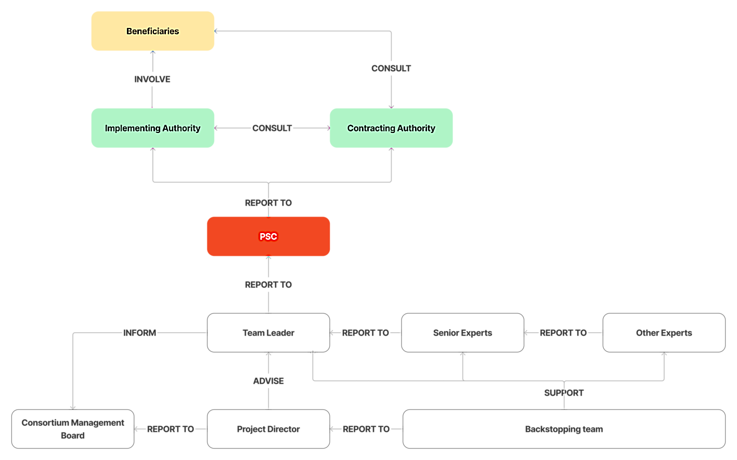

Figure 86 - Project Information Flow

The backstopping structure is presented in **Figure 85**. This two-dimensional structure will be able to support the team of experts with maximum flexibility and will be able to provide the expert teams with the full range of services needed for the project implementation.

Another important characteristics of our backstopping structure is integration. Each Consortium Member will allocate dedicated persons to be part of the project backstopping team. The roles and responsibilities will be well defined for each person and the backstopping team will act as a unitary entity with all needed functions/"departments" able to handle the different aspects which will be encountered during the project implementation. Acting as a unitary entity, the proposed backstopping structure will also have its own management and hierarchy.

NOTE: The backstopping structure as it is presented above is designed based on our current understanding of the ToR and on our knowledge of the current situation in the country. The structure may suffer modifications mostly based on the results of the Stakeholder Analysis but we do not foresee that the potential changes will dramatically affect the proposed backstopping structure.

The backstopping structure will be mobilised and will be in place in the first week after the award (thus, before the actual contract start). At the moment of the award, besides the PD, the staff on the Team Lead level will be already appointed and they will be already familiar with the ToR and the Technical Proposal so they could start their activities in the same time with the PD.

The communication procedure will be also in place at that time in order to ensure a smooth exchange of information between the backstopping structure and the expert team. The communication procedure will be based on the information flow diagram presented in **Figure 86**.

The appointed Project Director will be empowered by the Consortium Management Board with the right to make decisions on behalf of the Consortium within the boundaries of the scope of the project. The highlights of our backstopping structure is presented in below:

Table 45 - Highlights of the backstopping structure

|  |  |
| --- | --- |
| VERTICAL DIMENSION | Well delimited vertical services will allow the backstopping structure to provide fast support to expert in their area of expertise, without experiencing delays due to over-allocation of the resources |

|  |  |
| --- | --- |
| HORIZONTAL DIMENSION | The shared horizontal services will be able to support the project team with a unique way of providing the support due to the usage of the same procedures during the project implementation |

|  |  |
| --- | --- |
| INTEGRATION | The system of procedures which will be operational for the project implementation will create the integration needed among the multi-disciplinary and multi-national backstopping team. The Project IT Environment will also allow unique experience of all team members in accessing the project resources/documents and to communicate. |

|  |  |
| --- | --- |
| EXPERTISE | Well defined and delimited expertise at the level of the Consortium Members allows the subsequent creation of the vertical services within the backstopping structure. Thus, overlapping will be avoided and efficiency and effectiveness will be increased. |

|  |  |
| --- | --- |
| DEDICATED MANAGEMENT | Dedicated management of the backstopping structure (PD + Backstopping Team Leaders) will increase the efficiency in the support provided to the expert team. For the duration of the project, and for allocated activities, all resources will report directly to their Team Leads who will directly report to the PD. Functional Managers from the Consortium Members organisations will be kept informed but the direct reporting lines will be within the backstopping structure. |

### Consortium Management Board

The Consortium Managment Board is the management structure which will be put into operation immediatelly after the contract award. The Consortium Management Board will be made up from senior/top managers appointed by each Consortium Member. Each member of the Consortium Management Board will be empowered to make decisions, on behalf of the Consortium Member he/she is representing, in all aspects related to the project implementation.

The Consotium Management Board will be chaired by the repesentative of the Consortium Leader. The TL and other senior experts may be invited to participate to the Consortium Management Board meetings.

The Consortium Management Board **hold regular quarterly meetings** and extraordinary meetings when needed. If needed, the Consortium Management Board members are available to participate (as contributor/observer) to the project meetings.

The extraordinary meetings will be hold prior to major milestones which has to be achieved during the project implementation. The **Project IT Environment**, through its communication component will allow the members of the Consortium Management Board to access all needed information in due time.

As described earlier, the mobilisation of the project team (PD, KE, backstopping team) will be very fast after the award. Respecting this principle, the Consortium Management Board will be also available from the first day of project implementation in order to provide the PD will all decision support for starting the Inception Phase in the fastest way possible.

### Financial Management

During implementation of the project the Consortium will apply all the necessary measures and procedures to ensure that efficient, effective and solid financial management, in compliance with the EU Regulations on Financial Assistance. The establishment of a sound and efficient mechanism that will allow tracking the financial and documenting flows of the expenses executed in the framework of the project is very important as it constitutes one of the key and founding elements of a complete backstopping function. The main activities and focus of the backstopping financial function are presented in the table below:

Table 46-Main activities of financial backstopping function

| ACTIVITY | COMMENTS |
| --- | --- |
| Positive cashflow | The Financial Lead will present monthly reports to the PD related to this aspect as it is crucial to maintain a positive cashflow. The reports will contain also the forecast cashflow to the end of the project together with necessary measures to be implemented in order to keep the cashflow positive. |
| Project accounting | Together with the Financial Staff, the Financial Lead will keep accurate accounting records for the project. This mechanism will allow tracking the financial and documenting flows of the expenses executed in the framework of the project and will represent the baseline for any audit which will take place during or after the project implementation. |
| Accounts Receivable | The Financial Lead will have in their area of responsibility the issuing of the invoices and follow up payments to be received from the CAUT for the provision of the services. The Financial Lead will work in close collaboration with the Legal backstopping function (in order to ensure the full compliance with the Contract provisions), with the PD and KE team in order to collect the needed information for issuing the invoices. |
| Accounts payable | The Financial Lead and Financial staff will be responsible for the management and administration of payments to experts (and suppliers, where applicable), verification of the eligibility of project expenses in accordance with the case specific contractual rules |
| Single Point of Contact for Audit | The Consortium will develop and establish adequate audit-trail procedures for the financial management of the project. The audit-trail mechanism that will be developed shall enable the quick identification of each expense trail, in every step of its processing. |
| Single point of contact with financial services of all Consortium Members | The Financial Lead will act as a single point of contact with the financial services of all Consortium Members in order to ensure the integration between the financial procedures of EU-funded projects and the financial procedures applied by each Consortium Member in its home country and in order to ensure a smooth financial workflow activity. |
| Reporting | The Financial Lead will be responsible to produce periodically reports on the financial situation of the project as well as necessary forecast reports. The reports will contain at least the situation of the project cashflow, financial statements related to receivables and payables. The reports will be presented to the PD and, in case of major deviations, to the Consortium Management Board. |

Table 47 - Financial Manager

| Financial Manager: Javier Muñiz | |
| --- | --- |
|  | Mr. Javier Muñiz as the project’s Financial Manager, provided by the leading partner EVOLUXER S.L. He is Financial Director of EVOLUXER Holds a bachelor’s in economics from the Universidad Autonoma de Madrid.  He worked for five years for a Spanish Governmental Delegation in Brussels. During that period, Javier was the Head of Financial and Projects Department, where he managed an extensive number of EU funded project.  After that period, he followed a Master in Public Administration Management. Currently he is founder member of EVOLUXER S.L and Financial Director. He has experience in managing financially over 35 projects over 20 different countries. He speaks Spanish, Italian and English. |

### HR management

In this project, the human workforce is the most important resource required. The quality and the dedication of these experts to the project will have a direct impact on progress, quality of works and time. We rely on our strong background and expertise in mobilizing experts for successful and timely implementation. The number of experts and the number of input days reserved for an activity or output impacts the planning of the activity, thus the schedule. As such, these resources will need to be managed in a structured way to allow for the project management team to manage the input days’ utilization in order to successfully manage the Project work plan and the implementation of the Project as a whole.

The mai activity related to the HR management process during the project implementation will be dedicated to the experts, backstopping and support staff. The Consortium agreed that only the best human resources will be used for the implementation of this project, therefore, the HR backstopping team will use a three-step aproach to provide the project with the needed human resources.

**IDENTIFY**: Based on prior defined and agreed criteria, the HR backstopping team will use different sources to identify potential candidates matching the requirements. Identified candidates will be included on the **LONG LIST**.

**SELECT**: On the LONG LIST, the HR backstopping team will apply a predefined scoring matrix in order to select the best options. Also, when applicable and needed, interviews will be organised with the potential candidates. At the end of this process, the **SHORT LIST** will be available.

**HIRE**:The candidates from the SHORT LIST will receive the hiring offer and negotiations will take place. At the end of this process, the open position will be filled in with the best available candidate.

The HR backstopping team will have the reponsibility to optimise the recruitment process without harming the quality or the transparency of the process. Thus, there are several optimisation methods that will be used:

* **RESOURCE POOL:** Based on those candidates who were included on the SHORT LIST but were not hired
* **EMPLOYEES PRIORITY:** In the case when one existing empolyee of any Consortium Member is at the same level in terms of fulfilling the criteria with an external applicant, the employee will be preferred.
* **EXISTING DATABASE:** Each Consortium Member already has a database of potential candidates for its business.

For the expert’s related HR activities, the HR backstopping team will act as a "HR Department" of the project. The HR team will work together with the TL (and when required with the relevant senior experts) in order to draft the ToR for each needed other expert. Once the ToR was approved, the HR backstopping team will start the candidates identification process and will create the **LONG LIST**. Having inputs from the TL (and when required from the relevant senior experts) the HR backstopping team will apply the selection scoring matrix and will create the **SHORT LIST**. Negotiations discussions and interviews will be organised if applicable (online meetings are also applicable in order to speed-up the process). With the support from the Legal backstopping team, the HR backstopping team will conclude the contracts with selected other experts and will inform the PD, TL and relevant senior experts about the fact that the hired expert is available to start the activities/missions within the project.

In-line with the provisions of the GDPR Directive and according to the Privacy procedures which will be enforced by the Consortium, the HR backstopping team will respect the privacy and rights of all individuals who will be involved in the project implementation set out by the mentioned Directive, laws of countries of the Consortium Members and laws of Kosovo. Apart form respecting explicit rules for hiring as well as strict transparency rules, our Consortium will respect also implicit rules of hiring.

All consortium partners are equal opportunity employers, committed to fostering a diverse, multicultural work environment where our teams respect one another as well as our clients and share a commitment to our consortium values, mission, and strategies. We provide equal opportunities to all participants and employees without regard to race, religion, gender, nationality, age, disability, sexual orientation or marital status

We aim to mobilize experts who represent both genders, provided that the profile requirements are met by candidate experts.

The highlights of our HR management strategy for the implementation of the project is further presented:

Table 48 - Highlights of the HR Strategy

|  |  |
| --- | --- |
| PERFORMANCE | Only the best candidates will be hired or appointed for executing the activities within the project. The criteria for choosing the staff will be 100% in-line with the requirements of the project |

|  |  |
| --- | --- |
| EFFICIENCY | As much as possible, with respect of the performance criteria and with transparency requirements, we will choose local experts as part of our team. Thus we will increase the efficiency of using the budget as well as we will be able to deploy the experts very fast |

|  |  |
| --- | --- |
| BUSINESS CONTINUITY | Using the optimisation methods, we will be able to provide the experts in such manner that no interruption of work will be caused by potential leaves or delays in the hiring process |

|  |  |
| --- | --- |
| INVOLVEMENT | Each Consortium Member maintains its own resources pool in its area of expertise as part of its business-as-usual activity. These resources pools will be available for the project while |

|  |  |
| --- | --- |
| QUICK ON-BOARDING | Each new member of the team (expert, backstopping staff, support staff) will benefit on a quick induction and on-boarding period immediately after he/she is hired. |

### IT&C support

The responsibility for providing the team of experts with the needed support during the project implementation and the responsibility of making operational the **Project IT Environment** and to maintain it for the entire duration of the project implementation will belong to the IT Systems backstopping team under the lead of the Team Leader IT Systems. The Team Leader IT Systems will report to the PD and will coordinate a team of IT Experts from the backstopping staff.

Our experience in the technology area and software projects will allow the Consortium to put in place a distributed team of IT Experts able to provide both the services related to the Project IT Environment.

As part of setting up the project work environment the backstopping IT&C staff, immediately after the project start date, will put in place a dedicated IT environment to be used by the project team and relevant stakeholders during the project implementation.

The Project IT Environment is a separate and dedicated IT&C platform that will be made available by the Consortium in order to increase the efficiency and effectiveness of the tasks and activities during the project implementation

The project IT Environment will be put into operation having in mind and respecting the following principles:

Table 49-Principles of the Project IT Environment

|  |  |  |
| --- | --- | --- |
| **SECURE ACCESS** | **RESPONSIVENESS** | **PRIVACY PROTECTION** |
| the access to the Project IT Environment will be secured in terms of the communication as well will be protected through authentication mechanisms | the Project IT Environment will be accessible from desktop/laptop computers but also from mobile devices | the data security mechanisms within the Project IT Environment will implement the requirements related to Privacy and Personal Data Protection |
| **FOCUS ON WORK** | **ACCESS CONTROL LISTS** | **FLEXIBILITY** |
| dedicated data collection and reporting features will be available in order to allow fast collection of information and let the project team to focus on their work rather than on reporting or administrative tasks | each user will have well defined rights and permissions in order to access the most relevant features and/or content | easy and fast administration/update features in order to always keep the Project IT Environment aligned with the project evolution |

The main functionalities (modules) of the Project IT Environment are described in **Table 50**.

Table 50-Main functionalities of the Project IT Environment

| FUNCTIONALITY | COMMENTS |
| --- | --- |
| Project Library / Project Knowledge Management Database | This module represents the project content repository. Documents and other type of content will be accessible based on the role of each team member, dedicated access rights and permissions will be granted by the administrator. External (stakeholders such as CAUT, Beneficiary) will be granted with access rights and permissions as will be defined in the Inception phase |
| Communication platform | This module will allow the team members (and when needed other stakeholders also) to stay in contact during the project implementation. The module will provide fast communication methods including instant messaging and will give a special attention to the possibility to access all the communication features from the mobile devices. The module will implement the relevant results obtained during the Inception Phase. |
| Contact database | This module will provide all the users (team members and stakeholders) with all needed contact information for the parties and individuals involved in the project implementation. |
| Calendar and Project Implementation Events | This module will provide the project calendar and the events scheduling functionalities. Thus, using this module, each event can be scheduled, invitations can be sent to the future participants (using the above mentioned contact database), presentation materials can be uploaded to be available for participants review and minutes of meetings and/or other outputs from the events can be published afterwards. |
| Reporting | This module will be dedicated mostly to the project team. The functionalities will include timesheets reporting, progress reporting and team evaluations. This module will contribute to an increased efficiency of the services by allowing the team to focus on the work rather than on traditional paperwork related to reporting. It will also allow the TL, PD and Consortium Management Board to access real time consolidate information about the project status. |
| Stakeholder consultation | This module will have a great impact on connecting the project team with the stakeholders. The functionality will be implemented based on the results from the Inception phase, Stakeholder Analysis.  One of the most important goals to be achieved during the implementation of the project is related to the process of consultation of all stakeholders, getting them involved collecting and integrating their opinions and feedback. As much as possible the actions for collecting opinions and feedback from the stakeholders as well as consolidating the information and provide in-depth analysis will be automated by this module. All functionality will be accessible from mobile devices also, thus increasing the possibility and willingness of the stakeholders to provide the needed information. On the project team side, this module will allow a huge increase of efficiency and effectiveness for the activities related to the collection, consolidate, report and integrate the opinions and feedback from the stakeholders. |
| Privacy | The Project IT Environment will collect personal information from stakeholders and project team. With respect to the EU GDPR Directive, the Project IT Environment will implement the needed measures and functionalities in order to comply with the mentioned requirements and to respect the individual rights related to privacy and personal data protection. A Privacy Policy will be in place, the Cookies Policy will be transparent and visible and dedicated forms for data privacy enquires will be available on the Project IT Environment. |

Based on our experience form other similar projects, the most used architecture for the Project IT environment is presented in the figure below:

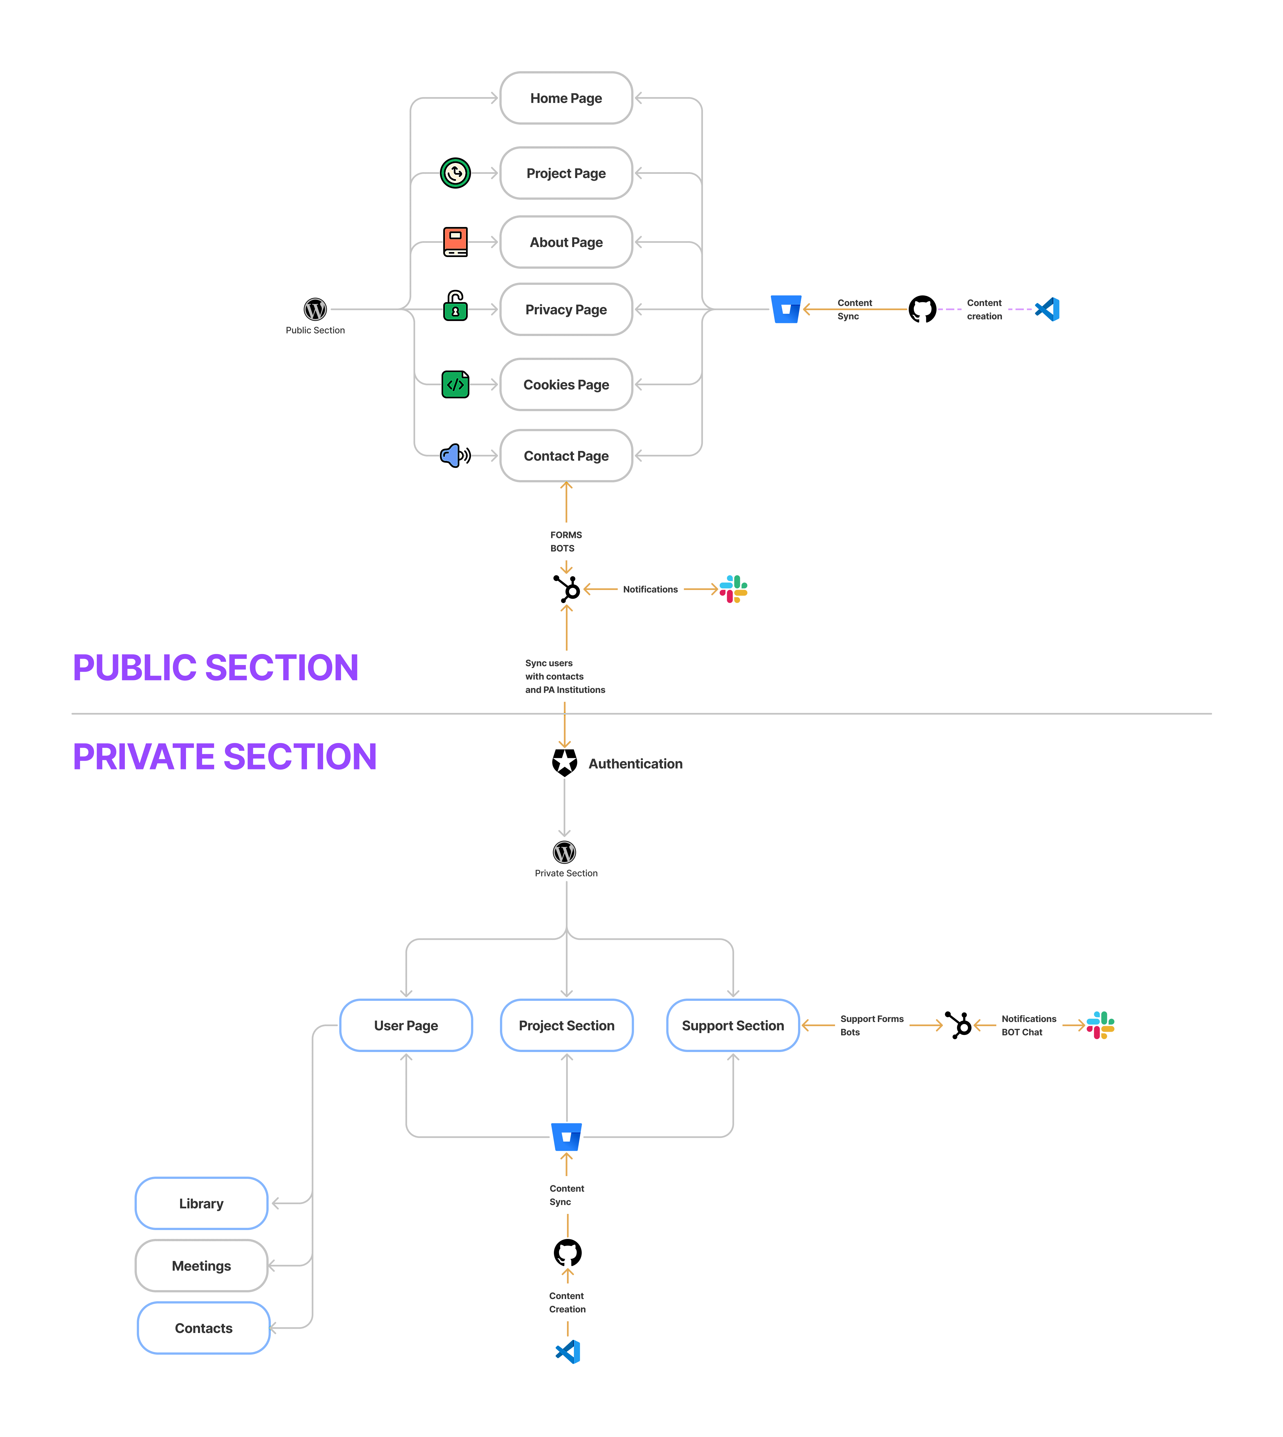

Figure 87 - Architecture of the Project IT Environment

With reference to the Mobile Based eID Marketing Web[52], the Project IT Environment is the perfect starting point for putting into operation this component of the system. The public section of the Project IT Environment will evolve during de implementation and the technical solution will be tested in real life. Based on this approach, at the end of implementation, this component will not be only fully functional but will also have a relevant quantity of quality content to be made available to the public after the end of the implementation.

### Quality Assurance

Quality Assurance and Control (QA/QC) will be one of the most important activities which will be carried out during the project implementation. That is why, the backstopping structure contains a dedicated role for executing these activities - the Quality Manager. The main responsible for the outputs of the QA/QC process will be the PD. His obligations will include periodically review the QA/QC procedures, methods and tools and the results of using them on the project's deliverables in order to assess the outcome against the expected quality of the project results. In the case when the PD will observe constant deviations from the expected quality as a result of using the mentioned procedures, methods and tools, he will require to the Quality Manager to do the necessary changes and updates. The Quality Manager will be responsible to apply the QA/QC procedures, methods and tools on the deliverables produced within the project and to produce the reports corresponding to the QA/QC process.

As a main work instrument for the QA/QC process, the Quality Manager (having inputs from the team of KE) will produce an internal working document, the Project Quality Plan (QAP) which will be presented for consultation and approval to the PD, TL and senior experts . This plan will contain detailed information about the quality criteria that each deliverable needs to comply with before releasing it to the Beneficiary. As main components, the QAP will be based on the following main components:

* QUALITY CRITERIA:The definition of the quality criteria will have as starting point the OVI definition as it will result from the inception phase (Revised Organisation and Methodology). Each quality criteria will be linked to one or more indicators (OVI) from the project plan in order to cover 100% the achievement of the project results at the expected and agreed quality. Additionally, the Quality Manager will consider other sources as inputs for the quality criteria. Without being final, examples of possible sources are presented in the table below:

Table 51-QA/QC: Sources for quality criteria

| SOURCE | COMMENTS |
| --- | --- |
| EU/EC recommendations for Communication and Visibility materials | The QAP will contain specific criteria to be verified before releasing and C&V material. The criteria will be compliant with Communication and Visibility in EU-financed external actions document. |
| Project documents | One important input when producing the Quality Plan will be the project documentation: ToR, Contract, Special Conditions, General Conditions. Additionally, EU regulations for EU-funded projects and the PRAG will be considered as valuable inputs. |
| Best practices | The QAP will contain quality criteria in-line with the best practices in the area covered by the project |
| Industry benchmarking | Mostly in relation with the IT&C tasks and activities, the QAP will contain specific criteria aligned with the wide accepted industry benchmarks. |
| Information security | Additionally to the quantitative and qualitative criteria, the QAP will contain specific mentions related to the information security criteria which the deliverables needs to comply with |
| Privacy and personal data protection | Quality criteria will also be complemented with specific criteria related to the privacy of individuals and with personal data protection provisions which has to be fulfilled by the deliverables in order to be released |
| Expert input | The qualitative part of the criteria will be based on the expert input. The QM will work closely with expert team and PD in order to define the qualitative measures for the deliverables quality. |
| Relevant standards and methodologies | The QAP will be produced based on the provisions and recommnedations of the most relevant standards in the area of Quality Management, Information Security Management, Service Management. Thus, based also on the experience of each Consortium Member and on the cerifications of their Quality Management Systems, the QAP will be in compliance with: ISO9001, ISO27001, ISO20000, ISO14001, ITIL. |

* QUALITY METHODS AND TOOLS: The tools will consist (without being limited to): evaluation an scoring grids for quantitative criteria, in-depth analysis made by subject matter experts for qualitative criteria, matrices of compliance for legal requirements, questionnaires. The QAP will contain a detailed description of each tool and method which will be used to establish the quality level of the deliverables produced during the project implementation.
* PREVENTIVE AND CORRECTIVE ACTIONS: The QAP will contain dedicated description of actions items to be applied if the quality methods and tools applied on the project deliverable will produce outputs revealing major deviations. Moreover, the QAP will describe the action items needed to be applied in order to prevent the occurrence of similar situations in the future (preventive actions). Scheduled preventive actions will be carried out on six-months basis and will consists in internal quality audits which will analyse the quality records produced by the quality methods and tools against the quality criteria and will propose potential improvements to the quality system. It will be the responsibility of the PD to conduct such audits as part of his obligation to review the QA/QC procedures, methods and tools and the results of using.

The project team will maintain on the Project IT Environment a complete repository of the quality records produced by the project Quality System as well as the records produced by the internal audit of the project Quality System.

Table 52 - Quality Manager

| Quality Manager: Tinatin Gabelia | |
| --- | --- |
|  | Tinatin Gabelia is a professional with over 10 years of experience in the international development field, predominantly working for the European Union funded interventions. She holds a BA Degree in English Language and Literature from TSU an MA Degree in Multidisciplinary European Studies from the EU funded TACIS Institute of European Studies.  Tinatin has also studied at Williams College, UK, and Leipzig University, Germany. Her first professional steps in the international development field started with the internship at the United Nations Office at Vienna, specifically UNODC followed by her role as a Project Manager at Microsoft. Since 2012 Tinatin works for the European Union funded projects in the role of a Project Manager/Quality Controller in Georgia, Armenia, Ukraine, Moldova, North Macedonia, Albania and beyond.  Tinatin excels in writing, editing, quality control, monitoring and evaluation. She has successfully performed as a Quality Controller/Project Manager for over 20 European Union funded projects under the FWC SIEA LOT 3 from 2018 till now. Tinatin is fluent in English, Georgian and Russian languages. |

### Project Director

The Project Director will be appointed by the Consortium Leader and will be available from the first day of the project. Since the future Project Director was directly involved in producing the Technical Proposal, at the time when the project will start he will have already a very good knowledge of the project context (based on the information available before the submission of the Technical Proposal) of the ToR and of the proposed Scope of the Work. Thus, the "induction period" for the PD would have been already passed at the moment when the project will start, the PD being fully capable to begin the tasks scheduled for the Inception Phase. For this project, the Consortium Leader, having the agreement of all Consortium Members nominated the Project Director as following:

Table 53-Project Director

| Project Director: Javier Ruiz | |
| --- | --- |
|  | Mr. Ruiz is a partner and Director for Eastern Europe in EVOLUXER. He counts with over 16 years of experience in managing large international Technical Assistance projects.  He has a degree in Social Sciences and a Master in Economy and is fully acquainted with area of electronic identification sector and internal affairs. He masters English, Romanian and Spanish.  He has extensive and successful experience in directing over 20 projects in IPA countrie and EU Member States, mainly in Turkey, Montenegro, Kosovo, Albania, Croatia, Bosnia and Herzegovina, Bulgaria and Romania, having been working both as Expert and Project Director in these assignments which provide him excellent knowledge and skills to carry out the duties of Project Director. He currently works as Project Director in two large innovation related projects in Turkey. |
| Responsibilities within the project | |
| * Represent the Consortium on all contractual matters. Participate in contractual meetings with the CAUT and Beneficiary. * Ensure proper and timely reporting according to EC reporting guidelines and requirements * Ensure operational and technical backstopping support for the Project Team in collaboration with all Consortium members * Ensure coordination between the Project Office, the Contractor’s headquarters, the Contracting Authority and the Beneficiary * Define the Quality Plan in collaboration with the Team Leader and assure overall project quality * Ensure, in collaboration with the Team Leader, mobilization of suitable experts * Exercise budget management and financial control and preparation of invoices with supporting documentation. | |

We are fully aware of the complexity and the importance of this project. That is why our approach for implementing a strong and professional project management structure is based on a permanent availability on-site of the Project Director role. By implementing this we believe that we will achieve a high level of communication with the CAUT and IAUT and Beneficiaries, permanent coordination of the expert teams deployed on site and a sound and smooth functioning of the local office and support staff. Moreover, by implementing this approach we will allow the TL to focus more on the specific scientific and technical tasks and activities of the projects rather than consuming important amounts of time on administrative aspects of the project. For this reason, the appointed Project Director will be shadowed by a local experienced project manager who will be 100% available in Pristina and/or on-sites as needed. This person will be appointed after the award and will also be available from the first day of the project implementation. This person will be Acting PD in the case when immediate mobilisation of the PD is needed and the travel time might become an issue.

### Backstopping Team Leaders

The backstopping structure that will be mobilised for the implementation of the project will contain dedicated teams for each service (vertical or horizontal) that is needed in order to support the team of experts. As part of the management function, each team will be coordinated by a Backstopping Team Leader. The main responsibility of the Backstopping Team Leaders will be to coordinate the relevant backstopping staff. They will report to the PD but they will aslo work closely with the TL and the experts providing them with the support needed according to their expertise.

The Backstopping Team Leaders were carefully selected by each Consortium Member and proposed to the Consortium Management Board for approval. Their experience is relevant and it was evaluated under several dimensions:

* Professional experience and knowledge in the area of expertise in which he/she will activate within the project
* Team Management skills
* Professional track record with the Consortium Member
* Specific experience in international projects with a specific accent on EU-funded projects
* Specific experience in TA projects
* Knowledge of English language and communication skills
* Availability for short missions abroad

The responsibilities of the Backstopping Team Leaders will include the following:

* coordination of his/hers technical team
* cooperation with the team of experts
* detailed planning and follow-up of the tasks assigned to his/hers technical team
* proper resource allocation
* quality reviews and validation of the results and outputs generated by his/hers technical team
* reporting to the PD
* horizontal collaboration with his/hers peers in order to ensure the required level of integration between teams
* attending team, project, external meetings
* enforcing the applicable procedures

For the entire duration of the project implementation and for all tasks and activities within the scope of the project, the Backstopping Team Leaders will be under direct coordination of the PD, their functional managers from the corresponding Consortium Member being always informed of the performance of the Backstopping Team Leaders in the project. The PD will have regular formal and informal meetings with the relevant functional managers in order to provide them with feedback about the activity od the Backstopping Team Leaders.

### Technical teams

Under the coordination of the Backstopping Team Leaders, technical team will be formed from specialists in each area needed for the vertical and horizontal services provided by the backstopping structure. The technical teams will be formed by selecting the best employees of each Consortium Member having solid track record in the organisation and proven results. As described in the section corresponding to the Backstopping Team Leaders, the Consortium will apply several selection criteria for the selection of the technical teams members:

* Professional experience, knowledge and certifications in the area of expertise in which he/she will activate within the project
* Previous experience in working under coordination of the appointed Backstopping Team Leader
* Professional track record with the Consortium Member
* Specific experience in international projects with a specific accent on EU-funded projects will be a plus
* Specific experience in TA projects will be a plus
* Knowledge of English language and communication skills
* Availability for short missions abroad

The responsibilities of the technical teams will include the following:

* proper execution of the assigned tasks
* reporting to the relevant Backstopping Team Leader
* cooperate with the team of experts, provide support and needed input when required
* attending team, project, external meetings
* apply and respect relevant procedures

As briefly described in the general description of the backstopping structure (section 3 Backstopping) the technical teams which will provide vertical and horizontal services for the project implementation are listed in the table below:

Table 54-Backstopping technical teams

| TECHNICAL TEAM | AREA OF EXPERTISE | ROLES WITHIN THE TEAM |
| --- | --- | --- |
| Financial team | Horizontal services   * Financial services | * Backstopping Team Leader Financial Services * Financial staff with relevant experience in international environments and EU-funded projects * Accounting staff |
| Logistic team | Horizontal services   * Logistic services * Procurement services   Vertical services   * Support for activities related to output c) | * Backstopping Team Leader Logistic Services * Procurement specialists with relevant experience of procurement under EU regulations * Travel agent |
| Human Resources team | Horizontal services   * Recruitment and on-boarding * Assessment and Evaluation | * Backstopping Team Leader HR Services * Recruitment staff with relevant experience in recruiting experts in international environments |
| QA/QC Team | Horizontal services   * QA/QC services   Vertical services   * Support for activities related to output b) | * Quality Manager |
| Legal team | Horizontal services   * Legal assistance * Privacy and data protection * Legal assistance for procurement * Contracts management   Vertical services   * Support for activities related to output a) | * Backstopping Team Leader Legal Services * Legal advisor * Technical staff with relevant experience in the field of the project |
| Support team | Horizontal services   * Local office management * Assistance expert team * Translation services | * Office Manager * Project Assistant/Translator |
| IT&C team | Horizontal services   * Project IT Environment   Vertical services   * Support for activities related to output b) | * Backstopping Team Leader IT Systems * IT Business analyst * Software architects * Cyber Security engineer * IT&C infrastructure and security engineer * Software developers * Software QA/QC engineers (testers) * Implementation engineers |

We have determined an appropriate structure based on the comparative advantages of the Consortium partners in terms of fields of experience, and we have consequently defined their roles and responsibilities presented below:

Table 55 - Proposed Backstopping Area Leaders

| Name | Technical Area | Short Presentation |
| --- | --- | --- |
| Jaume Fuentes  Jaume Fuentes | Software architecture | Mr Jaume Fuentes, Spanish national is currently CEO of Seidor. Mr Fuentes is responsible for the organisation, management and monitoring/control of the overall Contract acting as the SPOC for all contractual aspects with CUSTOMER. In response to requests from CUSTOMER, he works with the HR Manager to select the most suitable CVs from the Pool of Available Resources (PAR), which is a sufficiently large database containing CVs of qualified and suitable staff |
| Giulio D’Isanto | Solution engineer | Senior engineer with more than 15 years of experience in development of digital signature software, security applications using asymmetric cryptography, low level libraries for interfacing with smartcards and biometric devices on several OSs (Microsoft, Apple, Linux). |
| Sergio Vidal | Capacity building | Mr. Vidal is EVOLUXER´s Partner and Director of the International Department. Currently based in Madrid, he counts with over 15 years of experience in managing large EU projects. He has a Master´s degree in Economics from the University of Alcala in Spain, Post-Graduate Master in European Studies from the University of Bremen in Germany and a Post-Graduate Master is European Economics from the College of Europe in Bruges, Belgium. He is fluent in English, Spanish and French. He has an extensive and successful experience in implementing projects according to PRAG procedures mainly in Turkey, Montenegro, Croatia, Bulgaria, Romania and Georgia as well as Latin America having been project director of EU funded projects in all these countries.  Prior to joining EVOLUXER, he has worked in consulting companies in Brussels and Madrid managing the implementation of complex EU funded Technical Assistance projects as well as for the Regional Government of Madrid dealing with the implementation of EU funded projects. |
| Ana de la Fuente | Legal affairs | Ana is a Public Policy Senior Consultant. Ana is a lawyer and economist with more than ten years of experience in Cohesion Policy, having specialised in European Structural and Investment Funds under the 2014-2020 regulatory framework through her participation in an important number of ex-ante evaluations of several 2014-2020 OPs and Technical Assistances aimed at helping MAs drafting the Regional OPs.  Ana has also worked for the EC by delivering many Case Studies in different assignments for several DGs and has worked for the ESPON 2020 Programme in the European Project “Financial Instruments and Territorial Cohesion”. Being a native Spanish speaker, Ana is also proficient in English, Portuguese and French. |
| Mauro Iorio | Data protection | Senior engineer with more than 15 years of experience in infrastructures for the management of digital identities, PKI infrastructures, Certification Authority, Encryption and Digital Signature, Smart Cards and HSM, PKCS#11, Biometrics, Embedded Systems |
| Francesco Fienga | Cyber Security | Senior software developer with more than 10 years of experience in the development of web applications for the lifecycle management of digital certificates and integration with PKI infrastructures. |

### Logistic support team

TA projects carried out by international multi-disciplinary teams and involving a wide range of office and field activities can raise important logistic challenges. This challenges may be related to travel and accommodation arrangements for the experts and representatives of the Beneficiary and/or its partners, and many other aspects which can stay "hidden" until they impact the project.

The impact of an improper logistic support might become significant on the overal implementation of the project mostly when this will affect the tasks on the critical path of the schedule. That is the main reason for which our approach touches both the planning of the project ("GREEN CRITICAL PATH”) as well as the aspects related to a sound logistic support put in place for the smooth implementation of the project.

The logistic team will work closely with the PD, the expert team in order to provide them with support related to all the aspects mentioned above. The project work plan (Updated Organisation and Methodology and its updated versions together with inputs from the experts will be the baseline planning tool for the logistic team and will allow advance bookings for all travel and accomodation arrangements, providing the necessary equipment and other necessary means.

The team will have procurement specialists also, with relevant experience in executing procurement procedures under EU-funded projects regulations and with respect to the quality requirements of the project as well as for the needed transparency criteria.

The Consortium will establish the logistic support team allowing the experts to focus on their work and contributing to a smooth project implementation.

### Local support

An office space will be made available and appropriate furniture and equipments will be provided (furniture, office equipments, internet connection, secretarial services and the rest of the office facilities needed in order to accomodate in a proper way the members of the project team for the project duration).

The Project Director, will co-ordinate this activity. Moreover, appointment of an Office Manager and a Project Assistant/Translator (English and having at least basics EU funded project experience) will be carried out by the Project Director with input from the experrt team and with the support of the HR backstopping team.

These activities will complete the setup of the project office and also will complete the setup of the local support facilities. As having already prepared the induction materials and procedures (see section 3.3 HR Management), the Office Manager and the Project Assistant/Translator will be introduced very fast in the project and to support the experts with necessary activities (day-to-day administration of the office, producing hard copies of the materials, organization of meetings, visibility events, logistics for experts, local payments) as the Project Assistant will assist the TL and PD in liaison with the CAUT/IAUT and Beneficiaries being also involved in translation of short documents/reports and materials, interpretation at meetings, etc.

The local support staff will benefit on the strong support form the logistic backstopping team. As described in section 3.3 HR Management, the Consortium will have in place dedicated procedures for recruitment and hiring staff.

Under the supervision of the PD, the HR backstopping team will apply these procedures when hiring the local support staff in order to identify, select and hire the best available professionals in a transparent manner.

### Legal support team

As described in this Technical Proposal, the implementation of this project will raise some challenges related to the management of the legal provisions under which the project will be implemented. Moreover, the specific activities corresponding to one of the activities (Inception Phase) is strongly related to the legal framework in the area of the project. Furthermore, the Consortium will deal with contracting aspects related to the commercial relation with the experts in accordance with EU-funded projects regulations in the matter (PRAG). Last but not least, starting with 25th of May 2018, the provisions of the EU GDPR directive in relation with privacy and personal data protection entered into force.

Being in total compliance with all legal aspects will be one of the important concerns of the Consortium. The PD will have obligations in this direction and will have to inform the Consortium Management Board about any potential risk that may lead to a legal breach. Taking into consideration this complexity, the Consortium Management Board decided to establish the legal backstopping team which will provide the professional support to the team members in all mentioned legal aspects.

### Knowledge management

The nature of the project requires effective Knowledge Management processes that will support the work of the Project Team. The knowledge management of the Consortium partners has the in-house capacity to ensure that existing knowledge and best practices relevant to the project are timely available to the members of the Project Team. Consortium partners contribute to the creation of further relevant knowledge in the process of project implementation. Through their vast project experience and comprehensive network of resource partners, Consortium members and the pool of experts contribute to the effective provision of knowledge and transfer of know-how.

At the project outset, the main areas and sources of knowledge will be recorded per Consortium Member in terms of relevant services and sectors to the project. Following this, a process for managing specialized knowledge related requests from the Project Team will be defined in detail. It is envisaged that knowledge management (KM) requests by experts are first assessed by the TL. In case the requests cannot be addressed by the TL, he will communicate the request to the PD who shall forward the request to the relevant backstopping team leader who will respond having capitalized the existing know-how at the Consortium Member level.

The Project IT Environment will be used in order to facilitate the exchange of knowledge and resources both among experts and between the experts and members of the Technical Backstopping Teams. The methods and tools used to capitalise knowledge during the project implementation are presented in the table below:

Table 56-Knowledge Management methods and tools

|  |  |
| --- | --- |
| Interviews and Discussions | Project management meetings and meetings with EUD (to gather their views and relevant information for knowledge capitalization). |
| Advisability Analysis | Determination of the nature and field of crucial knowledge that needs to be capitalised, who has the knowledge, when and how it’s used, risks associated with lack of knowledge capitalization practice. |
| Lesson Learned Log | Will be prepared focusing on identifying project success and potential project problems, including recommendations for improvement of future performance on projects, concerning the technical, managerial and process aspect of the project. |

**Evoluxer employs a holistic approach for knowledge capitalisation** in improving the quality of our services. It focuses on knowledge capture, storage and re-use to support strategic decisions from project start up (bidding process or conceptual phase) to project implementation, through communication and information technology. This approach is based on the principle that as a consulting company, Evoluxer has a "**knowledge reservoir**" of its own. This knowledge base is much more than the sum of individual knowledge of employees, and it is capitalised, more or less over time, through information products (documents, databases, software etc.) or by knowledge exchanges/transfers, individual or collective. They employ a mix of tacit and codified knowledge which includes:

* **Codification of experiences gained through missions** worked out for different clients/contracting authorities and on their structuration in our information system. The sum of all knowledge accumulated by our consultants is stored in a ‘knowledge space’ (the intranet). This knowledge space is used for feeding our work with previous experiences and, at a higher level, to create best practices.
* **Personalisation, i.e. implementing a “know-who”** system about who holds knowledge and competence in a given domain. By building a network at a given moment to answer a particular issue a critical mass of competencies is created allowing the desired knowledge exchange. As this knowledge exchange is based on face-to-face interaction the impact is greater for the parties involved.

**The Knowledge Management System** that will be employed for this project will also interact closely with the internal knowledge management processes of the Consortium partners. The Consortium will ensure the capitalization and sharing of knowledge related to the implementation of the project. Lessons learned and observations of technical and pedagogical value, which might be interesting for other professionals or future projects, and which do not infringe with the obligations of the General Conditions of the Contract regarding intellectual property rights, will be shared by the Contractor using the capacity4dev.eu web platform. This platform is the European Commission’s primary online knowledge sharing platform on development, external cooperation and policy. It’s worth noting that the capacity4dev.eu platform will be used by the Consortium also for searching for interesting information relative to the project.

**Evoluxer approach to knowledge management**

**Knowledge management processes within Evoluxer** are supported by state-of-art web-based knowledge management tools that enable the archiving and sharing of knowledge among their staff and its network of experts and associates. These tools will be employed in order to support technical backstopping towards the Technical Assistance Team (team of experts) in relevant fields for the proposed project. The Project Director of this project will communicate knowledge support requests by the Project Team to Evoluxer’s Knowledge Management Officer and liaise for the transfer of relevant knowledge resources and material. Knowledge management will be further supported by the broad network of collaborators maintained by EVOLUXER including international and local experts who have been employed in similar Technical Assistance projects in other countries.

**Seidor approach to knowledge management**

**Knowledge Management Process within Seidor is constantly seeking to improve the quality of its services and has established a management system for this purpose.** Seidor invests a significant amount of consultant and managerial time in ensuring the maximum use across the group of its collective skills, experience and knowledge. The Company`s goal is to ensure the minimum of re-work of tasks carried out; to share experience across the Company that the consultants build up whilst carrying out their assignments. Seidor has a mature, coaching culture which encourages the passing on of information. The Company’s Knowledge Base is managed by an appointed Senior Manager and operated by a team of coordinators, administrators and quality assurance consultants. The team is responsible for updating the contents and articles of the Knowledge Base as well as for the overall quality of the technical information**.**

**Bit4ID approach to knowledge management**

Bit4id has an integrated approach to knowledge management that spans all the operational, tactical, and strategic levels.

On the **operational level**, all employees are trained in using collaborative systems, including document management systems (Sharepoint), Software management and development tools (Jira) and are constantly trained and reskilled (several thousand training hours per year all over the company).

On the **tactical level**, different methodologies are adopted:

* **Lego Serious Play** when we have to allow people with different backgrounds and needs to freely express and explore them in order to analyse a problem from a variety of perspectives;
* **Design Thinking** is also adopted when a specific design problem (e.g. which features are most preferred for a service or product) should be analysed;
* The **ISO 56002** is being implemented in the company to provide a continual improvement framework for our innovation management system. ISO 56003 for innovation partnership and ISO 56005 and ISO 56006 for intellectual property will follow soon

On the **strategic level**, Bit4id has a strong network of innovators, world class players, stakeholders associations, including:

* Bit4id is the founder of the Italian Committee UNINFO/CT 532 on **Blockchain and Distributed Ledger**, the CEN CENELEC JCT 19 on Blockchain and Distributed Ledger, his employees are national experts for this technologies for Italy and, in the context of the ISO/TC 307 Bit4id has written the Technical Report TR23249 “**Overview of existing DLT systems for identity management**”;
* Bit4id is member of the **ETSI Enterprise Signature Infrastructure** group and participates actively to the ETSI Interoperability tests for digital signature;
* Bit4id is founder and member of many relevant EU organizations, including: ECSO (**European Cyber Security Organization**), INATBA (International Association for Trusted Blockchain Applications), EEMA (European think thank on digital identity and signature), **Gaia-X** (European cloud standard), European Alliance on Industrial Data, Edge and Cloud, Alastria (Spanish blockchain and digital identity consortium);
* Bit4id is frequently consulted by many supranational organizations to evaluate and assess research and innovation project in the field of digital identity;
* Bit4id is a **consultant of the World bank** towards the Sustainable Development Goal SDG 16.9 “Identity for all”, developing many nation-wide identity systems for second and third world countries;

The innovation in the group is carried by a specific top-level business function, that reports directly to company’s CEO and as autonomous fundings

**KLSC approach to knowledge management**

The KLSC backstopping approach to knowledge management is focused on four primary working processes that enable the backstopping team to monitor and communicate in an effective and efficient manner during the whole project implementation.The four work processes include clear roles and responsibilities for the involved actors that coordinate the mechanism of the project execution. Improve decision-making with a well-designed working system that prevents deadlocks from paralyzing the system and enables quick and transparent decision-making.Identify one focal point to ensure timely communication, Knowledge, and know-how sharingthroughout the project's execution, as well as to guarantee that best practices are shared and adjusted as necessary.

By upholding the standard of quality at each stage of the project, our strategy has demonstrated success during the implementation of prior analogous projects. Projects such as “Provision of Services in the Fields of Civil Status and Information Technology” utilize the latest digital solutions and technologies in the development of civil registration in Kosovo. Additionally, the“Program Management Consultant for Assessment and Supervision Services for the Public Access to Judicial Information Activity”project that we are currently working on will help ensure that all Kosovo citizens have access to justice by allowing them to access data from the already-established CMIS through the two new platforms.

Furthermore, another related system developed is the “National Criminal Case Registry”which digitalized Kosovo's entire criminal record and ensures that reliable conviction certificates are issued through the system in accordance with international standards and ECRIS requirements, is also a similar system that has been built. These ground-breaking initiatives in e-governance, which are of critical importance to Kosovoare a clear indicator that our approach to knowledge management played an immense role in the development and implementation of our projects.

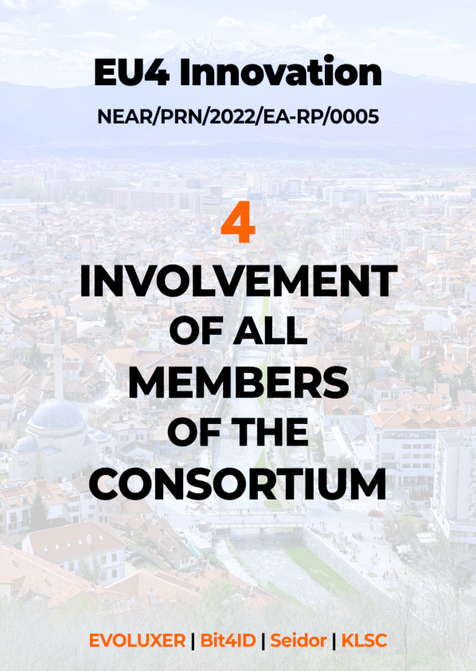

## Section 4 – Involvement of all members of the Consortium

1. **Summary**

The Consortium was brought together on the basis of its complementary skills and its capacity to efficiently and effectively implement all aspects of the project. The Consortium consists of five members that jointly cover the technical, as well as regional and managerial expertise needed.

The leader of the consortium, Evoluxer (ES) is a well-established managing consulting company, with permanent present and offices in Western Balkans and with vast experience in implementing donor financed technical assistance projects in Western Balkans and other IPA countries, thus providing the consortium with the regional and managerial experience needed.

While each section corresponding to the tasks (sections 2.4.1 - 2.4.7) describes in detail the contribution of each Consortium Member to the achievement of the expected results, we will further present a high level and summarised view of this aspect. Referring to the tasks to be carried out for the project implementation, the Consortium Members involvement and responsibility is presented in Table 57.

Table 57-High level Consortium Members Involvement

| **Tasks corresponding to** | **EVO** | **SEID** | **TLSP** | **KLSC** |
| --- | --- | --- | --- | --- |
| **Manage, monitor, control, report** | ○ | ⬅ | ⬅ | ⬅ |
| **Inception Phase** | ○ | ⬅ | ⬅ | ⬅ |
| **Build Digital Identity Service Implementation Chapter** | ○ | ⬅ | ⬅ | ⬅ |
| **Deploy Digital Identity Service Implementation Chapter** | ○ |  |  | ⬅ |
| **Capacity Building Implementation Chapter** | ⬅ |  |  | ○ |
| **Awareness Raising ImplementationChapter** | ⬅ |  |  | ○ |

○ Responsible for

⬅ Provides input/Contributor

1. **Presentation of Consortium Members**

| **EVOLUXER** | | |
| --- | --- | --- |
|  | Address: | Calle Ferraz, 28, 28008 Madrid, Spain |
| Web: | http://evoluxer.com/ |
| Phone: | +34 91 758 86 92 / +34 91 541 6035 |
| Email: | [projects@evoluxer.com](mailto:projects@evoluxer.com) |
| LinkedIn: | https://www.linkedin.com/company/evoluxer-sl/ |
| EVOLUXER SL is a Spanish leading consulting firm with strong presence in South East Europe, active in the provision of technical consultancy and services.  The company provides its services to both public sector entities and private sector businesses and has an active presence in all countries of its wider geographical region, offering services that meet the increased requirements resulting from the transformation of the economies in South East Europe and the Mediterranean Region.  The company is following a long-term strategic plan aiming to establish its leading presence in the region through a comprehensive portfolio of services, using as its key leverages:   * its highly qualified and experienced personnel, * the use of state-of-the-art technologies, * the development of solid and long-term international co-operations and * the significant geographical coverage that it offers   EVOLUXER is in the position to provide professional resources of knowledge and expertise through a combined network of highly qualified experts with extensive experience in South East Europe.  EVOLUXER offers its services mobilizing more than 30 highly trained consultants as permanent staff and over 8.000 potential external collaborators around the world. The appropriate measures are taken on a day-to-day basis for the continuous evaluation of the external collaborator and the training of internal staff for securing the high quality of offered services.  **Geographical coverage**  EVOLUXER’s head office is located in Madrid, Spain, with affiliated or subsidiary companies in Brussels, Tbilisi, Skopje and Ankara. Furthermore, EVOLUXER has established project offices in a number of countries in Southeast Europe as depicted in the map below.  Map  Description automatically generated  **Targeted sectors**  EVOLUXER’s international activity relates to the implementation of multiple project types across its service lines and industry coverage, which can be classified under the headings:   * Large-scale Technical Assistance; * Framework Contracts Technical Assistance; * Services to Donors; * Innovation and ICT projects. | |
| EVOLUXER’s international experience record includes hundreds of international projects, implemented in more than 30 countries, under a configuration outlined as follows:   |  | Large-scale TA | Framework Contracts TA | Services to Donors | Rural Development Projects | | --- | --- | --- | --- | --- | | EU Member states | **√** |  |  | **√** | | Candidate countries, Western Balkans | **√** | **√** | **√** | **√** | | EU Neighbourhood | **√** | **√** | **√** |  |   Details on the activities within the Western Balkans and Republic of Serbia, are presented on the map below:  A picture containing map  Description automatically generated  Our customer base over the geographies served includes EU Institutions and international donors, central and regional administrations, local governments and authorities, local and urban development agencies, financial institutions at international or regional or local level, state-owned organizations and enterprises, private enterprises active across main sectors of the economy.  Graphical user interface  Description automatically generated  **Services Offered**  Key constituents of EVOLUXER’s strategy to deliver high quality services and outstanding customer value are:   * Highly skilled professionals * Team spirit * Experience-driven knowledge management * Established partnerships * Strong international networking * Result-oriented culture   EVOLUXER’s strategy is to serve a broad range of customers with a broad range of complex needs demanding integrated capabilities of an external advisor with the ability to leverage its own capacity with leading international and local partners as needed. Our services integrate customer needs from concept and design to project management and implementation. We group our services along the following service lines:   * Management Consulting Services   + Good Governance   + Agricultural services   + Capacity Building & Institutional Strengthening   + Operations Improvement & Performance Management   + Organizational Restructuring & Transformation   + Human Capital Management   + Change Program Management * Information Technology Consulting Services   + ICT Strategy & Transformation   + Enterprise Architecture Design   + IT Programme & Project Management   + Information & Systems Security   + IT Solutions Delivery * Development Consulting Services   + Policy Development   + Programme Definition and Planning   + Public Finance Management/ Public Investments Programme Management   + Programme Evaluation   + Private Investments Funding & Management * Infrastructure Development Services   + Feasibility, Preparatory & Special Studies   + Design & Tender Management   + Programme, Project & Contract Management   + Construction Management & Supervision   + Technical Advisory Services   EVOLUXER staff has also extensive experience in Public Administration in Spain and in Brussels and are highly specialized in the management of projects for trade, law harmonization, training and capacity building of public institutions. EVOLUXER provide special assistance for any type or size of project formulation through to project implementation. Our main fields of activity are public and private sector development and social development:   * Institutional development, * Capacity building, * Trade promotion * Legislation harmonization * Monitoring and evaluation, * Public services arrangements, * Restructuring and business support services | | |
| Relevant Projects | | |
| Project name | Project description | |
| EU Funded Project: National Centralized Criminal Records in Kosovo | The purpose of this project is to provide support on the completion of the policy, legal and administrative framework and technical set-up for the establishment and implementation of a National Centralized Criminal Records Registry, in order to ensure the establishment of a fully functional Registry at central and courts level and ensuring the issue of the reliable conviction certificates through the system in line with international standards and ECRIS requirements. | |
| SmartNet | The overall objective of the contract is to increase the qualified intellectual properties, technological products and service capacity of Turkey, by improving efficiency and cooperation among TTIs.  The purpose of this contract is to establish effective technological cooperation between TTIs for development of technology transfer activities through artificial intelligence based smart network and technology acceleration principles | |

Table 58 - Consortium Partner 1: Seidor

| **SEIDOR** | |
| --- | --- |
|  | Seidor is a multinational that provides ICT services with 100% Spanish capital. Its origins date back to 1982 when it was founded by three brothers in Vic. The three founders are still leading the company. Nowadays, SEIDOR is still growing at an average rate of 20% per year and has over 6.000 employees.  With sales of 500 M€ in 2020 up from 410M€ in 2019, and staff of over 6.000 professionals, Seidor currently helps over 5,000 customers protect their technology investments and has become their technology partner of choice. We have achieved this special status thanks to our commitment to excellence. We have gained this status thanks to the professionalism of our technical employees, who are experts in their chosen field as attested by the certifications they hold from leading manufacturers |
| Seidor has three different business areas: Consulting, Infrastructure and Technology.  Diagram  Description automatically generated  The consulting area is in charge of the business solutions that involve SAP technology but also other technologies that might improve solutions, such as Opentext, Sybase, RFID, DDBB, etc. It is also in charge of horizontal solutions that might involve more than one technology (procurement, e-invoicing, warehouse, business intelligence, etc.). In this area we also place our consulting and project management activities and those related to studies (process reengineering, ITIL, COBIT; TOGAF, PMP, Project Management Offices, Service Management Offices, etc.).  The technology (or outsourcing) area is in charge of those solutions that involve other commercial packages rather than SAP and also tailored development of solutions with the most widely accepted development paradigms (J2EE stack, Microsoft stack, etc.). They are also in charge of the times and means activities and the help desk area. Most of our enterprise architects, business architects, etc. are in this area.  The infrastructure area is in charge of the provision and maintenance of advanced infrastructure solutions, both regarding the datacenter and the network. There is also our information security area.  The business areas are organized by expertise areas, either regarding a technology or a business solution.  Each expertise area has a technical director, several team managers, and technical personnel. Besides our technical areas, we must mention our Human Capital Management Department (People Department), as they are in charge both of the selection and retention of our staff. The People Department is composed by 12 staff members in Spain and around 30 in LATAM.   |  |  | | --- | --- | | Relevant projects | | | Project Name | Project Description | | VIDSIGNER | ValidatedID is an **esignatures** company with HQ in Spain and offices in Paris, London and Berlin. They are certified as a European QTSP (Qualified Trust Services Provider). [www.validatedid.com](http://www.validatedid.com)  They offer esignature solutions compliant with **EID**AS, including but not limited to, services such as time stamp, advanced **esignatures** and qualified **esignatures**. Among the different signature mechanisms they offer, there is BIO (handwritten signature captured by electronic means), Centralized (signature done with a Digital Certificate in the Cloud or on premise), and REMOTE (signature capturing two factor authentication evidences and environmental evidences.). All evidences are captured, encrypted and attached to the document. The document is signed with a Pades LT signature (including time stamp and digital certificate)  The project involved the creation of:   * A back end to perform **esignatures**: encryption, hash calculation, rendering, workflows support… * A front end app for BIO working on Android / Windows / Ios * A front end web (case sensitive) for the REMOTE signature process * A front end web (case sensitive) for signatures holder to sign with QUALIFIED DIGITAL CERTIFICATES. Development of features to manage the latter. * A front end tool to send documents to sign (with signer DDBB, signature templates…) * A front end console to monitor signature processes * Front ends developed in different languages (English, French, Spanish, German, Portuguese, Italian…) * Development of an Applet to sign with certificates in local equipment (token / windows certificate storage) * Integration with other QTSP that offer cloud HSMs / certificates to perform Qualified electronic signatures | | U-Sign | Development of the back office and the App for Android and Ios to allow any user to sign with Digital Certificates compliant with **EID**AS regulation. Main features are:   * Perform **esignatures** from the mobile device * **Esignatures** performed from any device, also from Mobile Phones. * **Esignatures** performed with QUALIFIED DIGITAL CERTIFICATES according to **eID**AS regulation * Management of different Digital Certificates and management (revocation, renewal etc..) of them.   The system allows to sign any kind of Document (PDF, XML….)  The App allows to manage both signed and unsigned documents  Functionality to add scanned handwritten signature  **Esignatures** can be performed online or offline.  For more information please visit:  <https://www.sofistic.com/uaresafeapps/usign/> | | RICSIGNER | RIC is an IT solutions company with over 20 years existence. Their software solutions area includes Document Management Systems (DMS) , having over 300 customers in this area. In 2017 RIC strategic plan decided to generate a signature platform, integrated with their DMS solutions, so they could digitalize more business processes that now were paper based. So RICSIGNER was designed and developed with SEIDOR, covering the following functionality:   * Manage different kinds of **esignatures**, including **esignatures** produced with Qualified Digital Certificates (cloud) or signature based in evidences (advanced **esignatures** according to **EID**AS) * Console to track status of sent document to sign (sent, pending all signatures, pending one/several signatures, rejected, signed). Reminders (mail, SMS) * Sending multiple documents to the same signer or the same document to multiple signers (with a unique signed document per signer) * Import signer data base form excel * Security – manage permissions of who can see what (departments, users...) * Usability – filters to find easily documents * Integration with DMSs such as Docuware (on premise and cloud) * Signature workflow templates * Advanced forms so that signers can introduce information prior to signature * Advanced forms for document generators / initiators of signature processes   For more info please see <https://ricsigner.com/> | | SENDTO / FIRMASUIT | Development of an **esignatures** solution to be commercialized to Peakway customers (city councils, private SME’s and corporations).  The **esignatures** solution consists in:   * Integration with different HSM to be able to use Cloud Digital Certificates to perform Qualified Signatures * Development of a local component to be able to sign using Qualified certificates hosted in local devices * Development of a web portal to be able to send document to sign (SENDTO) in all official Spanish languages, French and English   Integration with no code workflow solution Glad2link  Integration with city councils egoverment solutions like espublico, Absis, Berger Levrault, Aytos… | | |

Table 59 - Consortium Partner 2: Bit4ID

| **Bit4ID** | |
| --- | --- |
|  | Founded in 2004, BIT4ID operates in the field of information security and more specifically in the field of "digital identity," as also indicated by the company name itself: BIT4ID - Best Information Technology for digital IDentity.  All products and systems are developed and manufactured in BIT4ID's research and development laboratories in Napoli. The group's turnover is over 25 million euros with about 200 people employed in offices in Italy (Naples, Rome, Milan), Spain (Barcelona), Peru (Lima), the United Kingdom (London), and India (New Delhi).  Geographically, Bit4id has a recognized leadership position in Italy, has a strong presence in Spain, numerous clients in other European countries (mainly in Portugal, Poland, Bulgaria, Czech Republic, Slovenia, Romania, Hungary), South America (Peru, Ecuador), India and Macau in China  BIT4ID develops and markets products, systems and services based on PKI technology and cryptographic chips with applications and customers in the Public Administration, Banking, Trust Service Providers (certification authorities), system integrators and in general where digital signature, authentication and encryption capabilities are required |
| BIT4ID's range of products and systems includes the following market segments:   1. Hardware devices such as smartcard readers and cryptographic tokens for authentication and digital signature. 2. Drivers and system libraries for interfacing applications to cryptographic devices (PKCS#11 libraries, CSP/KSP, TokenD/CryptoTokenKit). 3. Desktop and mobile applications for digital signature and encryption. 4. Strong authentication systems over corporate networks or the Internet and single sign-on systems with tokens or smartcards (e.g., with the Regional Services Card or Electronic Identity Card). 5. Automated batch digital signature systems for digital transformation. 6. Services and projects for provisioning cryptographic devices by interfacing with Trust Service Providers for issuing digital certificates, either through tokens or remotely   BIT4ID is one of the few companies in the domestic and international market that can express deep expertise in the entire PKI technology stack, from cryptographic hardware design to low-level cross-platform library development, from digital signature client applications to sophisticated server systems for digital identity management, from complete PKI infrastructures to value-added digital identity services.    Particularly about the latter aspects, i.e., the implementation of infrastructure for trust service providers both with a fully on-premises model run by the customer and with an Infrastructure as a Service model run by BIT4ID, there are numerous high-profile references that we can list.  BIT4ID recently participated, as a technology and professional services provider of the Infocert-Aruba RTI, in the implementation of the new qualified CA of InfoCamere S.C.p.A. Thanks also to the skills and software systems developed by BIT4ID, Infocamere has been accredited as a Qualified Trusted Service Provider for digital signature, time stamp, electronic seal, as well as non-qualified services related to CNS.  BIT4ID fully developed the infrastructure of Uanataca S.A., QTSP doubly accredited in Spain at in MINTEUR and in Italy at AgID for digital signature services, time stamp, electronic seal. Uanataca S.A. is a BIT4ID group company established to offer digital identity services both in the form of certification services and as PKIaaS.  Azienda Zero, an entity of the health service of the Veneto region, is an accredited QTSP in Italy for the provision of digital signature, time stamp, and electronic seal services. Azienda Zero's infrastructure is fully outsourced at the datacenter of Uanataca S.A. Again, the BIT4ID and Uanataca teams took care of all technological, organizational, and documental aspects to pass the compliance audit required by AgID to avail of the status of qualified trust service provider.  The list of eIDAS-accredited QTSPs using BIT4ID and Uanataca's PKIaaS services also includes the following companies on the European Trusted List:   * BEWOR TECH, S.L. * DOCUTEN, S.L. * ELECTRONIC IDENTIFICATION, S.L. * ECERTIC DIGITAL SOLUTIONS, S.L. * VALIDATED ID, S.L * BRANDOCS, S.L.   This list just given is intended to highlight not only the technical expertise of BIT4ID in the implementation of infrastructure, but also and especially the experience gained in accreditation processes, which allows the client, who uses the services of BIT4ID, to have a guaranteed result. BIT4ID provides a multidisciplinary team with experience in the areas of legal, compliance, project management and technology.  In addition to accredited infrastructures according to eIDAS, BIT4ID has recently been awarded several prestigious PKI projects, worldwide, of strategic interest to the nations involved.  In Jordan, BIT4ID participated, on behalf of the Ministry of ICT (MoICT), in the implementation of the expansion of the national PKI infrastructure, used for the issuance of the electronic identity card, to support remote digital signature through an on-boarding process of users via eID.  In El Salvador, BIT4ID implemented the Root CA of the Ministry of Economy (MINEC) thanks to a fund provided by the World Bank (FOMILENIO II).  In Ecuador, BIT4ID saw the reconfirmation of its maintenance services for the PKI infrastructure, complete with remote signature and time stamp services, implemented on behalf of the Consejo de la Judicatura.  In several countries around the world, BIT4ID experts are called upon to serve as consultants on digital identity, electronic signature, and digital transformation projects; below is a summary list of consulting projects recently completed or nearing completion:   * SIGIEP, Ministère des Postes et Télécommunications, Cameroon * UNIRED, Administradora de Pagos de Nicaragüa * Registro Nacional de Identificación y Estado Civil de Perú * Transacciones y Transferencias, Red 5B de Guatemala  |  |  | | --- | --- | | Relevant projects | | | Project Name | Project Description | | FIRMAFACILE BUFFETTI | * Development of a full suite of digital signature products, hardware and software, for the retail mass market. * Development of business processes and supporting software tools for identification of end users, issuance of digital certificates and management of their life-cycle. * Development of a customer care service for supporting end users in the activation and use of digital signature products   Buffetti is a chain store for goods and services addressed to professionals in Italy. Bit4ID developed a solution that enables every shop to act as a Registration Authority for issuing digital signature solutions.  In numbers:   * 600 shops acting as a Registration Authorities * 1000 registration officers * 720.000 active certificates in the last 3 years   From this project we can inherit the experience in building a very scalable mass service, the business processes we  developed for establishing a capillary service and the capability of providing a best-in-class responsive customer  service. | | INFOCAMERE QTSP | Since more than 10 years BIT4ID in a Joint Venture with Infocert  and Aruba PEC provides to Infocamere, the IT service company  of the Italian Chamber of Commerce, a wide range of digital  signature and PKI solutions comprising digital signature devices  and applications, certificate management system.  Moreover, in the past 3 years Infocamere started a project to  become a QTSP provider itself and awarded the project  to the above-mentioned Joint Venture of companies.  The specific responsibility of BIT4ID in the consortium was:   * Evolution of the Web RA software (Certificate Management System) already in use at the Italian Chambers of Commerce to accommodate new workflows and business needs. * Deployment of the systems in a new infrastructure to scale up performances. * Integration of the Web RA with newly deployed components such as:   + CA software   + Long term archival system   + Remote digital signature system (HSM-based)   + TSA   + SPID system (National Web eID system) * Development of a Web application for the video remote identification of end-users * Development of the self-service portal for the management of end-users’ credentials * Integration of the digital signature software client, named firma4ng, with the remote digital signature infrastructure * Integration of the mobile app with the remote digital signature infrastructure   Evolution of the middleware software available for every operating system as PKCS#11, Microsoft KSP/CSP, Apple CryptoTokenKit to support remote digital signature besides the already supported cryptographic devices such as smartcards from different vendors and PKI USB tokens | | Notartel QTPS | Notartel SPA is the IT company of the National Council of Italian Notaries. Notartel provides several IT services to Italian notaries and in particular digital signature services, registered electronic email and long-term archiving.  In 2021 BIT4ID was awarded a contract to build a complete PKI infrastructure and to provide the necessary consulting services to pass the audit from AgID, the Italian supervisory body for digital identity, and therefore achieve the qualification of the infrastructure according to the eIDAS regulation as well as to the Italian law.  BIT4ID provided:   * Project management services. * Full stack of software components for the PKI (CA, VA, RA, Video Identification, TSA, Remote Signing System). * Integration services with existing infrastructure (e.g., long-term archiving system, monitoring system, etc.) * Deployment services (installation, network configuration, ect.). * Compliance consultancy services. * Staff training. * Supporting documentation | | Uanataca | BIT4ID fully developed the infrastructure of Uanataca S.A., QTSP doubly accredited in Spain at in MINTEUR and in Italy at AgID for digital signature services, time stamp, electronic seal. Uanataca S.A. is totally owned by BIT4ID Group and it is a subsidiary company established to offer digital identity services both in the form of certification services and as PKIaaS.  BIT4ID provides to Uanataca:   * Project management services. * Software design and development. * Full stack of software components for the PKI (CA, VA, RA, Video Identification, TSA, Remote Signing System). * Deployment services (installation, network configuration, etc.). * IT security services. * Compliance consultancy services. * Supporting documentation (Certificate Practice Statement, Certificate Policy). | | ELECTRONIC HEALTH RECORD – IT SECURITY CHAPTHER | Azienda Zero is the Veneto Region company set up to rationalise, integrate and improve the efficiency of the health, socio-health, and technical-administrative services of the regional health service. Among the competencies of Azienda Zero there is also the management of the ICT systems related to health services.  The Electronic Health Record (Fascicolo Sanitario Elettronico - FSE) is the tool through which citizens can trace and consult their entire health history, sharing it with health professionals to ensure a more effective and efficient service. The information in the Citizen's Record is provided and managed by each region.  BIT4ID provided technology and services for the FSE project in the security chapter as detailed in the following:   * A full PKI-as-a-Service was provided to Azienda Zero by means of the Uanataca TSP (100% owned by BIT4ID), comprising the accreditation services to become an Italian QTSP listed in European TSL.   A federated authentication platform called Identity Provider Assertion Manager (IPAM) based on the SAML 2.0 standard. The platform allows a medical doctor in one of the health local units of the Veneto Region to access the central DB for the Health Record of a patient by means of a Single Sign On from the local infrastructure | | National Identity Management Solution for the Ministry of Digital Economy and Entrepreneurship of Jordan | The project was aimed at providing the MoICT of Jordan with a national infrastructure for the Digital Identity provisioning to citizens, government employees and public and private organizations.  BIT4ID participated as a subcontractor to a Joint Venture of system integrators (Jordan Business Solutions and Cybertech/Engineering).  Jordan citizens already had an issued physical eID card and the MoICT was looking for a solution to make eID digital certificates available also from mobile devices (mobilification of eID ) or more in general to avoid the use of the physical card for the purpose of digital signature and authentication but keeping the security and trust of the underlying national PKI.  BIT4ID provided the following:   * Development of an onboarding platform for the registration of users based on eID and biometry. * Installation, configuration, and integration of a qualified remote signature system (r-QSCD) based on HSMs. * Development of software libraries to integrate desktop applications with the remote signature system. * Development of software libraries to integrate mobile applications with the remote signature system. * Support for integration of government applications with remote digital signature platform.   Training of system administrators, system integrators, software developers and first level help desk | | |

Table 60 - Consortium Partner 3 - Kosovo Legal Services Company

| **KOSOVO LEGAL SERVICES COMPANY** | | |
| --- | --- | --- |
|  | Address: | Str. Simon Shiroka 30C, E2/3, 10000 Pristine, Kosovo |
| Web: | [www.klsc.eu](http://www.klsc.eu) |
| Phone: | +383 (0) 38 778 095 |
| Email: | [info@klsc.eu](mailto:info@klsc.eu) |
| Company description  Kosovo Legal Services Company L.L.C (KLSC) is a Kosovo-based consultancy company operational since January 2011, that aims to provide technical assistance services to companies, public organizations and institutions, particularly within the scope of programmes and projects financed by international or bilateral bodies. | |
| Company profile  Information Technology has been an important component of nearly all our projects, through which framework, we have successfully contributed to the following areas:   * Currently in the process of supporting the Civil Registration Agency in Kosovo in the update of the IT and legal infrastructure for the matching and linking exercise between the certified-copy e-archive and the CCSR; * Assessed the pilot database on the criminal records and as per its results established a new National Centralized Criminal Record Database, currently under the framework of the Kosovo Judicial Council but transferring its ownership to the Ministry of Justice; * Assessing the status of the database of Sequestrated and Confiscated Assets which belongs to its specialized Agency within the Ministry of Justice; * Recovering the Database of the Agency for Management of Sequestrated and Confiscated Assets; populated it with data and conduct quality control functions; * Contributed to the maintenance and population of the Court Electronic Case Management Database; * Updated the software of the Financial Intelligence Unit of Kosovo to be fully in line with the new standards of GoAML; * Carried out needs and functional assessment of the free legal professions database and its interoperable with the one of the Ministry of Justice, Cadastral Agency, KBRA; * Developed Solution to the Ministry of Environment and Spatial Planning on how to deal with appeals of decision on constructions without permits.   Through the below-mentioned projects, and the ones implemented before, we have managed to successfully contribute to the country’s most important milestones, such as:   * Increasing the quality of legal infrastructure: Currently engaged in drafting the National Centralized Criminal Record Law (a novelty to the country, as so far, the issues to be regulated by this law, were regulated by secondary legislation only); competition related legal framework. We, prepared the basis for the Civil Code drafting process – to be the first one in the country; Law on Mediation, Law on Notary; Law on Amending and Supplementing the Law on Inheritance; Law on Amending and Supplementing the Law on Non-Contentious Procedure; Law on Amending and Supplementing the Enforcement Procedure; Law on Bar Exam; Law on Extended Powers of Confiscation and Sequestration; * National Level Strategic Documents: We led the drafting process of the National Strategy on Preventing and Fighting economic and financial crimes and it’s Monitoring Matrix; National Risk Assessment on financial and economic crimes; * Continues Legal Education Programs: through the support provided to the Justice Academy of Kosovo; * Basic and Advanced Training Programmes design and delivery, including Train the Trainers Program: not only delivered trainings on various topics, but, most importantly, built the capacities of local trainers by several ToT programmes through the Kosovo Institute for Public Administration; * Revised and updated Training Materials, Training Manuals and Guidelines: through most of our projects. * Performing monitoring, evaluation and quality control on the implementation status of legal framework. | | |
| Relevant Projects | | |
| Project name | Project description | |
| EU/DRC Funded Project: Provision of Services in the fields of Civil Status and Information Technology | The purpose is to ensure the provision of adequate subject-matter expertise to guarantee the matching and linking exercise between the certified-copy e-archive and the CCSR is implemented according to international and regional human rights, high-quality standards, pertinence to the relevant context (including with respect to the legal framework and long-term vision of the Kosovo Government). | |
| EU Funded Project: National Centralized Criminal Records in Kosovo | The purpose of this project is to provide support on the completion of the policy, legal and administrative framework and technical set-up for the establishment and implementation of a National Centralized Criminal Records Registry, in order to ensure the establishment of a fully functional Registry at central and courts level and ensuring the issue of the reliable conviction certificates through the system in line with international standards and ECRIS requirements. | |
| MCC/MFK Funded Project: Assessment and Supervision Services for the Public Access to Judicial Information Activity | The general objective of this assignment is to assess the environment and its components, identify constraints, pre-requisites, make actionable recommendations and provide a roadmap for the successful implementation and rollout of the Case Tracking Mechanism (CTM) and the Online Data Platform (ODP). | |

1. **Consortium partners’ synergies/ complementary areas of expertise**

As presented earlier, all members of the Consortium are well-established companies with proven experience in the agricultural sector and in the Western Balkans, which represents a guarantee in terms of understanding the country-specific political and socio-economic landscape. This creates a solid base for the design of a tailor-made project management and implementation methodology.

The Members of the Consortium fully cover the wide range of expertise and know-how required for this project as illustrated in the next table. Thus, across the areas identified as critical for the execution of this Contract, Consortium Members are expected to bring substantial skills and experience, largely drawing from their relevant experience in executing similar assignments.

Table 61 - Consortium Members: Relevant Expertise

|  | EVO | SEID | Bit4ID | KLSC |
| --- | --- | --- | --- | --- |
| Experience in the implementation of technical assistance projects for capacity building in the field of project | √ | √ | √ | √ |
| Experience in the implementation of projects in the field Digital Identity Services and related solutions | √ | √ | √ |  |
| Experience in the implementation of projects in the field of ICT | √ | √ | √ | √ |
| Experience in providing technical assistance for monitoring and evaluation of EU funded projects | √ | √ | √ | √ |
| Experience in supporting public authorities in implementation EU framework(s) | √ | √ | √ | √ |
| Management of complex, multi-stakeholder projects in Kosovo and IPA countries | √ | √ |  | √ |

1. **Consortium Function**

We have established a Consortium which will work as an integrated structure/team so as to be able to deliver optimal services.

The members of our Consortium bring complementary skills and experience to the Project and together are capable of providing the wide range of services required under the ToR. We consider that the above has been successfully proven in the application phase, by demonstrating a wide range of corresponding and complementary expertise that ultimately led to our Consortium being invited to present a proposal.

The Consortium members recognize the importance of working together with each other seamlessly and effectively.

As our usual practice, all the experts and/or project staff will be allocated from common pool of consortium expertise, regardless of their associated consortium member/company in order to deliver and manage the project as a single unit in a smooth way internally and externally.

1. **Consortium Management**

**The Consortium is governed by an Association Agreement and, according to its provisions, is headed by the Consortium Board (CB), which overviews the project implementation provides strategic guidance on the latter and decides on major issues affecting the efficiency of the Consortium function.**

The CB has been already established and comprises of one nominated representative from each Consortium partner, who has the authority to make the relevant decisions on behalf of the respective partner. The CB will be meet periodically during the project implementation (at least every 3 months).

CB meetings will be conducted face-to-face or via video/teleconference. The first official meeting of the CB will take place within one week from the project’s contract signature, while the second meeting will take place one day prior to the kick-off meeting, where the entire Consortium function summarized in the present proposal part and reflected in the Association Agreement will be mobilized. Procedures and rules for CB meetings, decision-making processes (issues requiring consensus vs. majority vote), changes in formal representation, frequency and places of meetings will be detailed, too.

The Consortium Board has appointed Mr. Javier Ruiz as Project Director (PD) who is the single person to represent the Consortium before the Contracting Authority and responsible for coordinating the CB. The meetings of the CB will be convened by the Project Director who will define the CB meeting agendas, keep and distribute minutes of the meetings.

Members of the Consortium Board are the Project Director (on behalf of the leading partner) and the Partner Backstopping Managers of the remaining partners, as they were presented in Section 3 of the proposal.

1. **Cooperation Model among Consortium Members**

The Consortium Board has adopted a function governed by the principle of excellence, namely the integration of complementarity and synergies among all Consortium partners across all aspects and stages of the project implementation, so that efficiency, quality and sustainability of service delivery are optimized.

The above-mentioned principles are reflected in the core functionalities of the Consortium during the entire project execution, including the Consortium management, the contribution in know-how and expertise, the backstopping mechanisms and the project monitoring and quality assurance processes. Moreover, the financial agreements between the Consortium members align with such a quality-driven cooperative pattern.

The Consortium partners have adopted a dynamic model of profit generation, directly related to economies resulting from optimal use of resources through complementarity and synergy.

Our experience has shown that such a cooperation model results to the ample achievement of the objectives of demanding TA projects once a strong and efficient project directorship is in place, and this is why an exhaustive managerial function is entrusted to the appointed Project Director.

Joint performance by all Consortium partners has been successfully exercised from the very beginning, namely from the proposal preparation stage, where the partners concertedly carried out the following functions:

* understanding of the project environment, the support services nature and expectations, and agreement on the methods of delivering the respective services;
* agreement of the Consortium management and function pattern and the Consortium Association Agreement;
* appointment of the Consortium Management Board, and assignment of the Project Director;
* compilation of the project work plan, breakdown of the project components, and agreement of the methodology, timing and resources to carry out each activity and task;
* identification of candidate key experts, objective comparative assessment of their qualification and experience versus the ToR requirements, their attitude, and their overall performance so far, and selection of the best among them;
* agreement of the non-key experts’ identification and selection process and proactive identification of a pool of non-key experts (including suitable in-house personnel of the Consortium partners), available to join the Project Team upon the project commencement;
* elaboration of the principles of the Project Monitoring, Quality Management and knowledge management procedures;
* agreement on the structure and staffing of the Back-stopping mechanism (Back-stopping Task Force, Operational Back-stopping Team, Technical Back-stopping Team).

The above issues will be further detailed by the Consortium prior to project commencement, in case of award, and they will be formalized and presented to the CAUT and IAUT for their finalization and approval during the Inception Phase.

The day prior to the project kick-off meeting, a new session of the Consortium Board will take place to confirm readiness by all partners to contribute with the inputs defined, and undertake the tasks and responsibilities agreed.

The main elements of those consortium arrangements are summarized as follows:

* the partners authorize the leading partner to sign the Contract with the Contracting Authority on behalf of the Consortium, and represent the Consortium before the CAUT and IAUT for amply implementing all technical and financial provisions of the Contract;
* all partners will equally participate in the management of the consortium via their participation in the Consortium Board;
* the Project Director that the Consortium assigns will be the single representative of the Consortium, undertaking the role and responsibility to apply all valid EuropeAid & IPA rules and procedures, and the respective guidelines by the CAUT and IAUT and guide the project implementation according to the precise Contract content and expectations from the TA service delivery;
* among the list of candidate Experts identified during the proposal preparation phase, the Consortium Board has selected the best ones that meet the ToR requirements; the partner that contracts each Expert according to the allocation presented herein will use and execute a model contract agreed by the Consortium;
* Consortium partners will contribute to the identification of experts, to the transfer of know-how and expertise, to the back-stopping of the operation and the Project Team, and to project monitoring and quality assurance according to their specific experience on the project fields. For this purpose, the fields of expertise necessary to carry out the operation have been matched with the experience of each Consortium partner;
* Consortium partners will contribute to the mobilization and contracting of experts. Upon approval of a certain expert ToR by the CAUT and IAUT, the Project Director will request proposals of candidates by the Consortium partners, including in-house staff. Even if the partner closer to the certain field of expertise is more likely to identify a suitable expert, the request will be addressed to all partners, and the best candidate will be selected under the joint responsibility of the Project Director and Team Leader and following the approval of the CAUT as per the selection procedures stipulated in the ToR, regardless of which partner will contract him/her (as presented earlier in this chapter); the model contract agreed by the Consortium will be applied again;
* the Consortium partners will continuously support the experts in all technical matters falling under the fields assigned to them as above, making available to the Project Director their knowledge and experience through the backstopping mechanism adopted (described in previous Section);
* similarly, all Consortium partners will contribute to the review of deliverables and reports, and the implementation of the Project Monitoring and Quality Management system, according to the distribution of said responsibilities among the project fields, under the coordination of the Project Director;
* while the costs of the contribution by the Consortium members as above will be continuously monitored and reimbursed by the leading partner through a resource management system agreed, no profit will be allocated to any partner before the end of the operation. Upon completion, all partners will be entitled to share the resulting profit on the basis of decisions taken by the Consortium Board.

The cooperation model outlined above, has been successfully applied by EVOLUXER in technical assistance projects in many countries, for many years, and it is considered as a unique model, ensuring both the availability of the entire Consortium knowledge to the project beneficiaries through the efficient project directorship by the leading partner and the fair treatment of the Consortium members

1. **Consortium Members’ roles and contributions**

According to the knowledge, experience and capacities of the Consortium partners, their precise role in project implementation has been defined and presented in this section.

The composition of the present Consortium has been carefully designed so as to ensure the successful implementation of the project. The Consortium represents a balanced mix of partners from the region and other parts of Europe, thus ensuring that state–of–the-art methods and solutions are effectively severally responsible for the achievement of the results of the project at the defined quality, within the specified time-frame and on the basis of the available resources.

Specifically, the four partners are committed to be engaged in the strategic management of the project (via the Consortium Board), the identification and recruitment of experts and the provision of operational and technical backstopping to the team of experts (Project Team).

Each Consortium partner will appoint a Backstopping Manager who will provide operational backstopping to the experts to be recruited and co-ordinate the provision of technical backstopping with the support of appointed Thematic Advisors. Moreover, permanent staff of the project partners may be engaged as experts in the project provided, they meet the specific requirements and undergo the standard selection process.

Moreover, the table below provides an indication of the levels of partner involvement in three activities of the project. The table demonstrates how we will transfer our expertise as a consortium during the implementation of this project, in line with the expertise we offer as a group.

Table 62 - Consortium Members Involvement: Detailed contribution

|  |  |  |
| --- | --- | --- |
| Project Phases | EVOLUXER | Consortium members |
| **Inception Phase** | * Setting up project office * Staffing project office * Organising kick off meeting * Overall contract management * Analysis of existing systems (existing source code’s quality, functional specifications and software functionality, interoperability) * Preparation, signing and gathering of confidentiality agreements * Analyse the already existing technical specifications for the supply tender related to the IT equipment necessary to make the eID system functional * Analysis of compatibility between the proposed technical specifications of the IT equipment and the software that will be designed and installed * Liaison with stakeholders * Carrying out baseline studies * Preparing Inception Report | * Analysis of existing environment at international level in the relevant sector * Support to the aanalysis the already existing technical specifications * Support to the analysis of compatibility between the proposed technical specifications of the IT equipment and the software that will be designed and installed * Support to prepare Inception Report |
| **Implementation Phase** | * Staffing as needed (expert allocation) * Organising PSC meetings * Overall contract management * Liaison with stakeholders * Preparing Project Reports | * Design and develop the Digital Identity Services * Deploy the Digital Identity Services * Provide required trainings (Capacity Building) * Execute Awareness Rasing Campaigns |
| **Closure Phase** | * Organising Final Steering Committee meeting * Overall contract management * Liaison with stakeholders * Preparing transfer and project takeover to Beneficiary * Preparing sustainability plan * Preparing Final Report | * Supporting to project transfer actions * Supporting to sustainability plan * Supporting preparation of Final Report |

Key leading role: EVOLUXER

In thecontext of the proposed project, EVOLUXER will coordinate the inputs of all consortium members and mobilize technical backstopping staff with experience in the delivery of the planned activities, having also experience in the implementation of EU-funded Technical Assistance projects in Western Balkans. In addition to coordinating the inputs of all consortium members, EVOLUXER will be in charge with supporting all training activities and support in the development of technical specifications for procurement.

In terms of technical expertise, EVOLUXER will be overall responsible for coordinating, managing and timely delivery of ALL activities, during the Inception and Implementation Phase of the project**.**

More specifically, the consortium partners will contribute to the implementation according to the table below:

|  |  |
| --- | --- |
| **IMPLEMENTATION PHASE** | |
| **Component B: Digital Identity Service** | |
| Component B | Contribution |
| * Deliver a technical solution for digital identity service * Registration process * Usage of digital identity | Evoluxer will be responsible for the overall coordination of the delivering of the Digital Identity Service. Evoluxer will coordinate the role and assignment of both Seidor and Bit4ID for the development, delivering and testing of the eID platform. It will be the leader responsibility to ensure timely delivery and to quality control the provided solution fully meets the ToR requirements and the functionalities agreed with the MoEE and EUOK during the inception phase.  Specialised inputs will be provided by SEIDOR and Bit4ID as Software development specialised companies for the development, implementation and testing of the eID platform. The experiences in similar assignments of both consortium parties make them completely suitable for carrying out this component. Moreover, they will put their joint experiences in the service of the project in order to ensure highest standards for the delivering of the eID solution. Seidor and Bit4ID count with over 20 years of experience in the field of software development and engineering, control, software reports, software audit, and development of specialised and targeted software and IT solutions for different public clients. This experience includes a substantial number of eID projects, for which Seidor and Bit4ID have developed the tailored software solutions. Therefore, Seidor and Bit4ID will provide inhouse resources for the development of the eID solution.  KLSC, through several teams of IT experts, has provided IT technical solutions to most of local institutions going through digitalisation processes, incl. Civil Registration Agency (CRA), Kosovo Judicial Council, Ministry of Justice, Ministry of Internal Affairs, Kosovo Cadastre Agency, etc., and thus KLSC will further utilize its expertise in this regard.  Further, KLSC, in the framework of various projects, has carried out IT infrastructure and legal infrastructure assessments related to digitalization, analysis and drafting of technical specifications for specific solutions, software/hardware deployment and installation, validation and testing, etc.  Given the experience that KLSC has in the establishment of new registration systems, especially in the aspects of the digitalisation/registration process, with the EU project for national criminal registry records/evidence being highlighted, can provide significant support in the implementation of this activity, making available a team with great experience in the field of IT. Since KLSC has experience in the field of digital identity, through the implementation of the DRC/EU project in support of the CRA, it offers the services of professional IT experts in the field of further development of IT infrastructure in the direction of digitization of essential services to citizens |
| **Component C: Capacity building at national and local level** | |
| Component C | Contribution |
| * Training needs assessment at local level * Design of training curricula * Organization of trainings at local level * Organization of study visits | Evoluxer will coordinate the overall organisation and delivering of capacity building component, selecting and managing trainers and perform quality control of training curricula and training outputs.  As Evoluxer, we count with extensive experience in providing capacity building for different Ministries of Economy, and we are currently implementing a large TA project in the Republic of North Macedonia. Also, we have provided with capacity building components in similar assignments in Spain, Georgia, Republic of North Macedonia, Turkey, Azerbaijan, and others, and we will thus put at the service of the Project our large experience in strengthening capacities at public institutions. Moreover, we will be responsible to the organisation and implementation of the study tour to be organised before the design of the eID solution  Seidor and Bit4ID will be responsible for the overall design and development of the eID solution, and therefore, they will be responsible of designing the training curricula and quality controlling the delivering. Moreover, Seidor and Bit4ID will analyse the training evaluation reports in order to adapt the training materials after the first sessions. Both companies have inhouse trainers who will be responsible for the supervision of the training implementation  KLSC has conducted a large number of training needs assessments (TNA) for different beneficiaries in the framework of the relevant projects, mainly those financed by the EU. These TNAs have led the relevant institutions to translate their results into long-term training programs, where it is worth emphasizing the support provided by IKAP, a special institution for providing training for public officials, as well as other institutions in the field of judiciary and justice, such as the Justice Academy, line ministries, KJC, KPC, etc. The training needs have covered the entire organizational and managerial level of the institutions, starting from the leadership positions to the officials of the departments and divisions, including the IT staff. Regarding the digitization processes, KLSC, in the framework of the relevant projects, has also conducted TNA for IT staff of NCCR, Justice System Strengthening Program, PAJI systems developments, etc. Having said that, KLSC can strongly contribute towards the drafting of TNA for the purposes of this project.  KLSC, emphasizing the above, and as a result of conducting many training needs assessments, has also designed many training programs and curricula for the different beneficiaries mentioned above, focusing on a content as rich as possible towards addressing of all needs and building professional and institutional capacities. The content of these training curricula includes competencies-based curriculum development, methodology for performance improvement cycle, incl. training development cycle, initial and continuous training programs, compliance with European and international standards, and horizontal training concepts. This experience enables KLSC to easily contribute to the framework of this project. The organization of trainings, workshops or ToT sessions is a characteristic of KLSC, which over the last 10 years, has supported a large number of institutions and professionals in raising their capacities. KLSC has organized a very large number of different practical, hands-on and on-job trainings on different topics, including those in the field of IT, a relevant sector of this project, where hundreds of thousands of beneficiaries have been supported. Furthermore, KLSC, mainly in the framework of projects financed by the EU, has also organized a series of train-the-trainer sessions, equipping them with essential knowledge on providing training on certain topics, incl. good governance and IT, which has resulted as a success story for KLSC, because a large number of trainers continue to offer training in their specialized fields. Given this extensive experience, KLSC can take over the organization of all the trainings planned in the framework of this project, and facilitate all the organizational and logistical aspects of the trainings |
| **Component D: Awareness raising** | |
| Component D | Contribution |
| * Development of public awareness campaigns | Evoluxer will be responsible for the overall coordination of the awareness raising campaign. We will use our experience in the implementation of similar assignments to ensure high standards for the PAC development and delivering. Currently, Evoluxer is implementing the Technical Assistance project to EU4You Communication in the Republic of North Macedonia.  In nearly all projects, KLSC used their expertise to design communication and awareness raising campaigns and deliver communication and public awareness related activities, including: awareness raising and outreach campaign to increase the public access to judicial information, increase transparency and public awareness on the success stories of courts; produce a video to increase awareness of Kosovo citizens on the novelties we have brought up on the criminal records and the process of issuing such certificates from the courts; conceptualized and designed the awareness and communication strategies for line institutions on the good governance and rule of law; conduct one-month awareness raising and outreach campaign on the role of free legal professions, consisting of all main elements such as: launching event, billboards, website of the campaign, social media kit, leaflets, banners and TV/social media presence; enhance public perception of civil society and media through targeted communication and visibility activities etc. This being said, KLSC is confident to further utilize communication and outreach experts to implement given activities related to this particular project |

1. **Allocation and management of project resources**

The consortium partners will mobilize and recruit required senior and orher experts in areas of expertise relevant to its expertise and networks, therefore will be responsible for the backstopping of each component throughout the implementation of the project. Taking into account the partners’ network strongholds, and the specifics of this project (global price, software development and deployment, capacity building, awareness raising) we will adopt a dynamic allocation of resources based on the implementation activities that will be carried out.

It will be the responsibility of the TL and PD to establish in advance the needed resource allocation. This will be made on quarterly basis and will be adatpated as needed each month.

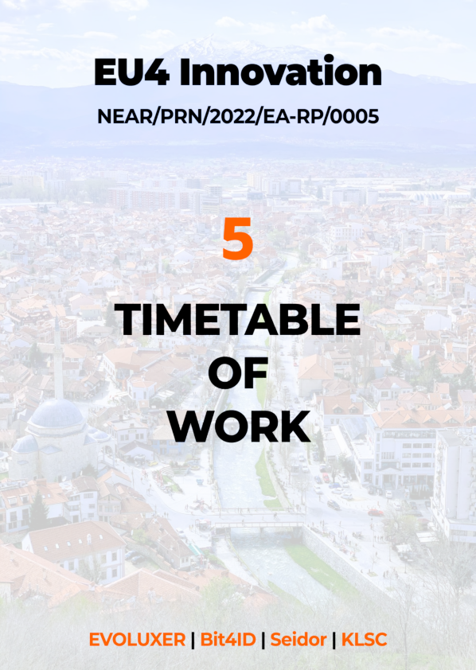

## Section 5 – Timetable of work

1. **Approach**

We put great importance to Section 5 Timetable of Work. In this section, we will provide the technical analyses of Project timetable, relationship between activities and interlink between resources as well as the methodology we use to track these variables in depth and detail.

We will use Professional Project Management Approach to visualize all these aspects within this section. Best projects can only be efficiently and professionally managed with an efficient planning and utilization of the project management tools through a strong background of experts and subject matter experience.

One of the major components of project triple constraints; time management, shall be evaluated as an integral part of project management. Thus, we have formed all the analysis provided within this section built upon our foundation described in detail under backstopping section within the context of:

* Subject matter expertise and expert judgement
* Extrapolation from our experience in similar EU funded projects we implemented in the same geography targeting capacity building provided to managing authorities for EU funds management, especially in the agriculture and rural development sectors.
* Using the guidelines of PCM and PMI
* Guidance from well-organized and structured Terms of Reference

1. **Time Management**

Time, together with scope, quality, budget, resource and risk are competing Project constraints that need very careful planning and tracking. This is especially true considering that time is a one-way vector always going forward, therefore there is no turning back. Successful management of Time, Scope, Quality, Budget, Resources and (positive and negative) Risks bring the achievement of the expected results of a project.

Time management is another important aspect as a lack thereof can lead to delays in deliverables and in the completion of the project. A delay in one task can lead to delays in a dependent task, for example if the first survey and first round of interviews are delayed, then the state-of-play will be delayed. For this reason, the work breakdown decomposition is important, the logical dependencies and sequence between tasks and activities is defined (this is done at proposal stage and updated during the inception). In addition, the duration of tasks and activities is estimated taking into consideration the start and end date of the contract.

We use the **Critical Path Method (CPM)**, which is a scheduling technique that calculates the necessary path of tasks and / or activities, hence the shortest possible duration of the project from its initiation until its completion. Often tasks and / or activities may have a delay margin and can, therefore, be slightly delayed without affecting the project completion date. A task and / or an activity is marked as critical and thus, it cannot be delayed, when one of the following stands:

* **Its delay margin is zero,** as in the case of the events that will be planned well in advance and it will not be possible to change the date once the event organisation is launched the then there is zero margin, so the content and speaker arrangements have to be finished on time – as is often the case in the project.
* **There is a mandatory starting or end date**, for example in the case of broader stakeholder engagement and consultation or where data needs to be collected before the summer period in order to ensure the availability of interviews, survey respondents, etc.
* **The task end date coincides with the date for the termination of the project**

Critical tasks and activities are therefore prioritised and special emphasis is put on them in order to shorten the duration of the critical path by compressing the critical path activities, allocating more resources and implementing more activities in parallel.

However, in practice it is a combination of techniques that is being applied, in order for a realistic and useful timetable to be drafted, which to the extent possible contains buffers to allow for potential delays. The sequence is affected, besides the constraints imposed by the ToR, by the resource quantities available, and the sequence these will be available. All activities are listed, and their timing is presented in the Workplan.

Project Workplan is the main document for planning, developing, managing, executing and monitoring the Project activities. The key benefit of a Project Workplan is that it provides a consolidated and concise guideline on how the Project schedule will be implemented throughout the Project life-cycle. The planning is illustrated in a Gantt chart (Horizontal bar diagram, see below).

In developing the planning, we do not only rely on the work breakdown, but also on experience and best practices, taking into account historical data on how long specific tasks and activities take (e.g. how long surveys need to be open in order to ensure sufficient responses). The Gantt chart and overall planning is then discussed with the team in order to ensure that everyone is aware of the planning and the critical paths as well as to make sure that everyone agrees that the assumptions, upon which the planning is based, are realistic.

During the development of this Work Plan, we have utilized the Expert Judgment technique. This was done by using the extensive experience gained (especially during the implementation of the EU Technical Assistance Projects) in project management, and its knowledge on the Project Management. This provides an unmatched ability to make accurate judgments regarding the duration and schedule of activities in this type of Project.

The specific planning on time aspects in this project is taking into account the following facts:

* **Duration of activities.** The typology of activities anticipates very different duration of those. While some of them are anticipated as one-time events others will be implemented through a longer period of time (above all the visibility of the project). With one-time events the milestones are clear while with longer activities regular checks of time aspects during the implementation will be introduced.
* **Logical sequencing of steps.** The Consortium has established that the description in the ToR provide possibility for logical and seaming sequencing of activities. One such example is the relation between conducting training needs assessments and delivery of different capacity building programmes, where one follows the other. The project action plan is therefore organised in a way that logical content steps will be implemented in sequence manner.
* **Possible overlapping in time.** The extensive number and scope of activities anticipates that some of the activities will need to be implemented in parallel. As a general rule the activities within the same component will be implemented on sequence basis while the activities between components could overlap in time. In relation to this possibility, it will be necessary to arrange the implementation in a way that two activities with the same or similar target groups are not implemented close to one-another.
* **Complexity and impact on duration.** Some of the anticipated activities require long time for implementation due to objective external reasons. Being aware of these cases the Consortium has moved such activities to earlier phases of implementation process. This will allow sufficient time to realisation and delivery of final results already in the time frame of the project.

The TA will introduce an internal management and control system of the time and resources, where initial assumptions will regularly be checked through the implementation phase.

Milestones and implementing periods of the activities will serve as benchmarks in this process. With periodical checks of implementing provisions, any eventual discrepancies will be identified early in the process, what will allow efficient introduction of corrective measures.

Before the presentation of the Workplan, we would like to share some introductory guidelines below for easy reference to cover the strategies further presented.

1. **Workplan**

We present in this section the detailed timetable of work for the project as we are proposing it at the date of the submission of this Technical Proposal. We would like to mention that this timetable will be the subject of analysis during the inception phase and subject to modifications within Inception phase: Revised Organisation&Methodology. It is also important to mention that, for the purpose of presenting this proposed timetable of work, we assumed that the project start date will be October 2022[53].

We also considered the maximum possible time needed for the implementation of the activities. Based on our experience, we foresee that we will be able to optimise the work plan as new information may become available during the inception period and the key stakeholders will become engaged into the implementation.

When proposing the timetable of work we considered several planning constraints as mentioned in the ToR and as identified by us based on the information available at the date of submission of this Technical Proposal (the ToR and our research about the current situation in the area of the project) as well as the milestones identified from the information available at the date of submission of this Technical Proposal (milestones are marked in red in the proposed timetable of work below). The constraints and milestones (those constraints that are also important milestones are clearly marked below) we took into consideration are presented in the table below:

* Our proposed timetable of work is also based on the recommendations made in Section 6 of the report **Preparation for implementation of e-IDAS in Kosovo Technical Study – Outputs 2 & 3 (Activities 3.3, 3.4)**
* The start date was shifted to October 2022 as indicated by the ToR

Table 63-Constraints and Milestones of the Timetable of Work

| **CONSTRAINT** | **ToR REFERENCE / Details** | **COMMENTS** | |
| --- | --- | --- | --- |
| Project Duration | ToR §5.2 Start date & Period of implementation of tasks  The period of implementation of the contract will be 24 months from this date (a maximum of 4 months for the inception period, 19 months for the implementation and 1 month for the closure of the project). | The activities were scheduled accordingly. For the purpose of this proposed timetable of work, as we consider that the intended first month of the Contract is October 2022, the last month will be September 2024. | |
| Travel time | All tasks and activities will be scheduled in order to accommodate reasonable travel time for the experts (when applicable) | The tasks and activities presented in the timetable below shows the actual start date of each task/activity. The proposed timetable of work should be understood as all previous arrangements for travel were made and the experts are available for deployment at the dates mentioned in the proposed timetable of work. | |
| Reviews and Approval time | The review and approval time necessary for the review and approval of the deliverables by CAUT/IAUT/Beneficiaries will be taken into consideration when scheduling the activities and tasks. Also, the time necessary for the update of the deliverable by the Contractor (in case of observations and comments) will be considered | All the tasks from the proposed timetable of work contain the time needed for review, modifications and approvals. The dates of delivery mentioned in the proposed timetable of work should be understood as the dates when the relevant deliverables are delivered/approved in their final version. It is part of our collaborative and participative approach to involve the key stakeholders in the process of review as early as possible in order to minimise the time needed for review and approval. | |
| Kick-Off Meeting | ToR §4.2: Kick-off Meeting  No later than 2 weeks from the day the Contract entered into force | ◆ | The proposed timetable of work respects this constraint which is also correlated with the presentation of the draft version of the Inception Report. |
| Inception Report | ToR §7.1: Inception Report  Inception Report: no later than 2 months from the day the Contract entered into force | ◆ | The proposed timetable of work respects this constraint. |
| C&V Strategy | ToR §2.1 d): Awareness Raising  The strategy is to be submitted at the beginning of the testing phase | The proposed timetable of work respects this constraint. | |
| Interim Progress Reports | ToR §7.1: Progress Report  There are no specifications of reporting period | ◆ | Considering the complexity of the assignment, we propose to deliver quarterly Progress Reports. The proposed timetable of work respects this constraint which is also correlated with the proposed schedule of the Project Steering Committee Meetings. |
| Final Report | ToR §7.1: Final Report   * Draft Final Report: no later than one month before the end of the implementation tasks * Final Report: 10 days after incorporating consolidated comments in the Draft Final Report | ◆ | The proposed timetable of work respects this constraint. |

Table 64-Timetable of work

|  |  |  |  |  |  |  |  |  |  |  |  |  |  |  |  |  |  |  |  |  |  |  |  |  |
| --- | --- | --- | --- | --- | --- | --- | --- | --- | --- | --- | --- | --- | --- | --- | --- | --- | --- | --- | --- | --- | --- | --- | --- | --- |
| **Timeline** | **2022** | | | **2023** | | | | | | | | | | | | **2024** | | | | | | | | |
| **1** | **2** | **3** | **4** | **5** | **6** | **7** | **8** | **9** | **10** | **11** | **12** | **13** | **14** | **15** | **16** | **17** | **18** | **19** | **20** | **21** | **22** | **23** | **24** |
|  | **OCT** | **NOV** | **DEC** | **JAN** | **FEB** | **MAR** | **APR** | **MAY** | **JUN** | **JUL** | **AUG** | **SEP** | **OCT** | **NOV** | **DEC** | **JAN** | **FEB** | **MAR** | **APR** | **MAY** | **JUN** | **JUL** | **AUG** | **SEP** |
| **INC: Inception Phase** |  |  |  |  |  |  |  |  |  |  |  |  |  |  |  |  |  |  |  |  |  |  |  |  |
| **IMP: Implementation Phase** |  |  |  |  |  |  |  |  |  |  |  |  |  |  |  |  |  |  |  |  |  |  |  |  |
| IMP: Build eID Service |  |  |  |  |  |  |  |  |  |  |  |  |  |  |  |  |  |  |  |  |  |  |  |  |
| Design&Development |  |  |  |  |  |  |  |  |  |  |  |  |  |  |  |  |  |  |  |  |  |  |  |  |
| Testing |  |  |  |  |  |  |  |  |  |  |  |  |  |  |  |  |  |  |  |  |  |  |  |  |
| IMP: Deploy eID Service |  |  |  |  |  |  |  |  |  |  |  |  |  |  |  |  |  |  |  |  |  |  |  |  |
| Debugging and Remediations |  |  |  |  |  |  |  |  |  |  |  |  |  |  |  |  |  |  |  |  |  |  |  |  |
| Installation/Configuration |  |  |  |  |  |  |  |  |  |  |  |  |  |  |  |  |  |  |  |  |  |  |  |  |
| IMP: Capacity Building |  |  |  |  |  |  |  |  |  |  |  |  |  |  |  |  |  |  |  |  |  |  |  |  |
| Study Visit |  |  |  | ● |  |  |  |  |  |  |  |  |  |  |  |  |  |  |  |  |  |  |  |  |
| Training Preparation |  |  |  |  |  |  |  |  |  |  |  |  |  |  |  |  |  |  |  |  |  |  |  |  |
| Training Sessions |  |  |  |  |  |  |  |  |  |  |  |  |  |  |  |  |  |  |  | ●●● | ●●● | ●●● | ● |  |
| IMP: Awareness Raising |  |  |  |  |  |  |  |  |  |  |  |  |  |  |  |  |  |  |  |  |  |  |  |  |
| Produce C&V Strategy |  |  |  |  |  |  |  |  |  |  |  |  |  |  |  |  |  |  |  |  |  |  |  |  |
| Produce Video Materials |  |  |  |  |  |  |  |  |  |  |  |  |  |  |  |  |  |  |  |  |  |  |  |  |
| Publish and Follow-Up |  |  |  |  |  |  |  |  |  |  |  |  |  |  |  |  |  |  |  |  |  |  |  |  |
| **MC: Monitoring and Control** |  |  |  |  |  |  |  |  |  |  |  |  |  |  |  |  |  |  |  |  |  |  |  |  |
| MC: Progress Reporting |  |  | ● |  |  | ● |  |  | ● |  |  | ● |  |  | ● |  |  | ● |  |  | ● |  |  | ● |
| MC: PSC Meetings |  |  | ● |  |  | ● |  |  | ● |  |  | ● |  |  | ● |  |  | ● |  |  | ● |  |  | ● |
| **CL:Project Closing** |  |  |  |  |  |  |  |  |  |  |  |  |  |  |  |  |  |  |  |  |  |  |  |  |
| CL: Draft Final Report |  |  |  |  |  |  |  |  |  |  |  |  |  |  |  |  |  |  |  |  |  |  |  | ● |
| CL: Final Report |  |  |  |  |  |  |  |  |  |  |  |  |  |  |  |  |  |  |  |  |  |  |  | ● |
| **MILESTONE**  Holding Kick-Off Meeting | **2022** | | | **2023** | | | | | | | | | | | | **2024** | | | | | | | | |
| **1** | **2** | **3** | **4** | **5** | **6** | **7** | **8** | **9** | **10** | **11** | **12** | **13** | **14** | **15** | **16** | **17** | **18** | **19** | **20** | **21** | **22** | **23** | **24** |
| **OCT** | **NOV** | **DEC** | **JAN** | **FEB** | **MAR** | **APR** | **MAY** | **JUN** | **JUL** | **AUG** | **SEP** | **OCT** | **NOV** | **DEC** | **JAN** | **FEB** | **MAR** | **APR** | **MAY** | **JUN** | **JUL** | **AUG** | **SEP** |
| ◆ |  |  |  |  |  |  |  |  |  |  |  |  |  |  |  |  |  |  |  |  |  |  |  |
| **Deliverables Affected** | | | | | | | | **Comments** | | | | | | | | | | | | | | | |
| **Inception Report Revised Organisation&Methodology** | | | | | | | | The main purpose of Kick-Off meeting is to gather all relevant stakeholders and to present the strategy for the implementation. It is important that the stakeholders to be informed as soon as possible about what will be their involvement and contribution to the implementation and also it is important for the Contractor to gather the feedback in order to update the Organisation&Methodology and to produce the Inception Report. Any delay in holding the Kick-Off meeting may have a negative impact on the Inception Report and its connected deliverables | | | | | | | | | | | | | | | |
| **MILESTONE**  Approval of Inception Report  Approval of the Revised Organisation&Methodology | **2022** | | | **2023** | | | | | | | | | | | | **2024** | | | | | | | | |
| **1** | **2** | **3** | **4** | **5** | **6** | **7** | **8** | **9** | **10** | **11** | **12** | **13** | **14** | **15** | **16** | **17** | **18** | **19** | **20** | **21** | **22** | **23** | **24** |
| **OCT** | **NOV** | **DEC** | **JAN** | **FEB** | **MAR** | **APR** | **MAY** | **JUN** | **JUL** | **AUG** | **SEP** | **OCT** | **NOV** | **DEC** | **JAN** | **FEB** | **MAR** | **APR** | **MAY** | **JUN** | **JUL** | **AUG** | **SEP** |
|  |  | ◆ |  |  |  |  |  |  |  |  |  |  |  |  |  |  |  |  |  |  |  |  |  |
| **Deliverables Affected** | | | | | | | | **Comments** | | | | | | | | | | | | | | | |
| **Subsequent deliverables of the project** | | | | | | | | The approval of the Inception Report and Revised Organisation&Methodology is one of the most important milestones of the Project since this approval sets the detailed work plan for the project. It is of crucial importance that the Contractor submits the final Inception Report on time (no later than 4 weeks from the start of the project) and it is at the same level of importance that the CAUT and IAUT shall review it and approve it in a timely manner.  The information from the approved Inception Report will impact all subsequent deliverables of the project. However, the preparatory actions for implementation will start after the submission of the Inception Report and will be adjusted accordingly (if needed) taking into consideration the final version of the Inception Report. | | | | | | | | | | | | | | | |
| **MILESTONE**  Approval of the Updated Technical Specifications for the related Supply tender of IT equipment |  | | |  | | | | | | | | | | | |  | | | | | | | | |
| **1** | **2** | **3** | **4** | **5** | **6** | **7** | **8** | **9** | **10** | **11** | **12** | **13** | **14** | **15** | **16** | **17** | **18** | **19** | **20** | **21** | **22** | **23** | **24** |
| **OCT** | **NOV** | **DEC** | **JAN** | **FEB** | **MAR** | **APR** | **MAY** | **JUN** | **JUL** | **AUG** | **SEP** | **OCT** | **NOV** | **DEC** | **JAN** | **FEB** | **MAR** | **APR** | **MAY** | **JUN** | **JUL** | **AUG** | **SEP** |
|  | ◆ |  |  |  |  |  |  |  |  |  |  |  |  |  |  |  |  |  |  |  |  |  |  |
| **Deliverables Affected** | | | | | | | | **Comments** | | | | | | | | | | | | | | | |
| **Detailed design of the technical solution Installation and Configuration Report** | | | | | | | | The approval of the Updated Technical Specifications for the related Supply tender of IT equipment is crucial for making the equipment available for the deployment of the technical solution.  It is known that organising a supply tender shall respect the schedule described in PRAG and may also experience delays due potential large volume of clarifications.  It is well known that, currently, all manufacturers face significant shortages of their supply chains resulting in long delivery periods. It is also obvious that uncertainty of the configuration of the production equipment can negatively influence the technical solution.  For these reasons, CAUT and IAUT shall take all necessary measures to approve the technical specifications in a timely manner and launch the supply tender as soon as possible. | | | | | | | | | | | | | | | |
| **MILESTONE**  Availability of IT Equipment(procurement procedure, supply contract signing, delivery, commissioning) | **2022** | | | **2023** | | | | | | | | | | | | **2024** | | | | | | | | |
| **1** | **2** | **3** | **4** | **5** | **6** | **7** | **8** | **9** | **10** | **11** | **12** | **13** | **14** | **15** | **16** | **17** | **18** | **19** | **20** | **21** | **22** | **23** | **24** |
| **OCT** | **NOV** | **DEC** | **JAN** | **FEB** | **MAR** | **APR** | **MAY** | **JUN** | **JUL** | **AUG** | **SEP** | **OCT** | **NOV** | **DEC** | **JAN** | **FEB** | **MAR** | **APR** | **MAY** | **JUN** | **JUL** | **AUG** | **SEP** |
|  |  |  | ◆ | ◆ |  |  |  | ◆ |  |  |  |  |  | ◆ |  | ◆ |  |  |  |  |  |  |  |
| **Deliverables Affected** | | | | | | | | **Comments** | | | | | | | | | | | | | | | |
| **Installation and Configuration Report Acceptance Report All deliverables from Capacity Building** | | | | | | | | The IT Equipment for the Digital Identity Service shall be fully operational before the start of the deployment (scheduled for Month 18). Any delay can have a significant negative impact on the deployment and, consequently, on the Capacity Building, causing the whole implementation to enter in delays. It is important to mention that the deployment of such service shall respect a well established procedures with clear steps that cannot be compressed (time wise).  The scheduled milestone for the availability of the IT equipment is the maximum possible without putting in danger the overall deadline of this implementation and includes all related tasks (delivery, installation and configuration, testing and commissioning). As an exercise of "**reverse engineering**", installation/configuration/testing/commissioning for such equipment may take more than 2 months, meaning that **the delivery shall be no later than month 15**.  A delivery time of at least 6 months shall be considered, meaning that **the Supply Contract shall be signed no later than Month 9**. Considering the potential duration of the purchasing procedure, the **Procurement Notice shall be published no later than Month 5** and **the Forecast Notice shall be published no later than Month 4**. | | | | | | | | | | | | | | | |
| **MILESTONE**  Availability of the detailed information from the Beneficiaries (e.g. the technical information about the existing IT systems that shall be connected with the Digital Identity Service) | **2022** | | | **2023** | | | | | | | | | | | | **2024** | | | | | | | | |
| **1** | **2** | **3** | **4** | **5** | **6** | **7** | **8** | **9** | **10** | **11** | **12** | **13** | **14** | **15** | **16** | **17** | **18** | **19** | **20** | **21** | **22** | **23** | **24** |
| **OCT** | **NOV** | **DEC** | **JAN** | **FEB** | **MAR** | **APR** | **MAY** | **JUN** | **JUL** | **AUG** | **SEP** | **OCT** | **NOV** | **DEC** | **JAN** | **FEB** | **MAR** | **APR** | **MAY** | **JUN** | **JUL** | **AUG** | **SEP** |
|  |  | ◆ |  |  |  |  |  |  |  |  |  |  |  |  |  |  |  |  |  |  |  |  |  |
| **Deliverables Affected** | | | | | | | | **Comments** | | | | | | | | | | | | | | | |
| **Detailed design of the technical solution** | | | | | | | | The needed information about current IT systems that shall be connected with the Digital Identity Service shall be made available as soon as possible (upon signature of related Confidentiality Agreements in the Inception Phase). Any delay may have a negative impact on the Detailed design and, subsequently, on the development and deployment of the Digital Identity Service. | | | | | | | | | | | | | | | |
| **MILESTONE**  Approval of the Detailed Design of the Digital Identity Service | **2022** | | | **2023** | | | | | | | | | | | | **2024** | | | | | | | | |
| **1** | **2** | **3** | **4** | **5** | **6** | **7** | **8** | **9** | **10** | **11** | **12** | **13** | **14** | **15** | **16** | **17** | **18** | **19** | **20** | **21** | **22** | **23** | **24** |
| **OCT** | **NOV** | **DEC** | **JAN** | **FEB** | **MAR** | **APR** | **MAY** | **JUN** | **JUL** | **AUG** | **SEP** | **OCT** | **NOV** | **DEC** | **JAN** | **FEB** | **MAR** | **APR** | **MAY** | **JUN** | **JUL** | **AUG** | **SEP** |
|  |  |  | ◆ |  |  |  |  |  |  |  |  |  |  |  |  |  |  |  |  |  |  |  |  |
| **Deliverables Affected** | | | | | | | | **Comments** | | | | | | | | | | | | | | | |
| **Test Report Correction Report Installation and Configuration Report Acceptance Report** | | | | | | | | CAUT and IAUT shall approve the Detailed Design of the Digital Identity Service in a timely manner in order to facilitate the development and, subsequently, testing and deployment activities. Although the development implementation chapter will consist in a number of activities carried out in parallel, at a certain moment, the Contractor will not be able to continue without the formal approval of the Detailed Design.  It is foreseen that the mentioned moment will be when the development activities will need to be carried out on top of the base digital identity platform that needs to be customised and localised. | | | | | | | | | | | | | | | |
| **MILESTONE**  Approval of the C&V StrategyApproval of the Video Materials | **2022** | | | **2023** | | | | | | | | | | | | **2024** | | | | | | | | |
| **1** | **2** | **3** | **4** | **5** | **6** | **7** | **8** | **9** | **10** | **11** | **12** | **13** | **14** | **15** | **16** | **17** | **18** | **19** | **20** | **21** | **22** | **23** | **24** |
| **OCT** | **NOV** | **DEC** | **JAN** | **FEB** | **MAR** | **APR** | **MAY** | **JUN** | **JUL** | **AUG** | **SEP** | **OCT** | **NOV** | **DEC** | **JAN** | **FEB** | **MAR** | **APR** | **MAY** | **JUN** | **JUL** | **AUG** | **SEP** |
|  |  |  |  |  |  |  |  |  |  |  |  |  | ◆ |  |  |  |  |  |  |  |  |  |  |
| **Deliverables Affected** | | | | | | | | **Comments** | | | | | | | | | | | | | | | |
| **Not a direct impact on the deliverables; potential negative impact on the awareness created and on securing long term result of this assignment** | | | | | | | | Although the production of the C&V Strategy and video materials (together with the setup of the distribution channels - YouTube, Social Media, Websites) will start earlier in the project and will be delivered as scheduled (before the start of the testing) , the CAUT and IAUT shall approve them as soon as possible.  Any delay may lead to a shorter promotion of the Digital Identity Service with a potential negative impact on the level of adoption of the service by its potential users. | | | | | | | | | | | | | | | |
| **MILESTONE**  Approval of the Test Report | **2022** | | | **2023** | | | | | | | | | | | | **2024** | | | | | | | | |
| **1** | **2** | **3** | **4** | **5** | **6** | **7** | **8** | **9** | **10** | **11** | **12** | **13** | **14** | **15** | **16** | **17** | **18** | **19** | **20** | **21** | **22** | **23** | **24** |
| **OCT** | **NOV** | **DEC** | **JAN** | **FEB** | **MAR** | **APR** | **MAY** | **JUN** | **JUL** | **AUG** | **SEP** | **OCT** | **NOV** | **DEC** | **JAN** | **FEB** | **MAR** | **APR** | **MAY** | **JUN** | **JUL** | **AUG** | **SEP** |
|  |  |  |  |  |  |  |  |  |  |  |  |  |  |  |  | ◆ |  |  |  |  |  |  |  |
| **Deliverables Affected** | | | | | | | | **Comments** | | | | | | | | | | | | | | | |
| **Correction Report Installation and Configuration Report Acceptance Report** | | | | | | | | CAUT and IAUT shall approve the Test Report in a timely manner. Any delay of the approval may cause subsequent delays on the activities related to the remediations/corrections/debugging, having a potential negative impact on the installation and configuration of the Digital Identity Service on the production environment. | | | | | | | | | | | | | | | |
| **MILESTONE**  Commitment on the Training Preparation | **2022** | | | **2023** | | | | | | | | | | | | **2024** | | | | | | | | |
| **1** | **2** | **3** | **4** | **5** | **6** | **7** | **8** | **9** | **10** | **11** | **12** | **13** | **14** | **15** | **16** | **17** | **18** | **19** | **20** | **21** | **22** | **23** | **24** |
| **OCT** | **NOV** | **DEC** | **JAN** | **FEB** | **MAR** | **APR** | **MAY** | **JUN** | **JUL** | **AUG** | **SEP** | **OCT** | **NOV** | **DEC** | **JAN** | **FEB** | **MAR** | **APR** | **MAY** | **JUN** | **JUL** | **AUG** | **SEP** |
|  |  |  |  |  |  |  |  |  |  |  |  |  |  |  |  |  |  | ◆ |  |  |  |  |  |
| **Deliverables Affected** | | | | | | | | **Comments** | | | | | | | | | | | | | | | |
| **Training Session Reports** | | | | | | | | The training preparation is scheduled to start with enough time before the actual start of the training sessions. This will allow all the training beneficiaries to schedule in advance the sessions and to commit to ensure the participation of the relevant persons to the training sessions. It is obvious that the training sessions shall be carried out on a software platform that is identically with the production version of the Digital Identity Service (although will be not carried out on the production environment).  Taking into account the scheduled deployment of the production version, it is clear that the commitment of the training beneficiaries is needed in order to be able to perform 3 training sessions/month and to keep the overall project timetable into the contractual boundaries. | | | | | | | | | | | | | | | |
| **MILESTONE**  Approval of the Acceptance Report | **2022** | | | **2023** | | | | | | | | | | | | **2024** | | | | | | | | |
| **1** | **2** | **3** | **4** | **5** | **6** | **7** | **8** | **9** | **10** | **11** | **12** | **13** | **14** | **15** | **16** | **17** | **18** | **19** | **20** | **21** | **22** | **23** | **24** |
| **OCT** | **NOV** | **DEC** | **JAN** | **FEB** | **MAR** | **APR** | **MAY** | **JUN** | **JUL** | **AUG** | **SEP** | **OCT** | **NOV** | **DEC** | **JAN** | **FEB** | **MAR** | **APR** | **MAY** | **JUN** | **JUL** | **AUG** | **SEP** |
|  |  |  |  |  |  |  |  |  |  |  |  |  |  |  |  |  |  |  |  |  |  | ◆ |  |
| **Deliverables Affected** | | | | | | | | **Comments** | | | | | | | | | | | | | | | |
| **Final Report** | | | | | | | | Timely approval of the Acceptance Report after the end of the deployment is important for keeping the overall project timetable into the contractual boundaries. Any delay of such approval can have a negative impact on the Final Report and on the official project closure. | | | | | | | | | | | | | | | |

**Legend:**

|  |  |  |  |  |
| --- | --- | --- | --- | --- |
|  | Phase |  | ● | Activity |
|  | Implementation Chapter |  | ◆ | Milestone |
|  | Activity |  |  |  |
|  | Design of the eID solution |  |  |  |

When analysing the timetable of work presented above, in terms of the duration of the project phases, the situation is as presented in the figure below:

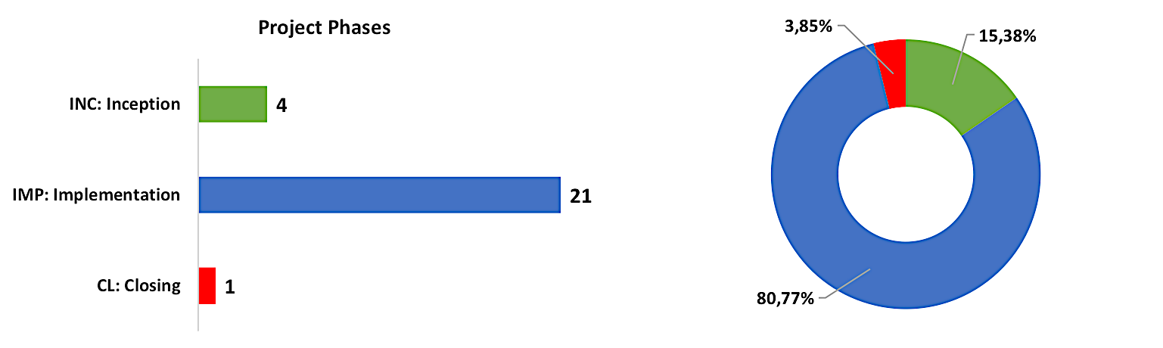

Figure 88 - Duration of project phases

The ToR mention as requirement that the duration of the project shall be 24 Months - **Inception**: 4 months (max); **Implementation**: 19 Months; **Closing**: 1 Month[54]. As it is shown in the detailed timetable of work and summarised in the figure above, our proposed plan is based on an inception period of 4 months (the Inception Report will be submitted in the middle of the inception period, no later than 2 months from the project start date[55]), a closure period of one month and a total duration of 24 months.

However, we believe that a longer Implementation phase would be for the benefit of the quality of the results. As ToR requires, in the inception period we wold develop and submit also two more important deliverables, the updated specifications for the related supply tender for IT equipment and the Basic algorithm[56]. Moreover, we would also analysis of existing systems for proposing integration or incorporation into the new system[57].

It is foreseen that the above-mentioned tasks that will be also carried out during the inception period to have an impact on the design of the eID solution (the first activity from the implementation phase). For this reason and in order to optimise the activities and to maximise the quality of the results of the design activity, we believe that parallel work in the last two months of the inception period would be for the overall benefit of the implementation.

That is why (as shown in the detailed timetable of work above) we overlap the last two months of the inception period with the first two months of the design activity, thus being able to offer a longer implementation period (21 months instead of 19 months). This approach is feasible due to our flexible way of allocating the resources and will also result in a much higher transparency of the whole process, practically eliminating the possibility of having consistent and time consuming corrections to the design and eliminating the risk of a possible rejection of the design by the IAUT and CAUT[58].

Going one step further, when planning the activities of this project, we used the best practices of the software industry. While using internally the AGILE methodology for software development (see section **2.1.2** - **Specific methodology**) that will allow us to be always aligned with the requirements, the overall planning respects the best practices that always led to quality results. The following figure illustrate the configuration of the activities that will be carried out for the Output b) (the eID software).

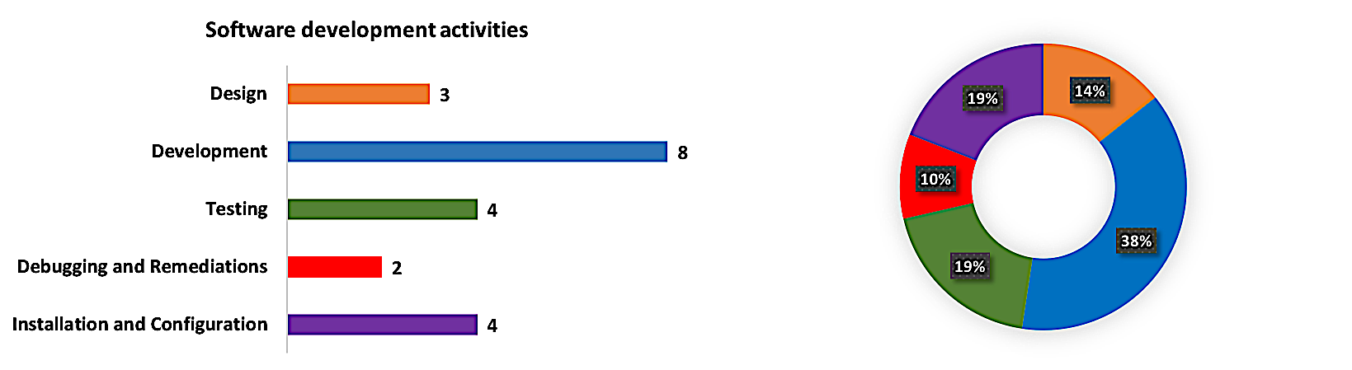

Figure 89 - Duration of Software Activities

As shown in the figure above, the longest activity is the development of the eID software solution. We plan that this activity will take 8 months and , as explained in section **2.1.2 - Specific methodology**, we intend to use AGILE software development with sprints between 2 and 4 weeks. We foresee that the sprint duration will be around 4 weeks in the first 5 months of the development activity , then will l be reduced to 2 weeks in the last 3 months. This approach will ensure a higher quality of the results while keeping the flexibility of the activity.

By using the above-described AGILE approach, we will be able to perform the internal quality reviews when relevant releases of the product will be finalised as part of the development process. In the first part of the development activity it is foreseen that the actual results may take longer until released, thus the sprint duration can be 4 weeks. In the second part of the development, it is needed to refine the mentioned result and perform a very deep unit testing of the results in order to ensure full compliance with the requirements. That’s why we will reduce the duration of the sprint , thus being able to prevent any minor or major deviation from the requirements.

It is also important to observe that we allocated a significant period of testing and it is also important to mention that this refers to the acceptance testing (on pre-production environment, before deployment) and not on the internal and unit testing that are performed by the development and software quality assurance teams before releasing the software to the pre-production environment.

The analyse of the design, development and testing activities is presented in the next figure and illustrates the structure of these activities.

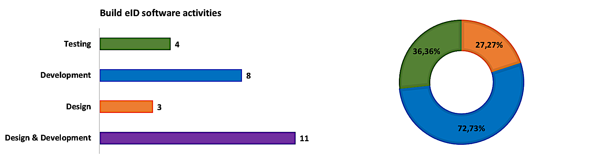

Figure 90 - Structure of design-development-testing activities

According to the best practices in the industry, it is known that the design activities should be around 30% from the total of the technical activities and the testing shall be at least 30% form the same total. As it is shown above, we respected the best practices in terms of the proportion of each activity.

However, we believe that we need to put more accent on testing in order to ensure the full compliance with the requirements. In the same time, as it was earlier explained in this Technical Proposal, the final eID solution is built on top of a read-made base eID platform which offer us the possibility to reduce a little the duration of the design activity and allocate more time to the testing activity without sacrificing the development, while still keeping everything according to the recommendations of the best practices in the industry.

When we integrate all information about the planning in the overall picture of activities structure, we obtain the information presented in the figure below:

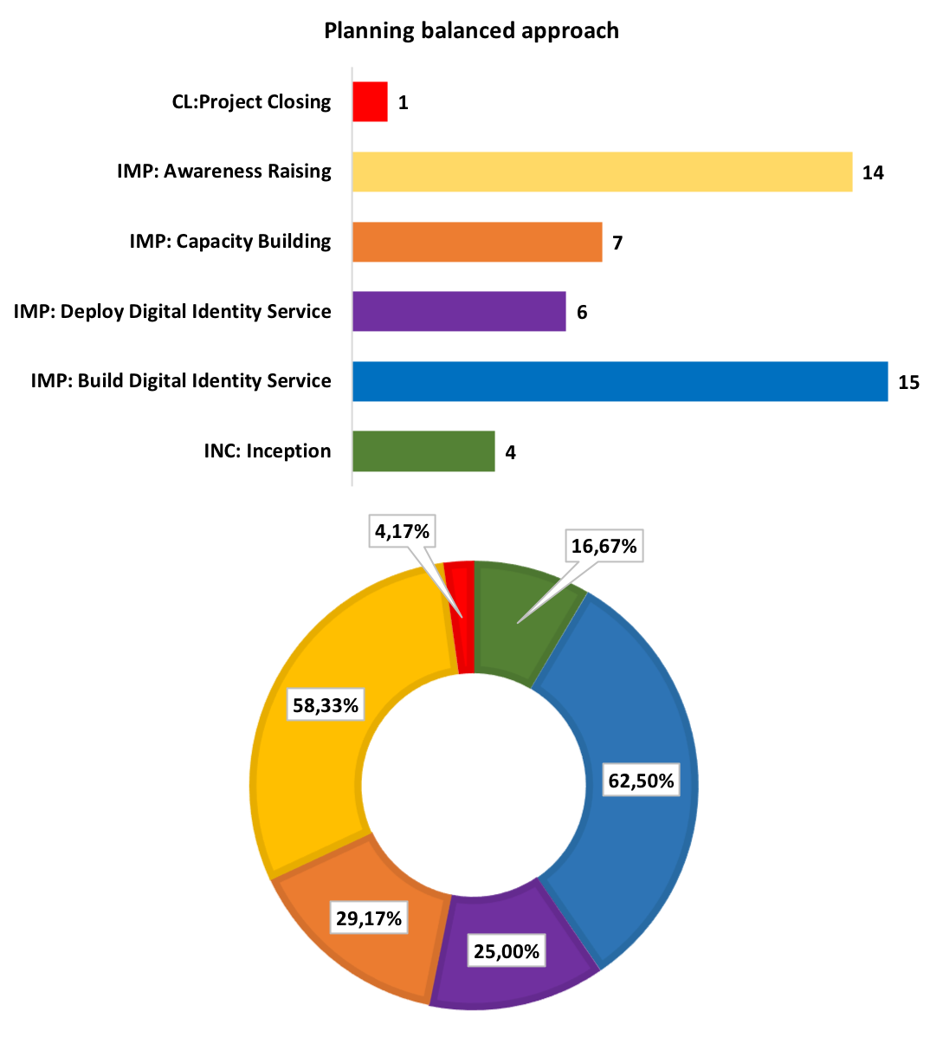

Figure 91 - Planning balanced approach

It is important to mention here that while we kept full compliance with the requirements of the ToR with regards of the overall planning of the activities, we managed also to propose a very balanced structure of activities that will allow the full achievement of all expected results and objectives.

It is shown in the picture above that we allocated significant amount of time for the most important activities of the project (development and deployment of the eID system) while we paid great attention to the other activities (capacity building and awareness raising) being aware of the fact that the value of an information system is always in the way in which the system can be used by its end-users.

The increased level of adoption depends very much on the good awareness that can be created with regards of the future eID system, thus we allocated a significant period for this activity. On the other hand, a good awareness without very well-prepared staff in the system “back-office” will lead to low level of satisfaction and, eventually, to a lower adoption level and lack of trust in the system. For this reason we allocated also a significant period of time for the capacity building activity putting a great accent on the preparation of the training sessions as it is also shown the detailed timetable of work above.

Last but not least, if we add the estimated durations of the activities from the figure above, we will obtain much more than 24 months. This means that we will perform a lot of parallel work (as illustrated also in the detailed timetable of work above). This approach will significantly increase the usage of the resources, will reduce the potential correction periods for different components and will accelerate the release of provisional/final results, thus the key stakeholders would be able to express their potential comments/observations in due time.

As we earlier mentioned, the resource allocation will be dynamic, according to the project phase, based on a quarterly estimation and on a monthly accurate calculation. However, we have an initial baseline for the resource allocation as it is presented in the figures below:

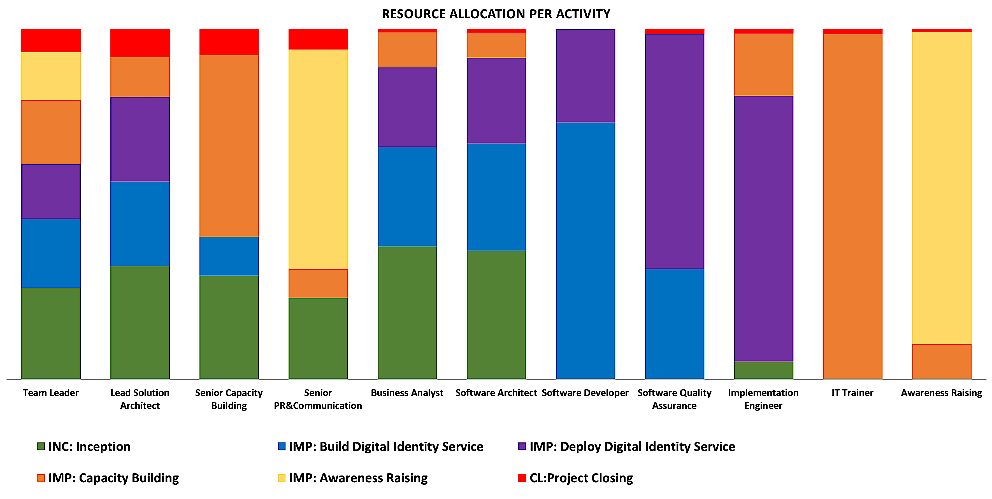

Figure 92 - Resources Allocation per Activity

For the purpose of this presentation, we divided the resources that will be involved in the implementation into several professional groups while keeping the senior experts as individuals. The professional groups that we used are: Business Analyst, Software Architect, Software Developer, Software Quality Assurance, Implementation Engineer and Awareness Raising professional. These professional groups contains all the categories described in section 2.2.2.2 - Other Experts. The senior experts are the ones presented in section 2.2.2.1 - Senior Experts.

Also for the purpose of this presentation we normalised the allocation of each resource to 100% (making all columns from the picture above to be equal), thus putting into evidence the balanced allocation of each resource to the related project activity.

The picture does not reflect the number of days allocated to each resource but reflects the level of involvement if the resource in a certain activity. As example, the involvement of the Team Leader, working full time in the project through the project implementation, in the Inception Phase will be higher that his involvement in other activities but, because of the proportion of the inception period in the overall structure of the activities, the number of days spent by the Team Leader in the inception period will be much lower that the number of days spent for other activities.

Reversing the figure above we obtain the resource involvement per each activity as shown below:

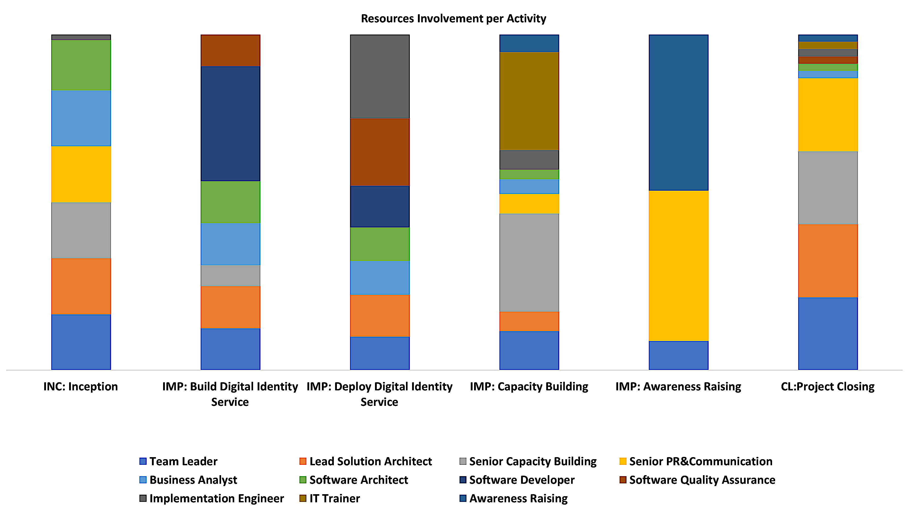

Figure 93 - Resources Involvement per Activity

The picture above illustrates which resource will contribute to each implementation activity and to what indicative extent. While we will keep the structure of the resources involved in each project activity, as earlier mentioned, the extent of contribution to the activity implementation can be subject to a dynamic allocation based on a quarterly estimation and on a monthly accurate calculation.

The senior experts’ level of allocation depends on the expertise of each senior expert as shown below:

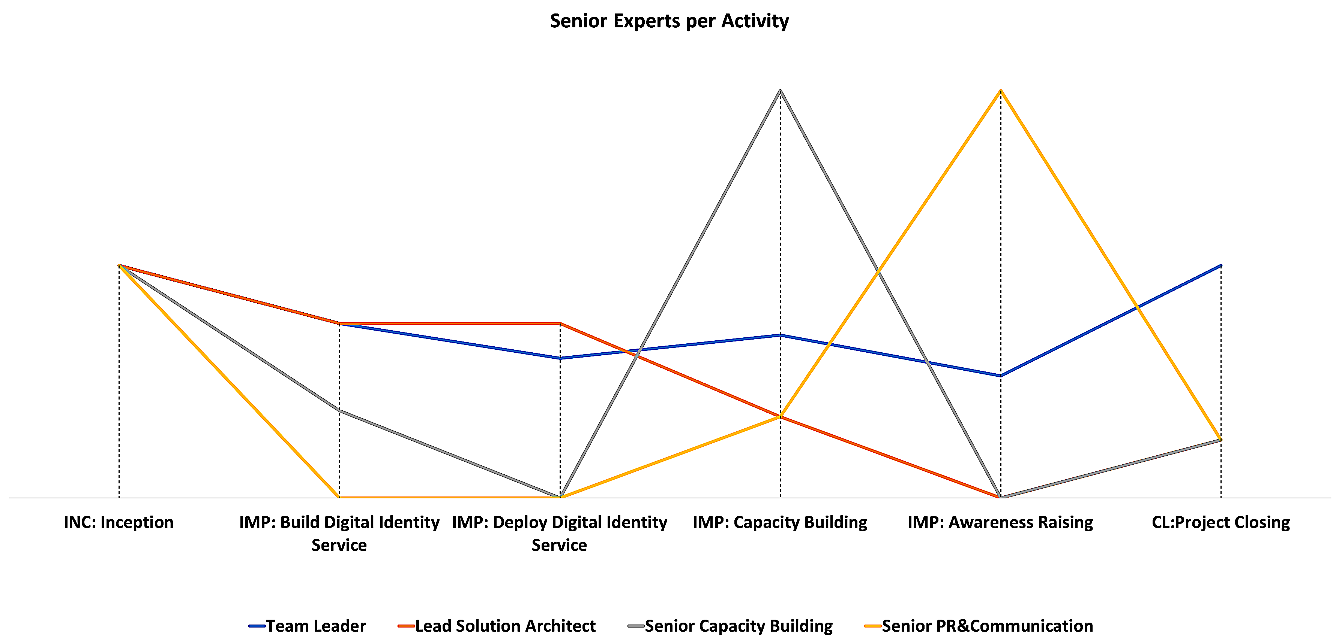

Figure 94 - Senior Experts per Activity

It is shown above that the seniors will be equally involved for the inception period. After that, the level of involvement of each expert will be higher in the activities that are in his area of expertise but, when applicable they will be also involved in other activities. As example, it is shown above that the senior capacity building expert will have an involvement in the build phase since it is natural to become familiar with the system in order to be able to better prepare the trainings. Similar to the senior capacity building expert, the senior PR&Communication expert will have a small involvement during the deployment activity in order to be able to design/amend the C&V Strategy. For the same reason he will have an involvement in the capacity building activity. The closing phase will be mainly under the responsibility of the Team Leader while the other seniors will be equally involved but at a lower level.

Another important aspect that we considered when planning the activities was the level of allocation of the relevant resources during the software related activities. This level of allocation is presented in the figure below:

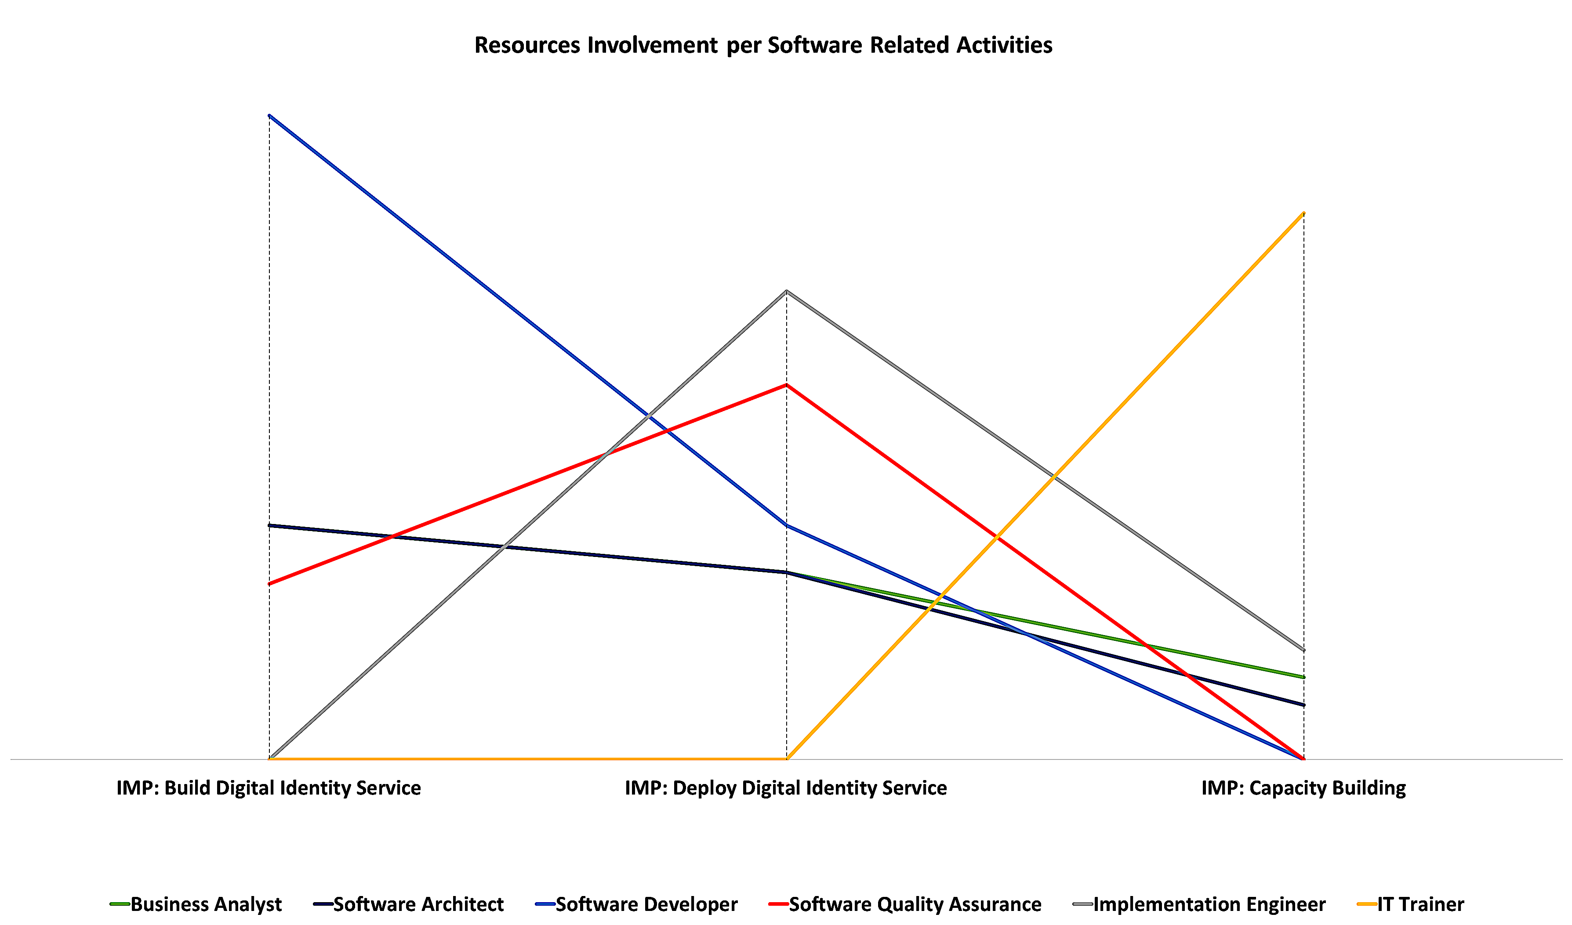

Figure 95 - Relevant Resources per Software Related Activities

It is shown in the figure above that the software developers will have the highest level of allocation in the development activity (Build Digital Identity Service) and this level will gradually decrease while more functionalities will be released, reaching the 0 level during the capacity building activity.

Meanwhile, naturally, the level of allocation of the Software Quality Assurance resources (used for testing) will increase gradually, having the maximum during the deployment (since then the most important acceptance testing will be carried out) and reaching 0 during the capacity building activity.

For the implementation engineers, the level of allocation will increase during the development since they need to become very familiar with the software that they will need to deploy, will reach a maximum during the deployment activity and they will also have a certain level of involvement during the capacity building activity as providing the IT Trainers with necessary support.

The level of allocation for the software architects will stay constant during the development activity, will decrease a bit during the deployment activity as they will play a secondary role comparing with the implementation engineers and will reach a minimum during the capacity building activity as they will also provide the trainers with needed support. Similar, almost the same level of allocation will be for the Business Analysts, the only difference will be that their involvement in the capacity building activity as providing needed support to the trainers will be higher than for the software architects.

The IT trainers will not have a significant involvement during development but their allocation will increase during deployment activity and will, obviously, reach the maximum during the capacity building activity.

As described in this section of the technical proposal, we took into consideration all relevant aspects when proposing the activity plan for this project. We identified and used all necessary resources, we applied the best practices in the industry and we provided a realistic image of the feasibility of the implementation that is fully supported by our strategy described in detail in section 2 - Section 2. Strategy.

However, as it is required by the ToR, the Organisation&Methodology will be revised during the inception period. We do not expect that the revision will lead to fundamental changes, thus what is proposed in the Technical Proposal is a solid base line. After the inception period we expect to have a much more granular image on the resources’ allocation and on the quantity of resources that we will involve in the implementation.

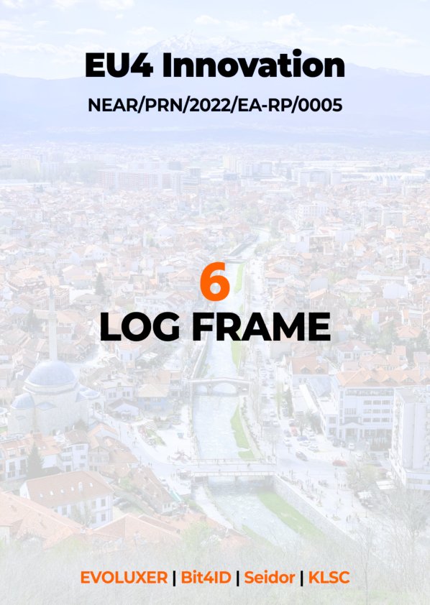

## Log Frame

Table 65 - Log Frame

| Project description | | | | Indicators | Means of Verification | Assumptions |
| --- | --- | --- | --- | --- | --- | --- |
| Overall objective  To increase efficiency and productivity of the private sector through increased use of ICT, create proper e-business/e-commerce ecosystem, and improve electronic service delivery for citizens and businesses. | | | | * Specific Objective 1 achieved * Specific Objective 2 achieved | * The approved Final Report | N/A |
|  | Specific Objectives   * **Specific Objective 1:** To contribute to Kosovo government efforts to digitalise and increase competitiveness and profitability of Kosovo businesses * **Specific Objective 2:** To improve performance of businesses by increased ICT usage | | | CL.FR approved | * Indicators for Output a) * Indicators for Output b) * Indicators for Output c) * Indicators for Output d) * Final Report | N/A |
|  | | Output a)  ToR, §2.3, point a), page 9 | | * INC.D1 approved * INC.D2 approved * INC.D3 approved * INC.D4 approved | * The supply tender for IT equipment can be launched by the CAUT * The inventory of existing information systems to be connected/integrated with the Digital Identity Service is complete and agreed by the relevant stakeholders * The Inception Report and Revised O&M reflects the findings from the Inception Phase and provides a detailed image of the next activities * The revised Basic Algorithm reflects the findings from the Inception Phase | * Availability of relevant information about existing Information Systems * Availability of Technical Specifications for the IT equipment needed for the deployment of the Digital Identity Services * Necessary institutional resources exist * Readiness of Kosovo institutions to collaborate for the implementation |
|  | | | Activity for Output a)  Inception Phase | Same as above | Same as above | Same as above |
|  | | Output b)  ToR, §2.3, point b), page 10 | | IMP.DDIS.D6-3 approved | The Acceptance Report resulted after the deployment of the Digital Identity Service is approved | * Adequate and sufficient beneficiary resources to the project implementation * Timely commissioning of the IT equipment * Adequate and sufficient beneficiary resources to the project implementation * Necessary institutional resources exist |
|  | | | Activity1 for Output b)  Build Digital Identity Service Implementation Chapter | IMP.BDIS.D5-2 approved | * All functional tests passed * All performance test passed * UX tests may have comments * The Contractor has enough relevant information about the corrections that shall be made | * Adequate and sufficient beneficiary resources to the project implementation |
|  | | | Activity2 for Output b)  Deploy Digital Identity Service Implementation-Chapter | * IMP.DDIS.D6-1 approved * IMP.DDIS.D6-2 approved * IMP.DDIS.D7 approved | * All corrections/remediations resulted from the testing activity were completed * The system is installed and configured in the production environment * The product documentation is complete and delivered to the relevant stakeholders | * Timely commissioning of the IT equipment * Adequate and sufficient beneficiary resources to the project implementation * Necessary institutional resources exist |
|  | | Output c)  ToR, §2.3, point c), page 10 | | IMP.CB.D8-1 – 10 delivered | * The planning of the training session is completed and approved before the installation/configuration on the production environment * Each training session is carried out as planned * All training sessions are completed by the end of the deployment to production | * Adequate and sufficient beneficiary resources to the project implementation * Necessary institutional resources exist * Readiness of Kosovo institutions to collaborate for the implementation |
|  | | | Activity for Output c)  Capacity Building Implementation-Chapter | Same as above | Same as above | Same as above |
|  | | Output d)  ToR, §2.3, point d), page 11 | | * IMP.AR.D9-2 approved * IMP.AR.D9-1 approved and published | * C&V strategy delivered before the start of the testing phase * Video materials produced, discussed and delivered before the approval of the C&V Strategy * Distribution channels (YouTube, Social Media, Websites) established before the approval of the Video materials | * Efficient institutional capacities for the implementation and operation of the Digital Identity Service * Political commitment for developing private sector through ICT remains high * Interest of businesses remains high |
|  | | | Activity for Output d)  Awareness Raising Implementation-Chapter | Same as above | Same as above | Same as above |

The logframe presented in the table above was drafted based on the information available at the date of submission of this Technical Proposal. During the inception period, we will analyse it based on the latest information that will become available and we will update it as part of the deliverable Revised Organisation&Methodology. The indicators will be used for evaluating the outputs/results while the overall evaluation shall be made according to the logframe. The approval of a deliverable (as listed in the logframe above) means that the indicators were evaluated as meeting the evaluation criteria. As stated in point 2.4.9 of this proposal, the indicative table of outputs is the following:

| Project Phases | Indicator |
| --- | --- |
| **Inception Phase** | * Each gap identified in the assessment of the current situation shall be classified in one of the following categories, organisational; technical; legal * The inventory of existing information systems that will be integrated with the eID system is complete (approved by IAUT and CAUT) and there is a clear integration solution for each of them * The supply tender for IT equipment can be launched by the CAUT * The inventory of existing information systems to be connected/integrated with the Digital Identity Service is complete and agreed by the relevant stakeholders * The Inception Report and Revised O&M reflects the findings from the Inception Phase and provides a detailed image of the next activities * The revised Basic Algorithm reflects the findings from the Inception Phase |
| **Build eID system** | * All use cases[59] to be covered in the design of the final eID solution * Each use case shall be linked to at least one technical gap identified during the assessment of the current situation performed in the inception period in order to maintain full traceability from the project objectives to the technical solution * The technical design covers business requirements->functional and non-functional requirements->design specifications->development tasks and full traceability shall be made in order to ensure the coverage of the required scope * All tests for blocking functionality passed with success * All functional tests passed * All performance test passed * UX tests may have comments * The Contractor has enough relevant information about the corrections that shall be made |
| **Deploy eID System** | * All potential non-conformities were corrected in the final version of the system (the version that will be deployed on the production environment) * The system documentation covers the whole scope of the system (use cases, regular users, CA users, RA users, administration, maintenance) * All corrections/remediations resulted from the testing activity were completed * The system is installed and configured in the production environment * The product documentation is complete and delivered to the relevant stakeholders |
| **Capacity Building** | * The planning of the training session is completed and approved before the installation/configuration on the production environment * Number of training sessions organised – at least 10 sessions for 2 days each. At least 2 extra sessions organised for staff of Ministry of Economy and Energy * Number of trainees – at least 20 participants per session. At least 5 staff of MoEE trained in extra training session. * Number of study visits organised – one study visit for three days to Italy or Denmark * Number of participants in study visits – at least 5 staff from MoEE * Each training session is carried out as planned * All training sessions are completed by the end of the deployment to production |
| **Awareness Raising** | * C&V strategy delivered before the start of the testing phase * Video materials produced, discussed and delivered before the approval of the C&V Strategy * Distribution channels (YouTube, Social Media, Websites) established before the approval of the Video materials |

1. ToR, section 5.1
2. ToR, section 4.3.2
3. ToR, section 4.3.1
4. ToR, section 4.3.2
5. ToR, section 4.1.3
6. ToR, section 5.2
7. Same as 6
8. The usual abbreviation used for Contracting Authority (CA) cannot be used in the context of this project since it is widely used to abbreviate the Certificate Authority
9. We choose to use IAUT abbreviation for the Implementing Authority in order to maintain consistency with the abbreviation used for the Contracting Authority
10. ToR, section 4.1.1
11. Technical Study Preparation for implementation of e-IDAS in Kosovo, Annex 2 – Output 1b (Activity 3.2), section 3
12. European Commission, “Directive 1999/93/EC of the European Parliament and of the Council of 13 December 1999 on a Community framework for electronic signatures”, Official Journal of the European Union, No. L 013, pp. 2–20, January 2000, <http://eur-lex.europa.eu/legal-content/en/TXT/?uri=CELEX%3A31999L0093>
13. European Commission, “Regulation (EU) No 910/2014 of the European Parliament and of the Council of 23 July 2014 on electronic identification and trust services for electronic transactions in the internal market and repealing Directive 1999/93/EC”, Official Journal of the European Union, No. 257, pp. 73–114, August 2014, <http://eur-lex.europa.eu/legal-content/EN/TXT/?uri=uriserv:OJ.L_.2014.257.01.0073.01.ENG>
14. https://www.mckinsey.com/industries/financial-services/our-insights/banking-matters/digital-id-the-opportunities-and-the-risks
15. <https://digital-strategy.ec.europa.eu/en/library/trusted-and-secure-european-e-id-regulation>
16. EC Recommendation of 3.6.2021 on a common Union Toolbox for a coordinated approach towards a European Digital Identity Framework
17. <https://asquared.company/en/blog/key-success-factors-for-e-identity-systems-843/>
18. KOSOVO DIGITAL AGENDA OBSERVATORY 2022, Country Report and Roadmap for the implementation of the Digital Agenda in Kosovo
19. KOSOVO DIGITAL AGENDA OBSERVATORY 2022, Country Report and Roadmap for the implementation of the Digital Agenda in Kosovo
20. https://ecommerce4all.eu/ecommerce-data/internet-use-and-e-shoppers/
21. <https://www.helvetas.org/en/eastern-europe/about-us/follow-us/helvetas-mosaic/article/December2021/21-Examples-of-Digital-Government-Best-Practices-in-the-Western-Balkans>
22. See ToR, sections 4.1.1, 4.2 b)
23. Web environment for digital signature creation/validation and file encryption/decryption can be selected and customised from the existing ones on the market (**ToR, section 4.1.1**)
24. Web environment for digital signature creation/validation and file encryption/decryption can be selected and customised from the existing ones on the market (ToR, section 4.1.1)
25. Techncial Study Preparation for implementation of e-IDAS in Kosovo, Annex 2 – Output 1b (Activity 3.2), section 3
26. Implementation of desktop environments for the main use cases and APIs for service providers should have the highest priority, while mobile environment can be introduced in second phase (ToR, section 4.1.1)
27. ToR, section 4.1.1
28. ToR, section 4.2 b)
29. ToR, section 4.2 b)
30. **EBSI (European Blockchain Services Infrastructure):** [EBSI](https://ec.europa.eu/cefdigital/wiki/display/CEFDIGITAL/EBSI) is the first Blockchain infrastructure in the EU, driven by the public sector, in line with European values and regulations and with the vision of leveraging Blockchain for the creation of reliable cross-border services for public administrations and their ecosystems. Since 2020, the network of nodes distributed throughout Europe is being prepared and use cases are defined. <https://ec.europa.eu/digital-building-blocks/wikis/display/EBSI/Home>
31. **ESSIF (European Self-Sovereign Identity Framework):** The European Union is creating a European Sovereign Identity Framework (ESSIF) compatible with eIDAS. The ESSIF uses decentralized identifiers (DIDs) and the European Blockchain Services Infrastructure (EBSI), to enable [e-ID](https://ec.europa.eu/cefdigital/wiki/display/CEFDIGITAL/eID) to all Europeans in the format of Verifiable Credentials. EBSI is a licensed network, so issuers must be registered in the TIR (Trusted Issuer Registry) as an entity authorized to issue credentials. The EU digital identity Wallet will also be standardized and provided to citizens .
32. <https://ec.europa.eu/digital-building-blocks/wikis/display/EBSI/Conformant+wallets>
33. ToR, section 4.2 b)
34. ToR, section 2.3 a)
35. Technical Study for Preparation for implementation of e-IDAS in Kosovo, Outputs 2 & 3 (Activities 3.3, 3.4), Annex 1
36. Technical Study for Preparation for implementation of e-IDAS in Kosovo, Outputs 2 & 3 (Activities 3.3, 3.4), section 4
37. Technical Study : Preparation for implementation of e-IDAS in Kosovo, Annex 1 – Output 1a (Activity 3.1).1)
38. Technical Study : Preparation for implementation of e-IDAS in Kosovo, Annex 1 – Output 1a (Activity 3.1)
39. Source: [https://ec.europa.eu/europeaid/aid-delivery-methods-project-cycle-management-guidelines-vol-1en](https://ec.europa.eu/europeaid/aid-delivery-methods-project-cycle-management-guidelines-vol-1_en)
40. ToR, Section 2.3
41. See ToR, section 8.1 – Monitoring and Evaluation
42. See Technical Study – Outputs 2 & 3 (Activities 3.3, 3.4), Annex 1
43. See section 3.5 - Quality assurance
44. See ToR, section 2.3 d)
45. Source: datareportal.com
46. ToR, section 4.2, b)
47. The internal preparation phase starts before the kick off meeting and continues after the meeting in order to take into account any information from the meeting
48. A requirement of our ISO 9001 Certification – is the number of issues that arise and how rapidly they are solved in a satisfactory manner
49. Project Management Institute (2000), A Guide to the Project Management Body of Knowledge (PMBoK® Guide), 2000 Edition. Newton Square, Pa.: Project Management Institute
50. Note that both the templates and guidelines as well as other materials are available to the Project Manager in our toolbox, however, the Quality Manager provides a reminder of where they are available – this is also the case for other guidelines and templates that are mentioned in the following sections.
51. In this section we use the distinction between hazards and risks identified in Tool #12: Risk assessment and management: 73, of the Commission's Better Regulation “Toolbox”, according to which “Hazard is a function of the inherent properties of the agent/event in question whereas risk is a function of both the hazard and of the potential likelihood and extent of being exposed to the hazard”
52. See Technical Study – Outputs 2 & 3 (Activities 3.3, 3.4), section 3.3.6 Mobile Based eID Marketing Web
53. ToR, section 5.2
54. ToR, section 5.2
55. ToR, secrion 7.1, Inception Report
56. ToR, section 2.3 a)
57. ToR, section 4.2 a)
58. ToR, section 4.2 b)
59. ToR, section 4.2, b)